Request for Proposals for Human Resource Management in Lebanese Red Cross Local Branches
Purpose:
To complete a detailed mapping of all paid employees in Lebanese Red Cross local branches, including build full employee files, identifying all pending National Social Security Fund issues and other relevant findings included in the body of this RFP
Commissioners: Lebanese Red Cross
Reporting to: Secretary General of the Lebanese Red Cross
Duration: 3 to 6 Months
Timeframe: Starting October 2021
Location: Lebanon

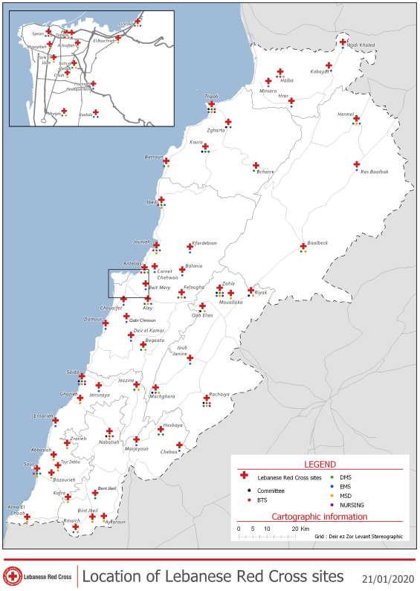1. Context
The Lebanese Red Cross (LRC) has 32 local branches, but a single legal entity.

List Of Branches:
Batroun, Bouchriyeh, Zahrani, Koura, Nabatiyeh, Antelias, Hermel, Bcharri, Baalback, Bent Jbeil, Beit El Din, Beirut, Jbeil, Jezzine, Jal el Dib, Jounyeh, Hasbaya, Halba, Rashaya, Riak, Zahle, Zgharta, Tyre, Saida, Tripoli, Aley, Falougha, Furn El Chebbak, Qob Elias, Marjeoun, Machghara, Meniara.

In the period between 1990 and 2014, there was no Secretary General in LRC and no Human Resources department. There was only an under-staffed and under-performing “personnel administration” office which oversaw the recruitment and files of the employees that were hired centrally by LRC HQ.

During that same period, due to weak central capacities, successive LRC Presidents allowed local branches to recruit their own employees and to open new National Social Security Funds (NSSF) and Ministry of Finance (MoF) numbers, so that they could handle all liabilities and legal issues resulting from the hiring of their local employees. This was contrary to HR, legal and management best practices and has resulted in a chaotic situation with the effects still being felt today.

Today, there are 171 employees that are considered to be branch-level employees:
· 95 of those are related to the Medico-Social centres that are funded and operated by the branch
· 32 of those are general branch employees (drivers, secretaries, administrators…)
· 32 Blood Transfusion Services employees (paid by HQ through the branches, some NSSF issues in Nabatiyeh for e.g.)
· 8 EMS employees for day shifts
· 4 Nursing School staff

Due to the economic collapse, branches are no longer able to fundraise locally, and are in many cases not able to continue paying their employees. The branches have asked HQ to support, but HQ has very limited information regarding the job descriptions, contracts, roles etc. of these employees.

2. Problem Statements
Problem #1: 9 branches are not able to obtain a “clearance certificate” from NSSF (in Arabic, “bara2et zemmeh”). Practically, this means that LRC could be liable for NSSF fees and other HR related taxes that it is not aware of, or that LRC could be paying NSSF fees for persons that are no longer employed by LRC.

Problem #2: when branch-based employees retire and try to collect their end of service indemnity, some of them realize that the branch had not been settling the NSSF fees for a certain period (or had not even enrolled them in NSSF). This leaves LRC with the obligation of settling NSSF fees to the employee from own funds via a direct settlement.

Problem #3: none of the 32 branches have full employee files, and therefore expose themselves and LRC to liabilities.
3. Consultancy Purpose
The objectives of the consultancy are:
1. Produce a full and final comprehensive mapping of all LRC branch-based employees
2. Build a full personnel file for each branch based employee
3. Obtain all information pertaining to LRC branch-based employees from the local NSSF authority, clearly identifying any pending issues with NSSF, and the steps needed to resolve the pending issues
4. Provide an evaluation of the current management and reporting lines of branch-based employees and recommendations on best practices to tackle the gaps.

4. Expected outputs:
1. Evaluation of line-management /reporting lines, as well as HR management responsibility, for branch-based employees (through interviews, observations and survey) and recommendations for a more effective and fit for purpose system
2. Definitive mapping of all LRC branch-based employees (see Annex 1)
3. Personnel file for each employee including:
a. Actual job description
b. National identification
c. Relevant certificates and diplomas
d. Curriculum Vitae
e. Employee interview report
f. Recommendations around the status of this employee
3. List of NSSF status for each employee showing if the employee file is in order with NSSF or describing the pending issue and steps for resolution. This should include:
- Employment date and NSSF registration date per employee
- List of registered employees from the NSSF for each branch, showing the date of registration for each employee
- Table showing the actual paid salaries (cross-checked between branch, HR and Finance) and salaries registered with NSSF in case of difference
- Statement of account from the NSSF local office showing the paid contributions and outstanding ones per employee
4. Log sheet of all conducted visits and interviews
5. Presentation of findings and recommendations to LRC leadership
5. Methodology
The consultant(s) will first be provided with a list of branches to start with by priority including the 32.
The consultant is expected to propose a methodology to meet the objectives listed above.
At a minimum, the consultant should:
1. Visit all LRC branches and meet with the employees and their line managers as well as with the relevant Local Committee Board members
2. Conduct a structured interview with each employee
3. Build the full personnel file for each employee
4. Visit the local NSSF office to cross-check information about each employee’s status with LRC
5. Identify in details any pending NSSF issues
6. Provide concrete recommendations for the resolution of pending NSSF issues
7. Assist in LRC in resolving NSSF issues if needed.
The consultant is expected to report to the SG office on a weekly basis.

The consultant will be provided by LRC with the following:

- Power of attorney in the name of the NSSF representative of the assigned company from the main branch and from each branch allowing him/her to represent LRC in front of the NSSF and to be able to collect all the needed information and documents
- Formal delegation letter allowing the assigned company to represent LRC in front of other branches.

6. Consultant Profile
Individuals, teams, or companies can apply. Only applicants with the following profile will be considered for selection:
1. Able to demonstrate significant experience and expertise in comparable human resource challenges in Lebanon
2. Able to demonstrate experience and expertise in identifying and tackling NSSF issues
3. Previous experience working with reputable NGOs is a plus
4. Good oral presentation and report writing skills
5. Able to provide at least 2 references for comparable work
6. Able to visit LRC branches and local NSSF offices and undertake all necessary field work

Notes:
- Selected consultant will be subject to a pilot phase after which LRC will determine if consultant performance is suitable for rollout of the remainder
- Payments will be linked to completed deliverables
7. Team
LRC does not have any restrictions regarding the number of persons who will carry out this review. The preferred option is for a team of 2 persons.

8. Timeline
> 6th of September 2021: ToR’s published
> 15th of September 2021: deadline for written questions to be submitted to LRC on the email addresses provided below
> 27th of September 2021: Deadline for submitting proposals to LRC
> October 2021 (1st half): First Contract signature
> Oct-Nov 2021: Pilot implementation
> Dec 2021: Evaluation of performance during pilot
> TBD: Second contract signature or end of engagement

9. Proposals
Your proposals should include:
· CVs and portfolios of the consultant(s) with description of roles and responsibilities in case of more than one consultant
· Description of previous experience with human resource projects including references
· Description of comparable human resource projects, including building personnel files and addressing NSSF issues, including references
· Roles and responsibilities of the members in case of a team of more than one person
· Proposed methodology and time-table for performing the requested evaluation
· Availability to start work in Lebanon
· Detailed financial proposal
Electronic copies of your proposal to be provided in a USB key to be enclosed in the sealed envelope upon bid submission.

10. Payment terms
· Payments will be made in “fresh USD” by direct wire transfer. Applicants are expected to adjust prices accordingly and to include any and all discounts in their original submission
· Applicants are required to provide flexible pricing per branch and/or per employee
· Applicants are required to propose payment terms based on a limited initial down-payment, with all subsequent payments linked to specific deliverables.

11. Annexes
· Annex 1: List of required information per employee
· Annex 2: Full list of all LRC branches with numbers of employees per branch

12. Evaluation
Only applicants meeting the profile described in Section 6 of this document will be considered.

The technical phase of the evaluation will be completed according to the following criteria:

1. Completeness of proposal. Incomplete proposals will not be considered.
2. Portfolio demonstrating relevant expertise of the individuals assigned to this project (40% weight)
3. References (20%)
4. CV(s) of consultants (20%)
5. Proposed methodology (20%)
The financial evaluation will be completed according to the following criteria:

1. Cost (50%)
2. Detailed breakdown of costs (25%)
3. Payment terms based on performance of consultant (25%)

All proposals to be delivered to LRC Spears (Finance Dept) in sealed envelopes by the 27th of September

Only written communication to the email addresses provided in the bidding document will be accepted between the date when the ToRs are published, and the final decision by LRC:

