Invitation to bid No: 2023-026 Search and Rescue Equipment “Framework Agreement for Three Years”
The Lebanese Red Cross (LRC) hereby invites sealed bids from manufacturers/reputed firms/ registered suppliers for the supply of the following supplies/ services:
LOT # | Main Catigory | Item description | Delivery of PO
Lot 1 | Rope and Rescue | CONNECTOR | ALL OVER LEBANON
Lot 2 |  | HARNESS
Lot 3 |  | HEAD LAMP
Lot 4 |  | HELMETS
Lot 5 |  | Kits
Lot 6 |  | LANYARD AND ENERGY ABSORBERS
Lot 7 |  | MOBILE FALL ARRESTERS
Lot 8 |  | PACKS
Lot 9 |  | PULLEYS
Lot 10 |  | Rescue Accessories
Lot 11 |  | ROPE CLAMPS
Lot 12 |  | ROPES
Lot 13 |  | TRIPOD AND ACCESSORIES
Lot 14 | Communication Tool | COMMUNICATION ITEMS
Lot 15 | Intervention Tools | CAMPING ACCESSORIES
Lot 16 |  | ELECTRICAL AND LIGHTING ITEMS
Lot 17 | Logs and Carrying | PACK
Lot 18 |  | CARRYING ACCESSORIES
Lot 19 |  | CASE
Lot 20 |  | ELECTRICAL
Lot 21 |  | TOOL KIT

ITENDER DETAILS
The Tender details are as follows:
INCOTERMS | DDP – Beirut Delivery Duty Paid
Delivery address of the Bid | Spears – Lebanese Red Cross HQ – Finance Department
ITB Published | Friday 30 June 2023
All documents can be downloaded from http://www.redcross.org.lb/ (Please select “Tender” from the menu at the top right of the page). Tenderers are advised to check the website regularly as any changes or additional information related to this tender will be updated via the website.
Tenders must be submitted in a sealed envelope
Mailing address for bid submission | Lebanese Red Cross Head Quarters,  Spears Street, Kantari, Beirut, Lebanon  Please submit your bid in a SEALED Envelope to FINANCE DEPARTMENT at 1st floor.
Tender deadline | Date: Monday 17 July 2023  Time: 4:00 PM PLEASE NOTE: NO BIDS WILL BE ACCEPTED AFTER THE ABOVE CLOSING TIME AND DATE
Bids to be marked | “Tender reference: 2023-020 Do not open before Monday 17 July 2023”
Deadline for questions | Date: Friday 07 July 2023,  Time: 4:00:00 PM
IMPORTANT INFORMATION REGARDING THIS ITB:
- BID SHOULD BE SUBMITTED TYPING AND NOT HAND WRITTEN (written by hand bids will be considered as ineligible)
- Please SIGN AND STAMP all the mentioned documents below
-For queries on this ITB, please contact the Procurement, on the following email: Hoda.fakih@redcross.org.lb

I. SELECTION AND AWARD CRITERIA
This tender will be awarded to the lowest cost technically compliant bid. The technical evaluation criteria are as per Annex 3 of Detailed Specifications.

- Administrative Evaluation (Sign and Stamp)
A bid shall pass the administrative evaluation stage before being considered for technical and financial evaluation. Bids that are deemed administratively non-compliant may be rejected in case the NO answer is not well justified.
LRC Requirements | Is bid compliant? Bidder to complete | Details - Please insert your comments
Awarded Bidder(s) must commit to Three Years Framework Agreement.  This means that LRC will sign a Long Term Frame work agreement with the awarded bidder. The bidder must commit to a fixed prices for 3 years and variable quantities. | ☐ Yes ☐ No
Validity of bids for evaluation is 90 days | ☐ Yes ☐ No
The mentioned Quantities are estimated, could be increase of decrease depend on the needs and availability of the budget | ☐ Yes ☐ No
advanced down payments are not applicable | ☐ Yes ☐ No
LRC payments terms are 30- 45 days from the date of GRN ( Good Received Note) | ☐ Yes ☐ No
LRC will pay in Fresh Transfer USD to the awarded bidder fresh account, but VAT amount will be paid in Cheque LBP based on Sayrafa (or any official upcoming memo from the government) | ☐ Yes ☐ No
A soft copy of the signed and stamped Invitation to bid must be submitted on a USB  A soft copy of the datasheets must be submitted on a USB | ☐ Yes ☐ No

Selection Criteria for Selecting a Bid Winner
Bidder should take into consideration the below requirement to get the higher score in the Criteria Evaluation:
Component | Scoring Element | Percentage | Description | Means of Verification
Technical Evaluation (60%) | Company Experience and Type | 20 % | Years of Experience (5%):  No previous Experience: 0%  Less than 1 Year of Experience: 1%  1-2 Years of Experience: 1%  3-5 Years of Experience: 4%  More than 5 Years of Experience: 15% | Company Legal Documents
 | Provision of Certified Items – Rescue Use | 20% | CE and EU-certified Equipment 20%  Other origin 0% | Certifications
 | LRC Experience | 10% | - No LRC experience 0%  - Experience with LRC in one of its projects but didn’t complete the work or requested services for any reason 0%(excluded from the bidders)  - Experience with LRC but with a bad history in delays or quality defects 0% (excluded from the bidders)  - Successfully implemented works/services with LRC in 10+ Projects 10% | Procurement Unit Archive
 | Available Items in Stock | 10% | - No Items in Stock 2%  -Items in stock 8% | Share available stock  Ability to check the warehouse
 | Company Profile | 10% | 0%: Small  3% Average  5%: Medium  10%: Large | Company Portfolio: Owned Equipment – Facilities – Number of Staff
Financial Evaluation (40%) | Financial Offer | 30% | The grade of the financial offer will be calculated using the below formula: Lowest Bid/Current Bid * 40
Total |  | 100% | (The Sum of the Technical & Financial Score)

Documents listed below shall be submitted with your bid.
# | Annex | Document | Instructions
1 | Annex 1 | LRCS Supplier Registration Form | Complete ALL sections in full, sign, stamp and submit  Mandatory.
2 | Annex 2 | Bid Form | Complete ALL sections in full, sign, stamp and submit  Mandatory.
3 | Annex 4 | Past Performance & Bidder References: Minimum 2 proofs of similar working  experience with an international,  NGO, national NGO, private, or public sector  Provide 2 references (phone and mail) | Mandatory , sign, stamp and submit  Proof of experience shall be a copy of contract/purchase order signed or copy of Job Completion.  Note that the notification of contract award is not a  Proof of experience for LRCS.
4 | Annex 5 | Tender Award and Acknowledge Certificate | Mandatory , sign, stamp and submit
5 |  | Copy of company registration – (Ministry of Justice)- وزارة العدل) ) شهادة تسجيل شركة تجارية | Mandatory
6 |  | Copy of tax registration (Ministry of Finance( (وزارة المالية) شهادة تسجيل الشركة | Mandatory
7 |  | Copy of VAT registration (Ministry of Finance) (وزارة المالية) شهادة تسجيل في الضريبة على القيمة المضافة | Mandatory
8 |  | اذاعة تجارية | Mandatory
9 |  | IBAN official Document | Mandatory
10 |  | Soft copy of your offer signed and stamped on (USB) not by email, must be submitted with the bid.  Including all the datasheets of the submitted items | Mandatory

B. Technical Evaluation
To be technically acceptable, the bid shall meet or exceed the stipulated requirements and specifications in the ITB.

A Bid is deemed to meet the criteria if it confirms that it meets all mandatory conditions, procedures and specifications in the ITB without substantially departing from or attaching restrictions with them. If a Bid does not technically comply with the ITB, it will be rejected.

c. All bids that pass the Technical Evaluation will proceed to the Financial Evaluation. Bids that are deemed technically noncompliant will not be financially evaluated.

II. TENDER PROCESS
The following processes will be applied to this Tender:
• Tender Period
• Tender Closing
• Tender Opening
• Administrative Evaluation
• Technical Evaluation
• Financial Evaluation
• Contract Award
• Notification of Contract Award

Instructions to bidders
Tenderers must meet all the requirements specified in the tender documents and therefore advised to go through the tender documents carefully before submission and be certain that they are able to comply with the specified terms & conditions.
- Bidding in lots:
If the tender is divided into lots, bidders should make every effort to bids for all items within the lot they are interested in. If bidders fail to complete all items within the lot LRCS reserves the right not to award the lot to the bidder. Bidders can bid for as many lots/items as they wish.
- Items and Quantity:
LRCS reserves the right to split up the order between suppliers.
- Specifications:
The detailed specification in respect of each item with packing, marking/ labelling instructions etc. are given in Annex 3 - Detailed Specifications which tenderers must adhere to.

Eligibility:

  - Bidders are solely responsible for ensuring that the full bid is received by LRCS in accordance with the ITB requirements, prior to the specified date and time mentioned above. LRCS will consider only those portions of the bids received prior to the closing date and time.
  - All responsive Bids shall be Typed on the LRCS Bid Form.
  - Bids submitted are at the Bidders risk and LRCS takes no responsibility for the receipt of such Bids.
  - Bidders are solely responsible for ensuring that the full Bid is received by LRCS, in accordance with the ITB requirements:
Hard Copy:
Bid shall be placed in an outer sealed envelope, addressed and delivered to:
“Tender reference: 2023-026 Do not open before 17 July 2023” Failure to comply with the above may disqualify the Bid.
  - Tenderer(s) must be Manufacturers, accredited Wholesalers, Traders / Suppliers, Agents in their registered countries.
  - Any unsealed tenders and tenders received after the submission deadline will not be accepted.
  - Tenderer(s) should have the capacity and capability to supply the items in accordance with the specifications within the prescribed delivery time and the terms & conditions mentioned herein.
  - Contracts can be awarded individually or jointly.
- Price:
  - Price should be best and final offer
  - Include discounts for early payment, if any
  - All prices should be denominated in the currency that is specified in the Addendum attached.
  - Applicable VAT/duty rates should be clearly stated per item in the offer as to facilitate any tax/ duty exemptions/ reimbursement
4.
- I’NCOTERMS:
DDP INCOTERMS©2021 as defined by the International Chamber of Commerce will be used to govern the terms of delivery/ contract.
- Delivery Destinations:
Details of the consignee and necessary details for the paperwork will be agreed at the time of signing contract with successful Tenderer/s. Tenderer(s) shall be responsible for all costs arising from packing, forwarding and delivering of goods to actual points of delivery including loading, unloading, transport and insurance and clearance costs as per the stated INCOTERMS.
- Delivery/Readiness Period:
The delivery/readiness must be within the agreed timeframe after the of signing the contract by both parties and all the items/quantities must be delivered at the delivery destinations within a maximum period as agreed on the signing of the contract. The successful Tenderer will be required to agree to the Delivery Schedule (as stated, in tranches so they meet the requirements of our consignee)
- Packaging:
All goods must be appropriately packed (if applicable – refer Annex 3 - Detailed Specifications suitable for sea/road transportation and loading/unloading including rough handling to final destinations.
- Marking/Labelling:
Marking / labelling instructions are provided in Annex 3 - Detailed Specifications
- Presentations:
Bids should be clearly legible. Prices entered in lead pencil will not be considered. All erasures, amendments, or alterations shall be initialed by the signatory to the Bid. Do not submit blank pages of the Bid Form and/or schedules, which are unnecessary for your offer. All documentation shall be written in English. All Bids shall be signed by a duly authorized
- Language:
The documents submitted will be accepted in English language only. The certificate, etc. from local government or local authorities (if applicable) could be provided in actual language All markings and labelling should appear in English only.
- Samples:
Please refer to the Addendum if samples are required with the bid submission or not. If required samples of all the items must be submitted together with your Tender documents. Samples must meet the required specifications as per Annex 3 - Detailed Specifications. Each sample must be clearly labelled. LRCS reserves the right to reject bids where Tender documents are not accompanied by the samples.
- Validity Period:
Bids shall be valid for at least the minimum number of days specified in the Addendum, and from the date of Bid closure. LRCS reserves the right to determine, at its sole discretion, the validity period in respect of Bids, which do not specify any such maximum or minimum limitation.
If the bid is successful and contracted, the bid will remain valid for the duration of the contract.
- Your offer should clearly state the following:
  - Country of origin of the goods
  - Place of manufacture and place of despatch
  - Unit prices / Total prices, etc. as per Annex 2 - Bid Form
  - Price should be net after deduction of any discount and should be compatible with the appropriate INCOTERMS specified in the Addendum.
  - Firm dates for starting and completion of delivery at delivery points.
  - Confirmation to comply with the specifications as per Annex 3 - Detailed Specifications if you can meet the specifications. If not, state clearly.
  - Confirmation to agree to accept the terms and condition as per this tender document and the general terms and conditions, stated within Annex 5 Tender and Award Acknowledge Certificate.
  - Full packing details (contents, weight and volume)
- Award of Contracts:
This ITB does not commit LRCS to award a contract or pay any costs incurred in the preparation or submission of Bids, or costs incurred in making necessary studies for the preparation thereof, or to procure or contract for services or goods. The Bidder of an offer made by LRCS will regard as an offer made by the Bidder and not as an acceptance any bid submitted.
No contractual relationship will exist except pursuant to a written contract document signed by a duly authorized official of LRCS and the successful Bidder.
LRCS may award contracts for part quantities or individual items. LRCS will notify successful Bidders of its decision with respect to their Bids as soon as possible after the Bids are opened.
LRCS reserves the right to cancel any ITB, to reject any or all Bids in completely or in part, and to award any contract.
Suppliers who do not comply with the contractual terms and conditions including delivering different products and of different origin than stipulated in their Bid and covering contract may be excluded from future LRCS ITBs.
- Acceptance:
LRCS reserves the right, at its sole discretion, to consider as invalid or unacceptable any Bid which is a) not clear; b) incomplete in any material detail such as specification, terms delivery, quantity etc.; or c) not presented on the Bid Form – and to accept or reject any amendments, withdraws and/or supplementary information submitted after the time and date of the ITB closure.
- CONFIDENTIALITY:
This ITB or any part hereof, and all copies hereof shall be returned to LRCS upon request. This ITB is confidential and proprietary to LRCS, contains privileged information, part of which may be copyrighted, and is communicated to and received by Bidders on the condition that no part thereof, or any information concerning it may be copied, exhibited, or furnished to
Others without the prior written consent of LRCS, except that Bidders may exhibit the specifications to prospective subcontractors for the sole purpose of obtaining offers from them. Notwithstanding the other provisions of the ITB, Bidders will be bound by the contents of this paragraph whether or not their company submits a Bid or responds in any other way to this ITB.

- COLLUSIVE BIDDING AND ANTI-COMPETITIVE CONDUCT
Bidders and their employees, officers, advisers, agent or sub-contractors shall not engage in any collusive bidding or other anti-competitive conduct or any other similar conduct, in relations to:

• The preparation of submission of Bids,
• The clarification of Bids,
• The conduct and content of negotiations,
• Including final contract negotiations,

In respect of this ITB or procurement process, or any other procurement process being conducted by LRCS in respect of any of its requirements.

For the purpose of this clause, collusive bidding, other anti-competitive conduct, or any other similar conduct may include, among other things, the disclosure to, exchange or clarification with, any other Bidder, person or entity, of information (in any form), whether or not such information is commercial information confidential to LRCS, any other Bidder, person or entity in order to alter the results of a solicitation exercise in such a way that would lead to an outcome other than that which would have been obtained through a competitive process.

- IMPROPER ASSISTANCE
Bids that, in the sole opinion of LRCS, have been compiled:

- With the assistance of current or former employees of LRCS, or current or former contractors of LRCS in violation of confidentially obligations or by using information not otherwise available to the general public or which would provide a non-competitive benefit,

- With the utilization of confidential and/or internal LRCS information not made available to the public or to the other Bidders,

In breach of an obligation of confidentially to LRCS, or contrary to these terms and conditions for submission of a Bid, shall be excluded from further consideration Without limiting the operation of the above clause, a Bidder shall not, in the absence of prior written approval from LRCS, permit a person to contribute to, or participate in, any process relating to the preparation of a Bid or the procurement process, if the person has at any time during the 6 months immediately preceding the date of issue of this ITB was an official, agent, functionary, or employee of, or otherwise engaged by LRCS and was engaged directly, or indirectly, in the planning or performance of the requirement, project, or activity to which this ITB relates.

- CORRUPT PRACTICES
L]RCS has zero tolerance for corruption. The Bidder represents and warrants that neither it nor any of its potential subcontractors are engaged in any form of corruption, defined by LRCS as the misuse of entrusted power for private gain.

This definition is not limited to interactions with public officials and covers both attempted and actual corruption, as well as monetary and non-monetary corruption. The definition includes, but is not limited to, corruption in the form of: facilitation payments, bribery, gifts constituting an undue influence, kickbacks, favoritism, cronyism, nepotism, extortion, embezzlement, misuse of confidential information, theft, and various forms of fraud, such as forgery or falsification of documents, and financial or procurement fraud. No offer, payment, consideration or benefit of any kind, which could be regarded as an illegal or corrupt practice, shall be made, promised, sought or accepted – directly or indirectly – as an inducement or reward in relation to activities funded by LRCS, including tendering, award or execution of core serves the right, without prejudice to any other right or remedy available to it, according to any violation of this clause to immediately reject the submitted offer, and to take such additional action, civil and/or criminal, as may be appropriate.

The Bidder agrees to accurately communicate LRCS policy with regards to Anti- Corruption to Third Parties. The Bidder furthermore, agrees to inform LRCS immediately of any suspicion or information it receives from any source alleging a violation of this policy to the contact details of the specific LRCS country operations

- CONFLICT OF INTEREST
A Bidder shall not, and shall ensure that its employees, officers, advisers, agents or subcontractors do not place themselves in a position that may, or does, give rise to an actual, potential or perceived conflict of interest between the interests of LRCS and the Bidder’s interests during the procurement process.
If during any stage of the procurement process or performance of any LRCS contract a conflict of interest arises, or appears likely to arise, the Bidder shall notify LRCS immediately in writing, setting out all relevant details of the situation, including those cases in which the interests of the Bidder conflict with the interests of LRCS, or cases in which any LRCS official, employee or person under contract with LRCS may have, or appear to have, an interest of any kind in the Bidder’s business or any kind of economic ties with the Bidder. The Bidder shall take steps as LRCS may reasonably require, to resolve or otherwise deal with the conflict to the satisfaction of LRCS.

- WITHDRAWAL/MODIFICATION OF BIDS
Requests to withdraw a Bid after the Bid closure time shall not be honored.
Withdrawal of a Bid may result in your suspension or removal from the LRCS suppliers List.
A Bidder may modify its Bid prior to the ITB closure. Any such modification shall be submitted in writing and in a sealed envelope, marked with the original Bid number. No modification shall be allowed after the ITB closure.

- LATE BIDS
All Bids received after the ITB closure will be rejected.

- OPENING OF THE ITB
The Tender Opening will take place at the time and location stated within Addendum.
Any attempt by a Bidder to influence the Evaluation Committee in the process of examination, clarification, evaluation and comparison of tenders, to obtain information on how the procedure is progressing or to influence LRCS in its decision concerning the award of the contract will result in the immediate rejection of the tender.
- CONDITIONS OF CONTRACT
All Bidders shall acknowledge that the LRCS General Conditions, or the Special Conditions of Contract, as applicable, are acceptable.

- CANCELLATION OF THE ITB
In the event of an ITB cancellation, Bidders will be notified by LRCS. If the ITB is cancelled before the outer envelope of any Bid has been opened, the sealed envelopes will be returned, unopened, to the Bidders.

The ITB may be cancelled in the following situations:
-where no qualitatively or financially worthwhile Bid has been received or there has been no response at all;
-the economic or technical parameters of the project have been fundamentally altered;
- Exceptional circumstances or force majeure renders normal performance of the project impossible;
- All technically compliant Bids exceed the financial resources available; or there have been irregularities in the procedure, in particular where these have prevented fair competition.
LRCS shall not be liable for damages, whatever their nature (in particular damages for loss of profits) or relationship to the cancellation of an ITB, even if LRCS has been advised of the possibility of damages. The publication of a procurement notice does not commit LRCS to implement the programme or project announced.

- QUERIES ABOUT THIS ITB
For queries on this ITB, please contact the Procurement, on the following email: Hoda.fakih@redcross.org.lb

All questions regarding this ITB shall be submitted in writing to the above. On the subject line, please indicate the ITB number.
Bids shall not be sent to the above email.

All questions during the tender period, as well as the associated answers, will be shared with all invited bidders.

- ITB DOCUMENTS
This ITB document contains the following:
1. This Invitation to Bid.
2. Addendum
3. Annex 1: LRCS Supplier Registration Form.
4. Annex 2: LRCS Bid Form.
5. Annex 3: Detailed Specifications.
6. Annex 4: Past Performance and Reference Check.
7. Annex 5: Tender and Contract Award Acknowledgement Certificate.
8. Annex 6: General Conditions of Procurement Contract.
9. Bidder Checklist.

Bidders shall observe the highest standard of ethics during the procurement and execution Of such contracts. LRCS will reject a Bid if it determines that the Bidder recommended for award, has engaged
in corrupt, fraudulent, collusive, or coercive practices in competing for, or in executing, the Contract.
Yours sincerely

Addendum
Bidders Instructions : | Item: | Specifications:
Price | Currency | USD
 | Exchange rate | For evaluation purposes, we will use the following exchange rate: 1USD = LBP1,507.5  No other currencies are acceptable.  Regarding the payment terms and as mentioned in the Tender Documents LRC is 45 days from the date of invoice and In case of payment in LBP, the value of the Lebanese Pound shall be determined according to the exchange of the US dollar issued by the Beirut Stock Exchange, on the payment's date  LRC will pay in Fresh USD  VAT Amount will be paid in Cheque LBP (sayrafa rate)
INCOTERMS© | Terms of delivery | DDP – Beirut Delivery Duty Paid
Tender delivery | Delivery address | Lebanese Red Cross  Finance office- 1st Floor, Head Quarter  Spears Street,Kantari, Beirut, Lebanon
Goods/ services delivery period | Start period | 25 AUGUST 2023
 | Delivery deadline | ---
Marking/ labelling |  | 2023-026
0Language | Tender document language | English
Samples | Samples to be delivered with bids? | - PRINTED DATA SHEETS, BROCHURES AND SAMPLES MUST BE SUBMITTED WITH THE BID.PLEASE REFER TO PAGE 81
Bid validity | Offer to be valid for | To match the validity of FWA
Liquidated damages | Damages per calendar day of delay | 0.5% of contract value
 | Maximum delay damages | 5% of contract value
Payment | Invoice to be raised on delivery of | Each batch/ final delivery
 | Payment terms | 30- 45 calendar days after the submission of all required documentation
 | Tender deadline | Date: 17 July 2023  Time: 4:00 PM
 | Bids to be marked | “Tender reference: 2023-026 Do not open before 14 July 2023
 | Deadline for questions | Date: 07 July 2023  Tim0e: 4:00 PM

Annex 1: Supplier Registration Form (Must be signed and stamped)
Please fill in this questionnaire in order to register. Information given in this questionnaire will be handled confidentially. Please attach all other documents requested in the questionnaire. All bidders should completely fill up this form. If found blank then the bidder's tender shall not be included in the Final Evaluation
- NAME OF COMPANY (Full Legal Name):
Address | Company’s Address:
 | Country:
Contact Person (s):
Tele: (Landline – Mobile)
Email
Website
Owner(s) Name(s):
VAT Number
Date of Registration of VAT
- ORGANISATION REGISTRATION: | Year Established: Under the laws of:
- SIZE OF BUSINESS | No. of Employees: No. of Branches:
 | No. of International Offices:
 | Location of Factories:
 | No. of Plants:
 | No. of Warehouses
- AFFILIATED/HOLDING/ SUBSIDIARY COMPANIES: | Name Address Nature of Affiliation
Bidder must fill up the below:
Bank Name
Bank Address
Beneficiary Name
Beneficiary Address
Account#
Currency
IBAN
SWIFT

Annex 2 - Bid Form (Must be signed and stamped)
- BID SHOULD BE SUBMITTED TYPING AND NOT HAND WRITTEN (written by hand bids will be considered as ineligible)
- PLEASE, FILL UP ALL THE DETAILS REQUESTED IN THE BELOW TABLE.
- Awarding could be to one Bidder or more.
- URGENT NOTE:
PLEASE NOTE THAT LRC NEED THE DELIVERY OF THE ITEMS BEFORE 25 AUGUST 2023 (PLEASE CONFIRM IF YES ____________________) OTHERWISE PLEASE SPECIFY YOUR LEADTIME OF DELIVERY IN THE BELOW TABLE FROM THE DATE OF PO

- Rope and Rescue Categories (Lot 1 Lot 13)
Lot I: CONNECTOR
Lot 1 | Category | Item | Unit | Estimated Quantity | Unit Price in USD, Exclusive VAT, but inclusive labor, material, installation and all other fees | Unit Price in USD, Inclusive VAT, labor, material, installation and all other fees | Total Price in USD, Exclusive VAT, but inclusive labor, material, installation and all other fees | LEAD TIME OF DELIVERY | Warranty period | submitted brand/reference
1.1 | Connector | Steel Recue Carabiner | Piece | 300
1.2 | Connector | Speedy Carabiner Aluminium small | Piece | 50
1.3 | Connector | Mallion Rapid - CT | Piece | 30
1.4 | Connector | Carabiner Aluminum | Piece | 50
 | Total For Lot 1 |  |  |  |  |  | -------------- USD

Lot 2: HARNESS
Lot 2 | Category | Item | Unit | Estimated Quantity | Unit Price in USD, Exclusive VAT, but inclusive labor, material, installation and all other fees | Unit Price in USD, Inclusive VAT, labor, material, installation and all other fees | Total Price in USD, Exclusive VAT, but inclusive labor, material, installation and all other fees | LEAD TIME OF DELIVERY | Warranty period | submitted brand/reference
2.1 | Harnesses | Sit Harness - industrial | Piece | 50
2.3 | Harnesses | Chest Harness + chest Top croll | Piece | 50
2.3 | Harnesses | Rescue Harness Pythagore | Piece | 20
2.4 | Harnesses | Rescue Basket stretcher - nest | Piece | 10
2.5 | Harnesses | Nest Stretcher - Confined space and caving stretcher | Piece | 10
2.6 | Harnesses | Sked - fodable rescue stretcher | Piece | 10
 | Total For Lot 2 |  |  |  |  |  | -------------- USD

Lot 3: HEAD LAMP
Lot 3 | Category | Item | Unit | Estimated Quantity | Unit Price in USD, Exclusive VAT, but inclusive labor, material, installation and all other fees | Unit Price in USD, Inclusive VAT, labor, material, installation and all other fees | Total Price in USD, Exclusive VAT, but inclusive labor, material, installation and all other fees | LEAD TIME OF DELIVERY | Warranty period | submiited brand/reference
3.1 | headlamp | Headlamp - with helmet attachment | Piece | 50
 | Total For Lot 3 |  |  |  |  |  | -------------- USD

Lot 4: HELMETS
Lot 4 | Category | Item | Unit | Estimated Quantity | Unit Price in USD, Exclusive VAT, but inclusive labor, material, installation and all other fees | Unit Price in USD, Inclusive VAT, labor, material, installation and all other fees | Total Price in USD, Exclusive VAT, but inclusive labor, material, installation and all other fees | LEAD TIME OF DELIVERY | Warranty period | submitted brand/reference
4.1 | Helmets | Search and rescue Helmet | Piece | 100
4.2 | Helmets | Patient Helmet - Red | Piece | 25
 | Total For Lot 4 |  |  |  |  |  | -------------- USD

Lot 5: KITS
Lot 5 | Category | Item | Unit | Estimated Quantity | Unit Price in USD, Exclusive VAT, but inclusive labor, material, installation and all other fees | Unit Price in USD, Inclusive VAT, labor, material, installation and all other fees | Total Price in USD, Exclusive VAT, but inclusive labor, material, installation and all other fees | LEAD TIME OF DELIVERY |  | Warranty period | submitted brand/reference
5.1 | Kit | Aztek kit | Kit | 20
 | Total For Lot 5 |  |  |  |  |  | -------------- USD

Lot 6: LANYARD AND ENERGY ABSORBERS
Lot 6 | Catrgory | Item | Unit | Estimated Quantity | Unit Price in USD, Exclusive VAT, but inclusive labor, material, installation and all other fees | Unit Price in USD, Inclusive VAT, labor, material, installation and all other fees | Total Price in USD, Exclusive VAT, but inclusive labor, material, installation and all other fees | LEAD TIME OF DELIVERY | Warranty period | submitted brand/reference
6.1 | Lanyard and Energy Absorbers | Grillon 3 m - Adjustable line Yard | Piece | 20
 | Total For Lot 6 |  |  |  |  |  | -------------- USD

Lot 7: MOBILE FALL ARRESTERS
Lot 7 | Catrgory | Item | Unit | Estimated Quantity | Unit Price in USD, Exclusive VAT, but inclusive labor, material, installation and all other fees | Unit Price in USD, Inclusive VAT, labor, material, installation and all other fees | Total Price in USD, Exclusive VAT, but inclusive labor, material, installation and all other fees | LEAD TIME OF DELIVERY |  | Warranty period | submitted brand/reference
7.1 | Mobile Fall Arresters | Fall Arrest Device with Trelock Carabiners | Piece | 10
7.2 | Mobile Fall Arresters | Shock Absorber - 20 cm | Piece | 10
7.3 | Mobile Fall Arresters | Raptor foot | Piece | 6
7.4 | Mobile Fall Arresters | Flat foot | Piece | 4
7.5 | Mobile Fall Arresters | ready Rope Protector | Piece | 50
7.6 | Mobile Fall Arresters | Roll Module | Piece | 20
7.7 | Mobile Fall Arresters | Anchor Strap | Piece | 20
 | Total For Lot 7 |  |  |  |  |  | -------------- USD

Lot 8: PACKS
Lot 8 | Category | Item | Unit | Estimated Quantity | Unit Price in USD, Exclusive VAT, but inclusive labor, material, installation and all other fees | Unit Price in USD, Inclusive VAT, labor, material, installation and all other fees | Total Price in USD, Exclusive VAT, but inclusive labor, material, installation and all other fees | LEAD TIME OF DELIVERY | Warranty period | submitted brand/reference
8.1 | Packs | Transportation bag - Cylindric shape - 60 L for equipment | Piece | 15
8.2 | Packs | Transportation bag - Cylindric shape - 45 L - For rope | Piece | 15
8.3 | Packs | Transporting Bags - 80L | Piece | 10
8.4 | Packs | Transporting Bags - 60 | Piece | 10
8.5 | Packs | Tripod bag system | Piece | 6
8.6 | Packs | Combi Pro - Bag - For hard equipment | Piece | 10
8.7 | Packs | Duffle bag | Piece | 20
 | Total For Lot 8 |  |  |  |  |  | -------------- USD

Lot 9: PULLEYS
Lot 9 | Category | Item | Unit | Estimated Quantity | Unit Price in USD, Exclusive VAT, but inclusive labor, material, installation and all other fees | Unit Price in USD, Inclusive VAT, labor, material, installation and all other fees | Total Price in USD, Exclusive VAT, but inclusive labor, material, installation and all other fees | LEAD TIME OF DELIVERY | Warranty period |  | submitted brand/reference
9.1 | Pulleys | Petzel rescue Pully | Piece | 20
9.2 | Pulleys | ProTraxion Pully | Piece | 20
9.3 | Pulleys | Rigging Plate Large | Piece | 10
9.4 | Pulleys | Rigging Plate Medium | Piece | 10
9.5 | Pulleys | Double pulley - giminy | Piece | 20
 | Total For Lot 9 |  |  |  |  |  | -------------- USD

Lot 10: Rescue Accessories
Lot 10 | Category | Item | Unit | Estimated Quantity | Unit Price in USD, Exclusive VAT, but inclusive labor, material, installation and all other fees | Unit Price in USD, Inclusive VAT, labor, material, installation and all other fees | Total Price in USD, Exclusive VAT, but inclusive labor, material, installation and all other fees | LEAD TIME OF DELIVERY | Warranty period | submitted brand/reference
10.1 | Rescue accessories | PMI Rope Rescue Gloves | Piece | 100
10.2 | Rescue accessories | Ladder - foldable - Industrial | Piece | 10
 | Total For Lot 10 |  |  |  |  |  | -------------- USD

Lot 11: ROPE CLAMPS
Lot 11 | Category | Item | Unit | Estimated Quantity | Unit Price in USD, Exclusive VAT, but inclusive labor, material, installation and all other fees | Unit Price in USD, Inclusive VAT, labor, material, installation and all other fees | Total Price in USD, Exclusive VAT, but inclusive labor, material, installation and all other fees | LEAD TIME OF DELIVERY | Warranty period |  | submitted brand/reference
11.1 | Rope Clamps | ID - Descender | Piece | 20
11.2 | Rope Clamps | Ascender | Piece | 20
11.3 | Rope Clamps | Step loop sling - tape | Piece | 20
 | Total For Lot 11 |  |  |  |  |  | -------------- USD
Lot 12: ROPES
Lot 12 | Category | Item | Unit | Estimated Quantity | Unit Price in USD, Exclusive VAT, but inclusive labor, material, installation and all other fees | Unit Price in USD, Inclusive VAT, labor, material, installation and all other fees | Total Price in USD, Exclusive VAT, but inclusive labor, material, installation and all other fees | LEAD TIME OF DELIVERY | Warranty period |  | submitted brand/reference
12.1 | Ropes | Steel Sling - 1.5 m | Piece | 20
12..2 | Ropes | Wire Strop | Puece | 40
12.3 | Ropes | Rope Semistatic | Puece | 40
12.4 | Ropes | Sling - 16mm - 1.20 m | Piece | 40
12.5 | Ropes | Rope - semistatic - 10.5mm - 200m - roll | Piece | 20
12.6 | Ropes | Rope - 10mm - Rescue Orange - Dynamic - 25 m | Piece | 20
12.7 | Ropes | Daisy chain - steel | Piece | 20
 | Total For Lot 12 |  |  |  |  |  | -------------- USD
Lot 13: TRIPOD AND ACCESSORIES

Lot 13 | Category | Item | Unit | Estimated Quantity | Unit Price in USD, Exclusive VAT, but inclusive labor, material, installation and all other fees | Unit Price in USD, Inclusive VAT, labor, material, installation and all other fees | Total Price in USD, Exclusive VAT, but inclusive labor, material, installation and all other fees | LEAD TIME OF DELIVERY | Warranty period |  | submitted brand/reference
13.1 | Tripod and Accessories | Rescue Tripod | Piece | 6
13.2 | Tripod and Accessories | Plate for tripod - wheel plate - Large | Piece | 18
13.3 | Tripod and Accessories | Plate for tripod - wheel plate - Small | Piece | 12
 | Total For Lot 13 |  |  |  |  |  | -------------- USD
- Communication Tools
Lot 14: COMMUNICATION ITEMS
Lot 14 | Category | Item | Unit | Estimated Quantity | Unit Price in USD, Exclusive VAT, but inclusive labor, material, installation and all other fees | Unit Price in USD, Inclusive VAT, labor, material, installation and all other fees | Total Price in USD, Exclusive VAT, but inclusive labor, material, installation and all other fees | LEAD TIME OF DELIVERY | Warranty period |  | submitted brand/reference
14.1 | Communication Items | Radio - Handy VHF | 20
14.2 | Communication Items | Radio - Base - VHF | 20
14.3 | Communication Items | Anthenas - Roof | 20
14.4 | Communication Items | Carrying Vest - Radio Chest | 100
14.5 | Communication Items | Cable | 3
14.6 | Communication Items | Cable | 3
14.7 | Communication Items | Radios Accessories - connections | 4
14.8 | Communication Items | Hand Pedall | 100
 | Total For Lot 14 |  |  |  |  |  | -------------- USD
- Intervention Tools
Lot 15: CAMPING ACCESSORIES
Lot 15 | Catrgory | Item | Unit | Estimated Quantity | Unit Price in USD, Exclusive VAT, but inclusive labor, material, installation and all other fees | Unit Price in USD, Inclusive VAT, labor, material, installation and all other fees | Total Price in USD, Exclusive VAT, but inclusive labor, material, installation and all other fees | LEAD TIME OF DELIVERY | Warranty period |  | submiited brand/reference
15.1 | Camping Accessories | Foldable mattresses | Piece | 100
15.2 | Camping Accessories | Tents - Red Dome - 5 pers | Piece | 20
15.3 | Camping Accessories | Heat pads | Piece | 100
15.4 | Camping Accessories | Mattresses inflatable | Piece | 100
15.5 | Camping Accessories | MRE - Ready Meals | Piece | 2000
15.6 | Camping Accessories | Gas Detector - monitor | Piece | 10
15.7 | Camping Accessories | Shovels | Piece | 50
 | Total For Lot 15 |  |  |  |  |  | -------------- USD
 | Lot 16: ELECTRICAL AND LIGHTING ITEMS
Lot 16 | Category | Item | Unit | Estimated Quantity | Unit Price in USD, Exclusive VAT, but inclusive labor, material, installation and all other fees | Unit Price in USD, Inclusive VAT, labor, material, installation and all other fees | Total Price in USD, Exclusive VAT, but inclusive labor, material, installation and all other fees | LEAD TIME OF DELIVERY | Warranty period |  | submitted brand/reference
16.1 | Electrical and Lighting Items | Generators | Piece | 9
16.2 | Electrical and Lighting Items | Searching Light - tripod | Piece | 10
16.3 | Electrical and Lighting Items | Thermal Camera - high pixcels | Piece | 10
16.4 | Electrical and Lighting Items | Voice detector | Piece | 5
16.5 | Electrical and Lighting Items | Head lamp | Piece | 10
 | Total For Lot 16 |  |  |  |  |  | -------------- USD
- Logs and Carrying
Lot 17: PACK
Lot 17 | Category | Item | Unit | Estimated Quantity | Unit Price in USD, Exclusive VAT, but inclusive labor, material, installation and all other fees | Unit Price in USD, Inclusive VAT, labor, material, installation and all other fees | Total Price in USD, Exclusive VAT, but inclusive labor, material, installation and all other fees | LEAD TIME OF DELIVERY | Warranty period |  | submitted brand/reference
17.1 | Pack | Sleeping Bag -10 Degree | PIECE | 100
17.2 | Pack | Bag pack - personal | PIECE | 50
 | Total For Lot 17 |  |  |  |  |  | -------------- USD
Lot 18: CARRYING ACCESSORIES
Lot 18 | Category | Item | Unit | Estimated Quantity | Unit Price in USD, Exclusive VAT, but inclusive labor, material, installation and all other fees | Unit Price in USD, Inclusive VAT, labor, material, installation and all other fees | Total Price in USD, Exclusive VAT, but inclusive labor, material, installation and all other fees | LEAD TIME OF DELIVERY | Warranty period |  | submitted brand/reference
18.1 | Carrying Accessories | Trolleys - foldable - Aluminium | PIECE | 5
 | Total For Lot 18 |  |  |  |  |  | -------------- USD
Lot 19: CASE
Lot 19 | Catrgory | Item | Unit | Estimated Quantity | Unit Price in USD, Exclusive VAT, but inclusive labor, material, installation and all other fees | Unit Price in USD, Inclusive VAT, labor, material, installation and all other fees | Total Price in USD, Exclusive VAT, but inclusive labor, material, installation and all other fees | LEAD TIME OF DELIVERY | Warranty period |  | submiited brand/reference
19.1 | Case | Shipping Case AL 3418 - Pelican | Piece | 10
19.2 | Case | Shipping Case 350 Cubic - Pelican | Piece | 15
19.3 | Case | Shipping Case 1610 - Pelican | Piece | 10
19.4 | Case | Shipping Case 1555 - Pelican | Piece | 10
19.5 | Case | Shipping Case 0500 NF - Pelican | Piece | 10
 | Total For Lot 19 |  |  |  |  |  | -------------- USD
Lot 20: ELECTRICAL
Lot 20 | Catrgory | Item | Unit | Estimated Quantity | Unit Price in USD, Exclusive VAT, but inclusive labor, material, installation and all other fees | Unit Price in USD, Inclusive VAT, labor, material, installation and all other fees | Total Price in USD, Exclusive VAT, but inclusive labor, material, installation and all other fees | LEAD TIME OF DELIVERY | Warranty period |  | submiited brand/reference
20.1 | Electrical | Power Bank 75000 mAh | Piece | 30
 | Total For Lot 20 |  |  |  |  |  | -------------- USD
Lot 21: TOOL KIT
Lot 21 | Catrgory | Item | Unit | Estimated Quantity | Unit Price in USD, Exclusive VAT, but inclusive labor, material, installation and all other fees | Unit Price in USD, Inclusive VAT, labor, material, installation and all other fees | Total Price in USD, Exclusive VAT, but inclusive labor, material, installation and all other fees | LEAD TIME OF DELIVERY | Warranty period |  | submiited brand/reference
21.1 | Tool Kit | Tool kits Maintenance - Combo | Piece | 20
 | Total For Lot 21 |  |  |  |  |  | -------------- USD

Lot Number | Total Price Excluding VAT | Total Price Including VAT
Lot 1
Lot 2
Lot 3
Lot 4
Lot 5
Lot 6
Lot 7
Lot 8
Lot 9
Lot 10
Lot 11
Lot 12
Lot 13
Lot 14
Lot 15
Lot 16
Lot 17
Lot 18
Lot 19
Lot 20
Lot 21
Total Price for Whole Tender

Annex 3- Detailed Specifications and Technical Requirements
Lot 1 | Items | Descriptions | وصف | PICTURES
1.1 | Connector | Steel Recue Carabiner | High-strength steel carabiner designed for use in difficult environments. The large-capacity asymmetrical shape is ideal for setting multiple anchors.  Description  High-strength steel carabiner for use in harsh environments, particularly suitable for setting up multiple anchors  Easier handling:  - fluid interior design limits the risk of having a catch point and facilitates rotation of the carabiner  - Keylock system to avoid any involuntary snagging of the carabiner  - may be used with a CAPTIV positioning bar to favor loading of the carabiner along the major axis, to keep it integrated with the device, and to limit the risk of it flipping  H cross-section:  - ensures an optimal strength/weight ratio  - protects markings from abrasion  Two locking systems available:  - TRIACT-LOCK: automatic locking with triple-action gate opening  - SCREW-LOCK: the manual screw-lock with red band provides a visual warning when the carabiner is unlocked  Steel suitable for harsh conditions  Large size for easy attachment of multiple items  Large opening for connection to thick anchors  Key lock system helps prevent the carabiner snagging during manoeuvres  Red indicator provides a visual warning when the carabiner is unlocked (on SCREW-LOCK version)  Material(s): steel  White Color | 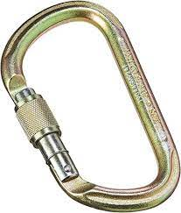
1.2 | Connector | Speedy Carabiner Aluminium small | The BE QUICK carabiner has an ergonomic faceted ring that makes it easy to use. Coupled with a reduced number of screw turns to limit the efforts of locking or unlocking, its setting in motion is ultra-fluid and very fast, secured by a keylock system.  Features that make this carabiner very effective during repeated maneuvers, especially on anchor points. In addition, it can be unlocked with a link in case of a blockage. | 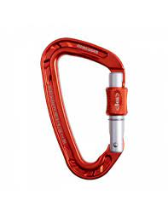
1.3 | Connector | Mallion Rapid - CT | The MRA small opening quick link is made of an FM-8 steel rod and an A-42FM steel nut. Its finish is white zinc plated. This quick link is also known as a "screw link", it allows several elements to be connected together  Yellow Color | 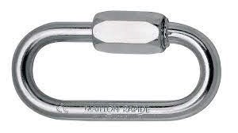
1.4 | Connector | Carabiner Aluminium | Great functionality, thanks to its capacity and dimensions:  - efficient shape for use on either end of the carabiner (belay systems)  - carabiner can hold a large quantity of equipment  Good handling and ergonomics:  - D shape for good handling  - shape designed for gripping with gloves on  - Keylock system to avoid any involuntary snagging of the carabiner  H profile:  - ensures an improved strength-to-weight ratio  - protects markings from abrasion  For occasional use, dirty environments  SCREW-LOCK manual system:  The red visual indicator is visible when the carabiner is unlocked. This system is suitable for difficult environments where contaminants (mud, ice) could cause an automatic locking system to jam  Galvanized Steel Color  EU – CE | 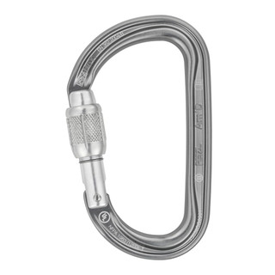
2.1 | Harnesses | Sit Harness - industrial | Gated ventral attachment point can be opened for optimal integration of equipment:  - connection of PROGRESS lanyards directly on the attachment point without need for a connector  - connection of TOP CROLL ventral rope clamp on the ventral point for greater efficiency on rope ascents  - connection of the PODIUM seat on the attachment point allows direct connection to the descender, while guaranteeing mobility at the ventral attachment point  Ultra-comfortable design:  - semi-rigid, wide waistbelt and leg loops for excellent support; sculpted and lined with breathable foam padding for comfort during suspension  - textile side attachment points with plastic insert ensure easy connection of equipment, with limited weight and bulk  Convenient adjustment:  - waistbelt equipped with self-locking DOUBLEBACK PLUS buckles for quick and easy adjustment  - leg loops equipped with FAST LT buckles for quick and easy opening and fastening without the need to readjust them, even while wearing gloves  Facilitates the carrying and organization of tools:  - six pre-shaped equipment loops with protective sheath  - two slots for CARITOOL tool holder  - two slots for TOOLBAG tool pouch  SPECIFICATIONS  Ventral attachment point: connection of a descender, a positioning lanyard for use in single mode, a progression lanyard, and a seat  Lateral attachment points: attachment for a positioning lanyard for use in double mode  Rear attachment point on the waistbelt: restraint lanyard attachment  Blue | 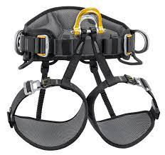
2.3 | Harnesses | Chest Harness + chest Top croll | TOP CROLL LARGE CHEST HARNESS 11-13MM ROPE  Cut down on the bulk of your kit by using multi-purpose and versatile gear in place of items that are dedicated to specific tasks. The Petzl TOP CROLL chest harness in size Large is the perfect solution to your climbing needs and pairs with your already-loved Petzl seat harnesses. Thanks to an integrated CROLL S ventral rope clamp, the TOP CROLL is compatible with the ASTRO SIT FAST, AVAO SIT, AVAO SIT FAST, FALCON and FALCON ASCENT, turning each into a rope access harness so you're sure to find a pairing suited to your task.  Rear connection points on each side of the harness give the user stability, while foam shoulder straps avoid neck chafing while evenly distributing the load across the shoulders, providing comfort in potentially uncomfortable situations. A textile sternal attachment point provides additional bulk and weight reduction, further streamlining this already-utilitarian chest harness.  Thanks to OmniProGear's commitment to supplying crews from around the world, you can rest assured that you'll be receiving only the highest quality gear at the most reasonable prices.  DESCRIPTION  Integrates a CROLL L ventral rope clamp to transform the ASTRO SIT FAST, AVAO SIT, AVAO SIT FAST, FALCON, FALCON ASCENT and SEQUOIA SRT harnesses into rope access harnesses  Connects to the rear loop and directly to the openable ventral attachment point of the ASTRO SIT FAST harness or with a connector to the AVAO SIT, AVAO SIT FAST, FALCON, FALCON ASCENT and SEQUOIA SRT harnesses  Foam shoulder straps are widely spaced to reduce neck chafing. When the waistbelt is loaded, they help distribute the load over the shoulders.  Shoulder straps equipped with self-locking DoubleBack PLUS buckles for quick and easy adjustment  SPECIFICATIONS  Sternal attachment point: fall arrest system attachment  Certification(s): CE EN 361 (with ASTRO SIT FAST, AVAO SIT, AVAO SIT FAST, FALCON, FALCON ASCENT, SEQUOIA SRT seat harness), CE EN 12841 type B, EAC  Material(s): nylon, polyester, aluminum, steel  11-13mm ROPE | 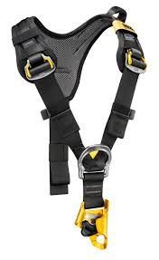
2.3 | Harnesses | Rescue Harness Pythagore | The PITAGOR evacuation triangle is designed for rescue operations and cable lift evacuations. The ergonomic shape of the seat and the presence of shoulder straps makes suspension more comfortable than with a classic evacuation triangle. Color-coding differentiates the back and seat, as well as the closure system, making it easier to put on the evacuee. The high-strength TPU tarp material allows regular to intensive use.  Description  Ergonomic and comfortable:  - Ergonomic shape allows the evacuee to easily sit in the triangle and makes suspension more comfortable than with a classic evacuation triangle  - Comfort handles allow the evacuee to correctly sit in the triangle  - Shoulder straps allow the triangle to remain on the evacuee and keep them upright  - DOUBLEBACK self-locking buckles allows it to be adjusted to a child (weighing more than 15 kg) and an adult (weighing up to 150 kg)  - Possible to connect a tag line at the rear in order to orient the evacuee when arriving at the ground  - Reflective strips on the back make it easier to use at night  Easy to put on:  - Color-coding to differentiate the back (yellow) and the seat (black), for quick donning  - Close by connecting three metal D-rings at the same time  Excellent durability for regular to intensive use:  - High-strength TPU (PVC-free) tarp material for regular to intensive use; it is resistant to UV exposure (doesn’t fade), to oil, grease and high and low temperatures, chlorine-free (no odor), and recyclable  Specifications  Weight: 1300 g  Black and Yellow | 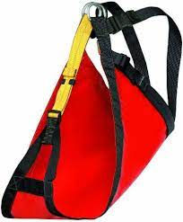
2.4 | Harnesses | Rescue Basket stretcher - nest | Stretcher for rescue in cramped spaces. The NEST stretcher was developed in cooperation with Secours Spéléo Français. They allow transportation victims in dangerous and cramped terrain, in every position (horizontal, diagonal, vertical). Easy in manipulations, they facilitate the insertion of the injured party. They are suitable for rescue in cramped spaces, but they are also used in rope rescue techniques.  Black and Yellow  Industrial - Standard Size | 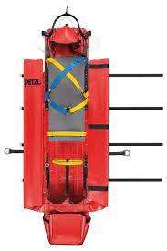
2.5 | Harnesses | Nest Stretcher - Confined space and caving stretcher | 1 Piece Stretcher  Constructed of lightweight 3/4” stainless steel tubing  Plastic rack for shoulder & hip support included  Nylon Straps Are Included  Can be lifted both Vertically or Horizontally  Payload 150 kg EU – CE | 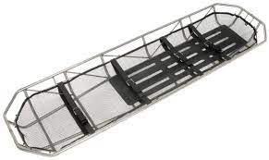
2.6 | Harnesses | Sked - fodable rescue stretcher | Skedco Basic Rescue System Features:  Material: Medium density E-Z glide non-absorbing polyethylene plastic.  Unbreakable at 120 degrees below zero.  Does not absorb chemicals, making it easily decontaminable.  Can be dragged over virtually any terrain  Patients can be rolled or dragged onto the Sked rather than lifting  Skeds can be rolled 1-4 per bundle for easy storage  Drag handle at the head end for patient safety – with two plastic grips for use by two rescuers.  Will fit on decon-conveyors for easy decontaminating, and handling of patients and litter.  Polypropylene slings can be attached to drag Skeds up and down stairways.  Dimensions:  Rolled Up  Diameter: 9" in  Length: 37" in  11 lbs (With Straps) - 17 lbs (With all items attached)  Laid Out  Length: 8' ft  Width: 3' ft  Height: 0.105" in  11 lbs (With Straps) - 17 lbs (With all items attached)  EU – CE | 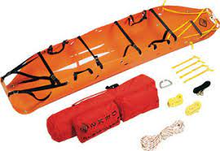
3.1 | headlamp | Headlamp - with helmet attachement | Headlamp for use in ATEX explosive environments, suitable for proximity lighting, movement and long-range vision. 100 lumens  Description  Headlamp keeps hands free for work and can be:  - worn on the head with the headband  - attached to the helmet with a mounting plate (included)  - placed on the ground  Several lighting modes adapt to each situation:  - for close-range work: uniform flood beam  - for movement: mixed beam with focused component allows user to move around comfortably  - for long-range vision: focused beam  Lighting for professionals that is reliable, practical and durable:  - storage position helps protect the headlamp lens and prevents inadvertently turning it on  - automatically switches to reserve mode when batteries are almost drained (signaled by blinking light and red indicator)  - rotating knob that is ergonomic, even with gloves  - excellent resistance to falls (2 m), impacts, and crushing (80 kg)  - comfortable and washable elastic headband  - resistant to chemicals  For use in ATEX zone 1/21 (II 2 GD Ex ib IIB T4 Gb IIIB T135° C Db) explosive environments  Specifications  Weight: 170 g  Technology: STANDARD LIGHTING  Beam pattern: wide, mixed or focused  Energy: 2 AA/LR06 alkaline batteries (included)  Battery compatibility: Ni-MH rechargeable batteries (only for non ATEX use), lithium batteries not compatible  Watertightness: IP67 (waterproof to -1 meter for 30 minutes; no maintenance required after immersion) EU – CE | 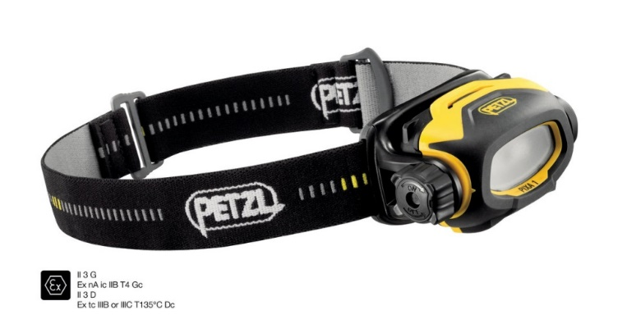
4.1 | Helmets | Search and rescue Helmet | Head circumference: 53-63 cm  Weight: 340 g  Material(s): ABS, expanded polystyrene, nylon, polycarbonate, high-strength polyester, polyethylene.  Excellent protection for work at height:  - impacts are absorbed by deformation of the expanded polystyrene liner  - strong chinstrap (more than 50 daN) limits the risk of losing the helmet during a fall  Built for reduced weight  Comfortable to wear:  - CenterFit adjustment system adjusts the headband and keeps the helmet centered on the head  - ventilation holes allow airflow through the helmet  - comes with two sizes of headband foam  Many accessories are available in order to adapt the helmet to its use:  - headlamp (front and back slots)  - headlamp with elastic headband (headlamp clips)  - Protective shield (side inserts)  - hearing protection (side slots) EU – CE | 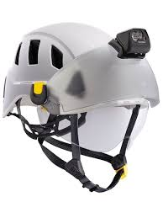
4.2 | Helmets | Patient Helmet - Red | the standard for mountaineering, climbing and caving. Extremely durable, this helmet can withstand the harsh conditions and rough treatment that are often encountered in the high mountains or deep caves.  Injection molded polycarbonate shell for protection and durability  Easy-to-use adjustment wheels dial in headband and nape strap size for an extremely comfortable fit, even while the helmet is being worn EU – CE | 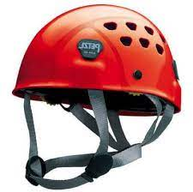
5.1 | Kit | Aztek kit | The AZTEK can be used as a pick off, adjustable directional, high directional guyline, high angle attendant tether, high angle litter scoop, load release hitch and much more. Each pulley is color coded to match with a corresponding prusik for quick identification. EU – CE | 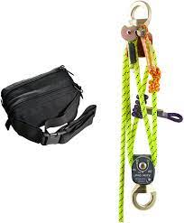
6.1 | Lanyard and Energy Absorbers | Grillon 3 m - Adjustable line Yard | Lanyard with fine adjustment system for precise work positioning Can be used in two ways: - double mode, on the lateral attachment points of the harness, to distribute the weight on the belt (user has weight on his feet): length is adjusted by pressing on the pivoting cam) - single mode, on the harness ventral attachment point, to distribute weight between the waistbelt and the leg loops (user is suspended): length is adjusted by operating the handle while holding the free end of the lanyard Removable protective sheath protects the rope from abrasive contact and favors smooth rope glide. The protection can be removed when the single lanyard technique is used, to bring the user closer to the anchor. EU – CE | 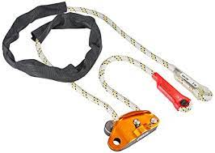
7.1 | Mobile Faal Arresters | Fall Arrest Device with Trelock Carabiners | • ASAP sets the standard in fall protection for workers at height. In normal use, the device moves freely along the rope without any manual intervention and follows the user in all his/her movements. In the event of a shock load or sudden acceleration, the ASAP locks on the rope and stops the user. Depending on the intended use, the ASAP may also be combined with an ASAP’SORBER or ASAP’SORBER AXESS energy absorber to work at a distance from the rope.  • Description  • Constant fall protection:  - arrests falls, slides, and uncontrolled descents  - works on vertical or angled rope  - locks on the rope even if grabbed during the fall  • Simple to use, and effective:  - moves up or down the rope, without any manual operation  - easy to install and remove at any point on the rope  - may be combined with an energy absorber to work at a distance from the rope: ASAP’SORBER or ASAP’SORBER AXESS. The latter can be used for loads of up to 250 kg in two-person rescue situations  • Certified to European and Russian standards when used with an OK TRIACT-LOCK carabiner  • Certified to American standards when used with a Bm’D or OXAN TRIACT-LOCK (international version) carabiner  • Specifications  • Material(s): aluminum, stainless steel  • Weight: 295 g  - Standard Size  - Tested and qualified in 2013 Available certification US and EU EU – CE | 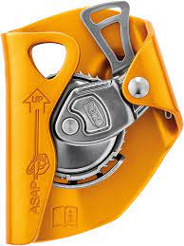
7.2 | Mobile Fall Aresters | Shock Absorber - 20 cm | Energy absorber for ASAP or ASAP LOCK  The ASAP’SORBER energy absorber may only be used with an ASAP or ASAP LOCK mobile fall arrester. It allows user to work at a distance from the rope, in order to protect it during certain work phases. Equipped with tear-webbing inside a pouch that opens on each end, the absorber is protected from abrasion, while allowing for regular inspection. It is available in two lengths, to provide the best balance between distance from the rope and reduced fall length.  Description  May only be used with an ASAP or ASAP LOCK mobile fall arrester  Allows the user to keep the rope at a distance in order to:  - free up the work area  - protect the rope from sharp tools and harmful contact points  Absorbs energy in case of a fall:  - tearing of the energy absorber webbing limits the impact force on the user  - designed for users who weigh between 50 and 130 kg  - durable fabric pouch with opening system at each end, protects the energy absorber from abrasion or contaminants while allowing for regular inspection of the absorber  Ends equipped with STRING to hold the connector in position and protect the webbing from abrasion  Available in two lengths, to provide the best balance between distance from the rope and reducing fall length  Specifications  • Material(s): nylon, polyester  - Blue and Black EU – CE | 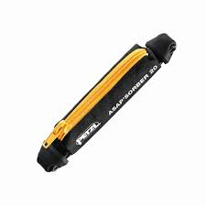
7.3 | Mobile Fall Aresters | Raptor foot | Raptor (Claw) Foot – uses replaceable carbide tip for optimal grip on appropriate surfaces. Rotates to adjust orientation. EU – CE | 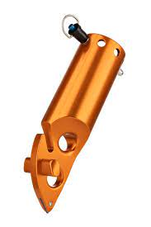
7.4 | Mobile Fall Aresters | Flat foot | Flat (Omni) Foot – features replaceable rubber sole for optimal grip on flat surfaces. Ball joint easily adjusts to necessary angle.  Flat Foot Replacement Pad – replaces a worn pad on the Flat Foot. EU – CE | 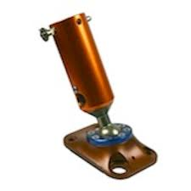
7.5 | Mobile Fall Aresters | ready Rope Protector | Rope protector is a lightweight, pliable sleeve to protect ropes from contact with sharp surfaces and edges. EU – CE | 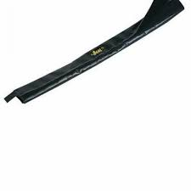
7.6 | Mobile Fall Aresters | Roll Module | The ROLL MODULE is an articulated protector with rollers designed to guide a moving rope and protect it from abrasion. It offers the possibility of adapting the number of modules to the terrain and of minimizing abrasion.  To guide a moving rope and protect it from abrasion  Vertical and horizontal rollers guide the moving rope with a minimum of rubbing  Each module can be positioned independently to adapt to the terrain  Modules are connected with quick links: the number of modules can be varied according to the terrain  Product sold as a kit: 4 modules + 6 quick links + carry bag  Weight: 1330 g EU – CE | 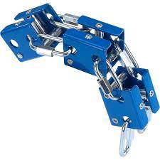
7.7 | Mobile Fall Aresters | Anchor Strap | Adjustable and fixed -  Dimensions - Length 1m  Polyamine  D Ring from 2 sides  Specific for rescue EU – CE
8.1 | Packs | Transportation bag - Cylindric shape - 60 L for equipment | Material PV  Water Proof  Black and yellow colors  Standard size EU – CE | 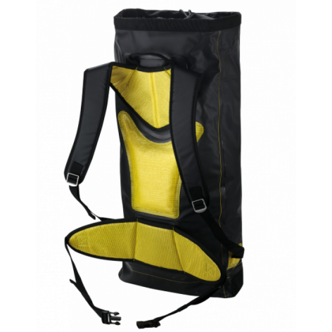
8.2 | Packs | Transportation bag - Cylindric shape - 45 L - For rope | The PRO RESCUE 40 bag was designed for rescue teams. It can carry a 30 meter rope with a diameter of 12.5mm and all the basic equipment. A webbing sling under the bag allows it to be guided from below if needed. In addition, a flap with a clear interior pouch lets you check the equipment.  Standard size for rescue EU - CE - 0598 | 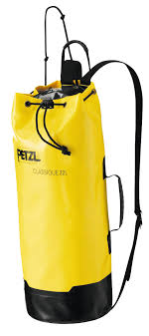
8.3 | Packs | Transporting Bags - 80L | The COMBI PRO 80 is a professional bag that uses our Quick Release concept. Its two-part opening facilitates quick access to the equipment. Once opened, the bag folds out flat, making it easy to see each piece of equipment. The bag is divided into compartments and segments to organise your gear, The maximum capacity of this bag is 80m of 10.5mm rope.The COMBI PRO 80’s integrated rope bag contains a large ground sheet so youcan use the rope immediately without it tangling. A red buckle identifies the bottom end of the rope, whilst a green buckle identifies the top end. This bag is made of PVC 1 100 g/m².  29 mm Gate openening  black and gold color EU – CE | 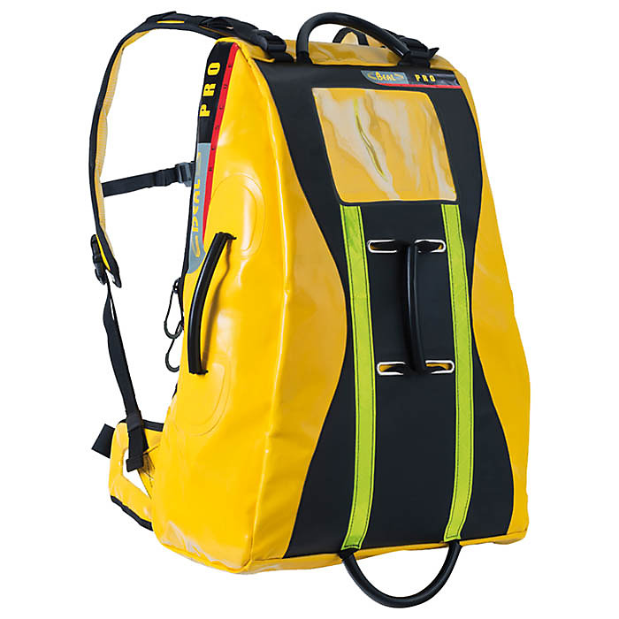
8.4 | Packs | Transporting Bags - 60 | The PRO WORK bag has a capacity of 45 or 60 liters, high frequency welds and a reinforced bottom, making it particularly suitable for heavy-duty carrying. For the user's comfort, a belt completes the ergonomic shoulder straps and the foam back. Their durability is ensured by metal adjustment buckles. The side carrying handle makes it easy to hold the bag.  Silver Color  NPT for Climbing EU – CE | 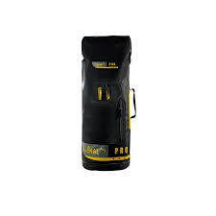
8.5 | Packs | Tripod bag system | Designed for ultimate accessibility and quick access, our new Arizona Vortex Bag System is extremely rugged and able to be carried on the back into the wilderness or in an industrial environment. Made of durable nylon, they feature extra protection in high-wear places for exceptional longevity. Recent improvements to the Vortex Bag System allow a single rope technician to carry the entire Vortex Kit using our RigTech Pack™ and 2 redesigned Leg Bags.  The RigTech Pack™ features end-to-end-zippers for full-length flat opening. There is plenty of space and protective padding to securely cradle the two head components and foot sets. The dual side pockets easily fit the pin set bag, 40-foot 8mm tether cord, and Vortex Hobble Straps. The top pocket is ideal for the Vortex User Manual or other items, and additional internal pockets can fit pulleys, carabiners, and hardware. (Vortex components, pulleys, and carabiners sold separately.)  The two leg bags feature carry handles and an adjustable padded shoulder sling for easy transport. End-to-end zippers for full-length opening either direction provide easy access, and the oversize bags can carry more leg sections than the previous design, allowing a single person to carry the entire Vortex. Two internal padded dividers allow for separated protection of the legs. Compression straps around the girth of the bag cinch tight to keep gear snugly in place.  Each of the two newly designed padded foot sleeves nest inside the RigTech Pack and fasten securely to hold three foot components, either flat or raptor style. This facilitates a quick change of feet, so that carrying both sets is not necessary. EU – CE | 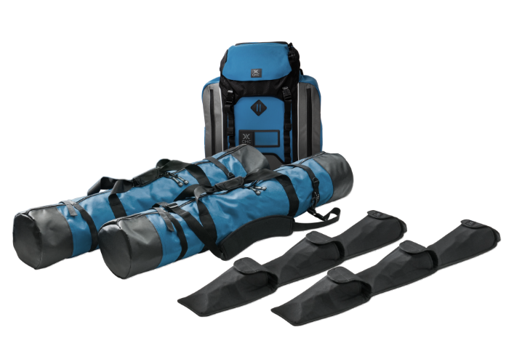
8.6 | Packs | Combi Pro - Bag - For hard equipment | Water Proof - Rescue carrying bag  80 L Capacity  Yellow - Right Hand EU – CE
8.7 | Packs | Duffle bag | Water Proof - Rescue carrying bag  60 L Capacity EU – CE | 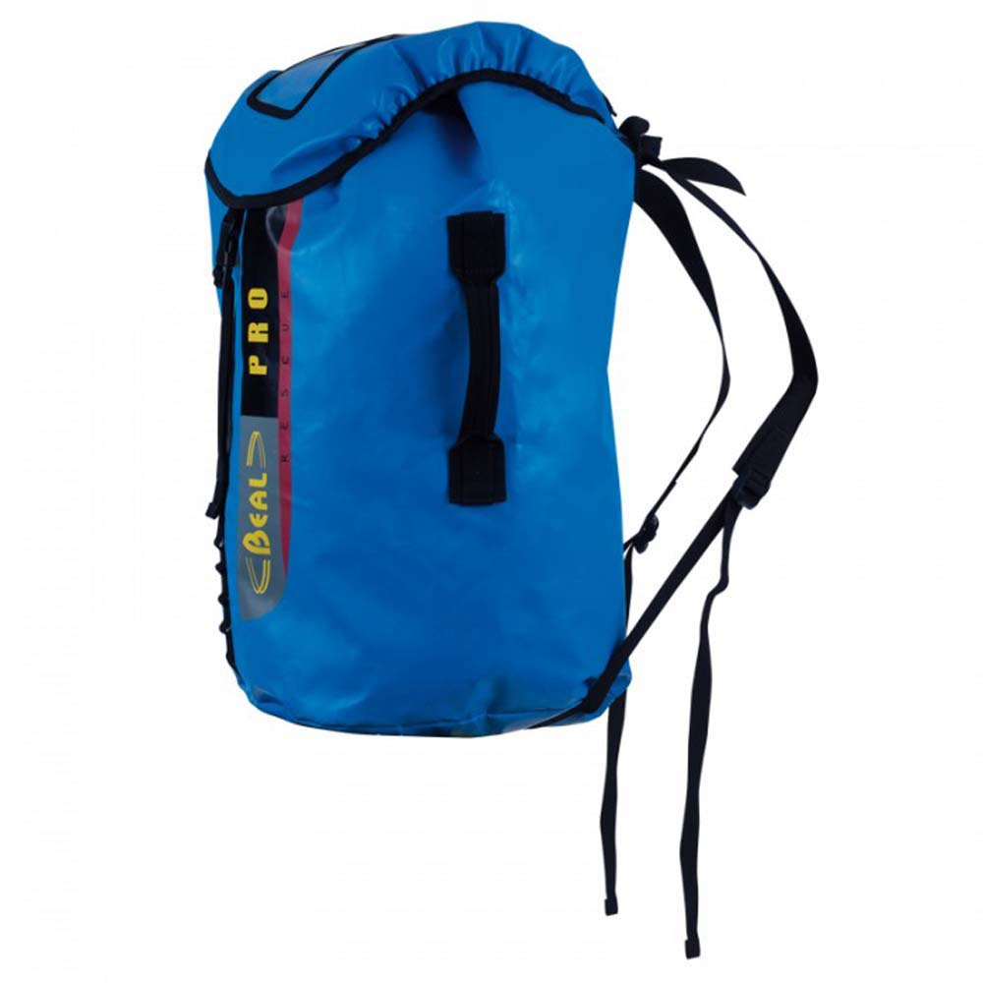
9.1 | Pulleys | Petzel rescue Pully | Description  For rescue professionals  Designed to handle heavy loads or for intensive use  Large diameter sheave mounted on sealed ball bearings for excellent efficiency  Accepts up to three carabiners to facilitate use  Available in two colors: red and black  Specifications  Rope compatibility: 7 to 13 mm  Sheave diameter: 38 mm  Ball bearings: yes  Efficiency: 95 %  Maximum working load: 4 kN x 2 = 8 kN  Weight: 185 g EU – CE | 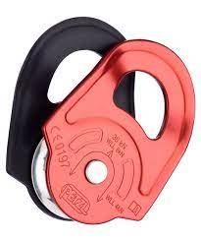
9.2 | Pulleys | ProTraxion Pully | Description  Loss-resistant pulley:  - allows a rope to be installed when the pulley is connected to the anchor  Well suited for hauling heavy loads:  - large diameter aluminum sheave mounted on sealed ball bearings for excellent efficiency  - side plate locks when loaded and prevents opening of the pulley during use  Versatile:  - lower connection point for creating different types of hauling systems  - toothed cam with self-cleaning slot optimizes performance under any conditions: frozen or dirty ropes...  - may be used as simple pulley by locking the cam in the raised position  Specifications  Weight: 265 g  Certification(s): CE EN 567, NFPA 1983 Technical Use, UKCA, EAC  Material(s): aluminum, stainless steel, nylon  Min. rope diameter: 8 mm  Max. rope diameter: 13 mm  Sheave type: sealed ball bearings  Sheave diameter: 38 mm  Maximum working load: 2 x 2,5 = 5 kN  Breaking strength - pulley: 11 kN x 2 = 22 kN  Maximum working load - rope clamp: 2.5 kN  Breaking strength - rope clamp: 4 kN  Efficiency: 95 % EU – CE | 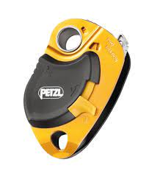
9.3 | Pulleys | Rigging Plate Large | PAW rigging plate allows the organizing of the workstation and setup of multi-anchor systems. The hole design allows ropes or slings to be threaded for direct connection. Made of forged aluminum, it offers an excellent strength-to-weight ratio.  Description  For easy organization of the workstation and setup of multi-anchor systems:  - 19 mm holes allow the locking sleeves of most carabiners to pass through, enabling the carabiner to be rotated  - hole design allows ropes or slings to be threaded for direct connection.  - main attachment hole accepts up to three carabiners  - the odd number of attachment holes enables the system to be centered and balanced  - up to three users can be connected at the same time  Durability:  - made of forged aluminum for an excellent strength-to-weight ratio  - durable markings, thanks to the recessed area in the center of the plate  Two wide auxiliary attachment holes (size L only  Specifications  Material(s): aluminum EU – CE
9.4 | Pulleys | Rigging Plate Medium | PAW rigging plate allows the organizing of the workstation and setup of multi-anchor systems. The hole design allows ropes or slings to be threaded for direct connection. Made of forged aluminum, it offers an excellent strength-to-weight ratio.  Description  For easy organization of the workstation and setup of multi-anchor systems:  - 19 mm holes allow the locking sleeves of most carabiners to pass through, enabling the carabiner to be rotated  - hole design allows ropes or slings to be threaded for direct connection.  - main attachment hole accepts up to three carabiners  - the odd number of attachment holes enables the system to be centered and balanced  - up to three users can be connected at the same time  Durability:  - made of forged aluminum for an excellent strength-to-weight ratio  - durable markings, thanks to the recessed area in the center of the plate  Specifications  Material(s): aluminum EU – CE | 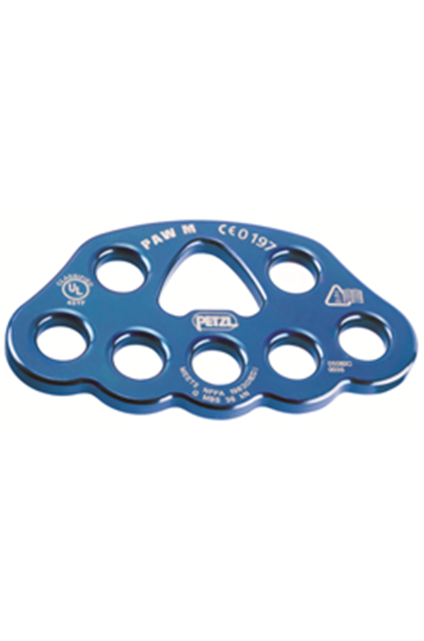
9.5 | Pulleys | Double pulley - giminy | GEMINI  Highly efficient and lightweight double Prusik pulley  GEMINI is a compact double pulley that sets up progress capture systems of high mechanical advantage.  Description  Special side plates designed for use with a Prusik friction hitch in progress capture systems  Parallel mounted sheaves and auxiliary attachment point for creating different types of hauling systems  Sheave mounted on sealed ball bearings for excellent efficiency  Compact and lightweight  Specifications  Rope compatibility: 7 to 11 mm  Sheave diameter: 25 mm  Ball bearings: yes  Efficiency: 91 %  Maximum working load: 2 x 1,5 kN x 2 = 6 kN  Weight: 135 g  Orange or Green color  Standard size for Patient EU – CE
10.1 | Rescue accessories | PMI Rope Rescue Gloves | Synthetic leather (palm base layer)  Cowhide layer (finger wear points and palm)  Ergonomically shaped for maximum protection and durability  Two-Way stretch spandex on top and fingers for greater mobility and breathability  Elastic cuff with pull-tab and Velcro® closure  Carabiner loop stores inside for snag free operations  Hand protection and finger dexterity at its best. This ultra-lightweight design is great for belaying, knot tying and other rigging work. It is not suitable hand protection for fast rope or other body rappel techniques.  white and red color only  Removable Head Lamp  Adjustable within the mentioned  white and red color EU – CE
10.2 | Rescue accessories | Ladder - foldable - Industrial | A vertical or inclined set of rungs or steps used for climbing or descending. There are two types: rigid ladders that are self-supporting or that may be leaned against a vertical surface such as a wall, and rollable ladders, such as those made of rope or aluminum, that may be hung from the top.  6m total lenth - 3m each side  Yellow color  Standard Size EU – CE | 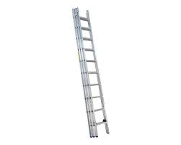
11.1 | Rope Clamps | ID - Descender | Description  Designed for work at height and rope access work  Easy to use:  - safety gate on the moving side plate allows the rope to be installed easily while the device remains connected to the harness  - easy rope installation, thanks to the rope guide and markings  - anti-error catch to reduce the risk of an accident due to incorrect installation of the device on the rope  - ergonomic handle allows the rope to be released and enables comfortable control of the descent. Two possible descent modes: on the side plate or in the V-shaped friction channel  - anti-panic function automatically stops the descent if the user pulls too hard on the handle  - allows smooth movement along inclined or horizontal terrain  - The AUTO-LOCK system allows users to easily position themselves at a workstation without having to manipulate the handle or tie off the device: as soon as the user releases the handle, the rope is automatically locked in the device. The automatic return system on the handle limits the risk of the device getting accidentally snagged  - handle automatically switches to storage position when the rope is removed from the device, reducing the risk of accidental snagging when the descender is carried on the harness.  - once locked, the rope can be taken up without having to manipulate the handle, for making a reversible haul system or for easy short ascents, for example  - cam can be manipulated to feed out slack easily or belay a lead climber using climbing techniques  - the moving side plate locks with a screw, allowing the I’D S to be integrated into rescue kits  - an auxiliary brake, open or closed, may be added to improve descent control depending on the weight and rope diameter  The stainless steel wear plate improves durability by reinforcing the rope friction zone  Descending a heavy load up to 250 kg  Rope compatibility: 10 to 11.5 mm diameter  Specifications  Material(s): aluminum, steel, nylon  Weight: 600 g  Maximum working load for one person: 150 kg)  Maximum working load for two persons (rescue): 250 kg  Anti-panic function, clamping cams block the rope if the user pulls too hard on the lever  Safety lock reduces the risk of an accident due to incorrect installation of the device on the rope  Locked position on the handle for positioning on the rope  For 10-11.5mm Rope EU – CE | 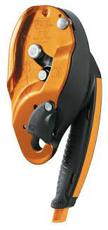
11.2 | Rope Clamps | Ascender | Description  Designed for ascending a rope  Simple to use, and effective:  - ergonomic molded handle allows a comfortable yet powerful grip  - wide opening allows the handle to be easily grasped, even with thick gloves.  - ergonomic upper part to maximize power when pulling with two hands  - safety catch is totally integrated into the body of the ascender to help prevent snagging  - toothed cam with self-cleaning slot optimizes performance under any conditions (frozen or dirty ropes...)  - wide lower hole allows the carabiners of the CONNECT ADJUST lanyard and FOOTAPE or FOOTCORD footloop to be easily attached  - upper hole for clipping a carabiner around the rope  Available in left-handed and right-handed versions  Specifications  Material(s): aluminum, stainless steel, plastic, rubber, nylon  Weight: 165 g  Rope compatibility: 8 to 13 mm  Red color EU – CE | 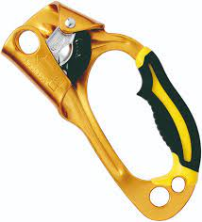
11.3 | Rope Clamps | Step loop sling - tape | Attaches to an ASCENSION or BASIC rope clamp for rope ascents  Underfoot strap is abrasion-resistant and is slightly rigid to make it easier to step into  Elastic keeps foot in loop. It is adjustable in length, so it works with any type of shoe and stores easily when not in use  DoubleBack buckle easily and quickly adjusts length of foot loop  Specifications  Material(s): nylon, steel, aluminum  Weight: 65 g  Induxtrial Heavy Duty - 6m EU – CE | 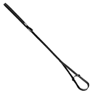
12.1 | Ropes | Steel Sling - 1.5 m | Wire rope slings are an important piece of rigging hardware used in lifting and hoisting operations and are commonly used across different industries. These slings connect the load to the lifting device and are available in a wide range of configurations that support a broad range of applications. | 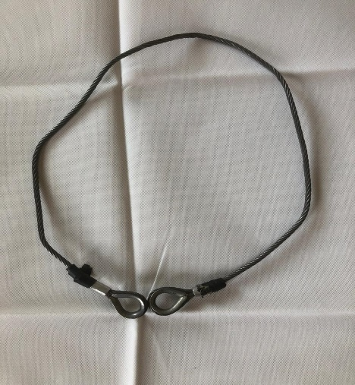
12..2 | Ropes | Wire Strop | 6.5 mm Diamtre  Polyratan sheet - UV treatment  two terminations of two different sizes over multi-configuration to set up an Anchor  different size of the attachment point  1.5 m length  breaking strength - 23 KN EU – CE
12.3 | Ropes | Rope Semistatic | Dimiensions - 10.5 mm EU – CE | 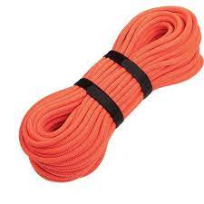
12.4 | Ropes | Sling - 16mm - 1.20 m | DESCRIPTION  • Open loop sling for setting up anchors  • Available in four lengths: 120 cm  • Color coded for easy identification of length  • Also available in black  SPECIFICATIONS  • Material(s): polyester  • Breaking strength: 22 kN | 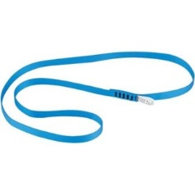
12.5 | Ropes | Rope - semistatic - 10.5mm - 200m - roll | Dimension 10.5 mm  Range Access difficult areas  Material - polyamine PA - Rope Core Polyamine PA  Sheet slippage 0mm  Proffessional use  Breaking load 2700 KG  Tested DAN  Static elongation - 2.9 %  Knots strength 1600kg DAN  Metallic - Industrial - Lebanese Manufacture
12.6 | Ropes | Rope - 10mm - Rescue Orange - Dynamic - 25 m | A dynamic rope is a specially constructed, somewhat elastic rope used primarily in rock climbing, ice climbing, and mountaineering. This elasticity, or stretch, is the property that makes the rope dynamic—in contrast to a static rope that has only slight elongation under load. Greater elasticity allows a dynamic rope to more slowly absorb the energy of a sudden load, such from arresting a climber's fall, by reducing the peak force on the rope and thus the probability of the rope's catastrophic failure.  Metallic  Industrial Lebanese Manfucture
12.7 | Ropes | Daisy chain - steel | Steel sling chain for many anchores  Red color, Standard for Patient Size | 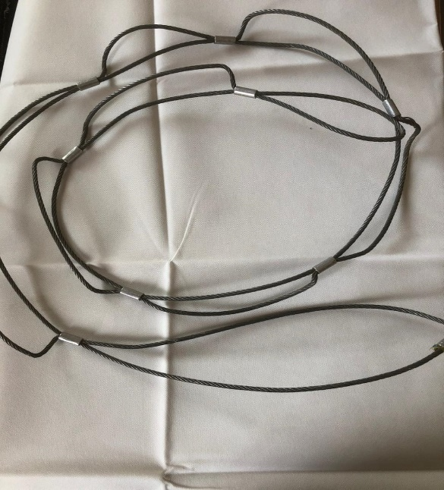
13.1 | Tripod and Accessories | Rescue Trippod | A very adaptable portable anchor / edge management device, that adapts to almost any terrain or set-up location. It is easily configured as a Tripod, a Bipod, or a Monopod. Lightweight, man-portable (individual parts can be split amongst a team), it is a must for rescue organisations looking for a rescue tripod or A frame. EU – CE | 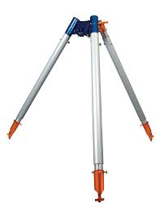
13.2 | Tripod and Accessories | Plate for tripod - wheel plate - Large | Sample Ready upon request EU – CE | 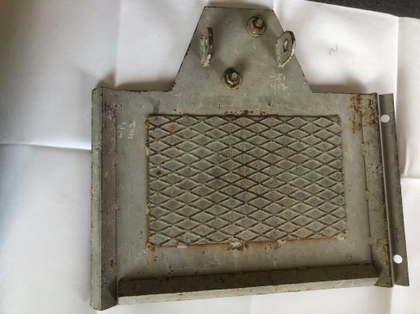
13.3 | Tripod and Accessories | Plate for tripod - wheel plate - Small | Sample Ready upon request - Orange Color EU – CE | 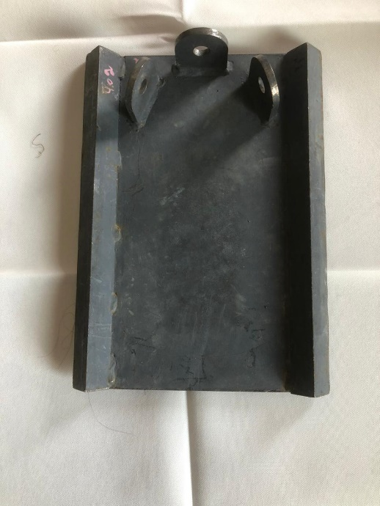

Item | Category | Descriptions | Detailed Specifications | Certificaiton | PICTURES
14.1 | Communication Items | Radio - Handy VHF | 5 wat VX - Potable - Pedal and full koit | EU - CE
14.2 | Communication Items | Radio - Base - VHF | VHF 50 watt | EU - CE
14.3 | Communication Items | Anthenas - Roof | 7070 Sail wave | EU - CE
14.4 | Communication Items | Carrying Vest - Radio Chest | To fit the previoius or requested items | EU - CE
14.5 | Communication Items | Cable | LMR400 - for base | EU - CE
14.6 | Communication Items | Cable | RG 58 | EU - CE
14.7 | Communication Items | Radios Accessories - connections | Connectors for the LMR and RG 58 - Cable DC 2x2.5 Batteri 88 amp to 100- chargeur automatic 15 amp - Switch power supply 17amp | EU - CE
14.8 | Communication Items | Hand Pedall | LEIMAXTE XPR 7550 Earpiece for Motorola XPR 6350 6550 7350 7550e  Two Way Radio Walkie Talkie Headset with Acoustic Tube and PTT Mic | EU - CE

Item | Category | Descriptions | Detailed Specifications | Certificaiton | PICTURES
15.1 | Camping Accessories | Foldable mattresses | Ridgerest Thermarest Sleeping pad camping 70x20" backpacking hiking.  The waffle design traps air and increases insulation.  Size: Long. | EU - CE | 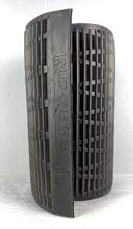
15.2 | Camping Accessories | Tents - Red Dome - 5 pers | A Tent With Poles That Is Easy To Pitch And Features Fresh&Black Technology. It Results In Less Heat And Light In Your Tent, So You Can Decide Just When To Get Up.  Capacity  Bedrooms: 140X210 Cm | Stand-Up Living Room: 3.5 Sqm | Basin Groundsheet  Easy Assembly / Dismantling  Pre-Assembled Bedroom | Simple Pitching Thanks To Coloured Markers On The Poles  Heat Reduction  Fresh Fabric: Reduces Heat Inside Your Tent In The Sun  Darkness  Black Fabric: Guarantees 99% Darkness In Your Bedrooms  Wind Resistance  Withstands Force 6 Winds - Around 50 Km/H | Wind Tunnel Test  Waterproof  Water Column | EU - CE | 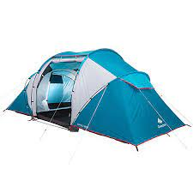
15.3 | Camping Accessories | Heat pads | Warm Tips: This product is forbidden for babies, disabled people, and people who are not sensitive to heat  Lightweight and portable, convenient to use at home or school or take with for outdoor camping or other activities on winters.Also applicable to the people who are afraid of coldness, and they will do not fear of winter any more with it.  USB Charge: You can directly put it into your jackets, vests and other clothes for warming and heat it by using 5V 2A power source, such as computer, power adapter or power bank(Not included).  With Temperature controladjustment by 3 gears. Red light: high temperature about 45-50 degree, green light: middle temperature about 40-45 degree, blue light: low temperature about 35-40 degree  Heating pad size: 12x8cmx5 pieces heating pad / 12x8cmx2 pieces heating pad is available | EU - CE | 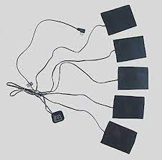
15.4 | Camping Accessories | Mattresses inflatable | Fully Waterproof, The Groundsheet Is Easy To Clean. A 70 Cm-Wide Camping Mattress For One Person That Both Comfortable And Affordable.  Sleeping Quality  Sizes: 190 X 70 X 16Cm | Velvety Feel  Durability  Mattress Approved To Withstand At Least 60 Inflation/Deflation Cycles  Easy Assembly / Dismantling  Inflates With A Pump In 1 Minute | One-Way Valve  Easy Transport  Weight: 1.9Kg | Size: 5.3L | Repair Kit Included  Compatibility  Can Be Inflated With All Our Camping Pumps(Foot, Hand, Electric) | EU - CE
15.5 | Camping Accessories | MRE - Ready Meals | Long shelf life when stored per manufacturer's directions. 2012 or newer Pack Date.  Genuine US War Fighter Rations are the ultimate survivalist, Prepper & outdoor enthusiast Meal.  Ideal for hunting, camping, hiking, fishing, boating, and emergency food supply.  Designed for maximum endurance and nutrition with average 1250 calories per meal. | EU - CE
15.6 | Camping Accessories | Gas Detector - monitor | Detects Oxygen, Combustibles/LEL, Hydrogen Sulfide, Carbon Monoxide  Barhole test mode  Internal sample drawing pump with up to 50 foot range  Vibration, visual, and audible alarms  Automatic backlight during alarms  Calibration reminder with lock out option  Lithium ion or alkaline power source (interchangeable)  Quick charge (complete charge in 90 minutes)  Glove friendly large buttons  Alarm latching or non-latching  High impact protective rubber overmolding  Up to 600 hours of datalogging with alarm trends  Autocalibration or single calibration  TWA and STEL readings with lunch-break mode  Intrinsically safe, ATEX/IECEX/CE, c CSA us (pending)  Water and dust resistant (IP-67)  2 year warranty | EU - CE | 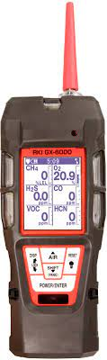
15.7 | Camping Accessories | Shovels | Robustness  Painted steel structure  Ease of use  Folds for easy storage  Impact protection  Storage and protection cover provided  HIGHLIGHTS  Dimensions and weight  Folded length 25 cm | Unfolded length | Weight with cover 1.08 kg | Weight without cover 0.80 kg | EU - CE
16.1 | Electrical and Lighting Items | Generators | Epa Super Quiet 220v 50hz 3500w 5000w 5kw 6500w 7000w 4000 6000 7000 Watt Gasoline Generator Inverter Generator | EU - CE | 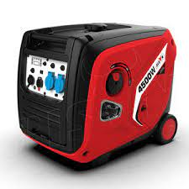
16.2 | Electrical and Lighting Items | Searching Light - tripod | 🔦【90000 Lumens Super Bright Spotlight Flashlight】This LED rechargeable spotlight flashlight is 20 brighter than other spotlights because it equips with an upgraded XHP50 LED wick(4 wicks in one), which max output up to 90000 lumens. The super bright spot light can light up an extra large garden entirely and illuminate within 1650ft. The powerful LED spotlight comes with a tripod making it convenient to use while camping, in an emergency, or on daily use.  🔦【USB Rechargeable Spotlight & USB Output Port】This USB rechargeable LED spotlight flashlight is designed with a USB input/output port. You can recharge the bright spotlight by power bank/car charger/laptop/etc. You also can use this searchlight to charge your smart devices. With an upgraded chip and circuit design, this LED spotlight has over-charge protection, over-discharge protection, and over-voltage protection, allowing you to use it more at ease.  🔦【120000 Hours Lifetime & Max 12 Hours Runtime】The powerful LED spot light flashlight has a high heat dissipation function and an upgraded built-in 8000mAh rechargeable ΒATTERY, making the high lumen spotlight has a lifespan of up to 120,000 hours. And the high powered spotlight flashlight can use for 10-12 hours After a single fully charged.  🔦【4 Lighting Modes & Widely Application】This powerful rechargeable searchlight has 4 lighting modes: High/Medium/Low/Strobe. It is easy to change the modes of the spotlight by pressing the switch button. You can turn the spot light to low mode to save power when you don't need super brightness. The strobe mode can scare evil animals away or make an alarming effect in emergencies. This spotlight is suitable for camping/hiking/fishing/cycling/night walks/adventure/power outages/emergencies/etc.  🔦【Removable Tripod & 360 Degree Rotate】This powerful LED spotlight comes with a removable hand-free triangle bracket. In addition, not only can this rechargeable spot light be adjusted up and down 90°, but also can be rotated 360°. This searchlight is a great helper while you are in camping, fishing, emergency operations and other situations.  🔦【Power Indicator】With three power display lights, you can keep track of the power of the high lumen spotlight flashlight at any time. In addition, the indicator lights will be on so that you can know whether the spotlight is fully charged or not during charging, and unplug it in time.  🔦【IPX5 Waterproof Spotlight】The rechargeable led spot light flashlight has IPX5 waterproof level that can prevent water from entering any angle. The LED spotlight flashlight can use in bad weather, such as heavy rain、heavy snow. You can even freeze it. But please don't soak the spotlight in water for a long time. It is a high-quality spotlight flashlight perfect for indoor and outdoor use.  🔦【Durable Material & Anti-slip Design】The case of this heavy-duty flashlight adopts high grade ABS material, which has high heat dissipation, drop resistance, and abrasion resistance. The flashlight can survive a 10 feet drop or run it over by a truck, and it will still work! With ergonomically designed, the handheld handle of the spotlight has a multi-stripe design to increase friction and prevent slipping. And the spot light comes with a hand-free tripod for portable use.  🔦【Perfect Gift】The product comes in an exquisite box, and the package includes: 1× Powerful LED Spotlight Flashlight,1* 8000mAh Built-in rechargeable ΒATTERY, 1× Tripod, 1× USB Cable, 1× manual. This LED spotlight flashlight not only can give you a super bright lighting experience in daily use, but also it can use as a perfect gift for family and friends for any occasion.  🔦【Worry-Free After-sales Service】The spotlight flashlight have 2 years of free replacement service and 7*24-hour customer service. If any questions, please contact our professional customer support team to get the best solution within 24 hours. We will provide you with the best solution. | EU - CE | 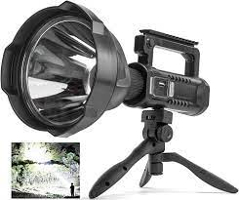
16.3 | Electrical and Lighting Items | Thermal Camera - high pixcels | EASIER TO READ greater detail and accuracy with improved 320 x 240 resolution. This is the professional quality IR Infrared Thermal Imager used for home inspections, fire fighting, farming, electronics manufacturing, studying traffic, archaeology and any other business, hobby, or science where accurate to 2.5°F temperature readings are required.  5 COLOR SCALE PALETTES make readings more useful and easier to visualize. Choose from Rainbow, Iron Red, Cold Color, Black and White, or White and Black. 3.2" Color Display Screen makes work faster and more accurate. Get jobs done right in less time thanks to the excellent integration of surface temperature and real time thermal imaging.  BONUS 3 GB BUILT-IN MEMORY CARD included for convenient storage. Uses micro USB connection to display on laptop, computer other device. Easy to use with no learning curve. Simple push button operation lets you start using immediately to get better measurements and more accurate information and visualization.  LIGHTWEIGHT WITH RECHARGEABLE BATTERY for 2 to 3 hours of continuous working time on a single charge. This is easy to hold thanks to the sure grip ergonomic handle and light 389 gram weight - less than one pound! Comes with a nice travel pouch for protection during transport and storage. | EU - CE | 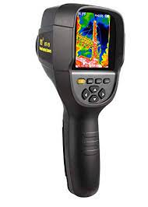
16.4 | Electrical and Lighting Items | Voice detector | Visualization is a detector of life in collapsed buildings and in confined spaces, for the rescue team to search for victims of the special tools, enabling rescue teams more quickly and more safely to take action. As long as the rescue workers and equipmentwill be put on the whole body, wearing headphones, holding his left hand rocker, the right hand according to the control handle,and rocker on display will be able to clearly show the front image; detector probe to install the camera automatically rotate, Once the rescue and dim light, you can open the lights. The command detector allows detection of the first informed of the danger. | EU - CE | 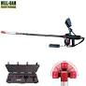
16.5 | Electrical and Lighting Items | Head lamp | Headlamp for use in ATEX explosive environments, suitable for proximity lighting, movement and long-range vision. 100 lumens  Description  Headlamp keeps hands free for work and can be:  - worn on the head with the headband  - attached to the helmet with a mounting plate (included)  - placed on the ground  Several lighting modes adapt to each situation:  - for close-range work: uniform flood beam  - for movement: mixed beam with focused component allows user to move around comfortably  - for long-range vision: focused beam  Lighting for professionals that is reliable, practical and durable:  - storage position helps protect the headlamp lens and prevents inadvertently turning it on  - automatically switches to reserve mode when batteries are almost drained (signaled by blinking light and red indicator)  - rotating knob that is ergonomic, even with gloves  - excellent resistance to falls (2 m), impacts, and crushing (80 kg)  - comfortable and washable elastic headband  - resistant to chemicals  For use in ATEX zone 1/21 (II 2 GD Ex ib IIB T4 Gb IIIB T135° C Db) explosive environments  Specifications  Weight: 170 g  Technology: STANDARD LIGHTING  Beam pattern: wide, mixed or focused  Energy: 2 AA/LR06 alkaline batteries (included)  Battery compatibility: Ni-MH rechargeable batteries (only for non ATEX use), lithium batteries not compatible  Watertightness: IP67 (waterproof to -1 meter for 30 minutes; no maintenance required after immersion) | EU - CE | 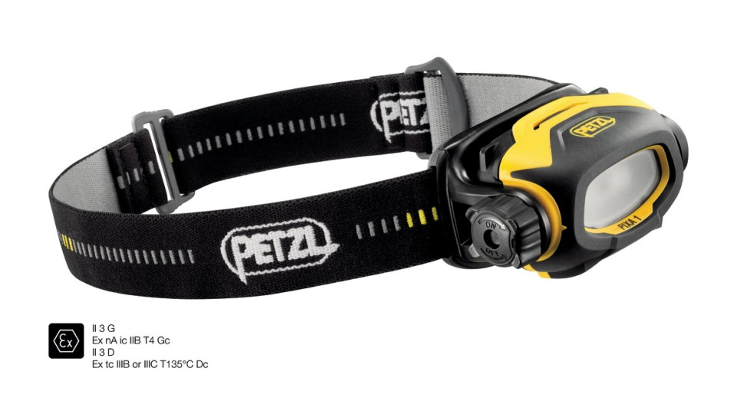
17.1 | Pack | Sleeping Bag -10 Degree | Optimum temperature  Comfort temperature: 0?C; limit temperature: -5?C. Synthetic wadding.  Easy transport  Size L: weight 1.67kg. 15.2 litre volume.Compression bag.  Sleeping quality  Very comfortable mummy shape. 2 x 3/4 zips with a double slider for ventilation.  Ecodesign  PES wadding made from 70% recycled fibres100% of the grey fabric is biton | EU - CE | 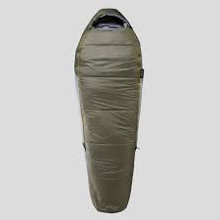
17.2 | Pack | Bagpack - personal | Carrying Comfort  Carry Style To Suit Male Body Shape Easyfit Automatic Back Adjustment.  Multiple Compartments  Volume With Compartments Access To Bottom Of Pack. 5 Pockets.  Versatility  Water Bottle Holder, Pole Holder, Rain Cover.  Weight  1.6 Kg. The Weight Indicated Is That Of Our Benchmark Sample.  Durability  Main Fabric In 600 Denier Polyester Bottom Of The Bag Is Reinforced(1600 Denier)  Ventilation  Back With Aluminium | EU - CE | 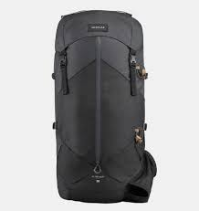

Item | Category | Descriptions | Detailed Specifications | Certification | PICTURES
18.1 | Carrying Accessories | Trolleys - foldable - Aluminium | Lightweight folding aluminium, manoeuvrability and space are required. Truck has a checkerplate platform which ensures a surer grip. Unit is mounted on : 125/160mm dia. 2 x fixed / 2 x swivel braked castors rubber tyred castors. Trolley has a folding handle at the swivel castor end for complete control and manoeuvrability, handle folds on to platform when not in use and for storage purposes. Unit is extremely lightweight yet strong and can be easily wiped down in hygienic areas. Trolley has a 150kg UDL capacity and weighs just 11/18kgs.  Features:-  Lightweight and strong  Scuff resistant  Easily stored  Capacity: 150kgs  Weight: 11/18kgs  Black Color | EU - CE | 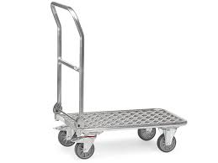
19.1 | Case | Shipping Case AL 3418 - Pelican | Comfort grip handles  Positive anti-shear locks, which prevent lid separation after impact  Reinforced corners and edges for additional impact protection  Molded-in ribs and corrugations for secure, non-slip stacking, columnar strength, and added protection  Recessed hardware for extra protection  Black Color | EU - CE | 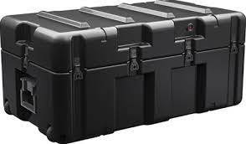
19.2 | Case | Shipping Case 350 Cubic - Pelican | Sensitive equipment needs protection, and since 1976 the answer has been the Pelican™ Protector Case. These cases are designed rugged, and travel the harshest environments on earth. Against the extreme cold of the arctic or the heat of battle, Pelican cases have survived.  Large 2-person fold down handles  Watertight, crushproof, and dustproof  Open cell core with solid wall design - strong, light weight  3 level Pick N Pluck™ with convoluted lid foam  Stainless steel hardware and padlock protectors  Automatic pressure equalization valve - balances interior pressure, keeps water out  O-ring seal  Black Color | EU - CE | 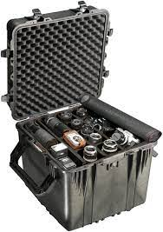
19.3 | Case | Shipping Case 1610 - Pelican | Watertight, crushproof, and dustproof  Strong polyurethane wheels with stainless steel bearings  3 level Pick N Pluck™ with convoluted lid foam  Open cell core with solid wall design - strong, light weight  Retractable extension trolley handle  Fold down handles  Easy open double-throw latches  Automatic pressure equalization valve - balances interior pressure, keeps water out  Stainless steel hardware and padlock protectors  O-ring seal  Black Color | EU - CE | 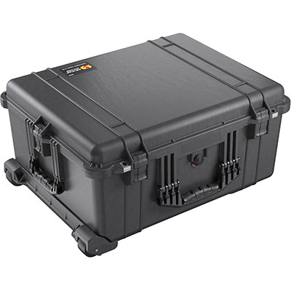
19.4 | Case | Shipping Case 1555 - Pelican | Waterproof, crushproof, dustproof  Super-light proprietary HPX²™ Polymer - up to 40% lighter  Press and Pull™ Latches  User-customizable Pick N Pluck™ foam  Fold down over-molded handle  Waterproof O-ring seal  Automatic pressure equalization valve - balances interior pressure, keeps water out  Stainless steel padlock protectors  IP67 & MIL-SPEC certified  Limited Lifetime Warranty  Made in the USA | EU - CE | 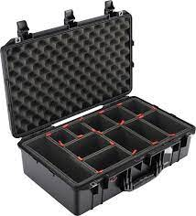
19.5 | Case | Shipping Case 0500 NF - Pelican | Fit two 0500 Cases per pallet, four when stacked!  Store documents outside the case with our Document Container  Can be inverted and used as a pallet with an airtight cover  Watertight, crushproof, and dustproof  Open cell core with solid wall design - strong, light weight  Double wide grip fold down handles - makes lifting easy  Easy open double-throw latches  Dual Integrated Automatic Pressure Equalization Valves  Lid is completely removable  O-ring seal  Optional Caster Wheel Kit complete with brakes  Optional Pallet Riser Kit  Black Color | EU - CE | 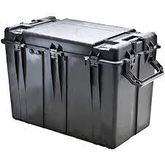
20.1 | Electrical | Power Bank 75000 mAh | 1. Capacity: 75000mAh 277.5Wh. Rated capacity: 44000mAh.  2. Input: Micro-USB / Type-C – 18W (for QC, for FCP, for AFC).  3. Output:  USB 1 – 22.5W (for QC, for FCP, for SCP, for AFC),  USB 2 / 3 – 5V / 2.1A.  Type-C – 20W (for PD, for QC, for FCP, for AFC).  Total output – 5V / 3A.  4. Display: LED digital display.  5. Material: ABS + PC flame retardant shell + lithium polymer battery.  6. Sizes: 157*116*45mm. Weight: 1400g.  Black Color | EU - CE | 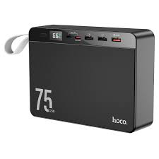
21.1 | Tool Kit | Tool kits Maintenance - Combo | A great helper for complete daily home and car maintenance.  Easy and comfortable to use.  Multifunctional & wide application tool kit  Organized and Sturdy Toolbox  High quality and durable.  Black Color | EU - CE

PLEASE NOTE THAT BIDDERS MUST SUBMIT DATASHEETS AND SAMPLES AS SPECIFY IN THE BELOW TABLE WITH THE BID (PLEASE NUMBED THE PRINTED DATASHEETS AS PER THE ITEM NUMBER MENTIONED IN THE BELOW TABLE):
Lot I: CONNECTOR
Lot 1 | Category | Item | Sample or Datasheet?
1.1 | Connector | Steel Recue Carabiner | Sample
1.2 | Connector | Speedy Carabiner Aluminium small | Sample
1.3 | Connector | Mallion Rapid - CT | Sample
1.4 | Connector | Carabiner Aluminum | Sample
Lot 2: HARNESS
Lot 2 | Category | Item
2.1 | Harnesses | Sit Harness - industrial | Sample
2.3 | Harnesses | Chest Harness + chest Top croll | Sample
2.3 | Harnesses | Rescue Harness Pythagore | Sample
2.4 | Harnesses | Rescue Basket stretcher - nest | Sample
2.5 | Harnesses | Nest Stretcher - Confined space and caving stretcher | Sample
2.6 | Harnesses | Sked - fodable rescue stretcher | Sample
Lot 3: HEAD LAMP
Lot 3 | Category | Item
3.1 | headlamp | Headlamp - with helmet attachment | Sample
Lot 4: HELMETS
Lot 4 | Category | Item
4.1 | Helmets | Search and rescue Helmet | Sample
4.2 | Helmets | Patient Helmet - Red | Sample
Lot 5: KITS
Lot 5 | Category | Item
5.1 | Kit | Aztek kit | Sample
Lot 6: LANYARD AND ENERGY ABSORBERS
Lot 6 | Catrgory | Item
6.1 | Lanyard and Energy Absorbers | Grillon 3 m - Adjustable line Yard | Sample
Lot 7: MOBILE FALL ARRESTERS
Lot 7 | Catrgory | Item
7.1 | Mobile Fall Arresters | Fall Arrest Device with Trelock Carabiners | Sample
7.2 | Mobile Fall Arresters | Shock Absorber - 20 cm | Sample
7.3 | Mobile Fall Arresters | Raptor foot | Sample
7.4 | Mobile Fall Arresters | Flat foot | Sample
7.5 | Mobile Fall Arresters | Ready Rope Protector | Sample
7.6 | Mobile Fall Arresters | Roll Module | Sample
7.7 | Mobile Fall Arresters | Anchor Strap | Sample
Lot 8: PACKS
Lot 8 | Category | Item
8.1 | Packs | Transportation bag - Cylindric shape - 60 L for equipment | Sample
8.2 | Packs | Transportation bag - Cylindric shape - 45 L - For rope | Sample
8.3 | Packs | Transporting Bags - 80L | Sample
8.4 | Packs | Transporting Bags - 60 | Sample
8.5 | Packs | Tripod bag system | Sample
8.6 | Packs | Combi Pro - Bag - For hard equipment | Sample
8.7 | Packs | Duffle bag | Sample
Lot 9: PULLEYS
Lot 9 | Category | Item
9.1 | Pulleys | Petzel rescue Pully | Sample
9.2 | Pulleys | ProTraxion Pully | Sample
9.3 | Pulleys | Rigging Plate Large | Sample
9.4 | Pulleys | Rigging Plate Medium | Sample
9.5 | Pulleys | Double pulley - giminy | Sample
Lot 10: Rescue Accessories
Lot 10 | Category | Item
10.1 | Rescue accessories | PMI Rope Rescue Gloves | Sample
10.2 | Rescue accessories | Ladder - foldable - Industrial | Sample
Lot 11: ROPE CLAMPS
Lot 11 | Category | Item
11.1 | Rope Clamps | ID - Descender | Sample
11.2 | Rope Clamps | Ascender | Sample
11.3 | Rope Clamps | Step loop sling - tape | Sample
Lot 12: ROPES
Lot 12 | Category | Item
12.1 | Ropes | Steel Sling - 1.5 m | Sample
12..2 | Ropes | Wire Strop | Sample
12.3 | Ropes | Rope Semistatic | Sample
12.4 | Ropes | Sling - 16mm - 1.20 m | Sample
12.5 | Ropes | Rope - semistatic - 10.5mm - 200m - roll | Sample
12.6 | Ropes | Rope - 10mm - Rescue Orange - Dynamic - 25 m | Sample
12.7 | Ropes | Daisy chain - steel | Sample
Lot 13: TRIPOD AND ACCESSORIES
Lot 13 | Category | Item
13.1 | Tripod and Accessories | Rescue Tripod | Data sheet
13.2 | Tripod and Accessories | Plate for tripod - wheel plate - Large | Sample
13.3 | Tripod and Accessories | Plate for tripod - wheel plate - Small | Sample
 | Lot 14: COMMUNICATION ITEMS
Lot 14 | Category | Item
14.1 | Communication Items | Radio - Handy VHF | Data sheet
14.2 | Communication Items | Radio - Base - VHF | Data sheet
14.3 | Communication Items | Anthenas - Roof | Data sheet
14.4 | Communication Items | Carrying Vest - Radio Chest | Sample
14.5 | Communication Items | Cable | Data sheet
14.6 | Communication Items | Cable | Data sheet
14.7 | Communication Items | Radios Accessories - connections | Data sheet
14.8 | Communication Items | Hand Pedall | Data sheet
 | Lot 15: CAMPING ACCESSORIES
Lot 15 | Catrgory | Item
15.1 | Camping Accessories | Foldable mattresses | Data sheet
15.2 | Camping Accessories | Tents - Red Dome - 5 pers | Data sheet
15.3 | Camping Accessories | Heat pads | Sample
15.4 | Camping Accessories | Mattresses inflatable | Sample
15.5 | Camping Accessories | MRE - Ready Meals | Sample
15.6 | Camping Accessories | Gas Detector - monitor | Data sheet
15.7 | Camping Accessories | Shovels | Sample
 | Lot 16: ELECTRICAL AND LIGHTING ITEMS
Lot 16 | Category | Item
16.1 | Electrical and Lighting Items | Generators | Data Sheet
16.2 | Electrical and Lighting Items | Searching Light - tripod | Sample
16.3 | Electrical and Lighting Items | Thermal Camera - high pixcels | Sample and Data sheet
16.4 | Electrical and Lighting Items | Voice detector | Sample and Data sheet
16.5 | Electrical and Lighting Items | Head lamp | Data Sheet
 | Lot 17: PACK
Lot 17 | Category | Item
17.1 | Pack | Sleeping Bag -10 Degree | Sample
17.2 | Pack | Bag pack - personal | Sample
Lot 18: CARRYING ACCESSORIES
Lot 18 | Category | Item
18.1 | Carrying Accessories | Trolleys - foldable - Aluminium
Lot 19: CASE
Lot 19 | Catrgory | Item
19.1 | Case | Shipping Case AL 3418 - Pelican | Data Sheet
19.2 | Case | Shipping Case 350 Cubic - Pelican | Data Sheet
19.3 | Case | Shipping Case 1610 - Pelican | Data Sheet
19.4 | Case | Shipping Case 1555 - Pelican | Data Sheet
19.5 | Case | Shipping Case 0500 NF - Pelican | Data Sheet
Lot 20: ELECTRICAL
Lot 20 | Catrgory | Item
20.1 | Electrical | Power Bank 75000 mAh | Data Sheet
Lot 21: TOOL KIT
Lot 21 | Catrgory | Item
21.1 | Tool Kit | Tool kits Maintenance - Combo | Sample

Annex 4 – Past Performance & Bidder References (Must be signed and stamped)
No. | Description | Customer | Unit | Quantity | Contract date | Contract value (USD)
1
2
3
4
5
6
Please provide the details of minimum two companies for your reference check. For these companies it is compulsory to attach a scan either / photo copy of the Contract/ Purchase order/ Completion certificate/ or Reference letters as proof.
Reference 1
Company name
Mailing address
Contact person
Contact title
Phone number
Email address
Reference 2
Company name
Mailing address
Contact person
Contact title
Phone number
Email address

Annex 5 Tender and Award Acknowledge Certificate

This attachment shall be signed and submitted with the Bid (Must be signed and stamped)
1. In compliance with the ITB Instructions and General Conditions of Procurement Contract, we the undersigned, offer to furnish some or all of the quoted for, at the prices entered in the attached LRCS Bid Form No [ITB/2023-026 delivered to the destination specified therein.  2. We accept the terms and conditions set forth in the ITB Letter, and the following requirements have been noted and will be complied with where applicable:  a. That unless otherwise stated, the Bids per each line item shall be on a DDP- Beirut (Incoterms 2020) basis.  b. We confirm that for any offer made where the  delivery destination is not as requested in the ITB, item shall be on a DDP- Beirut (Incoterms 2020) basis.  c. That conditional Bid cannot be accepted.  d. That the currency of the Bid should be in USD, or LEB, no other currencies will be accepted.  e. LRCS reserves the right, at its own discretion:  i. To award a contract for a lesser or greater  quantity than the total quantity Bid for.  ii. To reject any or all Bids and/or enter a contract with a Bidder other than the lowest Bidder.  f. Successful Bidders who are awarded contracts will be notified by the receipt of the original Purchase Order/Contract and acknowledgement copy. In case of urgency, successful Bidders(s) may also be notified by email.  g. Any samples requested, either with the Bid, or at a later date, will be in accordance with the  specifications of the required item(s). Failure to  comply with this may result in the Bid not being considered  h. We confirm that the validity of this offer match the FWA validity | i. We agree to the terms and conditions set in the LRCS General Conditions of Procurement Contract  j. We certify that the below mentioned company has not engaged in corrupt, fraudulent, collusive, or coercive practices in competing for, or in executing any contract.  k. We agree to abide by the LRCS Addendum,  3. We note that LRCS is not bound to proceed with this ITB and that it reserves the right to award only part of the contract. It will incur no liability towards us should it do so.  We agree to the above terms and conditions.  Submitted by:  Company Name-----------------------------------------  Place-------------------------------------------------------  Date--------------------------------------------------------  Title/Position--------------------------------------------  Print Name----------------------------------------------  Signature-------------------------------------------------  A duly authorized company representative any Stamp

Annex 6: General conditions of Procurement Contract.
Article 1. Terms & conditions on purchasing
1.1. Acceptance: No purchase order shall become effective and no contract shall exist until the
LRCS has received from the Supplier their written acceptance of the conditions which
govern the PO or contract. This can be accomplished by return of the signed Letter of
Authorization and Acknowledgment Form attached.
1.2. Tax Exemption: The Supplier’s price shall reflect any tax exemption to which the LRCS is
entitled by reason of any immunities which it enjoys. If it is subsequently determined that
any taxes which have been included in the price are not required to be paid, the LRCS shall
deduct the amount from the contract price or, if it has paid any such taxes, it shall be
refunded.
1.3. Discount: Time in connection with any discounts offered will be computed from the date of
receipt by the LRCS of full documentation as specified by the Purchase Order, contract or
Annex thereto.
1.4. Warranty: The Supplier warrants the goods or services furnished under this Purchase Order
/ Contract to be fit for their intended use, free from defects in workmanship or materials,
and indemnifies the LRCS against any claims resulting there from. This warranty is without
prejudice to any further guarantees that the Supplier provides to the Purchaser; such
guarantees shall apply to the subject goods of this Purchase Order / Contract.
1.5. Inspection: The duly accredited representatives of the LRCS shall have the right to inspect
the goods or services called for under this Purchase Order / Contract at the Supplier’s
stores, during manufacture, in the ports or at places of shipment, and the Supplier shall
cooperate and provide all facilities for such an inspection. The LRCS may issue a written
waiver of inspection at its discretion. Any inspection carried out by representatives of the
LRCS or any waiver thereof shall not prejudice the implementation of any other relevant
provisions of this Purchase Order / Contract concerning obligations subscribed by the
Supplier, such as warranty or specifications.
1.6. Packing: The Supplier shall pack all goods appropriately and with every care in accordance
with normal commercial standards of export packing for the type of goods specified herein.
Such packing materials used must be adequate to safeguard the goods while in transit. The
Supplier shall be responsible for any damage or loss which can be shown to have resulted
from faulty or inadequate packing.
1.7. Export License: The Purchase Order / Contract is subject to the obtaining of any export
license or other governmental authorization which may be required. It shall be the
responsibility of the Supplier to inform the LRCS beforehand of such restrictions and obtain
such license or authorization, but the LRCS will use its best endeavors to assist. In the
event of refusal thereof, the Purchase Order / Contract will be annulled and all claims
between the parties automatically waived.
1.8. Force Majeure: Force majeure, as used herein, shall mean acts of God (involuntary and
unexpected acts), laws or regulations, industrial disturbances, acts of war, explosions and
any other similar cause of equivalent force not caused by, nor within the control of either
party, and which neither party is able to overcome. As soon as possible after the
occurrence of the force majeure and within not more than 15 days, the supplier shall give
notice and full particulars in writing to the LRCS of such force majeure if the Supplier is
thereby rendered unable, wholly or in part, to perform his obligations and meet his
responsibilities under this Purchase Order / Contract. The LRCS shall then have the right to
terminate the Purchase Order / Contract by giving in writing seven days’ notice of
termination to the Supplier, and the Supplier shall return any deposit paid by the LRCS.
1.9. Default: In case of default by the Supplier, including but not limited to failure or refusal to
make deliveries within the time limit specified, the LRCS may procure the goods or services
from other sources and hold the Supplier responsible for any excess costs occasioned
thereby. Furthermore, the LRCS may by written notice terminate the right of the Supplier
to proceed with the deliveries, or such parts thereof as to which there has been default.
1.10. Conformity with Specifications: In the case of goods purchased on the basis of
specifications the Supplier warrants their conformity. The LRCS shall have the right to reject
the goods or any part thereof if they do not conform to specifications. Any supplies not
found to be in accordance with the specification and requirements will not be accepted and
in that eventuality the supplier shall replace the goods and bear the inspection cost and/or
other losses caused to LRCS, if any, by replacement of the items non–conforming to the
requirements/specification.
1.11. Liquidated Damages: Arrival of goods/ completion of services after agreed delivery
schedule will be subject to deduction of damages
1.12. Disputes-Arbitration: Any claim or controversy arriving out of this Purchase Order /
Contract, or to the breach, termination or invalidity thereof the parties agree to attempt to
settle it amicably via direct negotiations between the two sides within seven days. In case
of any dispute that cannot be settled in such way, the Lebanese law shall be applicable and
the Lebanese courts will settle any litigation in this regards that was not solved amicably
1.13. Privileges and Immunities: Nothing contained in this Purchase Order / Contract
shall be deemed a waiver, express or implied, of any privilege or immunity which the LRCS
may enjoy, whether pursuant to existing conventions or agreements.
1.14. Assignment: The Supplier shall not assign, transfer, pledge or make other
disposition of this Purchase Order / Contract or any part thereof or of any of the Supplier’s
rights, claims or obligations under this Purchase Order / Contract except with the prior
written consent of the LRCS.
1.15. Bankruptcy: Should the Supplier file any petition for bankruptcy, or should the
Supplier make a general assignment for the benefit of its creditors, or should a receiver be
appointed on account of the Supplier’s insolvency, the LRCS may under the terms of this
Purchase Order / Contract, terminate the same forthwith by giving the Supplier written
notice of such termination.
1.16. Advertising: Unless authorized in advance in writing by the LRCS, the Supplier shall
not advertise or otherwise make public the fact that he is a Supplier to the LRCS and / or
any National Red Cross or Red Crescent Society, or use the name, emblem or official seal of
the LRCS and / or any National Red Cross or Red Crescent Society, or any abbreviation of
the name of the LRCS and / or any National Red Cross or Red Crescent Society for
advertising purposes or any other purposes.
1.17. Officials Not to Benefit: The supplier represents and warrants that no official of the
LRCS has been, or shall be, admitted by the supplier to any direct or indirect benefit arising
from this contract or the award thereof. The supplier agrees that breach of this provision is
a breach of an essential term of this contract.
1.18. Amendments: No changes or modifications to this Purchase Order / Contract shall
be valid unless mutually agreed between both parties and confirmed by an official
amendment.
1.19. Notice: Service of any notice shall be deemed to be good if sent by registered mail,
or email to the addresses of both parties, set out in the heading of this Purchase Order /
Contract.
1.20. Jurisdiction: This Contract is considered to be concluded as defined in the attached
Addendum.
Article 2. Labour standards
2.1. Employment is freely chosen: There is no forced, bonded or involuntary prison labour.
Workers are not required to lodge `deposits’ or their identity papers with the employer and
are free to leave their employer after reasonable notice.
2.2. Freedom of association and the right to collective bargaining are respected: Workers,
without distinction, have the right to join or form trade unions of their own choosing and to
bargain collectively. The employer adopts an open attitude towards the legitimate activities
of trade unions. Workers representatives are not discriminated against and have access to
carry out their representative functions in the workplace. Where the right to freedom of
association and collective bargaining is restricted under law, the employer facilitates, and
does not hinder, the development of parallel means for independent and free association
and bargaining.
2.3. Working conditions are safe and hygienic: A safe and hygienic working environment shall
be provided, bearing in mind the prevailing knowledge of the industry and of any specific
hazards. Adequate steps shall be taken to prevent accidents and injury to health arising out
of, associated with, or occurring in the course of work, by minimising, so far as is reasonably
practicable, the causes of hazards inherent in the working environment. Workers shall
receive regular and recorded health and safety training, and such training shall be repeated
for new or reassigned workers. Access to clean toilet facilities and potable water and, if
appropriate, sanitary facilities for food storage shall be provided. Accommodation, where
provided, shall be clean, safe, and meet the basic needs of the workers. The company
observing the standards shall assign responsibility for health and safety to a senior
management representative.
2.4. Child Labour shall not be used: There shall be no new recruitment of child labour.
Companies shall develop or participate in and contribute to policies and programmes,
which provide for the transition of any child found to be performing child labour to enable
her/him to attend and remain in quality education until no longer a child. Children and
young people under 18 years of age shall not be employed at night or in hazardous
conditions. These policies and procedures shall conform to the provisions of the relevant
International Labour Organisation (ILO) standards.
2.5. Living wages are paid: Wages and benefits paid for a standard working week meet, at a
minimum, national legal standards or industry benchmarks. In any event wages should
always be high enough to meet basic needs and to provide some discretionary income. All
workers shall be provided with written and understandable information about their
employment conditions in respect to wages before they enter employment, and about the
particulars of their wages for the pay period concerned each time that they are paid.
Deductions from wages as a disciplinary measure shall not be permitted nor shall any
deductions from wages not provided for by national law be permitted without the express
and informed permission of the worker concerned. All disciplinary measures should be
recorded.
2.6. Working hours are not excessive: Working hours comply with national laws and benchmark
industry standards, whichever affords greater protection. In any event, workers shall not on
a regular basis be required to work in excess of the local legal working hours. Overtime shall
be voluntary, shall not exceed local legal limits, shall not be demanded on a regular basis
and shall always be compensated at a premium rate.
2.7. No discrimination is practised: There is no discrimination in hiring, compensation, access to training, promotion, termination or retirement based on race, caste, national origin,
religion, age, disability, gender, marital status, sexual orientation, union membership or
political affiliation.

2.8. Regular employment is provided: To every extent possible work performed must be on the basis of a recognised employment relationship established through national law and
practice. Obligations to employees under labour or social security laws and regulations
arising from the regular employment relationship shall not be avoided through the use of
labour-only contracting, sub-contracting or home-working arrangements, or through
apprenticeship schemes where there is no real intent to impart skills or provide regular
employment, nor shall any such obligations be avoided through the excessive use of fixedterm
contracts of employment.
basis of a recognised employment relationship established through national law and
practice. Obligations to employees under labour or social security laws and regulations
arising from the regular employment relationship shall not be avoided through the use of
labour-only contracting, sub-contracting or home-working arrangements, or through
apprenticeship schemes where there is no real intent to impart skills or provide regular
employment, nor shall any such obligations be avoided through the excessive use of fixedterm
contracts of employment.
2.9. No harsh or inhumane treatment is allowed: Physical abuse or discipline, the threat of
physical abuse, sexual or other harassment and verbal abuse or other forms of intimidation
shall be prohibited.
Article 3. Corporate social responsibility & other requirements
3.1. Business ethics: Suppliers are expected to maintain the highest degree of business ethics
when working or seeking to work with the LRCS.
3.2. Transparency of information provision: Suppliers shall not be involved in any fraudulent
activities, misrepresent information or facts for the purpose of influencing the selection and
contract-awarding process in their favour.
3.3. Fair competition: Suppliers shall not be involved in any corrupt, collusive or coercive
practices.
3.4. Conflict of interest: The supplier shall represent and warrants that no official/
representative/ staff member of the LRCS has been, or shall be, admitted by the supplier to
any direct or indirect benefit arising from the award of the contract.
3.5. Adherence to IFRC principles: When performing on behalf of or at any time representing
the LRCS, the supplier and all individuals assigned by it to perform works or services, shall
act in a manner consistent with the fundamental principles of the International Red Cross
and Red Crescent Movement.
3.6. Misrepresentation: By participating in the tender, submitting the bid and having being
selected as a Supplier, the supplier acknowledges their acceptance of the above stated
requirements and shall be held responsible and liable for the consequences of any false or
misrepresented information provided
Article 4. Environmental and carbon reduction policy
4.1. Suppliers should as a minimum comply with all statutory and other legal requirements
relating to the environmental impacts of their business. Detailed performance standards
are a matter for suppliers, but should address at least the following:
4.1.1. Waste Management: Waste is minimised and items recycled whenever this is
practicable. Effective controls of waste in respect of ground, air, and water pollution
are adopted. In the case of hazardous materials, emergency response plans are in
place.
4.1.2. Packaging and Paper: Undue and unnecessary use of materials is avoided, and
recycled materials used whenever appropriate.
4.1.3. Conservation: Processes and activities are monitored and modified as necessary to
ensure that conservation of scarce resources, including water, flora and fauna and
productive land in certain situations.
4.1.4. Energy Use: All production and delivery processes, including the use of heating,
ventilation, lighting, IT systems and transportation, are based on the need to maximise
efficient energy use and to minimise harmful emissions.
4.1.5. Safety precautions for transport and cargo handling: All transport and cargo
handling processes are based on the need to maximise safety precautions and to
minimise potential injuries to the environment, beneficiaries and staff as well as the
suppliers’ employees or those of its subcontractors.
Article 5. Ethical procurement
5.1. Supplier’s core business (over 20% turnover) should not:
5.1.1. Manufacture or sell arms.
5.1.2. Manufacture or sell tobacco
5.1.3. Damage the reputation of the Red Cross name and/or emblem
5.2. Legal requirements: Suppliers should always work within the laws of their country

Article 6. Payment.
6.1. Payment will be made upon approval by LRCS of a completed milestone/deliverable, and receipt of verified original invoice submitted by Contractor to LRCS, within 45 days, and will be new and unused, free from material defects in quality, material, and design under normal use, and free from any right of claim by any third party, including claims of infringement of any intellectual property rights.
Article 7. Tenderers shall be excluded from participation in a procurement procedure if:

7.1 They are bankrupt or being wound up, are having their affairs administered by the courts, have entered into an arrangement with creditors, have suspended business activities, are subject of proceedings concerning those matters, or are in any analogous situation arising from a similar procedure provided for in national legislation or regulations. However, tenderers in this situation may be eligible to participate insofar as the Grant Recipient is able to purchase supplies on particularly advantageous terms from either a supplier which is definitively winding up its business activities, or the receivers or liquidators of a bankruptcy, through an arrangement with creditors, or through a similar procedure under national law;
7.2 They or persons having powers of representation, decision-making or control over them have been convicted of an offence concerning their professional conduct by a final judgment;
7.3 They have been guilty of grave professional misconduct; proven by any means which the Grant Recipient can justify;
7.4 They have not fulfilled obligations relating to the payment of social security contributions or taxes in accordance with the legal provisions of the country in which they are established, or with those of the country of the Grant Recipient or those of the country where the contract is to be performed
7.5 They or persons having powers of representation, decision-making or control over them have been convicted for fraud, corruption, involvement in a criminal organization or money laundering by a final judgment
7.6 they make use of child labor or forced labor and/or practice discrimination, and/or do not respect the right to freedom of association and the right to organize and engage in collective bargaining pursuant to the core conventions of the International Labor Organization (ILO).

Bidder’s checklist
Description | To be filled by bidder |  | To be filled by LRCS committee
 | Included? |  | Present & complete? |  | Comments
Step/ document to be submitted with tender | Yes | No | Yes | No
Complete tender package delivered before the deadline specified - Compulsory
Annex 1 – LRCS Supplier Registration Form – completed, signed & stamped (if it was not submitted before) – Compulsory
Annex 2 - Bid Form – completed, signed & stamped – Compulsory
Annex 4 – Past performance & Bidder references – completed, signed & stamped Compulsory
Annex 5 - Tender Award and Acknowledge Certificate – signed & stamped – Compulsory
Supporting documents (Mandatory):
Copy of company registration – (Ministry of Justice)- وزارة العدل) ) شهادة تسجيل شركة تجارية Compulsory
Copy of tax registration (Ministry of Finance( (وزارة المالية) شهادة تسجيل الشركة – Compulsory
Copy of VAT registration (Ministry of Finance) (وزارة المالية) شهادة تسجيل في الضريبة على القيمة المضافة – Compulsory (if VAT registered)
اذاعة تجارية
IBAN BANK DOCUMENT Compulsory
AFD STATEMENT OF INTEGRITY (SIGNED AND STAMPED) Compulsory
GRC DECLARATION OF CONFORMITY + DUE DILIGENCE CHECK (SIGNED AND STAMPED) Compulsory

To be filled in by LRCS –Tender Opening Committee ONLY | Eligible | Ineligible
Outcome of administrative check.

