Annex 2 – Bid Form completed signed and stamped
- All bids must be typed; handwritten bids will not be considered.
- The contract will be awarded to the lowest-cost technically compliant bid per item
- The quantities mentioned below are required unless there is a variation within a specified range with proper justification. The LRC reserves the right to increase or decrease the quantities.
- The bidder is not permitted to alter the section labelled “LRC to complete” below. Bidder is not allowed to use any other template.
- In the event of any discrepancy between the unit price and the total price, LRC reserves the right to rely on the unit price as stated in the financial bid, rather than the total price without go back to the supplier. The unit price must be provided with no more than two decimal places.
LRC To Complete |  |  |  | Bidder to Complete
Item # | Item/Milestone Required | Unit of Measurement (UOM) | Estimated  Quantity | Unit Price in USD, Exclusive of VAT, but inclusive of labor, bank transfer fees, and delivery fees. | VAT (%) | Unit Price in USD  Inclusive of VAT, labor fees, bank transfer fees, and delivery fees. | Total Price in USD  Inclusive of VAT, labor fees, bank transfer fees, and delivery fees. | Lead time of delivery  (in calendar days) from the date of each Purchase Order.
1 | Standard Laptop | Pcs | 15
2 | Medium range laptop | Pcs | 3
3 | Laptop High Specs | Pcs | 2
4 | Laptop Backpack | Pcs | 5
5 | Wireless keyboard and mouse set | Pcs | 25

ANNEX 3: DETAILED SPECIFICATIONS

ITEM # | ITEM/MILESTONE REQUIRED | QTY/UOM | DESCRIPTION
1 | Standard Laptop | 15 Pcs | Display  - 16″ WUXGA (1920×1200) anti glare panel  - IPS technology with 400 nits brightness  - 16:10 aspect ratio for extra vertical workspace  Processor  - Core i7 Latest generation CPU with up to 12 cores  - Turbo speeds up to ~4.8 GHz depending on configuration  - Integrated AI acceleration engine for productivity workloads  Graphics  - Integrated GPU suitable for multitasking,  Memory  - 16GB DDR5 high speed RAM  - Dual channel capable  Storage  - 1 TB NVMe SSD (high speed, low latency)  - Supports future SSD upgrades via M.2 slot  Keyboard  - Arabic and English engraving mandatory  - Backlit keyboard  - Full keyboard with Numeric Keypad (NumLock included)  - Integrated TrackPoint (pointing stick)  Connectivity  - Wi Fi 6E + Bluetooth 5.x  - Optional 4G/5G WWAN capability  Ports  - 2× USB C (supports power delivery + display output)  - 2× USB A for legacy devices  - HDMI (supports 4K external display)  - Ethernet (RJ 45)  - 3.5mm audio jack  Build :16″ chassis with lightweight composite body  Battery & Power  - Battery options around 47–57Wh  - Fast charging support  - Charges via USB C  Security  - Fingerprint reader  - IR camera with privacy shutter  - Enterprise grade BIOS and TPM level protection  Data Sheet Mandatory
2 | Medium range laptop | 3 Pcs | Display & Build  - 16-inch UHD + (1920 × 1200) 4K OLED panel 16:10 aspect ratio  - Factory-calibrated with 100% DCI-P3 color gamut  - Spill-resistant full-size keyboard, integrated numeric keypad  - Arabic key engraving mandatory  - Integrated track point (pointing stick)  - Mechanical webcam privacy shutter  Performance & Memory  - Core i7 Latest-generation processor  - Dedicated NVIDIA RTX Ada Generation GPU (up to RTX 3000)  - 32GB LPDDR5x memory  - 1TB PCIe Gen 4 NVMe SSD, expandable via dual M.2 slots  Ports & Connectivity  - Built-in RJ45 Gigabit Ethernet port  - 2× USB-A 3.2 Gen 1, 2× Thunderbolt 4 (USB-C), HDMI 2.1, SD card reader  - 3.5mm combo audio jack  - Wi-Fi 6E and Bluetooth 5.3  - Compatible with mechanical side-docking stations and USB-C docks  Battery & Power  - 52.5Wh or 86Wh (depending on model)  - Up to 12 hours real-world usage  - Rapid Charge Pro via USB-C (up to 140W)  Security & Features  - Match-on-chip fingerprint reader and IR camera for facial recognition  - Full HD IR camera with auto-framing  - Discrete TPM 2.0, self-healing BIOS, secure wipe functionality  Data Sheet Mandatory
3 | Laptop High Specs | 2 Pcs | Display:  16" WQUXGA (3840 x 2400), OLED, Anti-Reflection/Anti-Smudge, Dolby Vision™, Non-Touch, HDR 500 True Black, 100%DCI-P3, 400 nits, 60Hz  Processor:  - Core Ultra 7 255HX  - Cores/Threads: 20‑core total  Base Speeds:  - P‑core: 2.4 GHz  - E‑core: 1.8 GHz  Max Turbo:  - P‑core: 5.2 GHz  - E‑core: 4.5 GHz  - Cache: 30MB Intel Smart Cache  Graphics:  - NVIDIA RTX™ 500 Ada Generation 4GB or equivalent Performance  Memory:  - 32GB DDR5  - Dual‑slot, upgradable  Storage:  - 1TB NVMe SSD, PCIe Gen4, M.2 slot  Keyboard:  - Full keyboard with NumPad  - TrackPoint included  - Backlit  - Arabic engraving mandatory  - Large touchpad  Camera:  - 5MP class camera (model‑dependent)  - Privacy shutter  Audio:  - Stereo speakers  - Dual microphones  Ports & Connectivity:  - 2 × USB‑A  - 2 × USB‑C / Thunderbolt  - HDMI 2.1  - 3.5mm audio combo jack  - SD card reader  - Smart card reader (optional)  - RJ‑45 Ethernet port  - Wi‑Fi 6E / Wi‑Fi 7  - Bluetooth  Battery: 90Wh, Fast charging  Data Sheet Mandatory
4 | Laptop Backpack  (Heavy Duty)  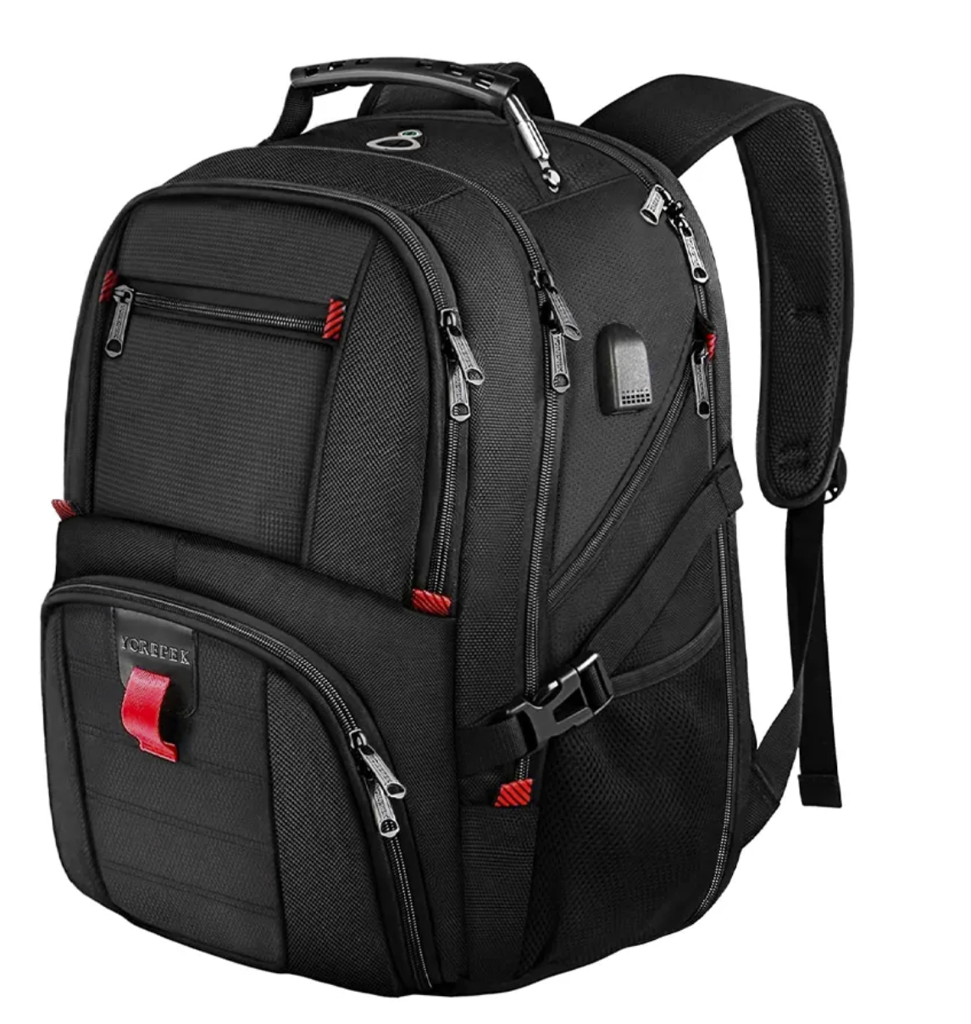 | 5 Pcs | Laptop Compartment  - Padded sleeve for up to 16-inch laptops  - Shock-absorbent padding  - Scratch-resistant inner lining  Dimensions (Typical Range)  - External size around: 45 × 30 × 15 cm  - Laptop pocket: approx. 38 × 26 cm (to safely handle 16" devices)  Material  - Water-resistant polyester or nylon  - Reinforced stitching  - Durable zippers (double-zip main compartment)  Compartments  - Main compartment with laptop sleeve  - Secondary compartment for accessories/documents  - Front organizer pocket  - Side pockets  Comfort  - Padded shoulder straps  - Breathable back panel (mesh airflow design)  - Lightweight frame  - Carry handle  - Luggage-trolley strap  - Internal cable-management pockets  - Black Color  Data Sheet and Sample Mandatory
5 | Wireless keyboard and mouse set | 25 Pcs | Type: Wireless keyboard and mouse set  Color: Black  Keyboard Specification  - Layout: Full-size desktop keyboard with numeric keypad  - Keys: Concave low-profile membrane keys with Incurve design for comfortable typing (English & Arabic engraving mandatory)  - Palm Rest: Cushioned palm rest integrated for wrist support  - Status Indicators: LCD display showing Caps Lock, Scroll Lock, Num Lock, and battery status  - Spill-resistant design  - Wireless Technology: Advanced 2.4 GHz Logitech Unifying wireless via USB receiver  - Wireless Range: Up to ~10 m (30 ft)  - Battery: 2 × AA alkaline (included) with up to 3 years battery life  Mouse  - Type: Full-size wireless mouse with sculpted design  - Buttons: Standard 5-button layout with scroll wheel  - Scroll: Hyper-fast scrolling with tilt wheel and precision tracking  - Wireless Technology: Same Unifying receiver as keyboard  - Battery: 2 × AA alkaline (included) with up to 3 years battery life  Wireless Receiver  - Receiver Type: Unifying USB receiver (pairs both keyboard and mouse)  - Interface: USB Type-A  - Connectivity: Advanced wireless 2.4 GHz RF with encrypted connection  Compatibility  - Operating Systems: Windows XP/Vista/7/8/10/11 and later (USB port required)  - Platform: PC and compatible laptops with USB Type-A  Physical & Packaging  - Keyboard Dimensions: ~460 × 242 × 31 mm  - Mouse Dimensions: ~109 × 60 × 38 mm  - Package Includes:  - Wireless keyboard  - Wireless mouse  - USB Unifying receiver  - 4 × AA batteries (pre-installed)  - User documentation and software CD  Data Sheet and Sample Mandatory

