Annex 2 – Bid Form completed signed and stamped
- All bids must be typed; handwritten bids will not be considered.
- The contract will be awarded to the lowest-cost technically compliant bid
- Under this Framework Agreement, the quantities indicated are estimates only and may vary depending on LRC operational requirements. Purchases will be executed through the issuance of Purchase Orders on an as-needed basis during the validity period of the agreement. LRC does not guarantee the procurement of the full estimated quantities.
- The bidder is not permitted to alter the section labelled “LRC to complete” below. Bidder is not allowed to use any other template.
- In the event of any discrepancy between the unit price and the total price, LRC reserves the right to rely on the unit price as stated in the financial bid, rather than the total price without go back to the supplier. The unit price must be provided with no more than two decimal places.
- Unit price must include manufacturing, customization, labor, packaging, transport, delivery to LRC warehouse, and all applicable bank transfer charges.
LRC To Complete |  |  |  | Bidder to Complete
Item # | Item/Milestone Required | Unit of Measurement (UOM) | Estimated  Quantity | Unit Price in USD  Exclusive of VAT | VAT (%) | Unit Price in USD  Inclusive of VAT | Total Price in USD  Inclusive of VAT | Lead time of delivery  (in calendar days) from the date of each Purchase Order.
1 | Rescue coverall designed for The LRC search and rescue teams (USAR) | Pcs | 150

ANNEX 3: DETAILED SPECIFICATIONS

ITEM # | ITEM NAME | Technical Specifications – Rescue Coverall | QTY / UOM
 |  | - General Description  The coverall shall be designed for personnel operating in demanding and high-risk environments requiring protective clothing with high durability, functionality, and comfort.  The garment shall provide adequate protection against abrasion, dirt, and mechanical stress while ensuring full freedom of movement during operational activities.  The coverall shall be suitable for use in high-visibility operational environments where personnel safety and identification are critical.  - Design and Ergonomics  The coverall shall feature an ergonomic design to ensure optimal mobility and operational efficiency, including but not limited to:  - Allowing full range of movement such as kneeling, squatting, bending, and crawling  - Designed for intensive and prolonged use in demanding operational conditions  - Equipped with two (2) heavy-duty two-way front zippers enabling easy donning and removal without the need to remove footwear  - Durability & Reinforcement  - Reinforced zones: Elbows and Knees  - Double-stitched seams for improved resistance to mechanical stress and tearing  - High durability fabric suitable for demanding rescue environments  - Key performance advantages:  - High resistance to abrasion and damage  - Ergonomic design for operator comfort  - High-visibility color for improved safety and identification  - Functional pocket system for operational efficiency  - Easy maintenance and cleaning  - Main advantages of the product:  - resistance to damage and abrasion,  - ergonomic cut ensuring comfort,  - intense color increasing visibility,  - practical pockets to make work easier,  - easy to clean.  - Storage & Practical Features  Integrated multi-pocket system designed for secure storage of tools and equipment  Adjustable features: Sleeve cuffs and Leg openings  Adjustability ensures:  - Improved ergonomic fit  - Prevention of dust, debris, and foreign material ingress  - Material Specifications  - Fabric composition: 60% Cotton /40% Polyester  - Fabric weight: 250 g/m²  - Knee area equipped with internal knee pad pockets for protection inserts  - Color Specification  - Primary color: High-visibility orange  - Hex code: FF4B33  - Description: Medium-light red-orange tone with high saturation, optimized for visibility in operational environments  #ff4b33 Paint ChipThe hexadecimal color code #ff4b33 is a medium light shade of red. In the RGB color model #ff4b33 is composed of 100.0% red, 29.41% green and 20.0% blue. In the HSL color space #ff4b33 has a hue of 7° (degrees), 100% saturation and 60% lightness. This color has an approximate wavelength of 605.41 nm.  Visibility and Reflective Elements (As per the Photo)  - The coverall shall include high-visibility reflective strips (gray/silver) positioned on the garment to ensure enhanced visibility in low-light, night-time, and emergency operational conditions.  - Reflective elements shall be durable, washable, and resistant to peeling or degradation after repeated use and washing cycles.  - Placement shall ensure 360-degree visibility of personnel during operations.  7. Branding, Logos & Tags on the Coverall Model USAR  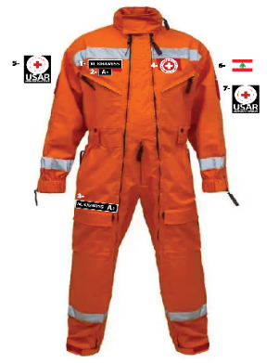  Front Side: (As per the Photo)  - Left Name Tag: 14 cm * 3.5 cm  - Left Blood Tag: 7.5 cm * 3.5 cm  - Left Foot Name Tag: 18.5 cm * 35 cm  - LRC Logo - Circle: 7 cm * 7 cm  - Left Arm - USAR Logo Tag: 8.5 cm * 10 cm  - Right Arm - Lebanese Flag Tag: 7 cm * 4.5 cm  - Right Arm - USAR Logo Tag: 8.5 cm * 10 cm  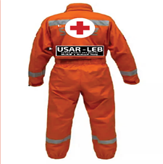  Back side (As per the Photo)  - LRC Logo (Circular): Diameter 19.5 cm (as per reference layout)  - USAR Logo Tag: 33 cm × 9.5 cm (as per reference layout)  All badges shall be provided by LRC. The supplier is responsible only for preparing and attaching hook-and-loop (Velcro-type) surfaces.  All Velcro areas shall be:  - Durable and industrial-grade  - Resistant to repeated washing cycles  - Positioned according to the required layout | 150 Pcs

