Annex 2 – Bid Form completed signed and stamped
- All bids must be typed; handwritten bids will not be considered.
- The contract will be awarded to the lowest-cost technically compliant bid.
- The quantities mentioned below are required unless there is a variation within a specified range with proper justification. The LRC reserves the right to increase or decrease the quantities.
- The bidder is not permitted to alter the section labelled “LRC to complete” below. Bidder is not allowed to use any other template.
- In the event of any discrepancy between the unit price and the total price, LRC reserves the right to rely on the unit price as stated in the financial bid, rather than the total price without going back to the supplier. The unit price must be provided with no more than two decimal places.
- Only one option is allowed for biding
- Sample for each item must be submitted with the bid and labelled reference to each item number
LRC To Complete |  |  |  | Bidder to Complete
Item number | Item/Milestone Required | Required UOM | Estimated Qty | Unit Price in USD, Exclusive VAT rated at 11%, but inclusive Labor, design, printing, engraving, Bank Transfer Fees, Delivery and all other fees | VAT (%) | Unit Price in USD, inclusive VAT, Labor, design, printing, engraving, Bank Transfer Fees, Delivery and all other fees | Total Price in USD, inclusive VAT, Labor, design, printing, engraving, Bank Transfer Fees, Delivery and all other fees | Lead time of delivery for any quantity from the date of each purchase order
1.1 | Small Speaker Red | Piece | 50
1.2 | Small Speaker White | Piece | 50
1.3 | Reusable Hot Beverage Cup | Piece | 400
1.4 | Stress Ball | Piece | 5000
1.5 | Pouch | Piece | 5000
1.6 | Reusable Water Bottle | Piece | 300
1.7 | Card Holder Black | Piece | 1500
1.8 | Card Holder Red | Piece | 500
1.9 | Adjustable Blood Donation Bracelet | Piece | 2000
1.10 | Weekly Planner Notebook | Piece | 1000
 | Total

Supplier to Advise about the quantities that could be delivered before September 2026 (mandatory to be completed by the bidders)
LRC To Complete |  |  |  | Bidder to Complete
Item number | Item/Milestone Required | Required UOM | Estimated Qty | Quantities Available at the Supplier Stock | Lead time of delivery for any quantity by September 2026
1.1 | Small Speaker Red | Piece | 50
1.2 | Small Speaker White | Piece | 50
1.3 | Reusable Hot Beverage Cup | Piece | 400
1.4 | Stress Ball | Piece | 5000
1.5 | Pouch | Piece | 5000
1.6 | Reusable Water Bottle | Piece | 300
1.7 | Card Holder Black | Piece | 1500
1.8 | Card Holder Red | Piece | 500
1.9 | Adjustable Blood Donation Bracelet | Piece | 2000
1.10 | Weekly Planner Notebook | Piece | 1000
 | Total

ANNEX 3: DETAILED SPECIFICATIONS

PROMOTIONAL ITEMS FOR VOLUNTARY BLOOD DONORS

Background/ Purpose
The Lebanese Red Cross Blood Transfusion Services conducts regular blood donation campaigns to ensure the continuous availability of safe blood products across Lebanon. As part of its donor engagement and awareness strategy, BTS utilizes promotional items to encourage voluntary blood donation, enhance donor experience, and strengthen community outreach. The purpose of this procurement is to supply promotional items to be used during blood donation campaigns, and for voluntary blood donors increased donor participation and retention.

Objective / Scope of Work
The objective of this procurement is to supply branded promotional items that support blood donation campaigns and awareness activities. The scope includes:
- Supply of various promotional items (e.g., giveaways, donor appreciation items, awareness materials).
- Branding of items with LRC/BTS logos and campaign messages.
- Delivery of items to designated BTS locations

Detailed Specifications / Requirements

- Small Speaker:
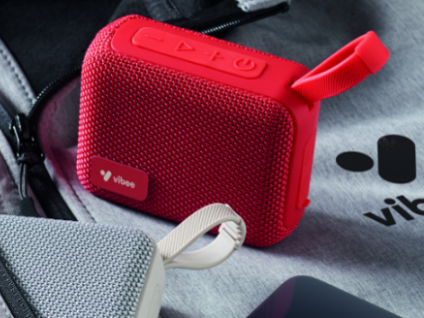
- Approx. Size:
Width: 40 mm
Height: 80mm
Length: 90 mm

- Connectivity:
Wireless Bluetooth

- Battery:
Rechargeable battery
Minimum playback time: 4–6 hours
Charging via USB (preferably C-type)

- Design & Build:
Compact and lightweight
Durable outer material (fabric or rubberized casing)
50 Pieces red + 50 Pieces white

- Controls:
On/off button
Volume control
Play/pause function

- Compatibility:
Compatible with smartphones, tablets, and other Bluetooth-enabled devices

- Branding Requirements
Surface suitable for printing LRC logo
High-quality printing
Logo to be placed in the center in size 2.5 cm

- Reusable Hot Beverage Cup

Reusable insulated cup designed for hot beverages, suitable for daily use and promotional distribution during blood donation campaigns.
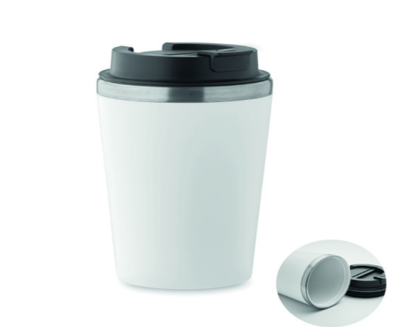
- Capacity:
300–400 ml

- Approx. Dimensions:
Height: 14cm
Diameter (top): 7 cm
Base Diameter: 6 cm

- Material:
Inner layer: food-grade stainless steel.
Outer layer: durable plastic.
White with black cover

- Insulation:
Double-wall insulation to maintain beverage temperature.
Suitable for hot beverages only.

- Lid:
Spill-resistant lid with secure closure.
Easy-open drinking mechanism.

- Temperature Resistance:
Designed to safely hold hot beverages (coffee, tea)
Heat-resistant exterior for safe handling.

- Design & Build:
Lightweight
Leak-resistant

  - Branding Requirements
High-quality, durable print resistant to heat and washing
The image below should be printed on the cup in size:
Wire: 4cm
Blood donors 3.5x3.5 cm.

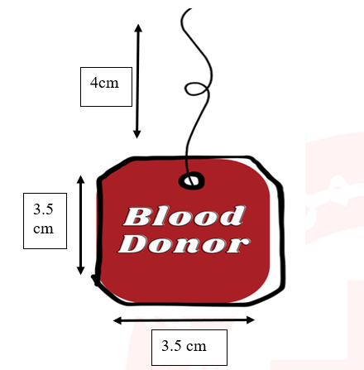

- Stress Ball:
Soft, squeezable blood drop-shaped stress ball designed for awareness and promotional use during blood donation campaigns. The item serves as an engaging giveaway to promote donor retention and public awareness.
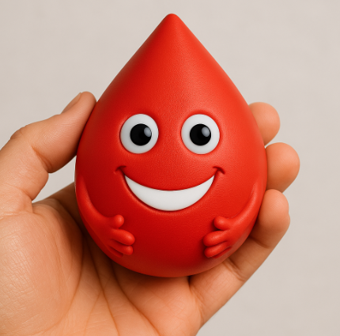
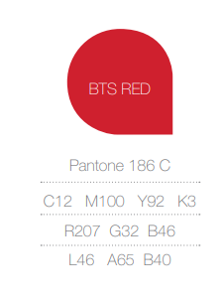
- Material:
Soft foam or PU material
Non-toxic and safe for handling

- Design:
Blood drop shape with 3D facial features
Red color to represent blood donation theme
Smooth and soft surface suitable for repeated squeezing

- Dimensions:
Approx. height: 8 cm
Lightweight and easy to carry

- Branding Requirements
Print LRC logo in the back center in size 2.5cm with white contour from the outside.
Printing must be durable and resistant to wear.

- Pouch:

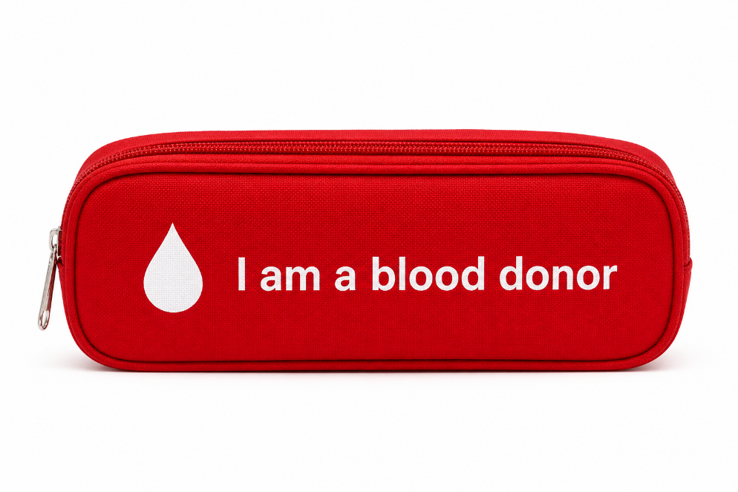
Zippered pouch designed for daily use, suitable as a promotional giveaway during blood donation campaigns.
- Material:
High-quality fabric
Durable and easy to clean

- Design:
Rectangular shape with zip closure
Lightweight and portable

- Dimensions:
Approx. 20–22 cm (length) × 6–8 cm (height) × 5–7 cm (width)

- Color:
Red

- Branding Requirements
Printed text: “I am a Blood Donor” + blood drop both in white in the center both should be 10cm length
Font: arial, location: center
Printing must be high-quality, durable, and resistant to fading

- Reusable Water Bottle:

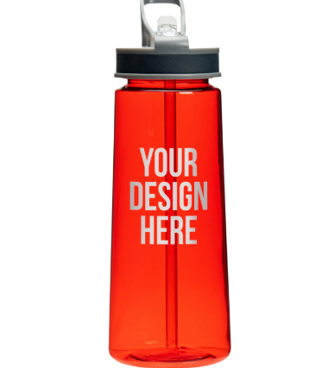

- Approx. Capacity:
700-800 ml

- Material:
Body: BPA-free plastic
Lid: Durable food-grade plastic
Straw: Food-grade silicone or plastic

- Design & Features:
Built-in straw for easy drinking
Leak-proof flip-top lid
Lightweight

- Dimensions:
Approx. height: 20-22 cm
Approx. width 7 cm

- Color:
Transparent red body

- Branding Requirements
Printing must be high-quality, durable, and resistant to washing and daily use.
The below image should be printed in size: width 7 cm x length 9.5 cm including white background
From the top it should be 4 cm down.
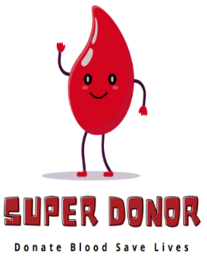

- Card Holder:

Card holder designed to store and protect cards, suitable for daily use and distribution as a promotional item during blood donation campaigns
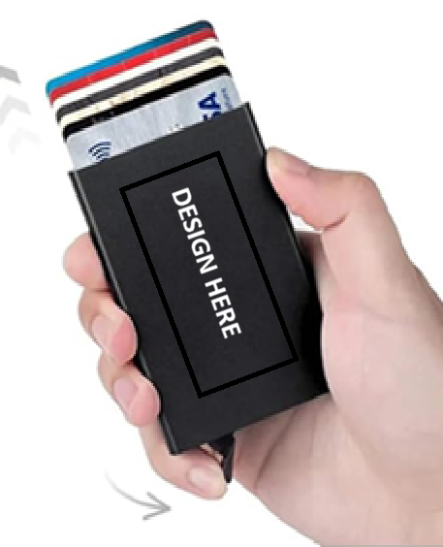
- Material:
Durable leather

- Capacity:
Holds approximately 5–7 cards

- Design & Features:
Slim, lightweight, and pocket-sized
Pop-up mechanism for easy access to cards
Smooth sliding button mechanism

- Dimensions:
Approx. 9.5–10 cm (height) × 6–6.5 cm (width)

- Color:
Red 500 piece and Black 1500 piece

- Branding Requirements
Printed text: “I am a Blood Donor” text 6cm in the middle.
Branding must be durable, scratch-resistant, and long-lasting
Placement: front surface of the card holder
White printing: 6 cm- writing length- in the middle (I am a Blood Donor) - see below printing layout
I am a Blood Donor

9 cm length and 6 cm width

- Adjustable Blood Donation Bracelet
Adjustable wrist bracelets are designed as a symbolic promotional item to raise awareness and encourage blood donation. Suitable for distribution during campaigns and donor engagement activities.
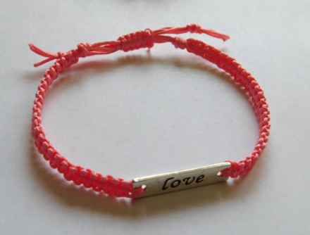
- Metal piece sizes:
Metal or durable alloy plate for engraving in size Width: 4 cm and height 1.5 cm Rectangular or custom-shaped plate
Smooth finish suitable for engraving

- Metal piece writing:
“I am a Blood Donor”
Arial font and the writing in the middle of the metal piece

- Material:
Braided cord fabric

- Design:
Adjustable sliding knot for universal fit
Red color

- Size:
One-size adjustable (fits adults and youth)
Approx. diameter of the bracelet: 12 to 15 cm
Thickness of the metal part should be 0.1mm

- Weekly Planner Notebook:

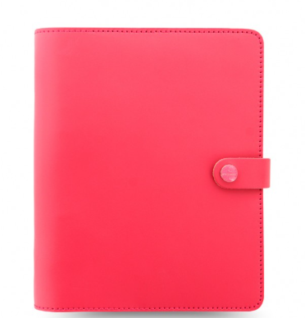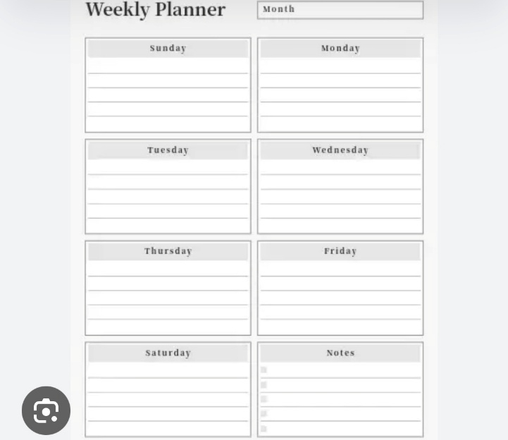

- Contents:
Notebook with weekly planner pages (as per above image with button)
52 pages planner + 3 blank pages

- Material:
Cover: recycled cardboard or kraft paper
Pages: recycled paper with days of the week
Hard cover will be 200 grm and the papers will be 100 grm

- Dimensions:
A5 size.

- Color:
Red

- Branding Requirements
Printing of LRC logo with size 3cm in the middle
Printing must be clear and durable
Placement: front cover of notebook in the middle.

Deliverables
- All promotional items in the agreed quantities, in accordance with the approved specifications.
- Pre-production samples for each item before printing for review and approval prior to mass production.
- Properly packaged items suitable for safe transport and distribution.
- Delivery of all items to the designated LRC Roumieh Warehouse.

Delivery / Execution Timeline
The Lebanese Red Cross (LRC) may require the delivery of the first order before September 2026, while the contract shall remain valid for a period of two (2) years.

