Annex 2 – Bid Form completed signed and stamped
- All bids must be typed; handwritten bids will not be considered.
- The contract will be awarded to the lowest-cost technically compliant bid per item
- Under this Framework Agreement, the quantities indicated are estimates only and may vary depending on LRC operational requirements. Purchases will be executed through the issuance of Purchase Orders on an as-needed basis during the validity period of the agreement. LRC does not guarantee the procurement of the full estimated quantities.
- The bidder is not permitted to alter the section labelled “LRC to complete” below. Bidder is not allowed to use any other template.
- In the event of any discrepancy between the unit price and the total price, LRC reserves the right to rely on the unit price as stated in the financial bid, rather than the total price without go back to the supplier. The unit price must be provided with no more than two decimal places.
Lot #1: PARTS LIST NX- 3320 and NX-320 UHF DIGITAL (Kenwood)
LRC To Complete |  |  |  | Bidder to Complete
Item # | Item/Milestone Required | Unit of Measurement (UOM) | Estimated  Quantity | Unit Price in USD  Exclusive of VAT, but inclusive of labor, bank transfer fees, and delivery fees. | VAT (%) | Unit Price in USD  Inclusive of VAT, labor fees, bank transfer fees, and delivery fees. | Total Price in USD  Inclusive of VAT, labor fees, bank transfer fees, and delivery fees. | Lead time of delivery  (in calendar days) from the date of each Purchase Order.
1 | UHF Whip Antenna, KRA-27 | Pcs | 40
2 | Li-ion Battery Pack, 7.4V/2000mAh, KNB-57L | Pcs | 25
3 | 2-Wire Palm mic with Earphone, KHS-8BL | Pcs | 20
4 | Leather Case For NX-320, KLH-179 | Pcs | 20
5 | Belt Clip For NX-320, KBH-12 | Pcs | 80
6 | Knob (PTT) For NX-320, K29-9500-03 | Pcs | 20
7 | Knob (VOL) For NX-320, K29-9485-03 | Pcs | 50
8 | Knob (Selector) For NX-320, K29-9486-03 | Pcs | 20
9 | 16 KEY FRONT CHASSIS KENWOOD A02-4132-03 NX-320 (NO KEYBOARDS) - 20D | Pcs | 80
10 | Speaker NX-320, T07-0787-05 | Pcs | 25
11 | Variable Resistor (VOL) NX-320, R31-0685-05 | Pcs | 50
12 | Rotary Switch (Selector) NX-320, S60-0448-05 | Pcs | 20
13 | Rapid Charger li-ion Only for NX-3320, KSC-25LS | Pcs | 10
14 | Multiple Charger (6-Pocket) For NX-320, KSC-256K | Pcs | 4
15 | Packing (16-Key) NX-320, G53-1865-01 | Pcs | 10
16 | Belt Clip for NX-3320, KBH-11 | Pcs | 20
17 | A0C-0179-00 Plastic Cabinet Assembly Radio Housing Case for KENWOOD NX3220/NX3320  Walkie Talkie Front Cover with Keypad Knobs, | Pcs | 20
18 | Portable Digital Radio, NX-3320E, Kenwood  The item must be complete and include the following: Belt Clip, Screw Set, Battery, rubber antenna and desktop charger | Set | 10
Lot #2: PARTS LIST NX- 3820 UHF DIGITAL Kenwood
LRC To Complete |  |  |  | Bidder to Complete
Item # | Item/Milestone Required | Unit of Measurement (UOM) | Estimated  Quantity | Unit Price in USD  Exclusive of VAT, but inclusive of labor, bank transfer fees, and delivery fees. | VAT (%) | Unit Price in USD  Inclusive of VAT, labor fees, bank transfer fees, and delivery fees. | Total Price in USD  Inclusive of VAT, labor fees, bank transfer fees, and delivery fees. | Lead time of delivery  (in calendar days) from the date of each Purchase Order.
1 | KMC-36 Keypad Microphone (IP55 With 12 keypad) | Pcs | 20
2 | KMC-66 Keypad Microphone (IP55 With 12 keypad) | Pcs | 20
3 | Internal Speaker 60 Ohm / 5W / 7W (to replace the old one), For the NX-3820 | Pcs | 15
4 | DC Power Cable (10 ft / 3 m), KCT-23 | Pcs | 20
5 | UPS 3KVA High Frequency (Online Sine Wave) | Pcs | 3
6 | DC Power Supply, KPS-16 | Pcs | 10
7 | UHF Mobile Antenna, Celwave, 7070C, Fixed (screw/bracket mount), not magnetic, Must include coaxial cable and BNC connector | Pcs | 30
8 | UHF Antenna Base 3 dB, BC-200 | Pcs | 5
9 | 8 Pin Microphone Cable Mic Cord Replacement for Kenwood KMC35/KMC36, RJ-45 | Pcs | 50
10 | Mobile Digital transceiver, UHF, Radio 25W complete include microphone and DC cable, NX-3820GE, Kenwood | Set | 10

ANNEX 3: DETAILED SPECIFICATIONS

ITEM # | ITEM / MILESTONE REQUIRED | QTY / UOM | Model # Required
Lot #1: PARTS LIST NX- 3320 and NX-320 UHF DIGITAL (Kenwood)
General Requirement:
The bidder must provide written statement confirming a One (1) year warranty for all the items proposed
1 | UHF Whip Antenna | 40 Pcs | 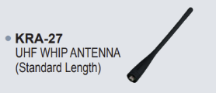  KRA-27
2 | Li-ion Battery Pack, 7.4V/2000mAh | 25 Pcs | 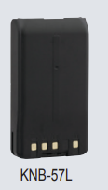  KNB-57L
3 | 2-Wire Palm mic with Earphone | 20 Pcs | 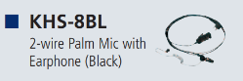  KHS-8BL
4 | Leather Case For NX-320 | 20 Pcs | 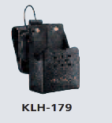  KLH-179
5 | Belt Clip For NX-320 | 80 Pcs | 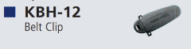  KBH-12
6 | Knob (PTT) For NX-320 | 20 Pcs | K29-9500-03
7 | Knob (VOL) For NX-320 | 50 Pcs | K29-9485-03
8 | Knob (Selector) For NX-320 | 20 Pcs | K29-9486-03
9 | 16 KEY FRONT CHASSIS KENWOOD A02-4132-03 NX-320 (NO KEYBOARDS) - 20D | 80 Pcs | 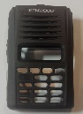  A02-4132-03
10 | Speaker NX-320 | 25 Pcs | T07-0787-05
11 | Variable Resistor (VOL) NX-320 | 50 Pcs | R31-0685-05
12 | Rotary Switch (Selector) NX-320 | 20 Pcs | S60-0448-05
13 | Rapid Charger li-ion Only for NX-3320 | 10 Pcs | 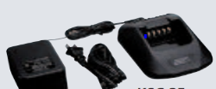  KSC-25LS
14 | Multiple Charger (6-Pocket) For NX-320 | 4 Pcs | 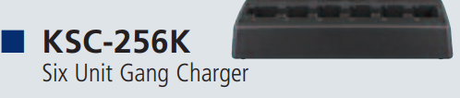  KSC-256K
15 | Packing (16-Key) NX-320 | 10 Pcs | G53-1865-01
16 | Belt Clip for NX-3320 | 20 Pcs | 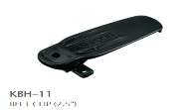  KBH-11
17 | A0C-0179-00 Plastic Cabinet Assembly Radio Housing Case for KENWOOD NX3220/NX3320  Walkie Talkie Front Cover with Keypad Knobs | 20 Pcs | 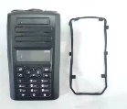  A0C-0179-00
18 | Portable Digital Radio  The item must be complete and include the following: Belt Clip, Screw Set, Battery, rubber antenna and desktop charger | 10 Pcs | NX-3320E  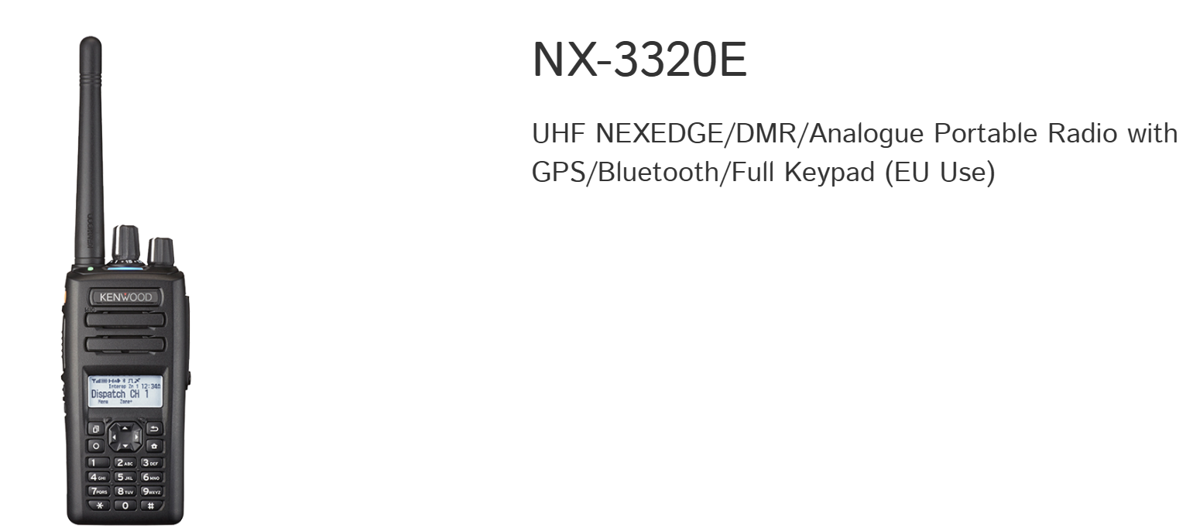
LOT 2- PARTS LIST NX- 3820 UHF DIGITAL Kenwood
1 | Keypad Microphone (IP55 With 12 keypad) | 20 Pcs | 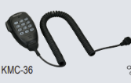  KMC-36
2 | Keypad Microphone (IP55 With 12 keypad) | 20 Pcs | 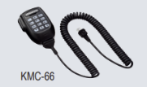  KMC-66
3 | Internal Speaker 60 Ohm / 5W / 7W (to replace the old one) | 15 Pcs | For the NX-3820
4 | DC Power Cable (10 ft / 3 m) | 20 Pcs | KCT-23 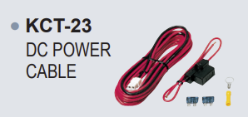
5 | UPS 3KVA High Frequency (Online Sine Wave) | 3 Pcs | Sine Wave
6 | DC Power Supply | 10 Pcs | KPS-16
7 | UHF Mobile Antenna, Celwave, 7070C, Fixed (screw/bracket mount), not magnetic, Must include coaxial cable and BNC connector | 30 Pcs | 7070C (Celwave)
8 | UHF Antenna Base 3 dB | 5 Pcs | BC-200
9 | 8 Pin Microphone Cable Mic Cord Replacement for Kenwood KMC35/KMC36 | 50 Pcs | RJ-45 Cord Replacement for Kenwood KMC35/KMC36
10 | Mobile Digital transceiver, UHF, Radio 25W complete include microphone and DC cable | 10 Pcs | 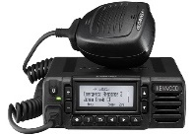  NX-3820GE

