Annex 2 – Bid Form completed signed and stamped
- All bids must be typed; handwritten bids will not be considered.
- The contract will be awarded to the lowest-cost technically compliant bid/Item
- Under this Framework Agreement, the quantities indicated are estimates only and may vary depending on LRC operational requirements. Purchases will be executed through the issuance of Purchase Orders on an as-needed basis during the validity period of the agreement. LRC does not guarantee the procurement of the full estimated quantities.
- The bidder is not permitted to alter the section labelled “LRC to complete” below. Bidder is not allowed to use any other template.
- In the event of any discrepancy between the unit price and the total price, LRC reserves the right to rely on the unit price as stated in the financial bid, rather than the total price without go back to the supplier. The unit price must be provided with no more than two decimal places.
- Unit price must include labor, packaging, transport, delivery to LRC warehouse, and all applicable bank transfer charges.
LRC To Complete |  |  |  | Bidder to Complete
Item # | Item/Milestone Required | Unit of Measurement (UOM) | Estimated  Quantity/ 2 Year | Unit Price in USD  Exclusive of VAT | VAT (%) | Unit Price in USD  Inclusive of VAT | Total Price in USD  Inclusive of VAT | Lead time of delivery  (in calendar days) from the date of each Purchase Order.
1 | CP Wheelchair CEREB.P. WHEEL 12" | Pcs | 16
2 | CP Wheelchair CEREB.P. WHEEL 14" | Pcs | 16
3 | CP Wheelchair CEREB.P. WHEEL 18" | Pcs | 16
4 | COMMODE WHEELCHAIR | Pcs | 40
5 | Quadruped CANE | Pcs | 20
6 | WALKER FOLDABLE | Pcs | 30
7 | WHEELCHAIR Foldable | Pcs | 30
8 | Diabetic shoes | Pair | 60
9 | Gypsum Plaster of Paris Powder | Kg | 7500
10 | Plaster of Paris Bandages 10cm | Roll | 5200
11 | Plaster of Paris Bandages 15 cm | Roll | 5000
12 | Plastazote White 20 mm | Sheet | 40
13 | Ankle Stirrup | Pcs | 50
14 | Rubber Sheet | Sheet | 40
15 | Tubular Super Stretch Nylon | Roll | 100
16 | Volara foam rolls | Roll | 2
17.1 | Real Genuine leather (Vachette Naturel) | ft | 128
17.2 | Real Genuine leather (Vachette Italy) | ft | 86
17.3 | Real Genuine leather (Chevere Nature) | ft | 70
17.4 | Real Genuine leather (Nappa Gris) | ft | 118
17.5 | Real Genuine leather (Nappa Caffe) | ft | 90
17.6 | Real Genuine leather (Daim Beige) | ft | 64

ANNEX 3: DETAILED SPECIFICATIONS

ITEM # | ITEM NAME | Technical Specifications | Estimated Qty/2 Years | Picture
1 | CP Wheelchair CEREB.P. WHEEL 12" | CP wheelchair for child users.  Seat width: 30 cm.  Seat depth: 28 cm.  High-back reclining frame, steel or aluminum.  Rear wheels: 12-inch solid.  Front casters: 6-inch swivel.  Weight capacity: minimum 50 kg.  Adjustable padded headrest.  Detachable padded armrests.  Elevating footrests.  Pelvic safety strap included.  Upholstery: washable, moisture-resistant.  Anti-tip stabilizers at rear.  Data sheet is mandatory to be submitted | 16 Pcs | 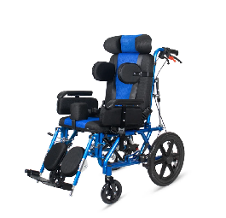
2 | CP Wheelchair CEREB.P. WHEEL 14" | CP wheelchair for youth users.  Seat width: 35 cm.  Seat depth: 33 cm.  High-back reclining frame, steel or aluminum.  Rear wheels: 14-inch solid.  Front casters: 6-inch swivel.  Weight capacity: minimum 75 kg.  Adjustable padded headrest.  Detachable padded armrests with height adjustment.  Elevating footrests.  Pelvic safety strap and lateral trunk supports included.  Upholstery: washable, moisture-resistant.  Data sheet is mandatory to be submitted | 16 Pcs
3 | CP Wheelchair CEREB.P. WHEEL 18" | CP wheelchair for adult users.  Seat width: 45 cm.  Seat depth: 42 cm.  High-back reclining frame, heavy-duty steel.  Rear wheels: 18-inch solid.  Front casters: 6-inch swivel.  Weight capacity: minimum 100 kg.  Fully adjustable padded headrest.  Detachable padded armrests with height adjustment.  Elevating footrests.  Pelvic strap, lateral trunk supports, and chest harness included.  Upholstery: washable, moisture-resistant.  Data sheet is mandatory to be submitted | 16 Pcs
4 | COMMODE WHEELCHAIR | Commode wheelchair.  Frame: steel with anti-corrosion finish.  Seat width: 45–50 cm.  Seat depth: 40–45 cm.  Overall width: maximum 65 cm.  Weight capacity: minimum 120 kg.  Removable polypropylene commode pan with lid, minimum 3-litre capacity.  Four locking swivel casters, minimum 5-inch diameter.  Detachable padded armrests.  Elevating footrests.  Upholstery: waterproof, wipeable.  Data sheet is mandatory to be submitted | 40 Pcs | 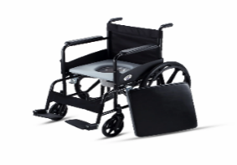
5 | Quadruped CANE | Quad cane.  Frame: lightweight aluminum.  Total weight: maximum 1.2 kg.  Height: adjustable 71–99 cm via push-button locking pin.  Weight capacity: minimum 136 kg.  Base: four rubber-tipped legs, minimum footprint 19 cm x 19 cm, non-slip.  Handle: offset ergonomic foam or rubber grip, suitable for left or right hand.  Data sheet is mandatory to be submitted | 20 Pcs | 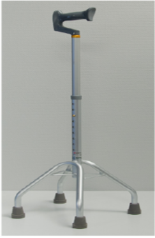
6 | WALKER FOLDABLE | Foldable walker.  Frame: aluminum.  Total weight: maximum 4 kg.  Weight capacity: minimum 136 kg.  Handle height: adjustable 81–107 cm via push-button or locking pin.  Folding: single-action center-fold or side-bar collapse.  All four feet: non-slip rubber caps.  Handles: contoured foam or rubber grip. When folded, must fit in a standard car boot.  Data sheet is mandatory to be submitted | 30 Pcs | 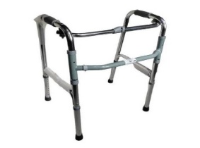
7 | WHEELCHAIR Foldable | Standard foldable manual wheelchair.  Frame: steel or aluminum, cross-brace (X-frame). Total weight: maximum 16 kg.  Seat width: 43 cm.  Seat depth: 43 cm.  Weight capacity: minimum 113 kg.  Rear wheels: 24-inch with push hand rims.  Front casters: 6-inch swivel.  Brakes: dual hand-operated on rear wheels. Footrests: swing-away, removable. Armrests: detachable.  Upholstery: durable nylon or equivalent.  Folds flat.  Data sheet is mandatory to be submitted | 30 Pcs | 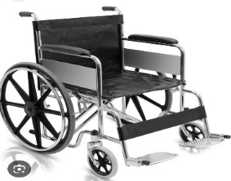
8 | Diabetic shoes | Diabetic shoe, men's and women's sizes.  Color: black.  Upper: stretchable, seamless or low-seam breathable fabric to minimize pressure points. Widths: Medium, Wide, and Extra-Wide must all be available.  Insole: removable, multi-density foam, minimum 6 mm depth, accommodates custom orthotic inserts. Supplied without custom insole.  Closure: single hook-and-loop (Velcro) strap.  Sole: flat or mild rocker, non-slip, shock-absorbing.  Data sheet is mandatory to be submitted | 60 Pair | 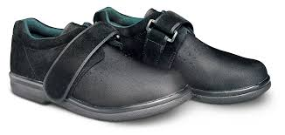
9 | Gypsum Plaster of Paris Powder | Plaster of Paris (POP) is a fine white powder primarily composed of Calcium sulfate hemihydrate powder (Plaster of Paris), minimum 95% purity. Color: white, fine powder, no lumps or foreign matter.  Setting time: initial 8–15 minutes, final maximum 30 minutes.  Packaging: 25 kg per bag, sealed polyethylene-lined bag.  Shelf life: minimum 12 months from manufacture date.  Batch number and expiry date printed on each bag.  the bidder can proposed different packing details as the total needed for 2 year is 7500 kg  Data sheet + Sample is mandatory to be submitted | 300  Bag  Or 7500 kg | 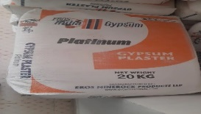
10 | Plaster of Paris Bandages 10cm | Plaster of Paris bandage.  Width: 10 cm.  Length: minimum 3 m per roll when extended. Base: cotton gauze, minimum 17 threads per cm, fully impregnated with calcium sulfate hemihydrate.  Setting time: 3–5 minutes after wetting.  Immersion: 3–10 seconds in lukewarm water. Packaging: each roll individually foil-sealed, moisture-proof. Shelf life: minimum 24 months. Batch number and expiry date on each roll.  Data sheet + Sample is mandatory to be submitted | 5200 Roll | 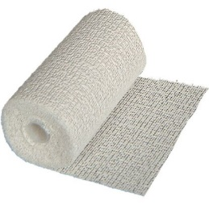
11 | Plaster of Paris Bandages 15 cm | Plaster of Paris bandage.  Width: 15 cm.  Length: minimum 3 m per roll when extended. Base: cotton gauze, minimum 17 threads per cm, fully impregnated with calcium sulfate hemihydrate.  Setting time: 3–5 minutes after wetting.  Immersion: 3–10 seconds in lukewarm water.  Packaging: each roll individually foil-sealed, moisture-proof.  Shelf life: minimum 24 months. Batch number and expiry date on each roll.  Data sheet + Sample is mandatory to be submitted | 5000 Roll
12 | Plastazote White 20 mm | Plastazote foam sheet, white, 20 mm thick. Material: closed-cell cross-linked polyethylene. Density: LD45 grade (approximately 45 kg/m³). Sheet size: 2000 mm x 1000 mm. Thickness tolerance: ±1 mm. Color: white throughout (not surface-coated).  Heat-moldable at 120–130°C. Non-toxic and waterproof.  Intended use: orthotic and insole fabrication.  Each sheet labeled with grade and batch reference.  Data sheet + Sample is mandatory to be submitted | 40 Sheet | 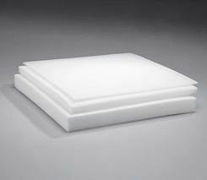
13 | Ankle Stirrup | Ankle stirrup brace.  Construction: one-piece stamped, weld-free.  Shells: rigid stainless steel or aluminum, minimum 3 mm (1/8 inch) thickness, medial and lateral.  Inner lining: padded, non-irritant.  Sizes to be supplied:  - child (tongue length minimum 55 mm)  - youth (minimum 70 mm)  - adult (minimum 175 mm).  Compatible with standard AFO leather strapping. Equivalent to Becker Orthopedic ankle stirrup or approved equal.  Data sheet is mandatory to be submitted | 50 Pcs | 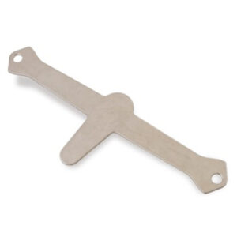
14 | Rubber Sheet | Black rubber sheet for insole production.  Material: natural rubber or high-quality SBR compound. Hardness: Shore A minimum 70.  Thickness: minimum 5 mm, supplier to state exact thickness offered.  Surface: smooth on both sides, no cracks or voids.  Sheet dimensions: minimum 500 mm x 500 mm.  Color: black throughout.  Data sheet + Sample is mandatory to be submitted | 40 Sheet | 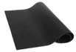
15 | Tubular Super Stretch Nylon | Tubular stretch nylon stockinette for orthotic and DAFO use.  Material: nylon or nylon-spandex knit, tubular construction.  Elasticity: minimum 150% stretch with full recovery. Wall thickness: 1–2 mm.  Color: white or natural. Latex-free, hypoallergenic. Roll length: minimum 25 m per roll.  Supplier to state diameter range available.  Data sheet + Sample is mandatory to be submitted | 100 Roll | 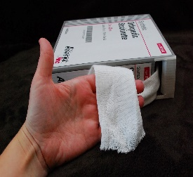  This Photo by Unknown Author is licensed under CC BY-NC-ND
16 | volara foam rolls | Volara foam roll.  Material: closed-cell irradiation cross-linked polyethylene foam.  Surface: smooth skin on both sides, fine uniform cell structure.  Roll width: minimum 600 mm.  Roll length: minimum 15 m.  Supplier to state thickness and density of product offered.  Intended use: orthotic padding and casting interface.  Data sheet + Sample is mandatory to be submitted | 2 Roll | 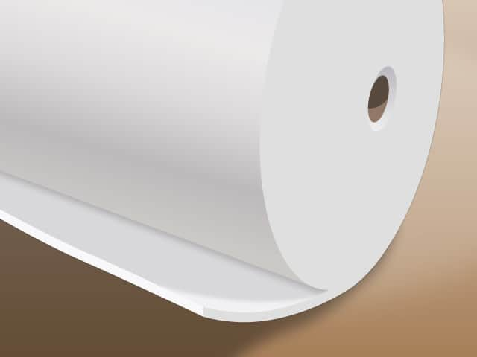
17 – Leather Materials (General Requirements)
- Material must be genuine leather (no synthetic or bonded leather accepted)
- All leather must be new, unused, and free from defects
- Free from: holes, tears, deep scars and excessive wrinkles
- Minor natural marks acceptable within industry tolerance
- Uniform color within the same batch (no patchiness or fading)
- Supplied in sheets or full sides (as applicable)
- Supplier must indicate: type of tanning (vegetable / chrome) , thickness offered , surface area per piece (ft²)
- Proper packaging to prevent: moisture and deformation
- Must be suitable for orthotic / medical use (non-toxic, skin-safe)
Sample is mandatory to be submitted for all the Leather
17.1 | Leather Vachette Naturel | Vachette Naturel leather.  Type: vegetable-tanned full-grain cowhide, natural finish.  Thickness: 1.8–2.2 mm. | 128 ft | 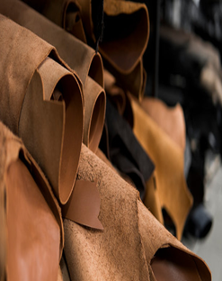
17.2 | Leather Vachette Italy | Vachette Italy leather.  Type: chrome-tanned full-grain cowhide, Italian tannery. Finish: smooth, natural or semi-aniline.  Thickness: 1.8–2.2 mm. | 86 ft
17.3 | Leather Chevere Nature | Chevere Nature leather.  Type: lightweight natural-finish leather (goatskin or fine cowhide).  Finish: smooth natural grain.  Thickness: 1.2–1.5 mm. | 70 ft
17.4 | Leather Nappa Gris | Nappa Gris leather.  Type: soft chrome-tanned nappa.  Finish: smooth full-grain or corrected grain. Thickness: 1.0–1.4 mm.  Color: uniform grey, consistent dye lot, no fading or patchiness. | 118 ft
17.5 | Leather Nappa Caffe | Nappa Caffe leather.  Type: soft chrome-tanned nappa  Finish: smooth full-grain or corrected grain. Thickness: 1.0–1.4 mm.  Color: uniform brown (café), consistent dye lot. | 90 ft
17.6 | Leather Daim Beige | Daim Beige leather.  Type: suede or nubuck finish.  Finish: uniform velvet surface, no bald patches or heavy blemishes.  Thickness: 1.0–1.3 mm.  Color: uniform beige, consistent dye lot. | 64 ft

