Annex 2 – Bid Form completed signed and stamped
- All bids must be typed; handwritten bids will not be considered.
- The contract will be awarded to the lowest-cost technically compliant bid.
- The quantities mentioned below are required unless there is a variation within a specified range with proper justification. The LRC reserves the right to increase or decrease the quantities.
- The bidder is not permitted to alter the section labelled “LRC to complete” below. Bidder is not allowed to use any other template.
- In the event of any discrepancy between the unit price and the total price, LRC reserves the right to rely on the unit price as stated in the financial bid, rather than the total price without going back to the supplier. The unit price must be provided with no more than two decimal places.
- Only one option is allowed for biding
- Sample for each item must be submitted with the bid and labelled reference to each item number
- LRC reserves the right to award the items per LOT.
LRC To Complete |  |  |  | Bidder to Complete
Item number | Item/Milestone Required | Required UOM | Estimated Qty | Unit Price in USD, Exclusive VAT rated at 11%, but inclusive Labor, packing, packaging, Bank Transfer Fees, Delivery and all other fees | VAT (%) | Unit Price in USD, inclusive VAT, Labor, packing, packaging, Bank Transfer Fees, Delivery and all other fees | Total Price in USD, inclusive VAT, Labor, packing, packaging, Bank Transfer Fees, Delivery and all other fees | Lead time of delivery for any quantity from the date of each purchase order
1.1 | First Aid Kit - Small | Piece | 3000
1.2 | First Aid Kit - Medium | Piece | 1500
1.3 | First Aid Kit - Large | Piece | 700
 | Total

ANNEX 3: DETAILED SPECIFICATIONS

Item | FA Kit Small | FA Kit Medium | FA Kit Large | U.O.M | Specs | Image
Sterilized Compress/ Gauze | 5 | 10 | 30 | Pcs | Size: approximately 2 in. × 2 in. (≈5 cm × 5 cm), acceptable range 1.8–2.2 in.  (≈4.5–5.5 cm) per side, 4-ply – may be packed in units of 2 dressings per pack | 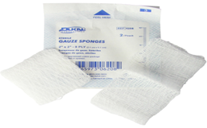
Gauze Bandage Small | 1 | 1 | 3 | Pcs | Size: approximately 4–5 cm in width,  acceptable range 3.5–5.5 cm depending on availability. | 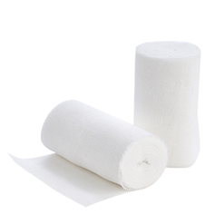
Gauze Bandage Medium | 1 | 1 | 3 | Pcs | Size: approximately 7–8 cm in width,  acceptable range 6.5–8.5 cm depending on availability. | 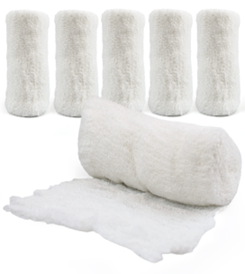
Gauze Bandage Large | - | 1 | 3 | Pcs | Size: approximately 9–10 cm in width,  acceptable range 8.5–10.5 cm depending on availability. | 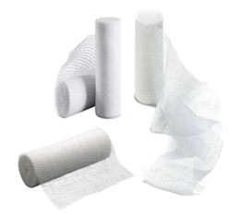
Elastic Bandage Small | - | 1 | 3 | Pcs | Size: approximately 4–5 cm in width,  acceptable range 3.5–5.5 cm depending on availability Color: brown or white. | 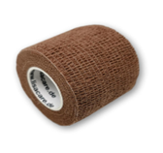
Elastic Bandage Medium | 1 | 1 | 3 | Pcs | Width: approximately 7–8 cm (acceptable range 6.5–8.5 cm depending on availability)  Color: brown or white | 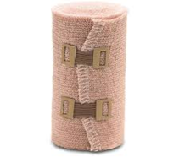
Elastic Bandage Large | - | 1 | 3 | Pcs | Width: approximately 9–10 cm (acceptable range 8.5–10.5 cm depending on availability)  Color: brown or white | 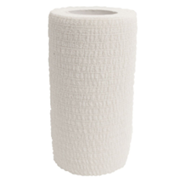
Compressive Bandage | 1 | 4 | 10 | Pcs | Elastic roll, with sterilized gauze pad, sealed | 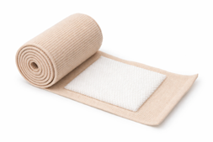
Triangular Bandage | 2 | 3 | 5 | Pcs | Shape: Triangular  Standard Dimensions: 102 cm × 102 cm × 142 cm (40 in × 40 in × 56 in)  Acceptable Size Range:  Base: 96–110 cm (39–43 in)  Sides: 96–110 cm (39–43 in)  Hypotenuse: 140–150 cm (55–59 in) | 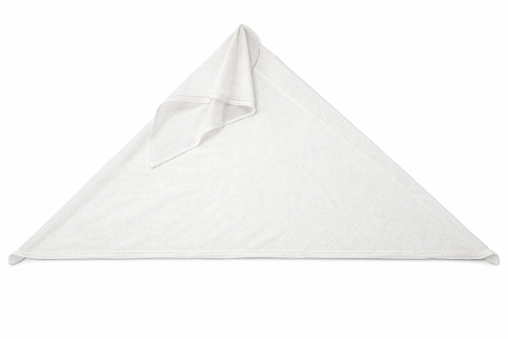
Emergency Survival Blanket | 1 | 1 | 2 | Pcs | Material: Metallized thermal foil  Properties: Waterproof and windproof  Minimum Size: 100 cm × 100 cm  Acceptable Size Range: 100–160 cm × 100–210 cm | 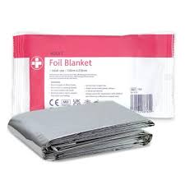
Ice Pack | - | 1 | 3 | Pcs | instant cold pack | 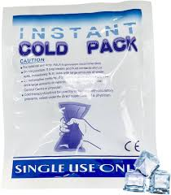
Scissors | 1 | 1 | 1 | Pcs | Metal, Size: 10-15 cm | 
Medical Tape | 1 | 1 | 2 | Pcs | Standard Size: 5 m × 2.5 cm  Acceptable Size Range:  Length: 4.5–5.5 m  Width: 2.0–3.0 cm | 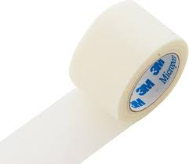
Antiseptic Wipe | 5 | 10 | 30 | Pcs | 2 ply / absorbent and saturated with chlorhexidine or povidone-iodine | 
Antiseptic Solution | - | 125ml | 250ml | bottle | chlorhexidine or povidone-iodine | 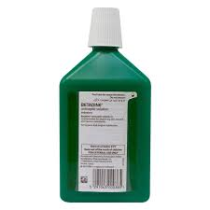
Band Aid | 10 | 30 | 50 | Pcs | Sizes Approx:  7cmx2cm  2.2cm ( round 2.2cm diameter )  7cmx5cm | 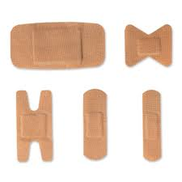
Normal Saline Solution (0.9% NaCl) | - | 500ml | 500ml | bottle | (0.9% NaCl) | 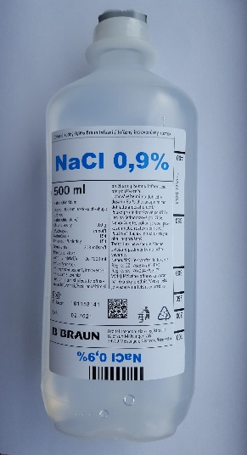
Burn Dressing | - | 3 | 3 | Pcs | Standard Size: 10 cm × 10 cm  Acceptable Size Range:  Length: 9–12 cm  Width: 9–12 cm | 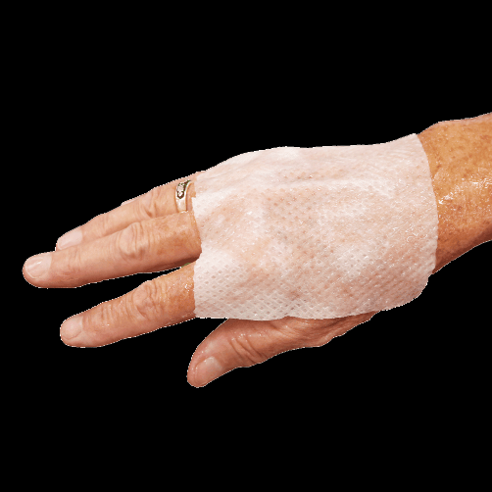
Safety Pins | 2 | 5 | 10 | Pcs | Standard Sizes: 27 mm (Size 0) or 22 mm (Size 00)  Acceptable Size Range:  Length: 20–30 mm | 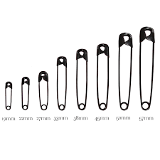
Nitrile Gloves | 4 | 4 | 12 | pair | non-sterile  size large | 
Face Mask | 3 | 10 | 10 | Pcs | 3 ply, non-woven fabric | 
Digital Thermometer | - | - | 1 | Pcs | Auto Shut-Off: Turns off after 5–10 minutes to save battery life.  Waterproof: Allows for easy cleaning and sterilization.  Switchable Units: Allows toggling between Celsius (° C) and Fahrenheit (° F).  Battery type: AAA | 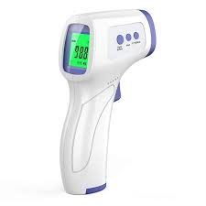
First Aid Bag small | 3000 | - | - | Pcs | First aid bag small Fabric  Approx: 22cmx16cmx8cm | 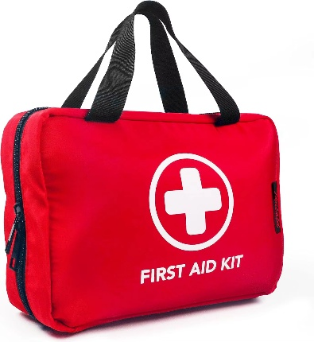
First Aid Bag medium | - | 1500 | - | Pcs | First aid bag medium fabric  Bag dimensions approximately 470x240x190mm  Note that the bags must be hand bag with a shoulder strap | 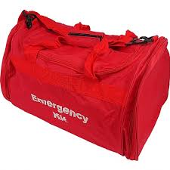
First Aid Bag large | - | - | 700 | Pcs | First aid bag large fabric  bag dimensions approximately 470x240x190mm  Note that the bags must be hand bag with a shoulder strap

