Annex 2 – Bid Form completed signed and stamped
- All bids must be typed; handwritten bids will not be considered.
- The contract will be awarded to the lowest-cost technically compliant Items/Lots
- The quantities mentioned below are required unless there is a variation within a specified range with proper justification. The LRC reserves the right to increase or decrease the quantities.
- The bidder is not permitted to alter the section labelled “LRC to complete” below. Bidder is not allowed to use any other template.
- In the event of any discrepancy between the unit price and the total price, LRC reserves the right to rely on the unit price as stated in the financial bid, rather than the total price without go back to the supplier. The unit price must be provided with no more than two decimal places.
- Only one option is allowed for biding
LOT 1: Relief Items
LRC To Complete |  |  |  | Bidder To Complete
Item number | Item/Milestone Required | Required UOM | Estimated Qty | Unit Price in USD, Exclusive VAT rated at 11%, but inclusive Labor, Bank Transfer Fees, and Delivery fees | VAT (%) | Unit Price in USD, inclusive VAT, Labor, Bank Transfer Fees, and Delivery and all other fees | Lead time of Delivery for any Quantity from the Date of the Purchase Order
1.1 | Ceramic Filter | Piece | 150
1.2 | Net- Rolls | Piece | 150
1.3 | Solar Lanterns | Piece | 150

LOT 2: CCOM HH TOOLBOX KIT
LRC To Complete |  |  |  | Bidder To Complete
Item number | Item/Milestone Required | Required UOM | Estimated Qty | Unit Price in USD, Exclusive VAT rated at 11%, but inclusive Labor, Bank Transfer Fees, and Delivery fees | VAT (%) | Unit Price in USD, inclusive VAT, Labor, Bank Transfer Fees, and Delivery and all other fees | Lead time of Delivery for any Quantity from the Date of the Purchase Order
2.1 | Wrench | Piece | 1
2.2 | Teflon | Piece | 2
2.3 | Cutter | Piece | 1
2.4 | Waterproof tape | Piece | 1
2.5 | Sandpaper | Piece | 2
2.6 | Faucet spare part | Piece | 1
2.7 | Toolbox | Piece | 1
 | Total for One Kit | Kit | 1
 | Total for 150 Kit | Kit | 150

LOT 3: Sanitation Kit
LRC To Complete |  |  |  | Bidder To Complete
Item number | Item/Milestone Required | Required UOM | Estimated Qty | Unit Price in USD, Exclusive VAT rated at 11%, but inclusive Labor, Bank Transfer Fees, and Delivery fees | VAT (%) | Unit Price in USD, inclusive VAT, Labor, Bank Transfer Fees, and Delivery and all other fees | Lead time of Delivery for any Quantity from the Date of the Purchase Order
3.1 | Wheelbarrow | Piece | 2
3.2 | Pick axe | Piece | 5
3.3 | Hoe | Piece | 5
3.4 | Shovel | Piece | 5
3.5 | Working gloves | Pair | 15
3.6 | Mason trowel | Piece | 2
3.7 | Plastic boots | Pair | 2
3.8 | Plastic gloves | Pair | 2
 | Total for One Kit | Kit | 1
 | Total for 30 Kit | Kit | 30

LOT 4: Wall vending machine (Dispenser) for sanitary pads and tokens
LRC To Complete |  |  |  | Bidder To Complete
Item number | Item/Milestone Required | Required UOM | Estimated Qty | Unit Price in USD, Exclusive VAT rated at 11%, but inclusive Labor, Bank Transfer Fees, and Delivery fees | VAT (%) | Unit Price in USD, inclusive VAT, Labor, Bank Transfer Fees, and Delivery and all other fees | Lead time of Delivery for any Quantity from the Date of the Purchase Order
4.1 | Vending machine | Piece | 10

ANNEX 3: DETAILED SPECIFICATIONS

LOT 1: Relief Items
1.1: Ceramic Filter
Detailed Specifications | Pictures | Quality Control Requirements
Free standing gravity water filter with 3 ceramic candles (cartridges) and 20 liters water containers with lid. The Ceramic filter ensures a filtration capacity of approximately 4 liters of water per hour. |  | Submit a fully assembled sample, which will be destroyed during quality control.
Water filter containers: 2 X 20 liters plastic bucketEach bucket volume = 20 litersWeight: 3.3 kg Dimension: 25*45 cmWater tap: Plastic heavy-duty tap and leak-proofIs attached to the bottom bucket and compatible with the bucket wall thickness. Middle of the tap is positioned 4.5 cm from the bottom of the lower bucket. Tap is composed of double gasket and to be installed part from inside the bucket and part from outside the bucket to prevent any leaking (attached reference photo)Color: White Recycled plastic not allowed Suitable for drinking water |  | Submit a fully assembled sample, which will be destroyed during quality control.
Water filter candles (or cartridges):For use within ALL gravity-fed water filter systems: Super Sterasyl® Type: CeramicLegacy Name: Super Sterasyl®Width (mm): 56Diameter (mm): 56Height (mm): 228Weight KG: 0.26Flow rate: 1.5 litres per hour per candle (cartridge)Working temperature range: 5 – 30 degree CelsiusFiltration rating: Sterasyl® microfilter plus granular activated carbon. 0.2-micron ceramic depth filter (Cleanable) |  | Submit a fully assembled sample, which will be destroyed during quality control.
Biodegrdable sponge:Natural cellulose non-scratch sponge Eco-friendly and 100% biodegradableDimensions: 19x10x5 cm |  | Submit a fully assembled sample, which will be destroyed during quality control.

1.2: Net Rolls
Specifications | Description | Inspection Checklist | PICTURES | Quality Control Requirements
Dimensions Width: 1m Length: 25m Material: Heavy duty plastic net resistant to water and sun | Supply and deliver heavy-duty recyclable plastic net rolls manufactured from recyclable UV-stabilized HDPE or equivalent recyclable polymer material, suitable for outdoor drainage, filtration, insect-barrier, and site-protection applications. Each roll shall be 1.00 m width × 25.00 m length, with mesh opening 5 × 5 mm ±1 mm tolerance, and strand thickness minimum 2–3 mm. The mesh shall be extruded/integrally formed (non-woven) with uniform square grid pattern and reinforced thermally bonded edges. Material shall be black color, UV-resistant, weatherproof, water-resistant, non-corrosive, and resistant to tearing and deformation. Product shall be flexible while maintaining dimensional stability during installation. Each delivered roll shall include either: 1. manufacturer technical datasheet attached to the roll/package OR 2. Certificate of manufacture/origin confirming recyclable material composition, UV stabilization, manufacturing date, and country of origin. | Inspection shall verify dimensions, mesh opening, strand thickness, edge reinforcement, packaging condition, recyclability documentation, and absence of defects or cuts. |  | Submit Full sample

1.3: Solar Lanterns

Quality Control Requirements | SUBMIT COMPLETE ORIGINAL DATASHEET – Submit full sample that will be used and tested
General information | - Time to charge: 12 hours sunlight.  - Rechargeable lithium-ion batteries only.  - Lifespan: 2 years minimum in daily use.  - Shelf life: 5 years when kept in original packaging between –10°C and 50°C. The lights are delivered with partially charged batteries; it is recommended to re-charge the batteries before use to ensure full maximum power. When stored fully charged, the batteries will hold charge for approximately 1 year, slowly discharging.
Specifications

Lamp, solar: | Rechargeable by solar panel and 220 V (cable and charger must be provided with the lamp, charger can be integrated or separate)
General quality: | Up to the highest industry standards.
Connectors: | Female USB outlet, to charge a mobile phone.  Compatible connector inlet for connecting the solar panel or the charger
Features: | At least 2 luminosity positions, high beam and low beam.  Battery charging indicator light
Lighting performance | High mode: ≥ 300 lumens  Runtime at ≥ 300 lumens: minimum 4 hours  Low mode: ≥ 75 lumens  Runtime at ≥ 75 lumens: minimum 12 hours
Light output angle: | 360 degrees, omnidirectional
Color temperature: | 5000–6500K
Material: | Casing made of shockproof plastic
Waterproof: | Rain resistant – minimum IPX4
Battery: | Lithium-ion battery  Minimum capacity 18Wh
Charge cycles: | Low Self Discharge, 500+ charges
Battery protection: | Automatic protection against deep battery discharge and overcharge
Solar panel: | - Integrated or separate (with a 3m cord with male Micro-USB/ or other compatible connector to connect to the Micro-USB inlet of the lamp or to charge a mobile phone).  - Minimum panel power: ≥ 4W
Time to fully charge: | 12h maximum bright sun light
Charging outlet (USB-A) performances: | Outlet minimum voltage with no load: 5V Outlet minimum current with load: 0.4A at 4.5V Outlet minimum available energy: 3.5Wh  Outlet minimum available energy after 4 hours charge starting from 100% discharged battery: 1Wh
Indicator and usability: | - Foldable handle, hook, strap or other mechanism to suspend the lamp e.g. from tent pole or branch.  - Charging indicator, low battery indicator
Packaging: | Wrapped in soft cardboard for protection (no plastic bags), packed in an individual strong cardboard box.

LOT 2: CCOM HH TOOLBOX KIT
ITEMS | Specifications | Description | Supporting Image | Inspection Checklist | Quality Control
Wrench | Adjustable wrench  200 mm 8" | Supply and deliver professional adjustable wrench, 200 mm / 8 inch, manufactured from drop-forged chrome vanadium steel or equivalent high-strength alloy steel, heat-treated and induction-hardened.  Maximum jaw opening shall be 24–27 mm, with precision-machined adjustable jaw operated by hardened worm gear mechanism, ensuring smooth adjustment with no backlash.  Jaws shall have anti-slip serration and hardness not less than 45–50 HRC.  Finish shall be chrome-plated, corrosion-resistant, and easy to clean.  Handle shall be ergonomic and anti-slip. | 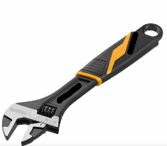 | Product shall be compliant with relevant DIN/ISO hand tool standards, and supplied free from deformation, cracks, rust, or loose moving parts. | Provide sample
Teflon | 100% PTFE  19mm * 15m * 0.2mm | Supply and deliver professional thread sealing tape made from 100% virgin PTFE, suitable for sealing threaded plumbing connections for water supply systems.  Tape dimensions shall be 19 mm width × 15 m length × 0.20 mm thickness.  Tape shall be chemically inert, non-toxic, non-flammable, water-resistant, and suitable for metal and plastic pipe threads.  Each roll shall be supplied on plastic spool with protective cover. | 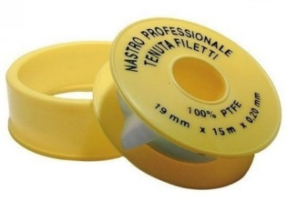 | Product shall be with packaging indicating material, dimensions, and manufacturer.  Inspection shall confirm roll length, width, thickness, packaging condition, and sealing quality. | Provide sample
Cutter | Toslen 30001  18 mm | Supply and deliver heavy-duty utility cutter with retractable 18 mm snap-off blade, manufactured with reinforced aluminum or impact-resistant ABS body.  Blade shall be high-carbon steel or stainless steel, segmented, replaceable, and securely fixed by mechanical slide-lock or auto-lock system.  Handle shall be ergonomic, anti-slip, and suitable for site use.  Cutter shall allow safe blade replacement and controlled cutting of plastic, cardboard, rubber, rope, and light construction materials. | 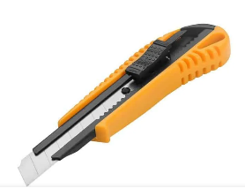 | Product shall be compliant with relevant hand-tool safety requirements.  Inspection shall confirm blade locking, body strength, blade sharpness, and safe operation. | Provide sample
Waterproof tape | High polymer butyl rubber | Supply and deliver waterproof sealing tape made from high-performance butyl rubber compound laminated with polyethylene or aluminum foil backing.  Tape shall be self-adhesive, flexible, UV-resistant, water-resistant, and suitable for sealing joints, cracks, roofs, concrete, metal, plastic, and drainage-related repairs.  Thickness shall be 1.0–1.5 mm — not meters — with width 50–100 mm, recommended 75 mm, and length 10 m per roll or approved equivalent. | 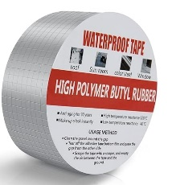 | Product shall be supplied in sealed packaging with datasheet.  Inspection shall confirm thickness, width, adhesion, backing quality, roll condition, and absence of dry or damaged adhesive | Provide sample
Sand paper | 270 SIC, P220 | Supply and deliver silicon carbide abrasive sandpaper sheets, grit size P220, suitable for fine finishing of plastic, PVC, metal, wood, painted surfaces, and wet/dry sanding applications.  Sheet dimensions shall be approximately 280 × 230 mm, with flexible moisture-resistant cloth backing and backing thickness 0.4–0.6 mm.  Abrasive grains shall be uniformly distributed with strong adhesion to backing material. Sandpaper shall be suitable for professional construction and maintenance applications. Manufacturing date of supplied material shall not exceed one year from delivery date, and supplier shall provide proof of manufacturing date upon request. | 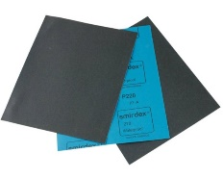 | Product shall be supplied in original manufacturer packaging indicating grit size, backing type, manufacturer, and manufacturing date. Inspection shall confirm grit classification, dimensions, backing quality, flexibility, packaging condition, and manufacturing date compliance. | Provide sample
Faucet spare part |  | Supply and deliver faucet internal spare part / valve mechanism suitable for 1/2 inch plumbing systems, manufactured entirely from solid brass material only for all metallic internal and external components.  No mixed metal materials shall be accepted. Component shall include precision-machined brass body, brass stem, brass threaded sections, and compatible rubber cover or EPDM sealing washer.  Nominal connection shall be 1/2 inch, internal stem diameter approximately 6–8 mm, and brass wall thickness minimum 2–3 mm.  External coating, if applicable, shall be chrome/nickel plated with minimum coating thickness 8–12 microns for corrosion resistance.  Component shall be suitable for operating pressure up to 10 bar and compatible with standard plumbing fixtures. | 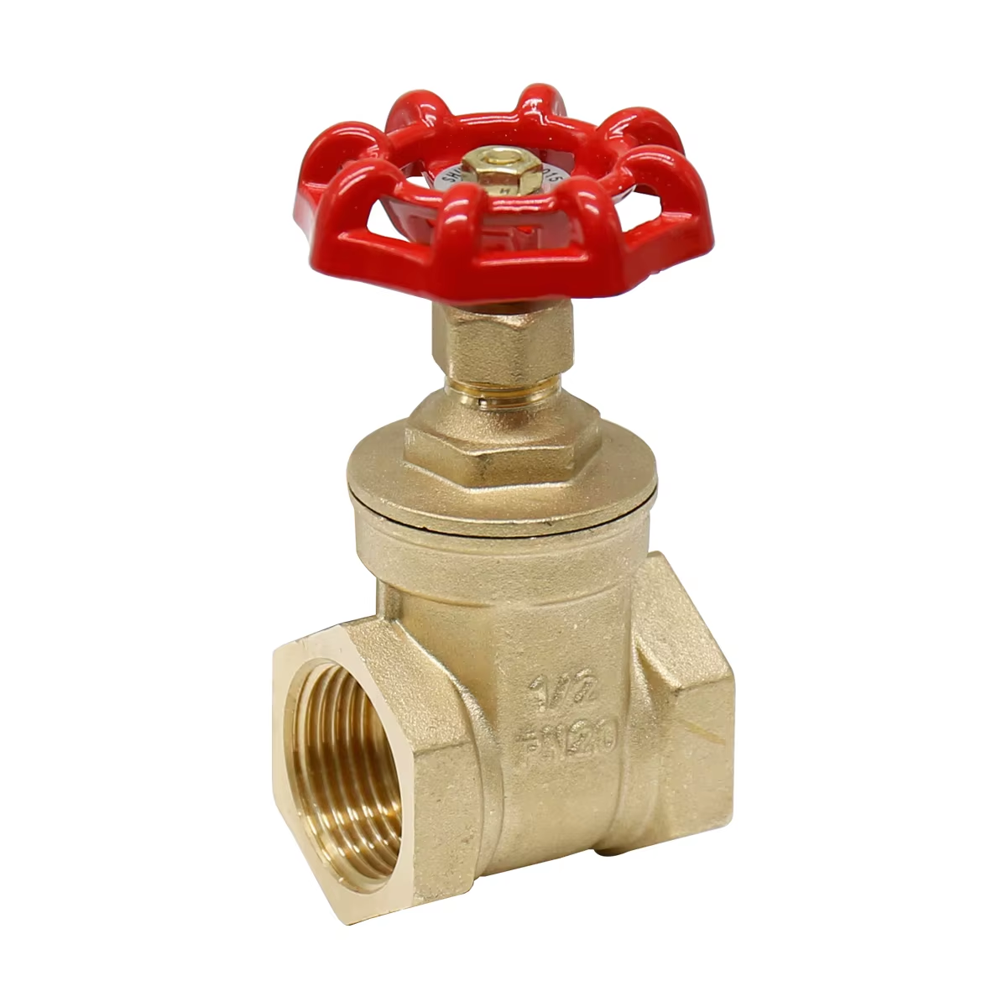  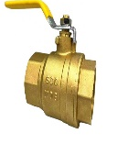 | Inspection shall confirm solid brass construction for all metallic parts, coating quality, thread accuracy, dimensions, pressure resistance, sealing performance, and absence of cracks or leakage | Provide sample
Tool box | 400mm * 200mm * 186mm | Supply and deliver heavy-duty portable steel toolbox, suitable for construction, maintenance, and site works.  Toolbox dimensions shall be approximately 400 × 200 × 180 mm or approved equivalent. Body shall be fabricated from powder-coated steel sheet with minimum thicknesses as follows: base thickness 0.8–1.0 mm, side walls and lid thickness 0.7–0.9 mm. All corners and edges shall be curved/smooth-finished to prevent injuries during handling.  Toolbox shall include reinforced steel carrying handle with anti-slip grip, heavy-duty steel hinges, and metal locking clips/latches minimum thickness 1.0–1.2 mm.  Load capacity shall be minimum 15–20 kg.  Steel surfaces shall be anti-rust treated and electrostatically powder-coated for corrosion resistance.  Toolbox shall include removable internal tray or compartment organizer where applicable. Color: red or black | 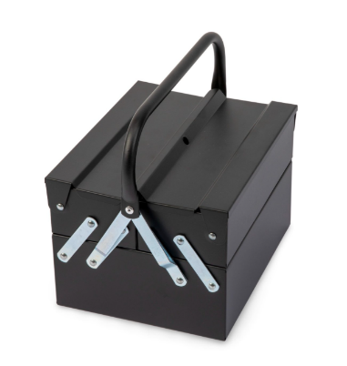 | Inspection shall confirm steel thicknesses, coating quality, handle rigidity, hinge alignment, latch operation, load resistance, smooth curved edges, and absence of sharp edges, dents, or corrosion. | Provide sample

LOT 3: SANITATION KIT
Item | Specifications | Description | Supporting image | Inspection Checklist | Quality Control
Wheelbarrow | Heavy duty wheelbarrow  Metal steel tray  Thickness > 1mm  100L capacity  Frame Ø ≥ 30mm | Supply and deliver heavy-duty wheelbarrow suitable for construction, landscaping, drainage cleaning, and general site works.  Tray shall be pressed mild steel with minimum capacity 100 L and thickness 1.2–1.5 mm, including reinforced front lip and fully curved/smooth-finished edges to eliminate sharp edges and improve handling safety.  Supporting frame shall consist of continuous welded steel pipe structure with diameter minimum 30–32 mm and wall thickness minimum 1.5 mm, with no spot welding permitted. All steel components shall be anti-rust treated and electrostatically powder-coated for corrosion resistance.  Wheel shall consist of heavy-duty pneumatic rubber tire minimum 14 inch diameter mounted on galvanized steel rim.  Rubber tire wall thickness shall be minimum 4–6 mm with inner tube thickness minimum 1.2–1.5 mm. Rubber material manufacturing date shall not exceed one year from delivery date. Supplier shall provide certificate/document confirming rubber manufacturing date. Handles shall include ergonomic anti-slip rubber grips.  Minimum load capacity shall be 100–150 kg. | 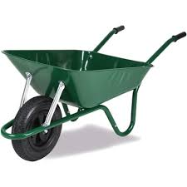 | Inspection shall verify tray thickness, frame welding continuity, curved edges, coating quality, wheel dimensions, tire manufacturing date certification, rubber condition, load stability, and absence of deformation or sharp edges. | Provide sample
Pick axe | Heavy duty metal steel pick axe  6" pick end with a 1.5" chisel blade  Wooden ± 120cm handle | Supply and deliver heavy-duty pick axe with forged high-carbon steel head, minimum weight 2.5–3.0 kg, heat-treated for hardness, strength, and impact resistance.  One side shall be pointed and the opposite side chisel-shaped, both sharpened and polished.  Handle shall be solid hardwood, ash/hickory or approved equivalent, length 90–120 cm, kiln-dried, smooth-sanded, moisture-resistant, and securely fixed through tapered eye with wedge locking system.  Steel head shall have anti-corrosion paint or lacquer coating. | 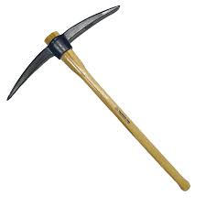 | Product shall be compliant with relevant hand-tool safety standards.  Inspection shall confirm head weight, handle fixing, straightness, coating, sharpness, and absence of cracks or looseness.. | Provide sample
Hoe | Heavy duty metal steel hoe  ±7" * 7" digging blade  Wooden ± 120cm handle | Supply and deliver heavy-duty agricultural/site hoe with forged carbon steel blade, blade size approximately 7 × 7 inch, thickness 3–5 mm, sharpened edge, and reinforced socket connection.  Handle shall be hardwood, length 120–150 cm, smooth-finished, moisture-resistant, and mechanically fixed using wedge, rivet, or approved secure connection.  All metal parts shall be anti-rust coated and suitable for repetitive soil cutting and landscaping works. | 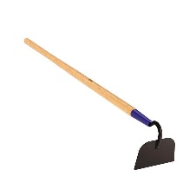 | Inspection shall confirm blade thickness, handle fixing, coating, sharpness, balance, and absence of deformation. | Provide sample
Shovel | Digging in hard soil shovel  Metal ± 22cm * ±30cm blade  Wooden ± 120cm handle | 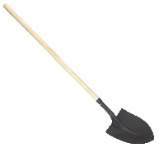  Supply and deliver heavy-duty digging shovel suitable for hard soil and construction works. Blade shall be pressed and hardened carbon steel, approximately 220 × 300 mm, thickness 1.5–2.0 mm, with reinforced curvature and steel collar/socket.  Handle shall be hardwood or fiberglass-reinforced core, length 100–120 cm, fixed by rivet or bolt connection.  Top grip shall be D-handle made of reinforced plastic or steel, ergonomic and securely fixed. All steel parts shall be powder-coated or painted for corrosion resistance. |  | Inspection shall confirm blade thickness, handle strength, D-grip fixing, coating quality, and safe edges. | Provide sample
Working gloves | Cut resistant  Tear resistant  Puncture resistant | Supply and deliver reusable heavy-duty working gloves manufactured from blended fabric composed mainly of cotton (minimum 70–80%) with small percentage polyester fibers (approximately 20–30%) to improve flexibility, dimensional stability, and durability, in accordance with common international PPE textile specifications.  Palm and fingers shall be nitrile-coated for abrasion resistance and anti-slip performance. Fabric thickness shall be 0.8–1.2 mm, nitrile coating thickness 0.5–0.8 mm, and total combined glove thickness approximately 1.5–2.2 mm.  Total glove length shall be 240–260 mm from cuff to fingertip.  Gloves shall be tear-resistant, puncture-resistant, breathable on upper side, and fitted with elastic wrist cuff. Double stitching shall be provided at high-stress areas.  Sizes: Standard (M/L), flexible fit. | 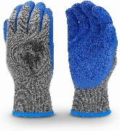 | Product shall be compliant with EN 388 or equivalent PPE standards.  Inspection shall verify fabric composition, nitrile coating quality, stitching, thickness, flexibility, sizing, and packaging condition. | Provide sample
Mason trowel | Masonry, pointing type  200mm blade | Supply and deliver professional mason/pointing trowel suitable for masonry, plastering, mortar application, and repair works.  Blade length shall be 200 mm, manufactured from hardened and tempered carbon steel or stainless steel with minimum blade thickness 1.0–1.2 mm.  Total trowel length including handle shall be approximately 300–330 mm.  Blade shall have polished finish with tapered pointing shape and securely welded or riveted shank connection.  Handle shall be ergonomic wood, rubber, or composite grip suitable for repetitive professional use and securely fixed to the shank without movement. | 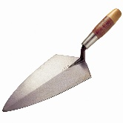 | Product shall be compliant with professional hand-tool quality standards.  Inspection shall confirm blade length, total length, blade thickness, handle fixing, straightness, polished finish, and absence of cracks, rust, deformation, or unsafe sharp edges. | Provide sample
Plastic boots | Liquid resistant plastic boots  Size 42 - 44 | 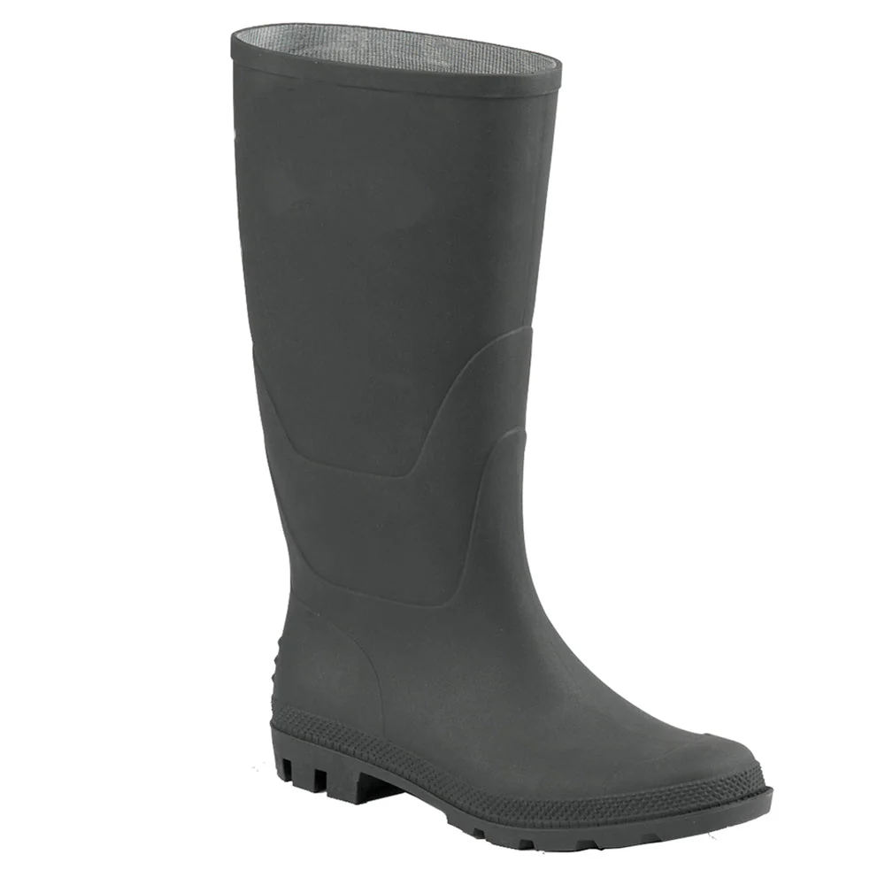  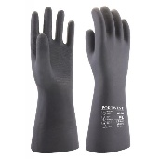  Supply and deliver waterproof safety boots manufactured from PVC or rubber compound with seamless molded construction suitable for wet, muddy, drainage, and cleaning works. Boots shall include anti-slip deep tread sole, shock-absorbing heel, and liquid-resistant upper body.  Internal lining fabric shall be composed mainly of cotton (minimum 70–80%) with small percentage polyester fibers (approximately 20–30%) for comfort, moisture absorption, durability, and faster drying, based on international PPE footwear textile standards. Height shall be minimum 30–35 cm, sizes 42–44, color green or black.  Optional steel toe cap may be included where required |  | Product shall be compliant with EN ISO 20347 or equivalent PPE standards.  Inspection shall confirm size, fabric lining composition, waterproofing, sole grip quality, flexibility, seams, and absence of cracks or deformation.Inspection shall confirm size, fabric lining composition, waterproofing, sole grip quality, flexibility, seams, and absence of cracks or deformation. | Provide sample
Plastic gloves | Liquid resistant gloves  Used to collect solid waste in drainage channels | Supply and deliver heavy-duty liquid-resistant protective gloves suitable for drainage-channel cleaning, sanitation works, waste collection, hygiene operations, and light-to-medium duty site protection.  Gloves shall be manufactured from high-quality nitrile rubber, powder-free and ambidextrous, providing high resistance against liquids, detergents, contamination, and puncture during sanitation activities.  Nitrile thickness shall be 0.08–0.12 mm with minimum total glove length of 240 mm and extended cuff preferred for additional wrist protection.  Gloves shall be flexible, tear-resistant, textured for improved grip in wet conditions, and suitable for prolonged professional outdoor and hygiene use.  Gloves shall be supplied in sealed manufacturer boxes containing 100 pieces. |  | Product shall be compliant with applicable PPE and hygiene standards including EN 374, EN 420, EN ISO 21420.  Inspection shall confirm material type, thickness, glove length, packaging integrity, powder-free condition, flexibility, and absence of tears, perforations, or manufacturing defects. | Provide sample

LOT 4: Wall vending machine (Dispenser) for sanitary pads and tokens

Quality Control Requirements |  | SUBMIT COMPLETE ORIGINAL DATASHEET
Detailed Specifications (Vending Machine)
Type | Wall mounted vending machine for Sanitary pad.
Color | White
Material | Metal (powder coated)
Storage Capacity | Minimum capacity 64 pcs – Maximum capacity 100 pcs
Type of items (rows) | 4 items
Capacity per row | Minimum capacity 16 pcs – Maximum capacity 25 pcs
Type of operation | Mechanical
Dimension | 520 mm * 725 mm * 125 mm, Customized.
Payment system | Token
Warranty | Minimum One Year
After sales services | Online support, video technical support

Detailed Specifications (Token)
Type | Tokens for the vending machine
Color | Light grey / White
Material | Hard Plastic or Metal (coated)
Number of items | 1000 token
Type of items (rows) | Standards, Fits with the with mode of payment (vending machine)
Capacity per row | One token per item
Type of operation | Mechanical
Dimension | Fits with the vending machine diameter
Warranty | Minimum One Year
After sales services | Online support, video technical support

Photos of similar products
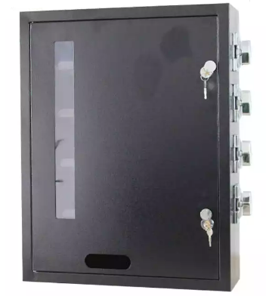 | 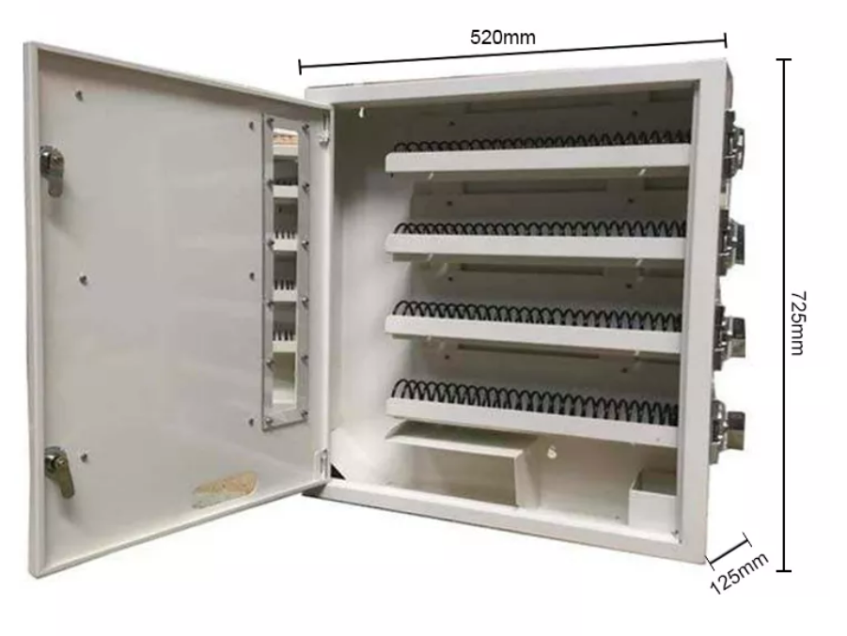
Video of similar products: https://www.alibaba.com/product-detail/Coin-operated-Small-vending-machine-condom_1600334668437.html?spm=a2700.7724857.0.0.3ded7696k3iINn

