Annex 2 – Bid Form completed signed and stamped
- All bids must be typed; handwritten bids will not be considered.
- The contract will be awarded to the lowest-cost technically compliant bid
- Under this Framework Agreement, the quantities indicated are estimates only and may vary depending on LRC operational requirements. Purchases will be executed through the issuance of Purchase Orders on an as-needed basis during the validity period of the agreement. LRC does not guarantee the procurement of the full estimated quantities.
- In the event of any discrepancy between the unit price and the total price, LRC shall rely on the unit price without requesting clarification from the bidder. The unit price must be provided with no more than two decimal places.
- The quoted unit prices shall include all costs related to manufacturing, labor, packaging, transportation, unloading, delivery to the designated LRC warehouse, customs duties (if applicable), and all bank transfer charges.
- The bidder is allowed to propose only one option for each item.
Lot #1: Pallet
LRC To Complete  The bidder is not permitted to alter the section labelled “LRC to complete” below. Bidder is not allowed to use any other template. |  |  |  | Bidder to Complete
Item # | Item/Milestone Required | Unit of Measurement (UOM) | Estimated  QTY/ 2 Years | Unit Price in USD  Exclusive of VAT | VAT (%) | Unit Price in USD  Inclusive of VAT | Total Price in USD  Inclusive of VAT | Lead time of delivery  (in calendar days) from the date of each Purchase Order.
1 | EU Wooden Pallet | Pcs | 1500
2 | US Wooden Pallet | Pcs | 600
3 | EU Plastic Pallet | Pcs | 1000
4 | EU Plastic Pallet, Open Deck | Pcs | 600
5 | US Plastic Pallet | Pcs | 1000
6 | US Plastic Pallet, Open Deck | Pcs | 600
7 | Plastic Pallet Container with Lid  Size:120x80x80 | Pcs | 150
8 | Plastic Pallet Container with Lid  Size:120x100x80 | Pcs | 150

Lot #2: Wrapping Rolls
LRC To Complete  The bidder is not permitted to alter the section labelled “LRC to complete” below. Bidder is not allowed to use any other template. |  |  |  | Bidder to Complete
Item # | Item/Milestone Required | Unit of Measurement (UOM) | Estimated  QTY/ 2 Years | Unit Price in USD  Exclusive of VAT | VAT (%) | Unit Price in USD  Inclusive of VAT | Total Price in USD  Inclusive of VAT | Lead time of delivery  (in calendar days) from the date of each Purchase Order.
1 | Nylon Roll for Wrapping Machine | Roll | 1000
2 | Nylon Roll for Wrapping Machine Pre-Stretch | Roll | 100
3 | Nylon Roll for Manual Wrapping | Roll | 1500
4 | Bubble Wrap Roll | Roll | 500

Lot #3: Carton Boxes
LRC To Complete  The bidder is not permitted to alter the section labelled “LRC to complete” below. Bidder is not allowed to use any other template. |  |  |  | Bidder to Complete
Item # | Item/Milestone Required | Unit of Measurement (UOM) | Estimated  QTY/ 2 Years | Unit Price in USD  Exclusive of VAT | VAT (%) | Unit Price in USD  Inclusive of VAT | Total Price in USD  Inclusive of VAT | Lead time of delivery  (in calendar days) from the date of each Purchase Order.
1 | Carton Box – 32 × 26 × 31 cm | Piece | 1500
2 | Carton Box – 40 × 40 × 20 cm | Piece | 1500
3 | Carton Box – 40 × 40 × 40 cm | Piece | 1500
4 | Carton Box – 60 × 40 × 40 cm | Piece | 1500
5 | Carton Box – 80 × 60 × 40 cm | Piece | 1500
6 | Carton Box – 80 × 60 × 60 cm | Piece | 1500
7 | Corrugated Kraft Carton Box (C-Flute, 460 gsm ±5%) – 49 × 29.2 × 25 cm | Piece | 500
8 | Corrugated Kraft Carton Box (C-Flute, 460 gsm ±5%) – 25 × 15 × 12.5 cm | Piece | 500
9 | Carton Box with Separate Top and Bottom Covers – 120 × 80 × 80 cm | Piece | 500

Lot #4: Packaging Accessories
LRC To Complete  The bidder is not permitted to alter the section labelled “LRC to complete” below. Bidder is not allowed to use any other template. |  |  |  | Bidder to Complete
Item # | Item/Milestone Required | Unit of Measurement (UOM) | Estimated  QTY/ 2 Years | Unit Price in USD  Exclusive of VAT | VAT (%) | Unit Price in USD  Inclusive of VAT | Total Price in USD  Inclusive of VAT | Lead time of delivery  (in calendar days) from the date of each Purchase Order.
1 | Nylon Bags | Piece | 10000
2 | Paper Bag | Piece | 5000
3 | Solid Cardboard Edge Protector | Piece | 5000
4 | Cardboard Sheets  Size (L*W) 120*80 cm | Piece | 5000
5 | Cardboard Sheets  Size (L*W) 120*100 cm | Piece | 2500
6 | Plastic Sheet Size (L*W) 120*80 cm | Piece | 1000
7 | Plastic Sheet Size (L*W) 120*100 cm | Piece | 1000
8 | Adhesive Packaging Tape | Piece | 5000

Lot #5: Strapping Accessories
LRC To Complete  The bidder is not permitted to alter the section labelled “LRC to complete” below. Bidder is not allowed to use any other template. |  |  |  | Bidder to Complete
Item # | Item/Milestone Required | Unit of Measurement (UOM) | Estimated  QTY/ 2 Years | Unit Price in USD  Exclusive of VAT | VAT (%) | Unit Price in USD  Inclusive of VAT | Total Price in USD  Inclusive of VAT | Lead time of delivery  (in calendar days) from the date of each Purchase Order.
1 | Heavy load Strapping Roll PET | meter | 1,000,000
2 | Light Load Strapping Rolls PP | meter | 1,000,000
3 | Strapping Rolls PP | meter | 100,000
4 | Metal Clips for Strapping | Piece | 10000
5 | Zip Ties Size: 4.8 x 350 mm | Piece | 10000
6 | Zip Ties Size: 7.6 x 450 mm | Piece | 10000
7 | Strapping Roll Dispenser | Piece | 15

Lot #6: Angle Grinder Accessories
LRC To Complete  The bidder is not permitted to alter the section labelled “LRC to complete” below. Bidder is not allowed to use any other template. |  |  |  | Bidder to Complete
Item # | Item/Milestone Required | Unit of Measurement (UOM) | Estimated  Quantity  / 2 Years | Unit Price in USD  Exclusive of VAT | VAT (%) | Unit Price in USD  Inclusive of VAT | Total Price in USD  Inclusive of VAT | Lead time of delivery  (in calendar days) from the date of each Purchase Order.
1 | Thin Cutting Disc | Piece | 200
2 | Grinding Disc | Piece | 200
3 | Sanding Disc | Piece | 200
4 | Diamond Cutting Disc | Piece | 200

Lot #7: Warehouse Equipment
LRC To Complete  The bidder is not permitted to alter the section labelled “LRC to complete” below. Bidder is not allowed to use any other template. |  |  |  | Bidder to Complete
Item # | Item/Milestone Required | Unit of Measurement (UOM) | Estimated  Quantity  / 2 Years | Unit Price in USD  Exclusive of VAT | VAT (%) | Unit Price in USD  Inclusive of VAT | Total Price in USD  Inclusive of VAT | Lead time of delivery  (in calendar days) from the date of each Purchase Order.
1 | Hand Pallet Truck | Piece | 40
2 | Electric Pedestrian Pallet Truck | Piece | 2
3 | Electric Pedestrian Stacker | Piece | 5
4 | Electric Counterbalance Trucks 3 Wheels | Piece | 2
5 | Electric Counterbalance Trucks 4 Wheels | Piece | 1
6 | Counterbalance Diesel 2T | Piece | 5
7 | Counterbalance Diesel 3.5 T | Piece | 1
8 | Wrapping Machine | Piece | 6
9 | Electric Strapping Machine | Piece | 25
10 | Manual Strapping Machine | Piece | 30
11 | Compact Professional High-Pressure Cleaner | Piece | 10
12 | Industrial Professional High-Pressure Cleaner | Piece | 10
13 | Single Disk Scrubbing Machine | Piece | 5
14 | Vacuum Cleaner | Piece | 5
15 | Mechanical Sweeper | Piece | 5
16 | Mobile Ladder | Piece | 15
17 | Retractable Ladder | Piece | 20
18 | Tool Kit | Piece | 25
19 | Cordless Angle Grinder | Piece | 25
20 | Cordless Screwdriver | Piece | 25
21 | Packaging Tape Dispenser | Piece | 100
22 | Cordless Blower | Piece | 20

ANNEX 3: DETAILED SPECIFICATIONS
ITEM # | ITEM NAME | Technical Specifications | Picture | QTY / UOM
Lot #1: Pallet
Submission of 1 physical sample + Data sheet for each item is mandatory
1 | EU Wooden Pallet | Size:120x80x15  Load Capacity: 2000 kg  Rackable | 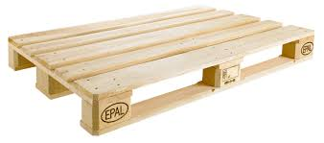 | 1500
2 | US Wooden Pallet | Size:100x120x15  Load Capacity: 2000 kg  Rackable | 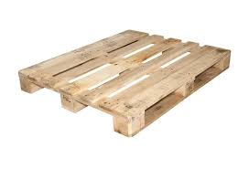 | 600
3 | EU Plastic Pallet | Size:120x80x15  Load Capacity: 2000 kg  Rackable | 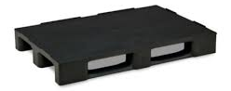 | 1000
4 | EU Plastic Pallet  Open Deck | Size:120x80x15  Load Capacity: 2000 kg  Rackable | 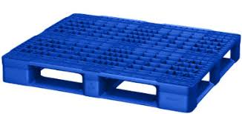 | 600
5 | US Plastic Pallet | Size:100x120x15  Load Capacity: 2000 kg  Rackable | 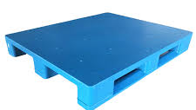 | 1000
6 | US Plastic Pallet  Open Deck | Size:100x120x15  Load Capacity: 2000 kg  Rackable | 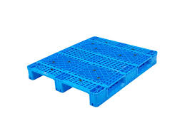 | 600
7 | Plastic Pallet Container with Lid  Size:120x80x80 | Size:120x80x80  Load Capacity: 2000 kg  Rackable | 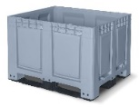 | 150
8 | Plastic Pallet Container with Lid  Size:120x100x80 | Size:120x100x80  Load Capacity: 2000 kg  Rackable | 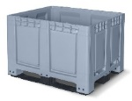 | 150
Lot #2 : Wrapping Roll
Submission of 1 physical sample + Data sheet for each item is mandatory
1 | Nylon Roll for Wrapping Machine | Height: 50 cm  Weight: 16 kg  Durable  Thickness: 35 Microns  Color: White, Black, Transparent | 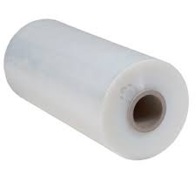 | 1000
2 | Nylon Roll for Wrapping Machine Pre-Stretch | Height: 50 cm  Weight: 16 kg  Pre-Stretch 250%  Durable  Thickness: 35 Microns  Color: White, Black, Transparent | 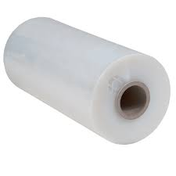 | 100
3 | Nylon Roll for Manual Wrapping | Height: 50 cm  Weight: 3 kg  Durable  Thickness: 35 Microns  Color: White, Black, Transparent | 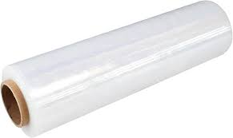 | 1500
4 | Bubble Wrap Roll | Height: 50 cm  Length: 100 m  Bubble Size: 4 mm  Durable  Thickness: 35 Microns  Color: White, Black, Transparent | 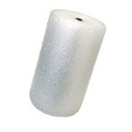 | 500
Lot #3: Carton Boxes
Submission of 1 physical sample + Data sheet for each item is mandatory
Needed Qualifications for all of the items in Lot 3
Durable, 5 Layers, Color: White, Brown, 5 Layers and reinforced corners
1 | Carton Box – 32 × 26 × 31 cm | Size(L*W*H): 32*26*31 cm | 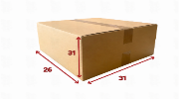 | 1500
2 | Carton Box – 40 × 40 × 20 cm | Size(L*W*H): 40 *40 *20 cm | 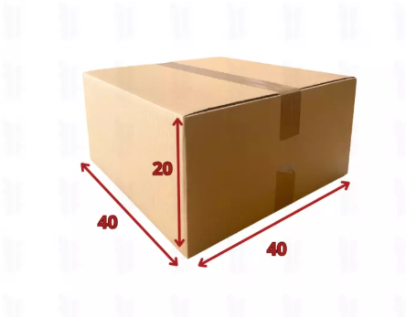 | 1500
3 | Carton Box – 40 × 40 × 40 cm | Size(L*W*H): 40 *40 *40 cm | 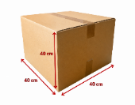 | 1500
4 | Carton Box – 60 × 40 × 40 cm | Size(L*W*H): 60 *40 *40 cm | 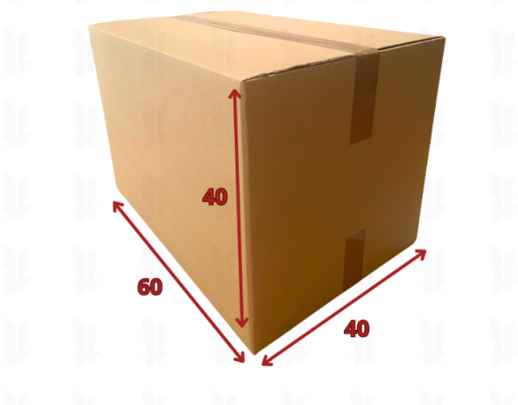 | 1500
5 | Carton Box – 80 × 60 × 40 cm | Size(L*W*H): 80 *60 *40 cm | 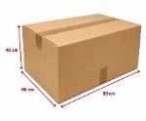 | 1500
6 | Carton Box – 80 × 60 × 60 cm | Size(L*W*H): 80 *60 *60 cm | 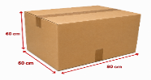 | 1500
7 | Corrugated Kraft Carton Box (C-Flute, 460 gsm ±5%) – 49 × 29.2 × 25 cm | Flute corrugated board composed of Kraft  outside liner then fluting medium and inside liner Kraft.  Size(L*W*H): 49*29.2*25 cm  Made from 460 gsm +/-5% C | 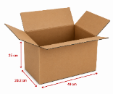 | 500
8 | Corrugated Kraft Carton Box (C-Flute, 460 gsm ±5%) – 25 × 15 × 12.5 cm | Flute corrugated board composed of Kraft  outside liner then fluting medium and inside liner Kraft.  Size(L*W*H): 25*15*12.5 cm  Made from 460 gsm +/-5% C | 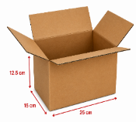 | 500
9 | Carton Box with Separate Top and Bottom Covers – 120 × 80 × 80 cm | Size(L*W*H): 120*80*80 cm  With Separate Top and Bottom Covers | 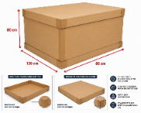 | 500
Lot #4: Packaging Accessories
Submission of 1 physical sample + Data sheet for each item is mandatory
1 | Nylon Bags | Size (L*W*H) 45*45*15 cm  Thickness: 60 Microns  Capacity: 15 kg | 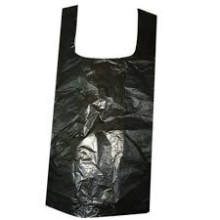 | 10000
2 | Paper Bag | Size (L*W*H) 33*32*20 cm  Capacity: 10-15 kg | 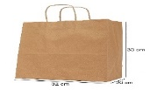 | 5000
3 | Solid Cardboard Edge Protector | Length: 150 cm  Width of legs (L-shape): 3 cm x 3 cm  Thickness: 5mm | 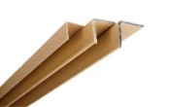 | 5000
4 | Cardboard Sheets  Size (L*W) 120*80 cm | Size (L*W) 120*80 cm  Thickness: 6mm  Material: Corrugated Cardboard | 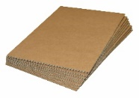 | 5000
5 | Cardboard Sheets  Size (L*W) 120*100 cm | Size (L*W) 120*100 cm  Thickness: 6mm  Material: Corrugated Cardboard | 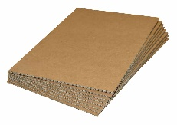 | 2500
6 | Plastic Sheet Size (L*W) 120*80 cm | Size (L*W) 120*80 cm  Thickness: 6mm  Material: Corrugated Plastic | 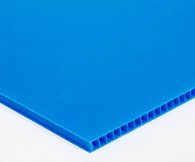 | 1000
7 | Plastic Sheet Size (L*W) 120*100 cm | Size (L*W) 120*100 cm  Thickness: 6mm  Material: Corrugated Plastic |  | 1000
8 | Adhesive Packaging Tape | Width: 48 mm  Length: 50 m  Thickness: 40–45 microns  Adhesive Type: Acrylic / Hot Melt  Color: Transparent | 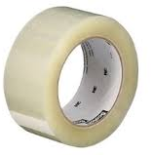 | 5000
Lot #5: Strapping Accessories
Submission of 1 physical sample + Data sheet for each item is mandatory
1 | Heavy load Strapping Roll PET | Width: 12 mm, Thickness: 0.6 mm, Length: 2000 m, Weight: 20 kg, Heavy Loads | 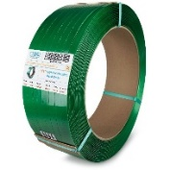 | 1,000,000 m
2 | Light Load Strapping Rolls PP | Width: 12 mm, Thickness: 0.6 mm, Length: 2000 m, Weight: 20 kg, Light Loads | 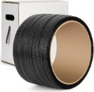 | 1,000,000 m
3 | Strapping Rolls PP | Width: 6 mm, Thickness: 0.6 mm, Length: 2000 m, Weight: 20 kg, Light Boxes | 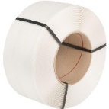 | 100,000 m
4 | Metal Clips for Strapping | Galvanized Metal  12 mm Strap | 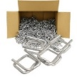 | 10000
5 | Zip Ties Size: 4.8 x 350 mm | Size: 4.8 x 350 mm |  | 10000
6 | Zip Ties Size: 7.6 x 450 mm | Size: 7.6 x 450 mm |  | 10000
7 | Strapping Roll Dispenser | Heavy-duty powder-coated steel construction  Integrated storage tray for tools and accessories  Two solid rubber wheels for easy mobility  Compatible strap width: 12 mm  Roll capacity: up to 25–30 kg  Corrosion-resistant steel frame  Built-in strap guide/brake system | 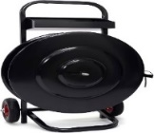 | 15
Lot #6: Angle Grinder Accessories
Submission of 1 physical sample + Data sheet for each item is mandatory
General Requirement
- Durable
- Made in EU, USA or Japan
1 | Thin Cutting Disc | Disc Diameter: 115 mm (4.5")  Bore Size: 22.23 mm  Thickness: 1.0–1.6 mm  Material Compatibility: Steel - Stainless steel - Sheet metal  Abrasive Material: Aluminum oxide  Reinforcement: Fiberglass reinforced | 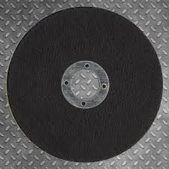 | 200
2 | Grinding Disc | Disc Diameter: 115 mm (4.5")  Thickness: 6 mm  Material Compatibility: Mild steel - Structural steel - Weld seams  Abrasive Material: Aluminum oxide | 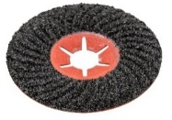 | 200
3 | Sanding Disc | Disc Diameter: 115 mm (4.5")  Sizes: 40 grit - 60 grit - 80 grit - 120 grit  Backing Material: Fiberglass backing plate  Abrasive Material: Zirconia alumina | 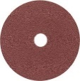 | 200
4 | Diamond Cutting Disc | Disc Diameter: 115 mm  Bore Size: 22.23 mm  Segment Type: Segmented rim  Application: Concrete – Brick – Masonry – Stone – Tile | 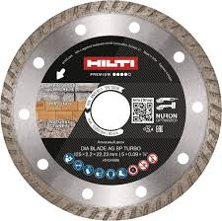 | 200
Lot #7: Warehouse Equipment
Submission of Data sheet for each item is mandatory. Failure to comply will result in disqualification.
Needed Qualifications for all the items
Durable, Parts Availability, Made in USA, Japan, or EU, 1 Year Warranty.
1 | Hand Pallet Truck | Technical Feature  Travel Distance: Short  Max Capacity: 2000 kg  Steering Wheel Material Solid Rubber  Lift: 130 mm  Safety Features  Neutral: Yes | 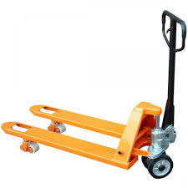 | 40
2 | Electric Pedestrian Pallet Truck | Technical Feature  Engine Electric  Max Capacity 1200 – 1600 kg  Battery Lead Acid  Mode Electric  Speed Adjustable  Lift 130 mm  Safety Features  Horns Yes  Emergency Stop Button Yes | 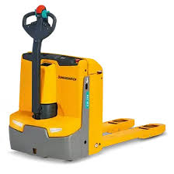 | 2
3 | Electric Pedestrian Stacker | Technical Feature  Engine Electric  Max Lift Height 4300 mm  Max Capacity 1200 kg  Mast Type Three Stage Free Lift  Mode Electric  Battery Led Acid  Safety Features  Autobrake Yes  Emergency Stop Button Yes  Horn Yes  Load Backrest Yes  Speed Reduction & High Elevation Sensor Yes | 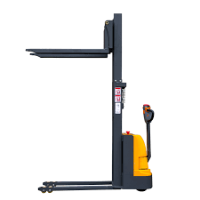 | 5
4 | Electric Counterbalance Trucks 3 Wheels | Technical Feature  Engine Electric  Wheels 3  Max Lift Height 5000 mm  Max Capacity 1500 kg  Type Double Motor  Mast Type Three Stage Free Lift  Battery Lead Acid  Controls Levers  Side Shifter Hydraulic  Safety Features  Seatbelt Yes  Overhead Guard Yes  Horns and Lights Yes  Load Backrest Yes  Emergency Stop Button Yes  Operator Presence Detection Yes  Anti-Rollback System Yes | 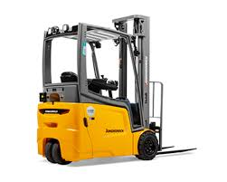 | 2
5 | Electric Counterbalance Trucks 4 Wheels | Technical Feature  Engine Electric  Wheels 4  Max Lift Height 5000 mm  Max Capacity 2000 kg  Type Double Motor  Battery Lead Acid  Mast Type Three Stage Free Lift  Controls Levers  Side Shifter Hydraulic  Safety Features  Seatbelt Yes  Overhead Guard Yes  Horns and Lights Yes  Load Backrest Yes  Emergency Stop Button Yes  Operator Presence Detection Yes  Anti-Rollback System Yes | 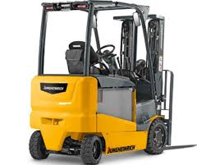 | 1
6 | Counterbalance Diesel 2T | Technical Feature  Engine Diesel  Max Lift Height 5000 mm  Max Capacity 2000 kg  Mast Type Three Stage Free Lift  Controls Levers  Transmission Type Power Shift  Tank Capacity 50 L  Side Shifter Hydraulic  Safety Features  Brakes Hydraulic  Must Include: Seatbelt, Overhead Guard, Horns and Lights, Load Backrest and Emergency Stop Button | 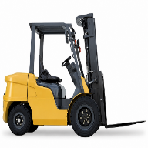 | 5
7 | Counterbalance Diesel 3.5 T | Technical Feature  Engine Diesel  Max lift height 4500mm  Max capacity 3500kg  Controls Levers  Transmission Type Power Shift  Lift Type Three Stage Free Lift  Tank Capacity 50 L  Side Shifter Hydraulic  Brakes Hydraulic  Safety Features  Wheels Double Rim  Seatbelt , Overhead Guard, Horns and Lights, Load Backrest and Emergency stop button | 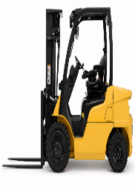 | 1
8 | Wrapping Machine | Technical Features  Turntable Diameter 1650 mm  Turntable Speed Adjustable up to 12 RPM  Turntable Weight Capacity 2000 kg  Turntable Height Low-profile, approx. 75 mm  Automatic Turntable Stop Positioning Yes  Turntable Ramp Pallet Jack Loading  Film Roll Width 500 mm  Film Thickness Compatibility 15–35 microns  Auto Film Cut Yes  Max Pallet Height Adjustable up to 2400 mm  Load Height Sensor Automatic Photo-Eye Sensor  Control Options Digital Programmable Control Panel  Wrapping Modes Manual & Automatic  Adjustable Top and Bottom Wraps Yes  Number of Film Rotations per Cycle  Adjustable  Speed Adjustment Film Carriage & Turntable Adjustable  Pause / Reset / Auto-Restart Yes  Ready-To-Wrap Profiles Yes  Tension Control Electronically Adjustable  Film Carriage Speed Up to 3 m/s Adjustable  Safety Features  Emergency Stop Yes  Electrical Specifications  Voltage 230V, 50/60 Hz | 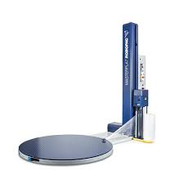 | 6
9 | Electric Strapping Machine | Technical Features  Material Type Polyester PET/PP  Strap Width 12–15 mm  Strap Thickness 0.6 mm  Cycle Speed 2.5 seconds per strap cycle  Production Rate 40 cycles per minute  Tension Force Adjustable up to 300 kg  Tension Method Automatic Tensioning  Sealing Type Friction Weld  Sealing Strength 75% of Strap Break Strength  Control Panel & Programming  User Interface Digital Control Panel with LCD Display  Programmable Settings Stores up to 10 Strap Settings  Error Display Low Strap, Miss Feed & Sealing Error Alerts  Additional Features  Brake Mechanism and Built-in Tool Tray  Durable  Parts Availability  Made in USA, Japan, or EU | 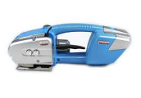 | 25
10 | Manual Strapping Machine | Technical Features  Material Type Polyester PET/PP  Strap Width 12–15 mm  Strap Thickness 0.6 mm  Tension Force Adjustable up to 300 kg  Tension Method Manual Tensioning  Sealing Type Mechanical Buckle  Additional Features  Strapping Dispenser Portable Steel Trolley  Brake Mechanism and Built-in Tool Tray  Durable  Made in USA, Japan, or EU | 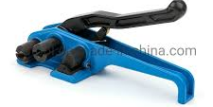 | 30
11 | Compact Professional High-Pressure Cleaner | Technical Feature  Type Cold Water High-Pressure Cleaner  Operation Vertical and Horizontal  Flow Rate 500 l/h  Working Pressure 150 bar / 15 MPa  Max Pressure 200 bar / 20 MPa  Max Inlet Temperature 60 °C  Number of Simultaneous Users 1  Mobility Ultra  Connection Load 2.8 kW  Weight 25.7 kg  Dimensions (L × W × H) 380 × 360 × 930 mm  Current Type 1 / 230 / 50 Ph/V/Hz  Spray Gun Easy Force  High-Pressure Hose 10 m / DN 6 / 250 bar  Spray Lance 840 mm  Triple Nozzle Manual (0°/25°/40°)  Pressure Relief Automatic  Pressure Cut-Off Yes  Carrying Handle Integrated  Push Handle Retractable  Cylinder Head Brass  Safety Features  Stable Horizontal Operation, Automatic Pressure Relief and Durable Quick-Release Couplings |  | 10
12 | Industrial Professional High-Pressure Cleaner | Technical Feature  Type High-Pressure Cleaner  Motor Type 4-Pole Low-Speed Electric Motor 220V  Pump Type Crankshaft Pump  Cylinder Head Brass  Frame Type Tubular Steel Frame  Flow Rate 450 – 600 l/h  Working Pressure 70 – 150 bar  Max Pressure 190 bar  Inlet Temperature Up to 60 °C  Supply Voltage 1 / 216 – 244 / 50 Phases/V/Hz  Connected Load 3.4 kW  Power Cable Length 5 m  Nozzle Size 036  Water Inlet 1″  Weight (with accessories) 51.6 kg  Weight incl. Packaging 64.62 kg  Dimensions (L × W × H) 740 × 528 × 952 mm  High-Pressure Hose Length 10 m  High-Pressure Hose Specification ID 8 / 315 bar  Spray Lance 840 mm  Pressure Switch-Off Yes  Variable Pressure & Water Flow Control Yes  Water Filter Integrated  Oil Level Inspection Glass Yes  Safety Features  Reduced Motor Speed, Low Engine Vibrations, Easy Service Access, Tool-Free Water Filter Removal |  | 10
13 | Single Disk Scrubbing Machine | Performance  Coverage Capacity 1500 – 2000 sqm/hour  Battery Runtime 2.5 – 3 Hours  Working Width 17 – 20 Inches (43 – 50 cm)  Brush Speed 150 – 200 RPM  Solution Tank Capacity 15 – 20 L  Recovery Tank Capacity 15 – 20 L  Battery  Battery Type Lithium-Ion or Maintenance-Free Gel  Voltage 24 V  Battery Capacity 80 – 120 Ah  Charging Time 4 – 6 Hours  Construction  Weight 40 – 70 kg  Chassis Material Heavy-Duty Plastic or Stainless Steel  Wheels Non-Marking Large Wheels  Ergonomics & Controls  Handle Type Adjustable Ergonomic Handle  Controls User-Friendly Controls  Adjustable Functions Speed, Water Flow, Brush Pressure  Additional Features  Cleaning Modes Scrubbing, Polishing, Buffing  Water Saving Mode Eco-Mode  Attachments Hard and Soft Brushes  Safety Features  Emergency Stop Button Yes  Low Battery Indicator Yes | 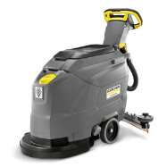 | 5
14 | Vacuum Cleaner | Technical Feature  Type Wet & Dry Vacuum Cleaner  Voltage 220 – 240 V  Frequency 50 – 60 Hz  Air Flow 2 × 74 l/s  Vacuum Pressure 254 mbar / 25.4 kPa  Container Capacity 65 L  Container Material Heavy-Duty Plastic  Rated Power Max. 2760 W  Standard Nominal Width ID 40  Cable Length 10 m  Noise Level 73 dB(A)  Weight 20 kg  Dimensions 600 × 480 × 920 mm  Suction Hose Length 4 m  Suction Tube Quantity 2 pcs  Suction Tube Material Stainless Steel  Filter Type Flat Pleated Filter  Filter Material Cellulose Fibre  Filter Cleaning System Semi-Automatic Ap Filter Cleaning  Fill Level Detection Electronic  Drain Hose Oil-Resistant  Mobility 2 Fixed Wheels + 2 Guide Rolls  Push Handle Ergonomic Push Handle  Hose Storage Yes  Accessory Holder Yes  On-Board Storage Yes  Safety Features  Automatic Cut-Out Yes  Protection Class Class II  Sturdy Bumper Yes  Stop Swivel Castor Yes | 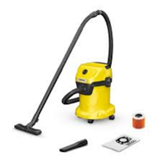 | 5
15 | Mechanical Sweeper | Technical Feature  Type Manual Walk-Behind Sweeper  Drive Type Manual  Max. Area Performance 3920 m²/h  Main Working Width 480 mm  Working Width with 1 Side Brush 700 mm  Working Width with 2 Side Brushes 980 mm  Container Capacity Gross/Net 45 L / 20 L  Dimensions (L × W × H) 989 × 800 × 416 mm  Sweeping System Sweeping Roller + 2 Side Brushes  Sweeper Roller Adjustment 6-Step Adjustable  Side Brush Adjustment Infinitely Adjustable  Filter Type Fine Dust Filter  Dust Control Virtually Dust-Free Sweeping  Push Handle Foldable & Height Adjustable  Handle Positions 3 Adjustment Positions  Storage Type Space-Saving Parking Position  Home Base System Yes  Indoor Use Yes  Outdoor Use Yes  Dirt Container Large Ergonomic Waste Container  Sweeper Principle Dustpan Principle  Roller Drive System Roller Driven by Both Wheels  Maneuverability Compact & Easy Handling  Safety Features  Dust Protection Filter, Ergonomic Operation, Foldable Handle Lock, Stable Parking Position | 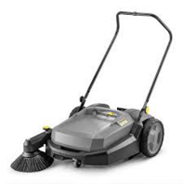 | 5
16 | Mobile Ladder | Technical Feature  Construction Material Welded Steel or Aluminum  Hand Rail Height 90 cm Above Platform  Locking System Hand Lever Locking Bar  Mobility Two Wheels  Feet Type Rubber Covered  Step Width 50 – 60 cm  Step Rise 20 – 25 cm  Platform Size 50 – 60 cm × 40 – 50 cm  Ladder Height 3 m  Safety Features Hand Rails Both Sides  Rubber Covered Feet, Locking Bar, Stable Platform | 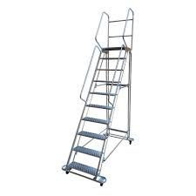 | 15
17 | Retractable Ladder | Technical Feature  Ladder Type Telescopic Ladder  Material Heavy-Duty Aluminum or Fiberglass  Load Capacity 150 kg Minimum  Open Height 4.1 m  Closed Height 1.2m  Number of Rungs 8 + 8  Rung Dimensions 30 x 30 x 1.5 mm  Locking System Automatic Safety Hinge Locks  Feet Type Non-Slip Industrial Rubber Feet  Stability Reinforced Wide-Base Frame  Corrosion Resistance Yes  Weather Resistance Yes  Storage Type Foldable Compact Design  Safety Features  Finger-Safe Locks, Stabilizer Bars , Reinforced Rails , Anti-Slip Rungs, Non-Slip Rubber Feet | 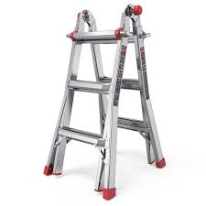 | 20
18 | Tool Kit | Technical Feature  Tool Set Type Professional Ratchet Wrench Tool Set  Number of Pieces 256 pcs  Case Material Aluminum  Tray Type 4 Removable Trays  Handle Type Removable Handle  Mobility Wheels for Easy Transport  Lock Type Key Lock Included  Tool Material Chrome Vanadium Steel (CR-V)  Case Dimensions 38 × 24 × 51 cm  Weight Over 15 kg  Tools  Ratchet Type Low Degrees Ratchets  Socket Sizes 4 mm – 30 mm  Combination Wrench Sizes 8 mm – 17 mm  Spark Plug Socket Sizes 16 mm / 21 mm  Hex Key Sizes 1.5 mm – 10 mm  Extension Bars 4 pcs  Flexible Extension Bar Yes  Included Tools Ratchets, Sockets, Wrenches, Screwdrivers, Pliers, Hex Keys  Ergonomics  Storage Type Organized Multi-Layer Tool Storage  Portability Portable Rolling Toolbox  Application Mechanical, Workshop, Household & Automotive Use  Construction Type Heavy-Duty Professional Grade  Carrying Style Pull Handle with Wheels  Security Feature Lockable Aluminum Case  Finish Type Chrome / Gold Finish  Tool Organization Removable Tray System | 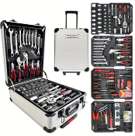 | 25
19 | Cordless Angle Grinder | Technical Features  Motor Type Brushless Motor  Power Equivalent 1500 W Mains-Powered Tool  Switch Type Paddle Switch with Dead Man Function  Brake System Fast Brake System  Disc Stop Time 1.5 Seconds  Anti-Vibration System Integrated Auto-Balancer  Disc Change System Tool-Free Quick System  Adjustable Guard Tool-Free, Twist-Proof  Battery Position Rotatable in 90° Steps  Safety Clutch S-Automatic Mechanical Safety Clutch  Protection Features Electronic Overload Protection, Soft Start, Restart Protection  Dust Protection Filter Detachable  Safety Features  Dead Man Function, Fast Brake System, Anti-Vibration System, Safety Bracket for Strap Attachment, Safety Clutch, Overload Protection, Restart Protection, Dust Protection Filter  Additional Features  Battery x 2 Included  Charger x 1 Included  Hard Case x 1 Included | 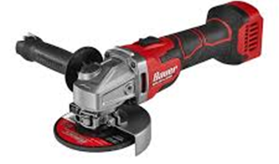 | 25
20 | Cordless Screwdriver | Technical Features  Motor Type Brushless Motor  Hammer Drill Function Yes  Gear Housing Material Aluminum Diecast  Torque Control Electronic Precision Stop  Overload Protection Yes  Euro Collar Size Ø 43 mm  Electronic Safety Shutdown Yes  LED Work Light Integrated with Afterglow Function  Belt Hook and Bit Case Yes  Safety Features Overload Protection Yes  Electronic Safety Shutdown Yes  Kickback Protection Yes  LED Work Light Yes  Precision Torque Control Yes  Additional Features  Battery x 2 Included  Charger x 1 Included  Hard Case x 1 Included | 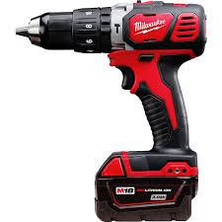 | 25
21 | Packaging Tape Dispenser | Technical Features  Tape Width 50 mm  Tape Roll Diameter 76 mm  Frame Material Steel  Handle Design Enclosed Full-Hand Grip  Hand Through Roll  Tension Method Adjustable Brake Mechanism  Operation  One-Hand Dispensing and Cutting  Additional Features  Safety Feature Integrated Blade guard  Tape Compatibility BOPP, PP, PVC, Acrylic | 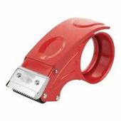 | 100
22 | Cordless Blower | Technical Feature  Motor Type Brushless Motor  Battery System Lithium-Ion  Air Speed Min 190 km/h  Air Volume Min 12 m³/min  Speed Control Variable Speed Trigger  Runtime Min 15 Minutes at Max Power  Additional Features  Battery x 2 Included  Charger x 1 Included  Hard Case x 1 Included | 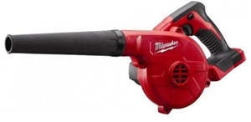 | 20

