Annex 2 – Bid Form completed signed and stamped
- All bids must be typed; handwritten bids will not be considered.
- The contract will be awarded to the lowest-cost technically compliant bid
- Under this Framework Agreement, the quantities indicated are estimates only and may vary depending on LRC operational requirements. Purchases will be executed through the issuance of Purchase Orders on an as-needed basis during the validity period of the agreement. LRC does not guarantee the procurement of the full estimated quantities.
- The bidder is not permitted to alter the section labelled “LRC to complete” below. Bidder is not allowed to use any other template.
- In the event of any discrepancy between the unit price and the total price, LRC reserves the right to rely on the unit price as stated in the financial bid, rather than the total price without go back to the supplier. The unit price must be provided with no more than two decimal places.
- Unit price must include manufacturing, labor, packaging, transport, delivery to LRC warehouse, and all applicable bank transfer charges.
LRC To Complete |  |  |  | Bidder to Complete
Item # | Item/Milestone Required | UOM | Quantity | Unit Price in USD  Exclusive of VAT | VAT (%) | Unit Price in USD  Inclusive of VAT | Total Price in USD  Inclusive of VAT | Lead time of delivery  (in calendar days) from the date of each Purchase Order.
1 | Single-axis foot for men size 23cm, left | Pcs | 2
2 | Single-axis foot for men size 24cm, left | Pcs | 4
3 | Single-axis foot for men size 25cm, left | Pcs | 4
4 | Single axis foot for men size 26 cm left | Pcs | 4
5 | Single-axis foot for men size 27cm, left | Pcs | 4
6 | Single axisfoot for men size 28cm, left | Pcs | 4
7 | Single axis foot for men size 23 cm right | Pcs | 2
8 | Single-axis foot for men size 24cm, right | Pcs | 4
9 | Single-axis foot for men size 25cm, right | Pcs | 4
10 | Single-axis foot for men size 26cm, right | Pcs | 4
11 | Single-axis foot for men size 27cm, right | Pcs | 4
12 | Single axis foot for men size 28cm, right | Pcs | 4
13 | Foot, sach 2.0, size 14, right, olive | Pcs | 1
14 | Foot, sach 2.0, size 15, right, olive | Pcs | 1
15 | Foot, sach 2.0, size 16, right, olive | Pcs | 1
16 | Foot, sach 2.0, size 17, right, olive | Pcs | 1
17 | Foot, sach 2.0, size 18, right, olive | Pcs | 1
18 | Foot, sach 2.0, size 19, right, olive | Pcs | 1
19 | Foot, sach 2.0, size 20, right, olive | Pcs | 1
20 | Foot, sach 2.0, size 21, right, olive | Pcs | 1
21 | Foot, sach 2.0, size 22, right, olive | Pcs | 3
22 | Foot, sach 2.0, size 23, right, olive | Pcs | 8
23 | Foot, sach 2.0, size 24, right, olive | Pcs | 3
24 | Foot, sach 2.0, size 25, right, olive | Pcs | 12
25 | Foot, sach 2.0, size 26, right, olive | Pcs | 18
26 | Foot, sach 2.0, size 27, right, olive | Pcs | 3
27 | Foot, sach, 2.0, size 28, right, olive | Pcs | 3
28 | Foot, sach 2.0, size 14, left, olive | Pcs | 1
29 | Foot, sach 2.0, size 15, left, olive | Pcs | 1
30 | Foot, sach 2.0, size 16, left, olive | Pcs | 1
31 | Foot, sach 2.0, size 17, left, olive | Pcs | 1
32 | Foot, sach 2.0, size 18, left, olive | Pcs | 1
33 | Foot, sach 2.0, size 19, left, olive | Pcs | 1
34 | Foot, sach 2.0, size 20, left, olive | Pcs | 1
35 | Foot, sach 2.0, size 21, left, olive | Pcs | 1
36 | Foot, sach 2.0, size 22, left, olive | Pcs | 4
37 | Foot, sach 2.0, size 23, left, olive | Pcs | 8
38 | Foot, sach 2.0, size 24, left, olive | Pcs | 3
39 | Foot, sach 2.0, size 25, left, olive | Pcs | 12
40 | Foot, sach 2.0, size 26, left, olive | Pcs | 18
41 | Foot, sach 2.0, size 27, left, olive | Pcs | 8
42 | Foot, sach 2.0, size 28, left, olive | Pcs | 3
43 | Foot for long stump, olive color, 25cm, left | Pcs | 1
44 | Foot for long stump, olive color, 21cm, left | Pcs | 1
45 | Foot for long stump, olive color, 21cm, right | Pcs | 1
46 | Foot for long stump, olive color, 23cm, right | Pcs | 1
47 | Foot for long stump, olive color, 25cm, right | Pcs | 1
48 | Foot sach low profile, olive colour, 20 cm right | Pcs | 1
49 | Foot sach low profile, olive colour, 22 cm right | Pcs | 1
50 | Foot sach low profile, olive colour, 24 cm right | Pcs | 3
51 | Foot sach low profile, olive colour, 26 cm right | Pcs | 1
52 | Foot sach low profile, olive colour, 20 cm left | Pcs | 1
53 | Foot sach low profile, olive colour, 22 cm left | Pcs | 1
54 | Foot sach low profile, olive colour, 24 cm left | Pcs | 1
55 | Foot sach low profile, olive colour, 26 cm left | Pcs | 1
56 | Tube Adapter stainless steel 30x2.5MM (Long ADULT) | Pcs | 25
57 | Tube ADAPTER STAINLESS (SHORT ADULT) TT-2R2 | Pcs | 170
58 | Tube clamp adapter-stainl.steel for tubes o 30mm | Pcs | 130
59 | Hip joint, adapter tube, tilt 20 degree | Pcs | 1
60 | Hip joint, adapter tube, tilt 10 degree | Pcs | 1
61 | Socket adapter with adjustment core stain.steel-with and lamination | Pcs | 15
62 | Socket adapter with rotation adjustment (raster adjustment)-stainless steel | Pcs | 10
63 | Socket adapter with adjustment core and lamination anchor-stain.steel-with lamination anchor-stainl.steel with lamination dummy | Pcs | 25
64 | Socket adapter, rotatable, with adjustment core support and lamination anchor-stainless steel | Pcs | 15
65 | Socket adapter with rotatable adjustment | Pcs | 40
66 | Socket adapter 4 arm with rotatable adjustment | Pcs | 20
67 | Sach foot adapter with bolted connection m8 | Pcs | 2
68 | Sach foot adapter with bolted connection m10 | Pcs | 120
69 | Bolted connection for sach foot thread m8 | Set | 2
70 | Single axis foot adapter foot size 26-30 | Pcs | 24
71 | Single axis foot adapter foot size 22-25 | Pcs | 24
72 | Service single axis foot adapter | Set | 7
73 | Connection cap for single axis foot, foot size 23 cm | Pcs | 5
74 | Connection cap for single axis foot, foot size 24 cm | Pcs | 5
75 | Connection cap for single axis foot, foot size 25 cm | Pcs | 5
76 | Connection cap for single axis foot, foot size 26 cm | Pcs | 5
77 | Connection cap for single axis foot, foot size 27 cm | Pcs | 5
78 | Connection cap for single axis foot, foot size 28cm | Pcs | 5
79 | Orthosis offset 20mm adult | Pair | 5
80 | Orthosis offset 16mm child | Pair | 5
81 | Orthosis droplock 20mm adult | Pair | 20
82 | Orthosis droplock 16mm child | Pair | 14
83 | Orthosis swisslock 20mm adult | Pair | 12
84 | Orthosis swisslock 16mm child | Pair | 8
85 | Double adapter stainless steel 32mm | Pcs | 4
86 | Double adapter stainless steel 45mm | Pcs | 4
87 | Double adapter stainless steel 60mm | Pcs | 4
88 | Double adapter stainless steel 75mm | Pcs | 4
89 | Double adapter titanium 32mm | Pcs | 4
90 | Double adapter titanium 45mm | Pcs | 4
91 | Double adapter titanium 60mm | Pcs | 4
92 | Double adapter titanium 75mm | Pcs | 2
93 | Foot abduction brace, type denis brown splint | Pcs | 8
94 | Foot abduction brace, type basko quick release splint | Pcs | 8
95 | Shoes size 86-93mm, for abduction brace, type denis brown | Pair | 2
96 | Shoes size 84-101mm, for abduction brace, type denis brown | Pair | 2
97 | Shoes size 102-109mm, for abduction brace, type denis brown | Pair | 2
98 | Shoes size 110-117mm, for abduction brace, type denis brown | Pair | 2
99 | Shoes size 118-125mm, for abduction brace, type denis brown | Pair | 2
100 | Shoes size 14 pair abduction brace type basko denis brown | Pair | 2
101 | Shoes size 16 pair abduction brace type basko denis brown | Pair | 2
102 | Shoes size 18 pair abduction brace type basko denis brown | Pair | 2
103 | Shoes size 20 pair abduction brace type basko denis brown | Pair | 2
104 | Shoes size 22 pair abduction brace type basko denis brown | Pair | 2
105 | Shoes size 26 pair abduction brace type basko denis brown | Pair | 2
106 | Shoes size 28 pair abduction brace type basko denis brown | Pair | 2
107 | Shoes size 30 pair abduction brace type basko denis brown | Pair | 2
108 | Derma seal sock 453d7=3 | Pcs | 5
109 | Derma seal sock 453d7=5 | Pcs | 5
110 | Derma seal sock 453d7=7 | Pcs | 5
111 | STRAP, VELCRO, PVC, WITH LOOP, BROWN, 300x25mm | Pcs | 10
112 | Strap, velcro, pvc, with loop, brown, 400x400 mm | Pcs | 20
113 | Strap, velcro, 30mm, hook | Roll | 1
114 | Strap, velcro, 30mm, loop/velvet | Roll | 1
115 | Strap, perlon webbing, 25mm | Roll | 1
116 | Strap, elastic, 25mm | Roll | 1
117 | Strap, elastic, 35mm | Roll | 1
118 | Strap, prostesis, 25mm | Roll | 1
119 | Strap, prostesis, 35mm | Roll | 2
120 | Strap, polyester, black, 40mm | Roll | 2
121 | Adhisive hook and loop black | Roll | 2
122 | Cosmetic soft foam cover | Pcs | 95
123 | Cosmetic soft foam cover left total net weight 22, 50000kg | Pcs | 40
124 | Hd foam cover | Pcs | 1
125 | Junior soft foam cover tf | Pcs | 1
126 | Junior soft foam cover tt | Pcs | 1
127 | Fiberglass stockinette type bufa width: 12omm, pu=1, 0 kg length per roll 12, 5m | Roll | 10
128 | Fiberglass stockinette type bufa width: 15omm, pu=1, 0 kg length per roll 9, 3m | Roll | 22
129 | Fiberglass stockinette type bufa width 200mm pu=1, 0kg length per roll 7, 2m | Roll | 15
130 | Fiberglass Stockinette 300 mm | Roll | 10
131 | Perlon extra elastic wide 40mm | Roll | 2
132 | Perlon stockinette, white width: 60mm pu=1, 0kg length per roll 37, 0m | Roll | 5
133 | Perlon stockinette, white width: 100mm pu=1, 0kg length per roll 37, 0m | Roll | 20
134 | Perlon stockinette, white width: 120mm pu=1, 0kg length per roll 33, 3m | Roll | 14
135 | Perlon stockinette, white width: 150mm pu=1, 0kg length per roll 27, 0m | Roll | 15
136 | Perlon stockinette, white width: 200mm pu=1, 0kg length per roll 20, 0m | Roll | 5
137 | Carbon-fiber cloth, black-616g12=30 | Roll | 1
138 | Carbon fiber stokinette 100mm | Roll | 1
139 | Tubular stockinette, cotton, 60mm, roll(25m) | Roll | 1
140 | Tubular stockinette, cotton, 80mm, roll(500g) | Roll | 1
141 | Tubular stockinette, cotton, 100mm, roll | Roll | 1
142 | Tubular stockinette, cotton, 120mm, roll | Roll | 1
143 | Tubular stockinette, cotton, 150mm, roll | Roll | 1
144 | Tubular stockinette, cotton, 200mm, roll | Roll | 1
145 | Hip joint for Prothese | Pcs | 4
146 | Modular brake knee joint stainless steel - monocentric, incl.extension assist | Pcs | 5
147 | Modular single axis knee joint stainless steel - monocentric, with lock & spring extension assist | Pcs | 6
148 | Modular 4-bar linkage knee joint-stainless steel | Pcs | 7
149 | Modular 4-bar linkage knee joint-stainless steel | Pcs | 6
150 | Modular 4-bar linkage knee joint-stainless steel | Pcs | 6
151 | Stump sock, trans-tibial, flat width 10 cm, length 35 | Pcs | 100
152 | Stump sock, trans-tibial, flat width 10cm, length 45 | Pcs | 100
153 | Stump sock, trans-tibial, flat width 10 cm, length 55 | Pcs | 60
154 | EVA FOAM, 3MM x 0.95M, 0.90M2, BEIGE | Sheet | 25
155 | Eva foam, 6mm x 0.95m x 0.95m, 0.90m2, beige | Sheet | 50
156 | EVA FOAM, 12MM x 1.10M x 1.10M, 1.21M2, BEIGE | Sheet | 12
157 | Connection disk for sach foot | Pcs | 60
158 | Flat rubber valve automatic | Pcs | 21
159 | Tube with seat ring | Pcs | 2
160 | Modular junction cup for lamination or thermof. Adult prot 1k90 | Pcs | 1
161 | Socket attachment block | Pcs | 1
162 | Orthocryl lamination resin | Pack | 26
163 | Pva film, 1000 x 0.08 x 30 mstr | Roll | 10
164 | Glue | Pack | 15
165 | Hard foam 300-617h32=4.6 pedline | Pack | 1
166 | Hardener for pedline | Pack | 1
167 | Powder hardener | Pack | 36
168 | PIGMENT PASTE beige | Pack | 1
169 | Vaseline | Pack | 1
170 | Thinner | Pack | 2
171 | Sealing | Pack | 1
172 | Pigment paste ottobock 1kg | Pack | 5
173 | Streifydur, polypropylene, 2000x1000x5 mm, clear white | Sheet | 5
174 | Homopolymer, 3mm x 1m x 2m x 5.5kg, beige color | Sheet | 3
175 | Homopolymer, 4mm x 1m x 2m x 7.5kg, beige color | Sheet | 20
176 | Homopolymer, 5mm x 1m x 2m x 9.2kg, beige color | Sheet | 30
178 | Polymer, ldpe 2m x 1m x 4mm | Sheet | 5
179 | Polymer, ldpe 2m x 1m x 5mm | Sheet | 10
180 | Polypropylene welding rod, 4mm, beige color | Coil | 1
181 | Tube adapter | Pcs | 3
182 | Tube clamp adapter | Pcs | 3
183 | Socket adapter with rotainal adjustment | Pcs | 1
184 | Socket attachment block with lamination dummy | Pcs | 1
185 | Modular knee joint | Pcs | 1
186 | Socket adapter with 4 adjustment set screws | Pcs | 1
187 | Foot adapter junior m6 | Pcs | 3
188 | Modular knee joint with lock | Pcs | 1
189 | Lamination anchor child | Pcs | 1

ANNEX 3: DETAILED SPECIFICATIONS

ITEM # | ITEM NAME | Technical Specifications | Estimated Qty | Picture
1 | Single-axis foot for men size 23cm, left | Single-axis prosthetic foot, men's, size 23 cm, left. Foot body moulded polyurethane over an alder-wood core; flat-convex forefoot; single-axis (uniaxial) ankle joint with replaceable plantar- and dorsiflexion bumpers. Heel height 10 mm. Build height 36 mm. Unit mass 310 g. Maximum patient body weight 100 kg. Mobility grade 1 (indoor walker). Supplied WITHOUT ankle adapter: requires single-axis foot adapter of size group 22-25 (32A4/22-25 stainless steel currently in use; 32A2 aluminium / 32A3 titanium also fit). Structural strength to ISO 10328 (lower-limb prosthesis components). Reference product: Streifeneder 30A14/23L, or technically equivalent. | 2 | 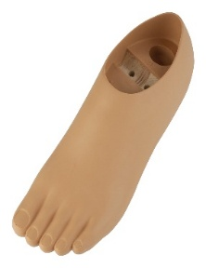
2 | Single-axis foot for men size 24cm, left | Single-axis prosthetic foot, men's, size 24 cm, left. Foot body moulded polyurethane over an alder-wood core; flat-convex forefoot; single-axis (uniaxial) ankle joint with replaceable plantar- and dorsiflexion bumpers. Heel height 10 mm. Build height 38 mm. Unit mass 330 g. Maximum patient body weight 100 kg. Mobility grade 1 (indoor walker). Supplied WITHOUT ankle adapter: requires single-axis foot adapter of size group 22-25 (32A4/22-25 stainless steel currently in use; 32A2 aluminium / 32A3 titanium also fit). Structural strength to ISO 10328 (lower-limb prosthesis components). Reference product: Streifeneder 30A14/24L, or technically equivalent. | 4 | 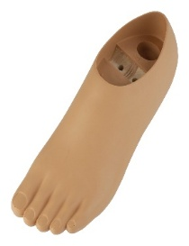
3 | Single-axis foot for men size 25cm, left | Single-axis prosthetic foot, men's, size 25 cm, left. Foot body moulded polyurethane over an alder-wood core; flat-convex forefoot; single-axis (uniaxial) ankle joint with replaceable plantar- and dorsiflexion bumpers. Heel height 10 mm. Build height 40 mm. Unit mass 370 g. Maximum patient body weight 100 kg. Mobility grade 1 (indoor walker). Supplied WITHOUT ankle adapter: requires single-axis foot adapter of size group 22-25 (32A4/22-25 stainless steel currently in use; 32A2 aluminium / 32A3 titanium also fit). Structural strength to ISO 10328 (lower-limb prosthesis components). Reference product: Streifeneder 30A14/25L, or technically equivalent. | 4 | 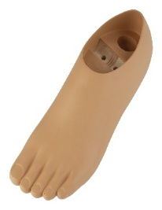
4 | Single axis foot for men size 26 cm left | Single-axis prosthetic foot, men's, size 26 cm, left. Foot body moulded polyurethane over an alder-wood core; flat-convex forefoot; single-axis (uniaxial) ankle joint with replaceable plantar- and dorsiflexion bumpers. Heel height 10 mm. Build height 40 mm. Unit mass 430 g. Maximum patient body weight 100 kg. Mobility grade 1 (indoor walker). Supplied WITHOUT ankle adapter: requires single-axis foot adapter of size group 26-30 (32A4/26-30 stainless steel currently in use; 32A2 aluminium / 32A3 titanium also fit). Structural strength to ISO 10328 (lower-limb prosthesis components). Reference product: Streifeneder 30A14/26L, or technically equivalent. | 4 | 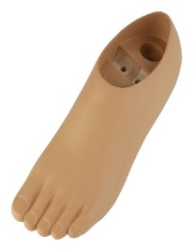
5 | Single-axis foot for men size 27cm, left | Single-axis prosthetic foot, men's, size 27 cm, left. Foot body moulded polyurethane over an alder-wood core; flat-convex forefoot; single-axis (uniaxial) ankle joint with replaceable plantar- and dorsiflexion bumpers. Heel height 10 mm. Build height 40 mm. Unit mass 470 g. Maximum patient body weight 100 kg. Mobility grade 1 (indoor walker). Supplied WITHOUT ankle adapter: requires single-axis foot adapter of size group 26-30 (32A4/26-30 stainless steel currently in use; 32A2 aluminium / 32A3 titanium also fit). Structural strength to ISO 10328 (lower-limb prosthesis components). Reference product: Streifeneder 30A14/27L, or technically equivalent. | 4
6 | Single axisfoot for men size 28cm, left | Single-axis prosthetic foot, men's, size 28 cm, left. Foot body moulded polyurethane over an alder-wood core; flat-convex forefoot; single-axis (uniaxial) ankle joint with replaceable plantar- and dorsiflexion bumpers. Heel height 10 mm. Build height 42 mm. Unit mass 500 g. Maximum patient body weight 100 kg. Mobility grade 1 (indoor walker). Supplied WITHOUT ankle adapter: requires single-axis foot adapter of size group 26-30 (32A4/26-30 stainless steel currently in use; 32A2 aluminium / 32A3 titanium also fit). Structural strength to ISO 10328 (lower-limb prosthesis components). Reference product: Streifeneder 30A14/28L, or technically equivalent. | 4 | 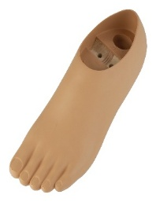
7 | Single axis foot for men size 23 cm right | Single-axis prosthetic foot, men's, size 23 cm, right. Foot body moulded polyurethane over an alder-wood core; flat-convex forefoot; single-axis (uniaxial) ankle joint with replaceable plantar- and dorsiflexion bumpers. Heel height 10 mm. Build height 36 mm. Unit mass 310 g. Maximum patient body weight 100 kg. Mobility grade 1 (indoor walker). Supplied WITHOUT ankle adapter: requires single-axis foot adapter of size group 22-25 (32A4/22-25 stainless steel currently in use; 32A2 aluminium / 32A3 titanium also fit). Structural strength to ISO 10328 (lower-limb prosthesis components). Reference product: Streifeneder 30A14/23R, or technically equivalent. | 2 | 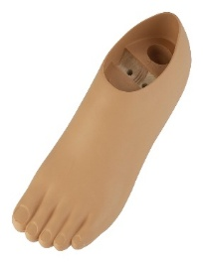
8 | Single-axis foot for men size 24cm, right | Single-axis prosthetic foot, men's, size 24 cm, right. Foot body moulded polyurethane over an alder-wood core; flat-convex forefoot; single-axis (uniaxial) ankle joint with replaceable plantar- and dorsiflexion bumpers. Heel height 10 mm. Build height 38 mm. Unit mass 330 g. Maximum patient body weight 100 kg. Mobility grade 1 (indoor walker). Supplied WITHOUT ankle adapter: requires single-axis foot adapter of size group 22-25 (32A4/22-25 stainless steel currently in use; 32A2 aluminium / 32A3 titanium also fit). Structural strength to ISO 10328 (lower-limb prosthesis components). Reference product: Streifeneder 30A14/24R, or technically equivalent. | 4 | 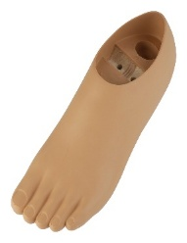
9 | Single-axis foot for men size 25cm, right | Single-axis prosthetic foot, men's, size 25 cm, right. Foot body moulded polyurethane over an alder-wood core; flat-convex forefoot; single-axis (uniaxial) ankle joint with replaceable plantar- and dorsiflexion bumpers. Heel height 10 mm. Build height 40 mm. Unit mass 370 g. Maximum patient body weight 100 kg. Mobility grade 1 (indoor walker). Supplied WITHOUT ankle adapter: requires single-axis foot adapter of size group 22-25 (32A4/22-25 stainless steel currently in use; 32A2 aluminium / 32A3 titanium also fit). Structural strength to ISO 10328 (lower-limb prosthesis components). Reference product: Streifeneder 30A14/25R, or technically equivalent. | 4 | 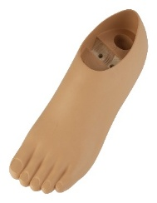
10 | Single-axis foot for men size 26cm, right | Single-axis prosthetic foot, men's, size 26 cm, right. Foot body moulded polyurethane over an alder-wood core; flat-convex forefoot; single-axis (uniaxial) ankle joint with replaceable plantar- and dorsiflexion bumpers. Heel height 10 mm. Build height 40 mm. Unit mass 430 g. Maximum patient body weight 100 kg. Mobility grade 1 (indoor walker). Supplied WITHOUT ankle adapter: requires single-axis foot adapter of size group 26-30 (32A4/26-30 stainless steel currently in use; 32A2 aluminium / 32A3 titanium also fit). Structural strength to ISO 10328 (lower-limb prosthesis components). Reference product: Streifeneder 30A14/26R, or technically equivalent. | 4 | 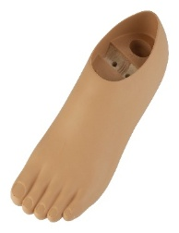
11 | Single-axis foot for men size 27cm, right | Single-axis prosthetic foot, men's, size 27 cm, right. Foot body moulded polyurethane over an alder-wood core; flat-convex forefoot; single-axis (uniaxial) ankle joint with replaceable plantar- and dorsiflexion bumpers. Heel height 10 mm. Build height 40 mm. Unit mass 470 g. Maximum patient body weight 100 kg. Mobility grade 1 (indoor walker). Supplied WITHOUT ankle adapter: requires single-axis foot adapter of size group 26-30 (32A4/26-30 stainless steel currently in use; 32A2 aluminium / 32A3 titanium also fit). Structural strength to ISO 10328 (lower-limb prosthesis components). Reference product: Streifeneder 30A14/27R, or technically equivalent. | 4 | 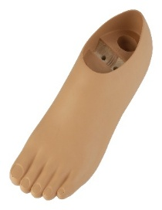
12 | Single axis foot for men size 28cm, right | Single-axis prosthetic foot, men's, size 28 cm, right. Foot body moulded polyurethane over an alder-wood core; flat-convex forefoot; single-axis (uniaxial) ankle joint with replaceable plantar- and dorsiflexion bumpers. Heel height 10 mm. Build height 42 mm. Unit mass 500 g. Maximum patient body weight 100 kg. Mobility grade 1 (indoor walker). Supplied WITHOUT ankle adapter: requires single-axis foot adapter of size group 26-30 (32A4/26-30 stainless steel currently in use; 32A2 aluminium / 32A3 titanium also fit). Structural strength to ISO 10328 (lower-limb prosthesis components). Reference product: Streifeneder 30A14/28R, or technically equivalent. | 4 | 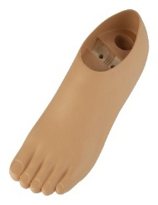
13 | Foot, sach 2.0, size 14, right, olive | Prosthetic foot, SACH type (Solid Ankle Cushion Heel), version 2.0, size 14 cm, right, colour olive. Polypropylene keel; cover moulded in polyurethane foam from a water-solvent system, polymerisation completed by exposure to high temperature and dry air. Foot is bolted through the foot arch and is therefore compatible with the ICRC polypropylene (PP) technology as well as with modular endoskeletal builds. Child size: supplied with one high-tensile M8 bolt and one lock washer; mates with SACH foot adapter 16A2/M8 (stainless steel). Storage: below 50 C and below 60 % relative humidity. Shelf life: to be fitted within 12-18 months of receipt - deliveries must carry a production date and at least 12 months remaining shelf life on arrival. Packed in cartons of 21 pieces (0.40 x 0.30 x 0.44 m, 0.05 m3 per carton). Reference product: ICRC catalogue code OCPOFOOTLI14R (CR-SACH, CR Equipements SA), or technically equivalent. NOTE: size 14 is below the smallest size (17 cm) published in the current ICRC standard catalogue - confirm availability before ordering. | 1 | 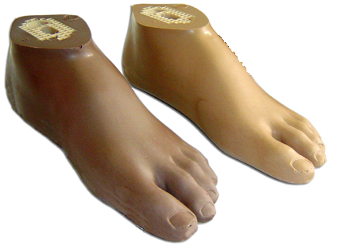
14 | Foot, sach 2.0, size 15, right, olive | Prosthetic foot, SACH type (Solid Ankle Cushion Heel), version 2.0, size 15 cm, right, colour olive. Polypropylene keel; cover moulded in polyurethane foam from a water-solvent system, polymerisation completed by exposure to high temperature and dry air. Foot is bolted through the foot arch and is therefore compatible with the ICRC polypropylene (PP) technology as well as with modular endoskeletal builds. Child size: supplied with one high-tensile M8 bolt and one lock washer; mates with SACH foot adapter 16A2/M8 (stainless steel). Storage: below 50 C and below 60 % relative humidity. Shelf life: to be fitted within 12-18 months of receipt - deliveries must carry a production date and at least 12 months remaining shelf life on arrival. Packed in cartons of 21 pieces (0.40 x 0.30 x 0.44 m, 0.05 m3 per carton). Reference product: ICRC catalogue code OCPOFOOTLI15R (CR-SACH, CR Equipements SA), or technically equivalent. NOTE: size 15 is below the smallest size (17 cm) published in the current ICRC standard catalogue - confirm availability before ordering. | 1 | 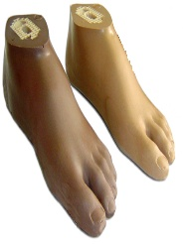
15 | Foot, sach 2.0, size 16, right, olive | Prosthetic foot, SACH type (Solid Ankle Cushion Heel), version 2.0, size 16 cm, right, colour olive. Polypropylene keel; cover moulded in polyurethane foam from a water-solvent system, polymerisation completed by exposure to high temperature and dry air. Foot is bolted through the foot arch and is therefore compatible with the ICRC polypropylene (PP) technology as well as with modular endoskeletal builds. Child size: supplied with one high-tensile M8 bolt and one lock washer; mates with SACH foot adapter 16A2/M8 (stainless steel). Storage: below 50 C and below 60 % relative humidity. Shelf life: to be fitted within 12-18 months of receipt - deliveries must carry a production date and at least 12 months remaining shelf life on arrival. Packed in cartons of 21 pieces (0.40 x 0.30 x 0.44 m, 0.05 m3 per carton). Reference product: ICRC catalogue code OCPOFOOTLI16R (CR-SACH, CR Equipements SA), or technically equivalent. NOTE: size 16 is below the smallest size (17 cm) published in the current ICRC standard catalogue - confirm availability before ordering. | 1 | 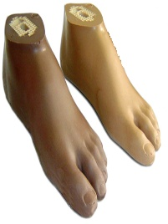
16 | Foot, sach 2.0, size 17, right, olive | Prosthetic foot, SACH type (Solid Ankle Cushion Heel), version 2.0, size 17 cm, right, colour olive. Polypropylene keel; cover moulded in polyurethane foam from a water-solvent system, polymerisation completed by exposure to high temperature and dry air. Foot is bolted through the foot arch and is therefore compatible with the ICRC polypropylene (PP) technology as well as with modular endoskeletal builds. Child size: supplied with one high-tensile M8 bolt and one lock washer; mates with SACH foot adapter 16A2/M8 (stainless steel). Storage: below 50 C and below 60 % relative humidity. Shelf life: to be fitted within 12-18 months of receipt - deliveries must carry a production date and at least 12 months remaining shelf life on arrival. Packed in cartons of 21 pieces (0.40 x 0.30 x 0.44 m, 0.05 m3 per carton). Reference product: ICRC catalogue code OCPOFOOTLI17R (CR-SACH, CR Equipements SA), or technically equivalent. | 1 | 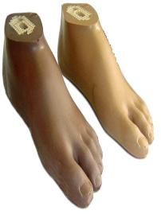
17 | Foot, sach 2.0, size 18, right, olive | Prosthetic foot, SACH type (Solid Ankle Cushion Heel), version 2.0, size 18 cm, right, colour olive. Polypropylene keel; cover moulded in polyurethane foam from a water-solvent system, polymerisation completed by exposure to high temperature and dry air. Foot is bolted through the foot arch and is therefore compatible with the ICRC polypropylene (PP) technology as well as with modular endoskeletal builds. Child size: supplied with one high-tensile M8 bolt and one lock washer; mates with SACH foot adapter 16A2/M8 (stainless steel). Storage: below 50 C and below 60 % relative humidity. Shelf life: to be fitted within 12-18 months of receipt - deliveries must carry a production date and at least 12 months remaining shelf life on arrival. Packed in cartons of 21 pieces (0.40 x 0.30 x 0.44 m, 0.05 m3 per carton). Reference product: ICRC catalogue code OCPOFOOTLI18R (CR-SACH, CR Equipements SA), or technically equivalent. | 1 | 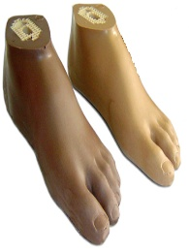
18 | Foot, sach 2.0, size 19, right, olive | Prosthetic foot, SACH type (Solid Ankle Cushion Heel), version 2.0, size 19 cm, right, colour olive. Polypropylene keel; cover moulded in polyurethane foam from a water-solvent system, polymerisation completed by exposure to high temperature and dry air. Foot is bolted through the foot arch and is therefore compatible with the ICRC polypropylene (PP) technology as well as with modular endoskeletal builds. Child size: supplied with one high-tensile M8 bolt and one lock washer; mates with SACH foot adapter 16A2/M8 (stainless steel). Storage: below 50 C and below 60 % relative humidity. Shelf life: to be fitted within 12-18 months of receipt - deliveries must carry a production date and at least 12 months remaining shelf life on arrival. Packed in cartons of 21 pieces (0.40 x 0.30 x 0.44 m, 0.05 m3 per carton). Reference product: ICRC catalogue code OCPOFOOTLI19R (CR-SACH, CR Equipements SA), or technically equivalent. | 1 | 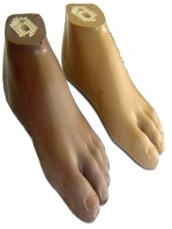
19 | Foot, sach 2.0, size 20, right, olive | Prosthetic foot, SACH type (Solid Ankle Cushion Heel), version 2.0, size 20 cm, right, colour olive. Polypropylene keel; cover moulded in polyurethane foam from a water-solvent system, polymerisation completed by exposure to high temperature and dry air. Foot is bolted through the foot arch and is therefore compatible with the ICRC polypropylene (PP) technology as well as with modular endoskeletal builds. Child size: supplied with one high-tensile M8 bolt and one lock washer; mates with SACH foot adapter 16A2/M8 (stainless steel). Storage: below 50 C and below 60 % relative humidity. Shelf life: to be fitted within 12-18 months of receipt - deliveries must carry a production date and at least 12 months remaining shelf life on arrival. Packed in cartons of 21 pieces (0.40 x 0.30 x 0.44 m, 0.05 m3 per carton). Reference product: ICRC catalogue code OCPOFOOTLI20R (CR-SACH, CR Equipements SA), or technically equivalent. | 1 | 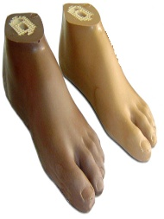
20 | Foot, sach 2.0, size 21, right, olive | Prosthetic foot, SACH type (Solid Ankle Cushion Heel), version 2.0, size 21 cm, right, colour olive. Polypropylene keel; cover moulded in polyurethane foam from a water-solvent system, polymerisation completed by exposure to high temperature and dry air. Foot is bolted through the foot arch and is therefore compatible with the ICRC polypropylene (PP) technology as well as with modular endoskeletal builds. Adult size: supplied with one high-tensile M10 bolt and one lock washer; mates with SACH foot adapter 16A2/M10 (stainless steel). Storage: below 50 C and below 60 % relative humidity. Shelf life: to be fitted within 12-18 months of receipt - deliveries must carry a production date and at least 12 months remaining shelf life on arrival. Packed in cartons of 28 pieces (0.40 x 0.30 x 0.44 m, 0.05 m3 per carton). Reference product: ICRC catalogue code OCPOFOOTLI21R (CR-SACH, CR Equipements SA), or technically equivalent. | 1 | 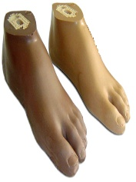
21 | Foot, sach 2.0, size 22, right, olive | Prosthetic foot, SACH type (Solid Ankle Cushion Heel), version 2.0, size 22 cm, right, colour olive. Polypropylene keel; cover moulded in polyurethane foam from a water-solvent system, polymerisation completed by exposure to high temperature and dry air. Foot is bolted through the foot arch and is therefore compatible with the ICRC polypropylene (PP) technology as well as with modular endoskeletal builds. Adult size: supplied with one high-tensile M10 bolt and one lock washer; mates with SACH foot adapter 16A2/M10 (stainless steel). Storage: below 50 C and below 60 % relative humidity. Shelf life: to be fitted within 12-18 months of receipt - deliveries must carry a production date and at least 12 months remaining shelf life on arrival. Packed in cartons of 28 pieces (0.40 x 0.30 x 0.44 m, 0.05 m3 per carton). Reference product: ICRC catalogue code OCPOFOOTLI22R (CR-SACH, CR Equipements SA), or technically equivalent. | 3
22 | Foot, sach 2.0, size 23, right, olive | Prosthetic foot, SACH type (Solid Ankle Cushion Heel), version 2.0, size 23 cm, right, colour olive. Polypropylene keel; cover moulded in polyurethane foam from a water-solvent system, polymerisation completed by exposure to high temperature and dry air. Foot is bolted through the foot arch and is therefore compatible with the ICRC polypropylene (PP) technology as well as with modular endoskeletal builds. Adult size: supplied with one high-tensile M10 bolt and one lock washer; mates with SACH foot adapter 16A2/M10 (stainless steel). Storage: below 50 C and below 60 % relative humidity. Shelf life: to be fitted within 12-18 months of receipt - deliveries must carry a production date and at least 12 months remaining shelf life on arrival. Packed in cartons of 28 pieces (0.40 x 0.30 x 0.44 m, 0.05 m3 per carton). Reference product: ICRC catalogue code OCPOFOOTLI23R (CR-SACH, CR Equipements SA), or technically equivalent. | 8
23 | Foot, sach 2.0, size 24, right, olive | Prosthetic foot, SACH type (Solid Ankle Cushion Heel), version 2.0, size 24 cm, right, colour olive. Polypropylene keel; cover moulded in polyurethane foam from a water-solvent system, polymerisation completed by exposure to high temperature and dry air. Foot is bolted through the foot arch and is therefore compatible with the ICRC polypropylene (PP) technology as well as with modular endoskeletal builds. Adult size: supplied with one high-tensile M10 bolt and one lock washer; mates with SACH foot adapter 16A2/M10 (stainless steel). Storage: below 50 C and below 60 % relative humidity. Shelf life: to be fitted within 12-18 months of receipt - deliveries must carry a production date and at least 12 months remaining shelf life on arrival. Packed in cartons of 28 pieces (0.40 x 0.30 x 0.44 m, 0.05 m3 per carton). Reference product: ICRC catalogue code OCPOFOOTLI24R (CR-SACH, CR Equipements SA), or technically equivalent. | 3
24 | Foot, sach 2.0, size 25, right, olive | Prosthetic foot, SACH type (Solid Ankle Cushion Heel), version 2.0, size 25 cm, right, colour olive. Polypropylene keel; cover moulded in polyurethane foam from a water-solvent system, polymerisation completed by exposure to high temperature and dry air. Foot is bolted through the foot arch and is therefore compatible with the ICRC polypropylene (PP) technology as well as with modular endoskeletal builds. Adult size: supplied with one high-tensile M10 bolt and one lock washer; mates with SACH foot adapter 16A2/M10 (stainless steel). Storage: below 50 C and below 60 % relative humidity. Shelf life: to be fitted within 12-18 months of receipt - deliveries must carry a production date and at least 12 months remaining shelf life on arrival. Packed in cartons of 28 pieces (0.40 x 0.30 x 0.44 m, 0.05 m3 per carton). Reference product: ICRC catalogue code OCPOFOOTLI25R (CR-SACH, CR Equipements SA), or technically equivalent. | 12
25 | Foot, sach 2.0, size 26, right, olive | Prosthetic foot, SACH type (Solid Ankle Cushion Heel), version 2.0, size 26 cm, right, colour olive. Polypropylene keel; cover moulded in polyurethane foam from a water-solvent system, polymerisation completed by exposure to high temperature and dry air. Foot is bolted through the foot arch and is therefore compatible with the ICRC polypropylene (PP) technology as well as with modular endoskeletal builds. Adult size: supplied with one high-tensile M10 bolt and one lock washer; mates with SACH foot adapter 16A2/M10 (stainless steel). Storage: below 50 C and below 60 % relative humidity. Shelf life: to be fitted within 12-18 months of receipt - deliveries must carry a production date and at least 12 months remaining shelf life on arrival. Packed in cartons of 28 pieces (0.40 x 0.30 x 0.44 m, 0.05 m3 per carton). Reference product: ICRC catalogue code OCPOFOOTLI26R (CR-SACH, CR Equipements SA), or technically equivalent. | 18
26 | Foot, sach 2.0, size 27, right, olive | Prosthetic foot, SACH type (Solid Ankle Cushion Heel), version 2.0, size 27 cm, right, colour olive. Polypropylene keel; cover moulded in polyurethane foam from a water-solvent system, polymerisation completed by exposure to high temperature and dry air. Foot is bolted through the foot arch and is therefore compatible with the ICRC polypropylene (PP) technology as well as with modular endoskeletal builds. Adult size: supplied with one high-tensile M10 bolt and one lock washer; mates with SACH foot adapter 16A2/M10 (stainless steel). Storage: below 50 C and below 60 % relative humidity. Shelf life: to be fitted within 12-18 months of receipt - deliveries must carry a production date and at least 12 months remaining shelf life on arrival. Packed in cartons of 28 pieces (0.40 x 0.30 x 0.44 m, 0.05 m3 per carton). Reference product: ICRC catalogue code OCPOFOOTLI27R (CR-SACH, CR Equipements SA), or technically equivalent. | 3 | 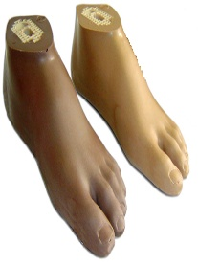
27 | Foot, sach, 2.0, size 28, right, olive | Prosthetic foot, SACH type (Solid Ankle Cushion Heel), version 2.0, size 28 cm, right, colour olive. Polypropylene keel; cover moulded in polyurethane foam from a water-solvent system, polymerisation completed by exposure to high temperature and dry air. Foot is bolted through the foot arch and is therefore compatible with the ICRC polypropylene (PP) technology as well as with modular endoskeletal builds. Adult size: supplied with one high-tensile M10 bolt and one lock washer; mates with SACH foot adapter 16A2/M10 (stainless steel). Storage: below 50 C and below 60 % relative humidity. Shelf life: to be fitted within 12-18 months of receipt - deliveries must carry a production date and at least 12 months remaining shelf life on arrival. Packed in cartons of 28 pieces (0.40 x 0.30 x 0.44 m, 0.05 m3 per carton). Reference product: ICRC catalogue code OCPOFOOTLI28R (CR-SACH, CR Equipements SA), or technically equivalent. | 3
28 | Foot, sach 2.0, size 14, left, olive | Prosthetic foot, SACH type (Solid Ankle Cushion Heel), version 2.0, size 14 cm, left, colour olive. Polypropylene keel; cover moulded in polyurethane foam from a water-solvent system, polymerisation completed by exposure to high temperature and dry air. Foot is bolted through the foot arch and is therefore compatible with the ICRC polypropylene (PP) technology as well as with modular endoskeletal builds. Child size: supplied with one high-tensile M8 bolt and one lock washer; mates with SACH foot adapter 16A2/M8 (stainless steel). Storage: below 50 C and below 60 % relative humidity. Shelf life: to be fitted within 12-18 months of receipt - deliveries must carry a production date and at least 12 months remaining shelf life on arrival. Packed in cartons of 21 pieces (0.40 x 0.30 x 0.44 m, 0.05 m3 per carton). Reference product: ICRC catalogue code OCPOFOOTLI14L (CR-SACH, CR Equipements SA), or technically equivalent. NOTE: size 14 is below the smallest size (17 cm) published in the current ICRC standard catalogue - confirm availability before ordering. | 1 | 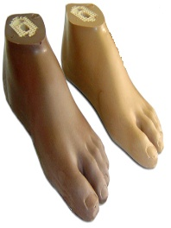
29 | Foot, sach 2.0, size 15, left, olive | Prosthetic foot, SACH type (Solid Ankle Cushion Heel), version 2.0, size 15 cm, left, colour olive. Polypropylene keel; cover moulded in polyurethane foam from a water-solvent system, polymerisation completed by exposure to high temperature and dry air. Foot is bolted through the foot arch and is therefore compatible with the ICRC polypropylene (PP) technology as well as with modular endoskeletal builds. Child size: supplied with one high-tensile M8 bolt and one lock washer; mates with SACH foot adapter 16A2/M8 (stainless steel). Storage: below 50 C and below 60 % relative humidity. Shelf life: to be fitted within 12-18 months of receipt - deliveries must carry a production date and at least 12 months remaining shelf life on arrival. Packed in cartons of 21 pieces (0.40 x 0.30 x 0.44 m, 0.05 m3 per carton). Reference product: ICRC catalogue code OCPOFOOTLI15L (CR-SACH, CR Equipements SA), or technically equivalent. NOTE: size 15 is below the smallest size (17 cm) published in the current ICRC standard catalogue - confirm availability before ordering. | 1 | 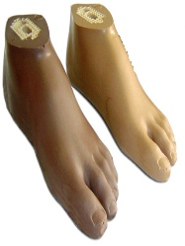
30 | Foot, sach 2.0, size 16, left, olive | Prosthetic foot, SACH type (Solid Ankle Cushion Heel), version 2.0, size 16 cm, left, colour olive. Polypropylene keel; cover moulded in polyurethane foam from a water-solvent system, polymerisation completed by exposure to high temperature and dry air. Foot is bolted through the foot arch and is therefore compatible with the ICRC polypropylene (PP) technology as well as with modular endoskeletal builds. Child size: supplied with one high-tensile M8 bolt and one lock washer; mates with SACH foot adapter 16A2/M8 (stainless steel). Storage: below 50 C and below 60 % relative humidity. Shelf life: to be fitted within 12-18 months of receipt - deliveries must carry a production date and at least 12 months remaining shelf life on arrival. Packed in cartons of 21 pieces (0.40 x 0.30 x 0.44 m, 0.05 m3 per carton). Reference product: ICRC catalogue code OCPOFOOTLI16L (CR-SACH, CR Equipements SA), or technically equivalent. NOTE: size 16 is below the smallest size (17 cm) published in the current ICRC standard catalogue - confirm availability before ordering. | 1 | 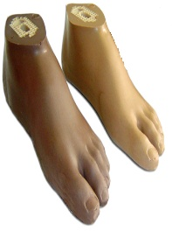
31 | Foot, sach 2.0, size 17, left, olive | Prosthetic foot, SACH type (Solid Ankle Cushion Heel), version 2.0, size 17 cm, left, colour olive. Polypropylene keel; cover moulded in polyurethane foam from a water-solvent system, polymerisation completed by exposure to high temperature and dry air. Foot is bolted through the foot arch and is therefore compatible with the ICRC polypropylene (PP) technology as well as with modular endoskeletal builds. Child size: supplied with one high-tensile M8 bolt and one lock washer; mates with SACH foot adapter 16A2/M8 (stainless steel). Storage: below 50 C and below 60 % relative humidity. Shelf life: to be fitted within 12-18 months of receipt - deliveries must carry a production date and at least 12 months remaining shelf life on arrival. Packed in cartons of 21 pieces (0.40 x 0.30 x 0.44 m, 0.05 m3 per carton). Reference product: ICRC catalogue code OCPOFOOTLI17L (CR-SACH, CR Equipements SA), or technically equivalent. | 1 | 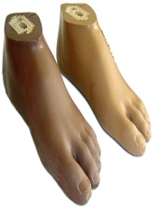
32 | Foot, sach 2.0, size 18, left, olive | Prosthetic foot, SACH type (Solid Ankle Cushion Heel), version 2.0, size 18 cm, left, colour olive. Polypropylene keel; cover moulded in polyurethane foam from a water-solvent system, polymerisation completed by exposure to high temperature and dry air. Foot is bolted through the foot arch and is therefore compatible with the ICRC polypropylene (PP) technology as well as with modular endoskeletal builds. Child size: supplied with one high-tensile M8 bolt and one lock washer; mates with SACH foot adapter 16A2/M8 (stainless steel). Storage: below 50 C and below 60 % relative humidity. Shelf life: to be fitted within 12-18 months of receipt - deliveries must carry a production date and at least 12 months remaining shelf life on arrival. Packed in cartons of 21 pieces (0.40 x 0.30 x 0.44 m, 0.05 m3 per carton). Reference product: ICRC catalogue code OCPOFOOTLI18L (CR-SACH, CR Equipements SA), or technically equivalent. | 1 | 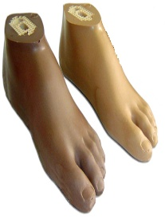
33 | Foot, sach 2.0, size 19, left, olive | Prosthetic foot, SACH type (Solid Ankle Cushion Heel), version 2.0, size 19 cm, left, colour olive. Polypropylene keel; cover moulded in polyurethane foam from a water-solvent system, polymerisation completed by exposure to high temperature and dry air. Foot is bolted through the foot arch and is therefore compatible with the ICRC polypropylene (PP) technology as well as with modular endoskeletal builds. Child size: supplied with one high-tensile M8 bolt and one lock washer; mates with SACH foot adapter 16A2/M8 (stainless steel). Storage: below 50 C and below 60 % relative humidity. Shelf life: to be fitted within 12-18 months of receipt - deliveries must carry a production date and at least 12 months remaining shelf life on arrival. Packed in cartons of 21 pieces (0.40 x 0.30 x 0.44 m, 0.05 m3 per carton). Reference product: ICRC catalogue code OCPOFOOTLI19L (CR-SACH, CR Equipements SA), or technically equivalent. | 1
34 | Foot, sach 2.0, size 20, left, olive | Prosthetic foot, SACH type (Solid Ankle Cushion Heel), version 2.0, size 20 cm, left, colour olive. Polypropylene keel; cover moulded in polyurethane foam from a water-solvent system, polymerisation completed by exposure to high temperature and dry air. Foot is bolted through the foot arch and is therefore compatible with the ICRC polypropylene (PP) technology as well as with modular endoskeletal builds. Child size: supplied with one high-tensile M8 bolt and one lock washer; mates with SACH foot adapter 16A2/M8 (stainless steel). Storage: below 50 C and below 60 % relative humidity. Shelf life: to be fitted within 12-18 months of receipt - deliveries must carry a production date and at least 12 months remaining shelf life on arrival. Packed in cartons of 21 pieces (0.40 x 0.30 x 0.44 m, 0.05 m3 per carton). Reference product: ICRC catalogue code OCPOFOOTLI20L (CR-SACH, CR Equipements SA), or technically equivalent. | 1
35 | Foot, sach 2.0, size 21, left, olive | Prosthetic foot, SACH type (Solid Ankle Cushion Heel), version 2.0, size 21 cm, left, colour olive. Polypropylene keel; cover moulded in polyurethane foam from a water-solvent system, polymerisation completed by exposure to high temperature and dry air. Foot is bolted through the foot arch and is therefore compatible with the ICRC polypropylene (PP) technology as well as with modular endoskeletal builds. Adult size: supplied with one high-tensile M10 bolt and one lock washer; mates with SACH foot adapter 16A2/M10 (stainless steel). Storage: below 50 C and below 60 % relative humidity. Shelf life: to be fitted within 12-18 months of receipt - deliveries must carry a production date and at least 12 months remaining shelf life on arrival. Packed in cartons of 28 pieces (0.40 x 0.30 x 0.44 m, 0.05 m3 per carton). Reference product: ICRC catalogue code OCPOFOOTLI21L (CR-SACH, CR Equipements SA), or technically equivalent. | 1
36 | Foot, sach 2.0, size 22, left, olive | Prosthetic foot, SACH type (Solid Ankle Cushion Heel), version 2.0, size 22 cm, left, colour olive. Polypropylene keel; cover moulded in polyurethane foam from a water-solvent system, polymerisation completed by exposure to high temperature and dry air. Foot is bolted through the foot arch and is therefore compatible with the ICRC polypropylene (PP) technology as well as with modular endoskeletal builds. Adult size: supplied with one high-tensile M10 bolt and one lock washer; mates with SACH foot adapter 16A2/M10 (stainless steel). Storage: below 50 C and below 60 % relative humidity. Shelf life: to be fitted within 12-18 months of receipt - deliveries must carry a production date and at least 12 months remaining shelf life on arrival. Packed in cartons of 28 pieces (0.40 x 0.30 x 0.44 m, 0.05 m3 per carton). Reference product: ICRC catalogue code OCPOFOOTLI22L (CR-SACH, CR Equipements SA), or technically equivalent. | 4 | 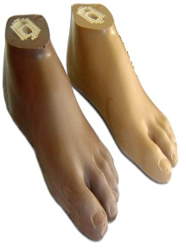
37 | Foot, sach 2.0, size 23, left, olive | Prosthetic foot, SACH type (Solid Ankle Cushion Heel), version 2.0, size 23 cm, left, colour olive. Polypropylene keel; cover moulded in polyurethane foam from a water-solvent system, polymerisation completed by exposure to high temperature and dry air. Foot is bolted through the foot arch and is therefore compatible with the ICRC polypropylene (PP) technology as well as with modular endoskeletal builds. Adult size: supplied with one high-tensile M10 bolt and one lock washer; mates with SACH foot adapter 16A2/M10 (stainless steel). Storage: below 50 C and below 60 % relative humidity. Shelf life: to be fitted within 12-18 months of receipt - deliveries must carry a production date and at least 12 months remaining shelf life on arrival. Packed in cartons of 28 pieces (0.40 x 0.30 x 0.44 m, 0.05 m3 per carton). Reference product: ICRC catalogue code OCPOFOOTLI23L (CR-SACH, CR Equipements SA), or technically equivalent. | 8 | 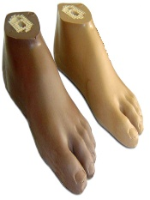
38 | Foot, sach 2.0, size 24, left, olive | Prosthetic foot, SACH type (Solid Ankle Cushion Heel), version 2.0, size 24 cm, left, colour olive. Polypropylene keel; cover moulded in polyurethane foam from a water-solvent system, polymerisation completed by exposure to high temperature and dry air. Foot is bolted through the foot arch and is therefore compatible with the ICRC polypropylene (PP) technology as well as with modular endoskeletal builds. Adult size: supplied with one high-tensile M10 bolt and one lock washer; mates with SACH foot adapter 16A2/M10 (stainless steel). Storage: below 50 C and below 60 % relative humidity. Shelf life: to be fitted within 12-18 months of receipt - deliveries must carry a production date and at least 12 months remaining shelf life on arrival. Packed in cartons of 28 pieces (0.40 x 0.30 x 0.44 m, 0.05 m3 per carton). Reference product: ICRC catalogue code OCPOFOOTLI24L (CR-SACH, CR Equipements SA), or technically equivalent. | 3 | 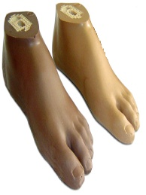
39 | Foot, sach 2.0, size 25, left, olive | Prosthetic foot, SACH type (Solid Ankle Cushion Heel), version 2.0, size 25 cm, left, colour olive. Polypropylene keel; cover moulded in polyurethane foam from a water-solvent system, polymerisation completed by exposure to high temperature and dry air. Foot is bolted through the foot arch and is therefore compatible with the ICRC polypropylene (PP) technology as well as with modular endoskeletal builds. Adult size: supplied with one high-tensile M10 bolt and one lock washer; mates with SACH foot adapter 16A2/M10 (stainless steel). Storage: below 50 C and below 60 % relative humidity. Shelf life: to be fitted within 12-18 months of receipt - deliveries must carry a production date and at least 12 months remaining shelf life on arrival. Packed in cartons of 28 pieces (0.40 x 0.30 x 0.44 m, 0.05 m3 per carton). Reference product: ICRC catalogue code OCPOFOOTLI25L (CR-SACH, CR Equipements SA), or technically equivalent. | 12
40 | Foot, sach 2.0, size 26, left, olive | Prosthetic foot, SACH type (Solid Ankle Cushion Heel), version 2.0, size 26 cm, left, colour olive. Polypropylene keel; cover moulded in polyurethane foam from a water-solvent system, polymerisation completed by exposure to high temperature and dry air. Foot is bolted through the foot arch and is therefore compatible with the ICRC polypropylene (PP) technology as well as with modular endoskeletal builds. Adult size: supplied with one high-tensile M10 bolt and one lock washer; mates with SACH foot adapter 16A2/M10 (stainless steel). Storage: below 50 C and below 60 % relative humidity. Shelf life: to be fitted within 12-18 months of receipt - deliveries must carry a production date and at least 12 months remaining shelf life on arrival. Packed in cartons of 28 pieces (0.40 x 0.30 x 0.44 m, 0.05 m3 per carton). Reference product: ICRC catalogue code OCPOFOOTLI26L (CR-SACH, CR Equipements SA), or technically equivalent. | 18 | 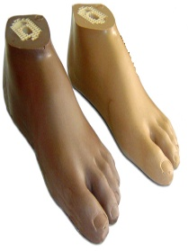
41 | Foot, sach 2.0, size 27, left, olive | Prosthetic foot, SACH type (Solid Ankle Cushion Heel), version 2.0, size 27 cm, left, colour olive. Polypropylene keel; cover moulded in polyurethane foam from a water-solvent system, polymerisation completed by exposure to high temperature and dry air. Foot is bolted through the foot arch and is therefore compatible with the ICRC polypropylene (PP) technology as well as with modular endoskeletal builds. Adult size: supplied with one high-tensile M10 bolt and one lock washer; mates with SACH foot adapter 16A2/M10 (stainless steel). Storage: below 50 C and below 60 % relative humidity. Shelf life: to be fitted within 12-18 months of receipt - deliveries must carry a production date and at least 12 months remaining shelf life on arrival. Packed in cartons of 28 pieces (0.40 x 0.30 x 0.44 m, 0.05 m3 per carton). Reference product: ICRC catalogue code OCPOFOOTLI27L (CR-SACH, CR Equipements SA), or technically equivalent. | 8 | 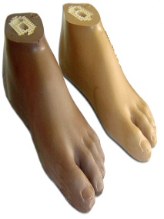
42 | Foot, sach 2.0, size 28, left, olive | Prosthetic foot, SACH type (Solid Ankle Cushion Heel), version 2.0, size 28 cm, left, colour olive. Polypropylene keel; cover moulded in polyurethane foam from a water-solvent system, polymerisation completed by exposure to high temperature and dry air. Foot is bolted through the foot arch and is therefore compatible with the ICRC polypropylene (PP) technology as well as with modular endoskeletal builds. Adult size: supplied with one high-tensile M10 bolt and one lock washer; mates with SACH foot adapter 16A2/M10 (stainless steel). Storage: below 50 C and below 60 % relative humidity. Shelf life: to be fitted within 12-18 months of receipt - deliveries must carry a production date and at least 12 months remaining shelf life on arrival. Packed in cartons of 28 pieces (0.40 x 0.30 x 0.44 m, 0.05 m3 per carton). Reference product: ICRC catalogue code OCPOFOOTLI28L (CR-SACH, CR Equipements SA), or technically equivalent. | 3 | 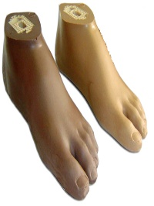
43 | Foot for long stump, olive color, 25cm, left | Prosthetic foot for long residual limb / Syme level, SACH type, size 25 cm, left, olive. Reduced build height to allow fitting where the residual limb extends close to the floor. Polypropylene keel with polyurethane foam cover; bolt fixing through the foot arch, compatible with ICRC polypropylene technology. Storage below 50 C and below 60 % relative humidity; to be fitted within 12-18 months of receipt. Supplier to state in the offer: build height (mm), unit mass (g), bolt thread (M8/M10) and maximum patient body weight (kg) for the size quoted. Reference: ICRC catalogue family 'Feet for long stump - Type SACH for Syme' (OCPOFOOT02), item code OCPOFOOTLILS25L, or technically equivalent. | 1 | 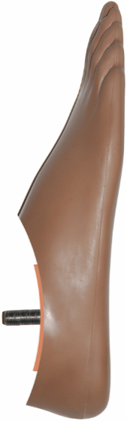
44 | Foot for long stump, olive color, 21cm, left | Prosthetic foot for long residual limb / Syme level, SACH type, size 21 cm, left, olive. Reduced build height to allow fitting where the residual limb extends close to the floor. Polypropylene keel with polyurethane foam cover; bolt fixing through the foot arch, compatible with ICRC polypropylene technology. Storage below 50 C and below 60 % relative humidity; to be fitted within 12-18 months of receipt. Supplier to state in the offer: build height (mm), unit mass (g), bolt thread (M8/M10) and maximum patient body weight (kg) for the size quoted. Reference: ICRC catalogue family 'Feet for long stump - Type SACH for Syme' (OCPOFOOT02), item code OCPOFOOTLILS21L, or technically equivalent. | 1
45 | Foot for long stump, olive color, 21cm, right | Prosthetic foot for long residual limb / Syme level, SACH type, size 21 cm, right, olive. Reduced build height to allow fitting where the residual limb extends close to the floor. Polypropylene keel with polyurethane foam cover; bolt fixing through the foot arch, compatible with ICRC polypropylene technology. Storage below 50 C and below 60 % relative humidity; to be fitted within 12-18 months of receipt. Supplier to state in the offer: build height (mm), unit mass (g), bolt thread (M8/M10) and maximum patient body weight (kg) for the size quoted. Reference: ICRC catalogue family 'Feet for long stump - Type SACH for Syme' (OCPOFOOT02), item code OCPOFOOTLILS21R, or technically equivalent. | 1
46 | Foot for long stump, olive color, 23cm, right | Prosthetic foot for long residual limb / Syme level, SACH type, size 23 cm, right, olive. Reduced build height to allow fitting where the residual limb extends close to the floor. Polypropylene keel with polyurethane foam cover; bolt fixing through the foot arch, compatible with ICRC polypropylene technology. Storage below 50 C and below 60 % relative humidity; to be fitted within 12-18 months of receipt. Supplier to state in the offer: build height (mm), unit mass (g), bolt thread (M8/M10) and maximum patient body weight (kg) for the size quoted. Reference: ICRC catalogue family 'Feet for long stump - Type SACH for Syme' (OCPOFOOT02), item code OCPOFOOTLILS23R, or technically equivalent. | 1
47 | Foot for long stump, olive color, 25cm, right | Prosthetic foot for long residual limb / Syme level, SACH type, size 25 cm, right, olive. Reduced build height to allow fitting where the residual limb extends close to the floor. Polypropylene keel with polyurethane foam cover; bolt fixing through the foot arch, compatible with ICRC polypropylene technology. Storage below 50 C and below 60 % relative humidity; to be fitted within 12-18 months of receipt. Supplier to state in the offer: build height (mm), unit mass (g), bolt thread (M8/M10) and maximum patient body weight (kg) for the size quoted. Reference: ICRC catalogue family 'Feet for long stump - Type SACH for Syme' (OCPOFOOT02), item code OCPOFOOTLILS25R, or technically equivalent. | 1
48 | Foot sach low profile, olive colour, 20 cm right | Prosthetic foot, SACH type, LOW PROFILE, size 20 cm, right, olive. Low build height for long trans-tibial residual limbs. Polypropylene keel with polyurethane foam cover; bolt fixing through the foot arch, compatible with ICRC polypropylene technology. Storage below 50 C and below 60 % relative humidity; to be fitted within 12-18 months of receipt. Supplier to state in the offer: build height (mm), unit mass (g), bolt thread (M8/M10) and maximum patient body weight (kg). DATA ISSUE: this item shares the code prefix OCPOFOOTLILS with the 'long stump / Syme' feet above - the two families must be given distinct codes before the order is placed, otherwise the supplier cannot tell them apart. | 1
49 | Foot sach low profile, olive colour, 22 cm right | Prosthetic foot, SACH type, LOW PROFILE, size 22 cm, right, olive. Low build height for long trans-tibial residual limbs. Polypropylene keel with polyurethane foam cover; bolt fixing through the foot arch, compatible with ICRC polypropylene technology. Storage below 50 C and below 60 % relative humidity; to be fitted within 12-18 months of receipt. Supplier to state in the offer: build height (mm), unit mass (g), bolt thread (M8/M10) and maximum patient body weight (kg). DATA ISSUE: this item shares the code prefix OCPOFOOTLILS with the 'long stump / Syme' feet above - the two families must be given distinct codes before the order is placed, otherwise the supplier cannot tell them apart. | 1
50 | Foot sach low profile, olive colour, 24 cm right | Prosthetic foot, SACH type, LOW PROFILE, size 24 cm, right, olive. Low build height for long trans-tibial residual limbs. Polypropylene keel with polyurethane foam cover; bolt fixing through the foot arch, compatible with ICRC polypropylene technology. Storage below 50 C and below 60 % relative humidity; to be fitted within 12-18 months of receipt. Supplier to state in the offer: build height (mm), unit mass (g), bolt thread (M8/M10) and maximum patient body weight (kg). DATA ISSUE: this item shares the code prefix OCPOFOOTLILS with the 'long stump / Syme' feet above - the two families must be given distinct codes before the order is placed, otherwise the supplier cannot tell them apart. | 3
51 | Foot sach low profile, olive colour, 26 cm right | Prosthetic foot, SACH type, LOW PROFILE, size 26 cm, right, olive. Low build height for long trans-tibial residual limbs. Polypropylene keel with polyurethane foam cover; bolt fixing through the foot arch, compatible with ICRC polypropylene technology. Storage below 50 C and below 60 % relative humidity; to be fitted within 12-18 months of receipt. Supplier to state in the offer: build height (mm), unit mass (g), bolt thread (M8/M10) and maximum patient body weight (kg). DATA ISSUE: this item shares the code prefix OCPOFOOTLILS with the 'long stump / Syme' feet above - the two families must be given distinct codes before the order is placed, otherwise the supplier cannot tell them apart. | 1
52 | Foot sach low profile, olive colour, 20 cm left | Prosthetic foot, SACH type, LOW PROFILE, size 20 cm, left, olive. Low build height for long trans-tibial residual limbs. Polypropylene keel with polyurethane foam cover; bolt fixing through the foot arch, compatible with ICRC polypropylene technology. Storage below 50 C and below 60 % relative humidity; to be fitted within 12-18 months of receipt. Supplier to state in the offer: build height (mm), unit mass (g), bolt thread (M8/M10) and maximum patient body weight (kg). DATA ISSUE: this item shares the code prefix OCPOFOOTLILS with the 'long stump / Syme' feet above - the two families must be given distinct codes before the order is placed, otherwise the supplier cannot tell them apart. | 1
53 | Foot sach low profile, olive colour, 22 cm left | Prosthetic foot, SACH type, LOW PROFILE, size 22 cm, left, olive. Low build height for long trans-tibial residual limbs. Polypropylene keel with polyurethane foam cover; bolt fixing through the foot arch, compatible with ICRC polypropylene technology. Storage below 50 C and below 60 % relative humidity; to be fitted within 12-18 months of receipt. Supplier to state in the offer: build height (mm), unit mass (g), bolt thread (M8/M10) and maximum patient body weight (kg). DATA ISSUE: this item shares the code prefix OCPOFOOTLILS with the 'long stump / Syme' feet above - the two families must be given distinct codes before the order is placed, otherwise the supplier cannot tell them apart. | 1
54 | Foot sach low profile, olive colour, 24 cm left | Prosthetic foot, SACH type, LOW PROFILE, size 24 cm, left, olive. Low build height for long trans-tibial residual limbs. Polypropylene keel with polyurethane foam cover; bolt fixing through the foot arch, compatible with ICRC polypropylene technology. Storage below 50 C and below 60 % relative humidity; to be fitted within 12-18 months of receipt. Supplier to state in the offer: build height (mm), unit mass (g), bolt thread (M8/M10) and maximum patient body weight (kg). DATA ISSUE: this item shares the code prefix OCPOFOOTLILS with the 'long stump / Syme' feet above - the two families must be given distinct codes before the order is placed, otherwise the supplier cannot tell them apart. | 1
55 | Foot sach low profile, olive colour, 26 cm left | Prosthetic foot, SACH type, LOW PROFILE, size 26 cm, left, olive. Low build height for long trans-tibial residual limbs. Polypropylene keel with polyurethane foam cover; bolt fixing through the foot arch, compatible with ICRC polypropylene technology. Storage below 50 C and below 60 % relative humidity; to be fitted within 12-18 months of receipt. Supplier to state in the offer: build height (mm), unit mass (g), bolt thread (M8/M10) and maximum patient body weight (kg). DATA ISSUE: this item shares the code prefix OCPOFOOTLILS with the 'long stump / Syme' feet above - the two families must be given distinct codes before the order is placed, otherwise the supplier cannot tell them apart. | 1
56 | Tube Adapter stainless steel 30x2.5MM (Long ADULT) | Tube adapter, stainless steel, tube outside diameter 30 mm. Aluminium light-alloy tube 30 x 2.5 mm crimped to a stainless-steel tube-clamp body with adjustment-core (pyramid) support and 4 adjustment screws 22A2/M8x14, zinc-plated. Adjustable effective height 78 mm (min.) to 414 mm (max.) - cut to length on assembly. Unit mass 360 g. Maximum patient body weight 125 kg. Structural strength to ISO 10328 (lower-limb prosthesis components). Reference product: Streifeneder 15A3/S400, or technically equivalent. | 25 | 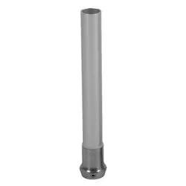
57 | Tube ADAPTER STAINLESS (SHORT ADULT ) TT-2R2 | Tube adapter, stainless steel, short adult, tube outside diameter 30 mm. Tube 30 x 2.5 mm with adjustment-core (pyramid) support and 4 zinc-plated adjustment set screws; for short trans-tibial builds. Supplier to state in the offer: exact tube length / adjustable effective height range (mm), unit mass (g) and maximum patient body weight (kg). Structural strength to ISO 10328 (lower-limb prosthesis components). Reference: existing stock is marked 'TT-2R2'; the equivalent short-tube adapters are Streifeneder 15A5/S100 (57-100 mm) and 15A3/S200 (78-214 mm). DATA ISSUE: item code (OCPOMODU2R2) and ICRC code (OCPOMODU2R3) do not match in the inventory - reconcile before ordering. | 170
58 | Tube clamp adapter-stainl.steel for tubes o 30mm | Tube clamp adapter, stainless steel, for tubes of 30 mm outside diameter. Total height 47 mm; effective (build) height 14 mm. With adjustment-core (pyramid) support and 4 adjustment screws 22A2/M8x14, zinc-plated. Split-clamp fixing. Unit mass 120 g. Maximum patient body weight 125 kg. Structural strength to ISO 10328 (lower-limb prosthesis components). Service/clamping parts set 11A11/E2 (white) available separately. Reference product: Streifeneder 11A11/S, or technically equivalent. | 130 | 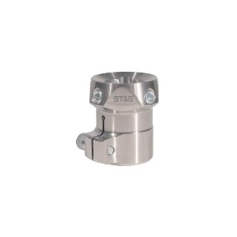
59 | Hip joint, adapter tube, tilt 20 degree | Tube clamp adapter with 20 degree tilt, for hip-disarticulation builds, for tubes of 30 mm outside diameter. Total height 58 mm; effective (build) height 24 mm. With 4 adjustment set screws 22A2/M8x12, zinc-plated, and complete clamping unit. Recommended for larger pelvic baskets. Titanium version 80 g, maximum patient body weight 100 kg. Intended for use with modular hip joint 7A5 only. Structural strength to ISO 10328 (lower-limb prosthesis components). Reference product: Streifeneder 11A20/T, or technically equivalent. Confirm required material (titanium vs stainless steel) before ordering. | 1 | 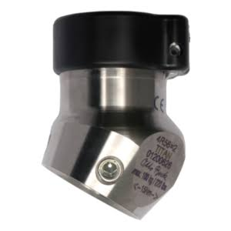
60 | Hip joint, adapter tube, tilt 10 degree | Tube clamp adapter with 10 degree tilt, for hip-disarticulation builds, for tubes of 30 mm outside diameter. Total height 55 mm; effective (build) height 21 mm. With adjustment-core support and 4 adjustment screws 22A2/M8x14, zinc-plated. Intended for use with modular hip joint 7A4 only. Available in aluminium (63 g, max. 75 kg), titanium (75 g, max. 100 kg) or stainless steel (125 g, max. 125 kg). Structural strength to ISO 10328 (lower-limb prosthesis components). Reference product: Streifeneder 11A12/S, or technically equivalent. Confirm required material before ordering. | 1
61 | Socket adapter with adjustment core stain.steel-with and lamination | Socket adapter with adjustment core (pyramid), stainless steel, for trans-tibial sockets. For direct lamination; wide peripheral groove for resin key. Central bore 8.1 mm. Effective (build) height 14 mm. Unit mass 85 g. Maximum patient body weight 100 kg. Supplied with silicone lamination dummy 22A8 to protect the pyramid during lamination. Structural strength to ISO 10328 (lower-limb prosthesis components). Reference product: Streifeneder 10A3/S, or technically equivalent. | 15 | 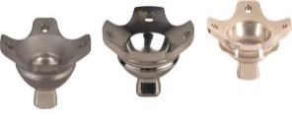
62 | Socket adapter with rotation adjustment (raster adjustment)-stainless steel | Socket adapter with adjustment-core SUPPORT and rotation adjustment (raster / indexed type), stainless steel. For connection of modular parts or a distal socket end. With 4 adjustment set screws 22A2/M8x14, zinc-plated. Effective (build) height 18 mm. Unit mass 125 g. Maximum patient body weight 125 kg. Replacement pressure plate 10A96/SE1 available separately. Structural strength to ISO 10328 (lower-limb prosthesis components). Reference product: Streifeneder 10A95/S, or technically equivalent. | 10 | 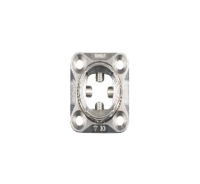
63 | Socket adapter with adjustment core and lamination anchor-stain.steel-with lamination anchor-stainl.steel with lamination dummy | Socket adapter with adjustment core (pyramid) AND lamination anchor, stainless steel, for direct lamination into trans-femoral sockets. Effective (build) height 12 mm. Unit mass 118 g. Maximum patient body weight 150 kg. Supplied with silicone lamination dummy 22A8. Structural strength to ISO 10328 (lower-limb prosthesis components). Reference product: Streifeneder 10A5/S, or technically equivalent. | 25 | 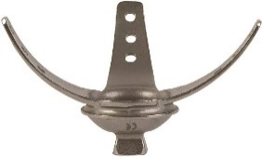
64 | Socket adapter, rotatable, with adjustment core support and lamination anchor-stainless steel | Socket adapter, rotatable, with adjustment-core SUPPORT and lamination anchor, stainless steel, for direct lamination into trans-femoral sockets. Continuous (stepless) rotation adjustment. With 4 adjustment set screws 22A2/M8x12, zinc-plated, and socket cap screw 22A2/M5x30. Effective (build) height 21 mm. Unit mass 169 g. Maximum patient body weight 125 kg. Lamination dummy 22A9 to be ordered separately. Structural strength to ISO 10328 (lower-limb prosthesis components). Reference product: Streifeneder 10A2/S, or technically equivalent. | 15 | 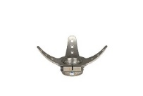
65 | Socket adapter with rotatable adjustment | Socket adapter, rotatable, with adjustment core (pyramid) and lamination anchor, stainless steel, for direct lamination into trans-femoral sockets. Central bore 8.5 mm. Continuous (stepless) rotation adjustment. Supplied with socket cap screw 22A2/M5x30. Effective (build) height 13 mm. Unit mass 170 g. Maximum patient body weight 125 kg. Lamination dummy 22A9 to be ordered separately. Structural strength to ISO 10328 (lower-limb prosthesis components). Reference product: Streifeneder 10A1/S, or technically equivalent. | 40 | 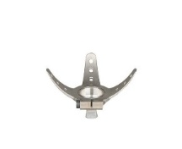
66 | Socket adapter 4 arm with rotatable adjustment | Socket adapter, 4-arm, stainless steel, with rotation adjustment and adjustment core (pyramid). For direct lamination into trans-femoral sockets; also suitable for direct connection to check sockets. Continuous (stepless) rotation adjustment. Supplied with socket cap screw 22A2/M5x20. Effective (build) height 23 mm. Unit mass 180 g. Maximum patient body weight 150 kg. Lamination dummy 22A9 to be ordered separately. Structural strength to ISO 10328 (lower-limb prosthesis components). Reference product: Streifeneder 10A8/S, or technically equivalent. | 20 | 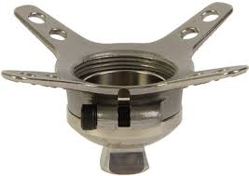
67 | Sach foot adapter with bolted connection m8 | SACH foot adapter, stainless steel, thread M8, complete with bolted connection (steel socket cap screw, washer, serrated lock washer). Effective (build) height 9 mm. Unit mass 118 g. Maximum patient body weight 100 kg. Bonded to the foot with adapter adhesive 118P32 or equivalent. Structural strength to ISO 10328 (lower-limb prosthesis components). Reference product: Streifeneder 16A2/M8, or technically equivalent. | 2 | 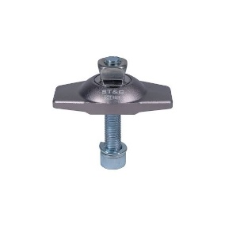
68 | Sach foot adapter with bolted connection m10 | SACH foot adapter, stainless steel, thread M10, complete with bolted connection (steel socket cap screw, washer, serrated lock washer). Effective (build) height 9 mm. Unit mass 128 g. Maximum patient body weight 125 kg. Bonded to the foot with adapter adhesive 118P32 or equivalent. Structural strength to ISO 10328 (lower-limb prosthesis components). Reference product: Streifeneder 16A2/M10, or technically equivalent. | 120 | 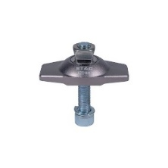
69 | Bolted connection for sach foot thread m8 | Bolted connection set for SACH foot, thread M8, for use with SACH foot adapter 16A2/M8. Set consists of 1 steel socket cap screw, 1 washer and 1 serrated lock washer. Service/replacement item. Reference product: Streifeneder 16A2/E8, or technically equivalent. | 2 | 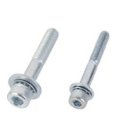
70 | Single axis foot adapter foot size 26-30 | Single-axis foot adapter, steel, for foot sizes 26-30 cm. Supplied with lower bearing shell, plantar flexion bumper and one dorsal flexion bumper 32A6/D5 (5 mm). Effective (build) height 27 mm. Unit mass 320 g. Maximum patient body weight 100 kg. Heel height and dorsiflexion are adjusted by exchanging the dorsal flexion bumper (32A6/D5 = 5 mm, 32A6/D10 = 10 mm; also 32A1/D10, 32A1/D12). Mates with single-axis feet 30A14 / 30A15 / 30A13 / 30A16. Structural strength to ISO 10328 (lower-limb prosthesis components). Reference product: Streifeneder 32A4/26-30, or technically equivalent. | 24 | 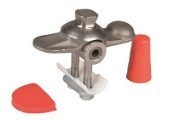
71 | Single axis foot adapter foot size 22-25 | Single-axis foot adapter, steel, for foot sizes 22-25 cm. Supplied with lower bearing shell, plantar flexion bumper and one dorsal flexion bumper 32A6/D5 (5 mm). Effective (build) height 27 mm. Unit mass 305 g. Maximum patient body weight 100 kg. Heel height and dorsiflexion are adjusted by exchanging the dorsal flexion bumper (32A6/D5 = 5 mm, 32A6/D10 = 10 mm; also 32A1/D10, 32A1/D12). Mates with single-axis feet 30A14 / 30A15 / 30A13 / 30A16. Structural strength to ISO 10328 (lower-limb prosthesis components). Reference product: Streifeneder 32A4/22-25, or technically equivalent. | 24 | 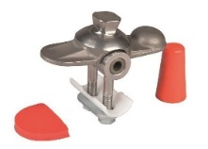
72 | Service single axis foot adapter | Service parts set for single-axis foot adapter, suitable for adapters 32A2, 32A3 and 32A4. Set consists of: 1 oval two-hole steel washer, 1 lower bearing shell, and 3 plantar flexion bumpers (1 soft/green, 1 medium/red, 1 hard/blue). Reference product: Streifeneder 32A6/E (previously listed as 32A4/E), or technically equivalent. | 7 | 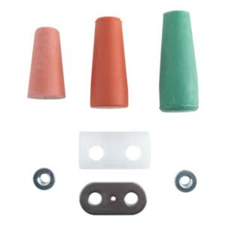
73 | Connection cap for single axis foot, foot size 23 cm | Connection cap for single-axis prosthetic foot, foot size 23 cm. Moulded plastic, slotted for easier insertion. Closes the ankle gap between the foot and the cosmetic foam cover. Fits single-axis foot adapters 32A2, 32A3 and 32A4. Unit mass 11 g. Bonded to the cosmetic soft foam cover with contact adhesive (Listra Fix 118P12 or equivalent) and clipped onto the foot. Reference product: Streifeneder 32A5/23, or technically equivalent. | 5 | 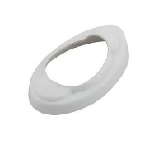
74 | Connection cap for single axis foot, foot size 24 cm | Connection cap for single-axis prosthetic foot, foot size 24 cm. Moulded plastic, slotted for easier insertion. Closes the ankle gap between the foot and the cosmetic foam cover. Fits single-axis foot adapters 32A2, 32A3 and 32A4. Unit mass 12 g. Bonded to the cosmetic soft foam cover with contact adhesive (Listra Fix 118P12 or equivalent) and clipped onto the foot. Reference product: Streifeneder 32A5/24, or technically equivalent. | 5 | 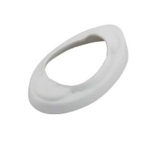
75 | Connection cap for single axis foot, foot size 25 cm | Connection cap for single-axis prosthetic foot, foot size 25 cm. Moulded plastic, slotted for easier insertion. Closes the ankle gap between the foot and the cosmetic foam cover. Fits single-axis foot adapters 32A2, 32A3 and 32A4. Unit mass 13 g. Bonded to the cosmetic soft foam cover with contact adhesive (Listra Fix 118P12 or equivalent) and clipped onto the foot. Reference product: Streifeneder 32A5/25, or technically equivalent. | 5 | 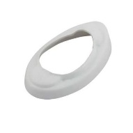
76 | Connection cap for single axis foot, foot size 26 cm | Connection cap for single-axis prosthetic foot, foot size 26 cm. Moulded plastic, slotted for easier insertion. Closes the ankle gap between the foot and the cosmetic foam cover. Fits single-axis foot adapters 32A2, 32A3 and 32A4. Unit mass 14 g. Bonded to the cosmetic soft foam cover with contact adhesive (Listra Fix 118P12 or equivalent) and clipped onto the foot. Reference product: Streifeneder 32A5/26, or technically equivalent. | 5
77 | Connection cap for single axis foot, foot size 27 cm | Connection cap for single-axis prosthetic foot, foot size 27 cm. Moulded plastic, slotted for easier insertion. Closes the ankle gap between the foot and the cosmetic foam cover. Fits single-axis foot adapters 32A2, 32A3 and 32A4. Unit mass 15 g. Bonded to the cosmetic soft foam cover with contact adhesive (Listra Fix 118P12 or equivalent) and clipped onto the foot. Reference product: Streifeneder 32A5/27, or technically equivalent. | 5 | 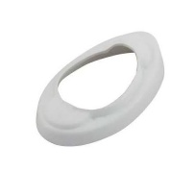
78 | Connection cap for single axis foot, foot size 28cm | Connection cap for single-axis prosthetic foot, foot size 28 cm. Moulded plastic, slotted for easier insertion. Closes the ankle gap between the foot and the cosmetic foam cover. Fits single-axis foot adapters 32A2, 32A3 and 32A4. Unit mass 16 g. Bonded to the cosmetic soft foam cover with contact adhesive (Listra Fix 118P12 or equivalent) and clipped onto the foot. Reference product: Streifeneder 32A5/28, or technically equivalent. | 5 | 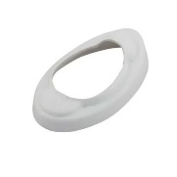
79 | Orthosis offset 20mm adult | Orthotic knee joint for knee-ankle-foot orthosis (KAFO), adult size, stainless steel, for uprights 20 mm wide. Type: free-motion knee joint whose axis is offset POSTERIOR to the weight-bearing line, giving stance-phase stability without any lock; unrestricted flexion, extension stop at 0 degrees. Supplied as a matched medial/lateral PAIR complete with proximal and distal uprights and all rivets/fixing screws. Uprights to be contourable cold without cracking. Structural strength to ISO 22523 (external limb prostheses and orthoses). Supplier to state in the offer: joint material and finish, bar width x thickness (mm), upright lengths (mm), unit mass and maximum patient body weight. Reference: ICRC catalogue code OCPOKNEEB20OFxx family. NOTE: confirm whether the price is per pair or per single joint before ordering - the current inventory does not record the unit. | 5 | 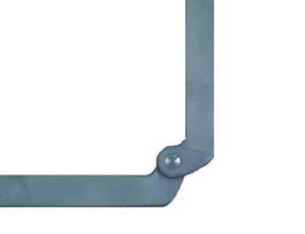
80 | Orthosis offset 16mm child | Orthotic knee joint for knee-ankle-foot orthosis (KAFO), child size, stainless steel, for uprights 16 mm wide. Type: free-motion knee joint whose axis is offset POSTERIOR to the weight-bearing line, giving stance-phase stability without any lock; unrestricted flexion, extension stop at 0 degrees. Supplied as a matched medial/lateral PAIR complete with proximal and distal uprights and all rivets/fixing screws. Uprights to be contourable cold without cracking. Structural strength to ISO 22523 (external limb prostheses and orthoses). Supplier to state in the offer: joint material and finish, bar width x thickness (mm), upright lengths (mm), unit mass and maximum patient body weight. Reference: ICRC catalogue code OCPOKNEEB16OFxx family. NOTE: confirm whether the price is per pair or per single joint before ordering - the current inventory does not record the unit. | 5
81 | Orthosis droplock 20mm adult | Orthotic knee joint for knee-ankle-foot orthosis (KAFO), adult size, stainless steel, for uprights 20 mm wide. Type: knee joint with DROP / RING LOCK: a sliding ring drops over the joint under gravity to lock it in full extension and is lifted manually by the wearer to release flexion; extension stop at 0 degrees. Supplied as a matched medial/lateral PAIR complete with proximal and distal uprights and all rivets/fixing screws. Uprights to be contourable cold without cracking. Structural strength to ISO 22523 (external limb prostheses and orthoses). Supplier to state in the offer: joint material and finish, bar width x thickness (mm), upright lengths (mm), unit mass and maximum patient body weight. Reference: ICRC catalogue code OCPOKNEEB20DRxx family. NOTE: confirm whether the price is per pair or per single joint before ordering - the current inventory does not record the unit. | 20 | 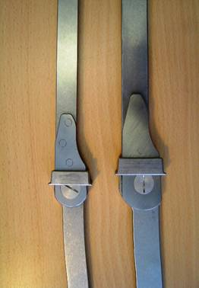
82 | Orthosis droplock 16mm child | Orthotic knee joint for knee-ankle-foot orthosis (KAFO), child size, stainless steel, for uprights 16 mm wide. Type: knee joint with DROP / RING LOCK: a sliding ring drops over the joint under gravity to lock it in full extension and is lifted manually by the wearer to release flexion; extension stop at 0 degrees. Supplied as a matched medial/lateral PAIR complete with proximal and distal uprights and all rivets/fixing screws. Uprights to be contourable cold without cracking. Structural strength to ISO 22523 (external limb prostheses and orthoses). Supplier to state in the offer: joint material and finish, bar width x thickness (mm), upright lengths (mm), unit mass and maximum patient body weight. Reference: ICRC catalogue code OCPOKNEEB16DRxx family. NOTE: confirm whether the price is per pair or per single joint before ordering - the current inventory does not record the unit. | 14
83 | Orthosis swisslock 20mm adult | Orthotic knee joint for knee-ankle-foot orthosis (KAFO), adult size, stainless steel, for uprights 20 mm wide. Type: knee joint with SWISS LOCK (bail lock, German 'Schweizer Sperre'): spring-loaded locking pawls on the medial and lateral joints engage automatically at full extension; both sides are released simultaneously by lifting the semi-circular posterior bail, allowing the wearer to sit without reaching down to each joint separately; extension stop at 0 degrees. Supplied as a matched medial/lateral PAIR complete with proximal and distal uprights and all rivets/fixing screws. Uprights to be contourable cold without cracking. Structural strength to ISO 22523 (external limb prostheses and orthoses). Supplier to state in the offer: joint material and finish, bar width x thickness (mm), upright lengths (mm), unit mass and maximum patient body weight. Reference: ICRC catalogue code OCPOKNEEB20SWxx family. NOTE: confirm whether the price is per pair or per single joint before ordering - the current inventory does not record the unit. | 12 | 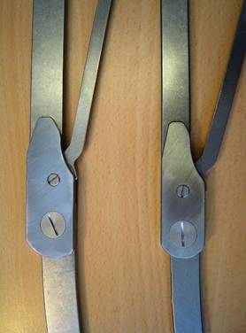
84 | Orthosis swisslock 16mm child | Orthotic knee joint for knee-ankle-foot orthosis (KAFO), child size, stainless steel, for uprights 16 mm wide. Type: knee joint with SWISS LOCK (bail lock, German 'Schweizer Sperre'): spring-loaded locking pawls on the medial and lateral joints engage automatically at full extension; both sides are released simultaneously by lifting the semi-circular posterior bail, allowing the wearer to sit without reaching down to each joint separately; extension stop at 0 degrees. Supplied as a matched medial/lateral PAIR complete with proximal and distal uprights and all rivets/fixing screws. Uprights to be contourable cold without cracking. Structural strength to ISO 22523 (external limb prostheses and orthoses). Supplier to state in the offer: joint material and finish, bar width x thickness (mm), upright lengths (mm), unit mass and maximum patient body weight. Reference: ICRC catalogue code OCPOKNEEB16SWxx family. NOTE: confirm whether the price is per pair or per single joint before ordering - the current inventory does not record the unit. | 8
85 | Double adapter stainless steel 32mm | Double adapter, stainless steel, effective (build) height 32 mm. Connects two pyramid / adjustment cores; permits angular correction at both the proximal and the distal end. Fitted top and bottom with 4 adjustment set screws each, 22A2/M8x12, zinc-plated. Unit mass 114 g. Maximum patient body weight 150 kg. Structural strength to ISO 10328 (lower-limb prosthesis components). Reference product: Streifeneder 10A50/S32, or technically equivalent. | 4 | 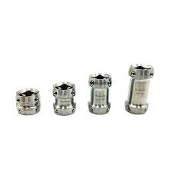
86 | Double adapter stainless steel 45mm | Double adapter, stainless steel, effective (build) height 45 mm. Connects two pyramid / adjustment cores; permits angular correction at both the proximal and the distal end. Fitted top and bottom with 4 adjustment set screws each, 22A2/M8x12, zinc-plated. Unit mass 139 g. Maximum patient body weight 150 kg. Structural strength to ISO 10328 (lower-limb prosthesis components). Reference product: Streifeneder 10A50/S45, or technically equivalent. | 4
87 | Double adapter stainless steel 60mm | Double adapter, stainless steel, effective (build) height 60 mm. Connects two pyramid / adjustment cores; permits angular correction at both the proximal and the distal end. Fitted top and bottom with 4 adjustment set screws each, 22A2/M8x12, zinc-plated. Unit mass 162 g. Maximum patient body weight 150 kg. Structural strength to ISO 10328 (lower-limb prosthesis components). Reference product: Streifeneder 10A50/S60, or technically equivalent. | 4
88 | Double adapter stainless steel 75mm | Double adapter, stainless steel, effective (build) height 75 mm. Connects two pyramid / adjustment cores; permits angular correction at both the proximal and the distal end. Fitted top and bottom with 4 adjustment set screws each, 22A2/M8x12, zinc-plated. Unit mass 194 g. Maximum patient body weight 150 kg. Structural strength to ISO 10328 (lower-limb prosthesis components). Reference product: Streifeneder 10A50/S75, or technically equivalent. | 4
89 | Double adapter titanium 32mm | Double adapter, titanium, effective (build) height 32 mm. Adjustment-core support at both ends for connection between two pyramid / adjustment cores; permits angular correction proximally and distally. Fitted top and bottom with 4 adjustment screws each, 22A2/M8x14, zinc-plated. Unit mass 82 g. Maximum patient body weight 125 kg. Structural strength to ISO 10328 (lower-limb prosthesis components). Reference product: Streifeneder 10A50/T32, or technically equivalent. | 4
90 | Double adapter titanium 45mm | Double adapter, titanium, effective (build) height 45 mm. Adjustment-core support at both ends for connection between two pyramid / adjustment cores; permits angular correction proximally and distally. Fitted top and bottom with 4 adjustment screws each, 22A2/M8x14, zinc-plated. Unit mass 96 g. Maximum patient body weight 125 kg. Structural strength to ISO 10328 (lower-limb prosthesis components). Reference product: Streifeneder 10A50/T45, or technically equivalent. | 4
91 | Double adapter titanium 60mm | Double adapter, titanium, effective (build) height 60 mm. Adjustment-core support at both ends for connection between two pyramid / adjustment cores; permits angular correction proximally and distally. Fitted top and bottom with 4 adjustment screws each, 22A2/M8x14, zinc-plated. Unit mass 108 g. Maximum patient body weight 125 kg. Structural strength to ISO 10328 (lower-limb prosthesis components). Reference product: Streifeneder 10A50/T60, or technically equivalent. | 4
92 | Double adapter titanium 75mm | Double adapter, titanium, effective (build) height 75 mm. Adjustment-core support at both ends for connection between two pyramid / adjustment cores; permits angular correction proximally and distally. Fitted top and bottom with 4 adjustment screws each, 22A2/M8x14, zinc-plated. Unit mass 122 g. Maximum patient body weight 125 kg. Structural strength to ISO 10328 (lower-limb prosthesis components). Reference product: Streifeneder 10A50/T75, or technically equivalent. | 2
93 | Foot abduction brace, type denis brown splint | Foot abduction brace, type Denis Browne splint, for maintenance of correction in congenital talipes equinovarus (clubfoot). Rigid abduction bar with fixed shoe mounting plates; bar length to be adjustable to the child's shoulder width and abduction angle to be adjustable independently left and right. Supplied without shoes - order shoes separately by size. Reference: ICRC catalogue code OCPOFOOTTDB, or technically equivalent. NOTE: consumption of the Denis Browne type is very low against the Basko quick-release type - review whether this line should be retained at all. | 8 | 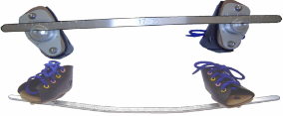
94 | Foot abduction brace, type basko quick release splint | Foot abduction brace, type Basko quick-release splint, for post-operative / post-casting management of congenital talipes equinovarus (clubfoot) under the Ponseti method. Adjustable abduction bar with QUICK-RELEASE shoe mountings allowing either shoe to be detached independently. Bar length adjustable to the child's shoulder width; abduction angle adjustable independently left and right (nominally 60-70 degrees on the affected side, 30-40 degrees on the unaffected side); dorsiflexion built into the bar. Supplied without shoes - order shoes separately by size. Reference: ICRC catalogue code OCPOFOOTADBASKO, or technically equivalent. | 8 | 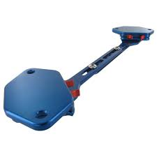
95 | Shoes size 86-93mm, for abduction brace, type denis brown | Shoes, pair, foot length 86-93 mm, for foot abduction brace type Denis Browne. Open-toe design with rigid sole drilled/plated to accept the Denis Browne bar. Upper in soft leather or equivalent with full-length opening and hook-and-loop closure. Supplied as a matched pair. Must be dimensionally compatible with the Denis Browne splint already in service. Reference: ICRC catalogue code OCPOFOOTTDBS2, or technically equivalent. DATA ISSUE: the size ranges recorded for OCPOFOOTTDBS2 (86-93 mm) and OCPOFOOTTDBS3 (84-101 mm) overlap - verify against the catalogue before ordering. | 2
96 | Shoes size 84-101mm, for abduction brace, type denis brown | Shoes, pair, foot length 84-101 mm, for foot abduction brace type Denis Browne. Open-toe design with rigid sole drilled/plated to accept the Denis Browne bar. Upper in soft leather or equivalent with full-length opening and hook-and-loop closure. Supplied as a matched pair. Must be dimensionally compatible with the Denis Browne splint already in service. Reference: ICRC catalogue code OCPOFOOTTDBS3, or technically equivalent. DATA ISSUE: the size ranges recorded for OCPOFOOTTDBS2 (86-93 mm) and OCPOFOOTTDBS3 (84-101 mm) overlap - verify against the catalogue before ordering. | 2
97 | Shoes size 102-109mm, for abduction brace, type denis brown | Shoes, pair, foot length 102-109 mm, for foot abduction brace type Denis Browne. Open-toe design with rigid sole drilled/plated to accept the Denis Browne bar. Upper in soft leather or equivalent with full-length opening and hook-and-loop closure. Supplied as a matched pair. Must be dimensionally compatible with the Denis Browne splint already in service. Reference: ICRC catalogue code OCPOFOOTTDBS4, or technically equivalent. DATA ISSUE: the size ranges recorded for OCPOFOOTTDBS2 (86-93 mm) and OCPOFOOTTDBS3 (84-101 mm) overlap - verify against the catalogue before ordering. | 2
98 | Shoes size 110-117mm, for abduction brace, type denis brown | Shoes, pair, foot length 110-117 mm, for foot abduction brace type Denis Browne. Open-toe design with rigid sole drilled/plated to accept the Denis Browne bar. Upper in soft leather or equivalent with full-length opening and hook-and-loop closure. Supplied as a matched pair. Must be dimensionally compatible with the Denis Browne splint already in service. Reference: ICRC catalogue code OCPOFOOTTDBS5, or technically equivalent. DATA ISSUE: the size ranges recorded for OCPOFOOTTDBS2 (86-93 mm) and OCPOFOOTTDBS3 (84-101 mm) overlap - verify against the catalogue before ordering. | 2
99 | Shoes size 118-125mm, for abduction brace, type denis brown | Shoes, pair, foot length 118-125 mm, for foot abduction brace type Denis Browne. Open-toe design with rigid sole drilled/plated to accept the Denis Browne bar. Upper in soft leather or equivalent with full-length opening and hook-and-loop closure. Supplied as a matched pair. Must be dimensionally compatible with the Denis Browne splint already in service. Reference: ICRC catalogue code OCPOFOOTTDBS6, or technically equivalent. DATA ISSUE: the size ranges recorded for OCPOFOOTTDBS2 (86-93 mm) and OCPOFOOTTDBS3 (84-101 mm) overlap - verify against the catalogue before ordering. | 2
100 | Shoes size 14 pair abduction brace type basko denis brown | Shoes, pair, size 14, for foot abduction brace type Basko. Open-toe design with rigid sole and a fixing plate/interface matched to the Basko quick-release bar. Upper in soft leather or equivalent with full-length opening and hook-and-loop closure to allow the foot to be seated without force. Supplied as a matched pair. Must be dimensionally compatible with the abduction brace already in service (Basko quick-release splint). Reference: ICRC catalogue code OCPOFOOTBAS14, or technically equivalent. | 2
101 | Shoes size 16 pair abduction brace type basko denis brown | Shoes, pair, size 16, for foot abduction brace type Basko. Open-toe design with rigid sole and a fixing plate/interface matched to the Basko quick-release bar. Upper in soft leather or equivalent with full-length opening and hook-and-loop closure to allow the foot to be seated without force. Supplied as a matched pair. Must be dimensionally compatible with the abduction brace already in service (Basko quick-release splint). Reference: ICRC catalogue code OCPOFOOTBAS16, or technically equivalent. | 2
102 | Shoes size 18 pair abduction brace type basko denis brown | Shoes, pair, size 18, for foot abduction brace type Basko. Open-toe design with rigid sole and a fixing plate/interface matched to the Basko quick-release bar. Upper in soft leather or equivalent with full-length opening and hook-and-loop closure to allow the foot to be seated without force. Supplied as a matched pair. Must be dimensionally compatible with the abduction brace already in service (Basko quick-release splint). Reference: ICRC catalogue code OCPOFOOTBAS18, or technically equivalent. | 2
103 | Shoes size 20 pair abduction brace type basko denis brown | Shoes, pair, size 20, for foot abduction brace type Basko. Open-toe design with rigid sole and a fixing plate/interface matched to the Basko quick-release bar. Upper in soft leather or equivalent with full-length opening and hook-and-loop closure to allow the foot to be seated without force. Supplied as a matched pair. Must be dimensionally compatible with the abduction brace already in service (Basko quick-release splint). Reference: ICRC catalogue code OCPOFOOTBAS20, or technically equivalent. | 2
104 | Shoes size 22 pair abduction brace type basko denis brown | Shoes, pair, size 22, for foot abduction brace type Basko. Open-toe design with rigid sole and a fixing plate/interface matched to the Basko quick-release bar. Upper in soft leather or equivalent with full-length opening and hook-and-loop closure to allow the foot to be seated without force. Supplied as a matched pair. Must be dimensionally compatible with the abduction brace already in service (Basko quick-release splint). Reference: ICRC catalogue code OCPOFOOTBAS22, or technically equivalent. | 2
105 | Shoes size 26 pair abduction brace type basko denis brown | Shoes, pair, size 26, for foot abduction brace type Basko. Open-toe design with rigid sole and a fixing plate/interface matched to the Basko quick-release bar. Upper in soft leather or equivalent with full-length opening and hook-and-loop closure to allow the foot to be seated without force. Supplied as a matched pair. Must be dimensionally compatible with the abduction brace already in service (Basko quick-release splint). Reference: ICRC catalogue code OCPOFOOTBAS26, or technically equivalent. | 2
106 | Shoes size 28 pair abduction brace type basko denis brown | Shoes, pair, size 28, for foot abduction brace type Basko. Open-toe design with rigid sole and a fixing plate/interface matched to the Basko quick-release bar. Upper in soft leather or equivalent with full-length opening and hook-and-loop closure to allow the foot to be seated without force. Supplied as a matched pair. Must be dimensionally compatible with the abduction brace already in service (Basko quick-release splint). Reference: ICRC catalogue code OCPOFOOTBAS28, or technically equivalent. | 2
107 | Shoes size 30 pair abduction brace type basko denis brown | Shoes, pair, size 30, for foot abduction brace type Basko. Open-toe design with rigid sole and a fixing plate/interface matched to the Basko quick-release bar. Upper in soft leather or equivalent with full-length opening and hook-and-loop closure to allow the foot to be seated without force. Supplied as a matched pair. Must be dimensionally compatible with the abduction brace already in service (Basko quick-release splint). Reference: ICRC catalogue code OCPOFOOTBAS30, or technically equivalent. | 2
108 | Derma seal sock 453d7=3 | Sealing sleeve / suspension sock for prosthetic socket, reference 453D7=3. Knitted textile sleeve with a sealing band, worn over the residual limb and the proximal socket brim to maintain suction suspension. Size 3. Supplier to state in the offer: size range in circumference (cm), length (cm), material composition and washing instructions. Reference: Ottobock 453D7=3, or technically equivalent. DATA ISSUE: in the current inventory the item codes and the descriptions disagree - OPHYREHA453D77 is described as '453D7=5' and OPHYREHA453D75 is described as '453D7=7'. Reconcile code against size before ordering, or the wrong size will be delivered. | 5 | 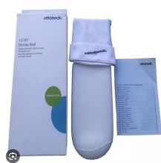
109 | Derma seal sock 453d7=5 | Sealing sleeve / suspension sock for prosthetic socket, reference 453D7=5. Knitted textile sleeve with a sealing band, worn over the residual limb and the proximal socket brim to maintain suction suspension. Size 5. Supplier to state in the offer: size range in circumference (cm), length (cm), material composition and washing instructions. Reference: Ottobock 453D7=5, or technically equivalent. DATA ISSUE: in the current inventory the item codes and the descriptions disagree - OPHYREHA453D77 is described as '453D7=5' and OPHYREHA453D75 is described as '453D7=7'. Reconcile code against size before ordering, or the wrong size will be delivered. | 5 | 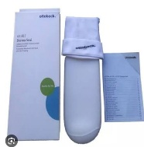
110 | Derma seal sock 453d7=7 | Sealing sleeve / suspension sock for prosthetic socket, reference 453D7=7. Knitted textile sleeve with a sealing band, worn over the residual limb and the proximal socket brim to maintain suction suspension. Size 7. Supplier to state in the offer: size range in circumference (cm), length (cm), material composition and washing instructions. Reference: Ottobock 453D7=7, or technically equivalent. DATA ISSUE: in the current inventory the item codes and the descriptions disagree - OPHYREHA453D77 is described as '453D7=5' and OPHYREHA453D75 is described as '453D7=7'. Reconcile code against size before ordering, or the wrong size will be delivered. | 5 | 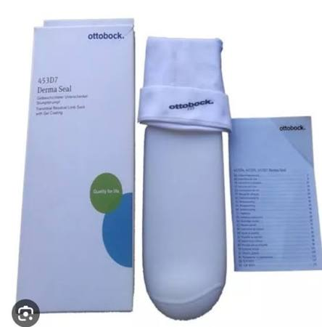
111 | STRAP, VELCRO, PVC, WITH LOOP, BROWN, 300x25mm | Strap, PVC-coated, brown, 300 x 25 mm, with sewn loop and hook-and-loop closure. For fastening lower-limb orthoses. Loop end to allow the strap to be passed through a D-ring and folded back onto itself. PVC coating to be wipe- cleanable and non-absorbent. Reference: ICRC catalogue code OSBOSTRVP325, or technically equivalent. | 10 | 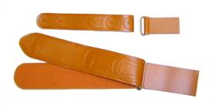
112 | Strap, velcro, pvc, with loop, brown, 400x400 mm | Strap, PVC-coated, brown, 400 x 40 mm, with sewn loop and hook-and-loop closure. For fastening lower-limb orthoses. Loop end to allow the strap to be passed through a D-ring and folded back onto itself. PVC coating to be wipe- cleanable and non-absorbent. Reference: ICRC catalogue code OSBOSTRVP440, or technically equivalent. DATA ISSUE: the inventory records this item as '400 X 400 MM', which is almost certainly a typing error for 400 x 40 mm (consistent with the code suffix 440). Confirm before ordering. | 20
113 | Strap, velcro, 30mm, hook | Hook-and-loop fastener tape, HOOK side only, width 30 mm, black. Supplied on a continuous roll, sew-on (non-adhesive) backing. Supplier to state roll length (m) and to quote price per metre and per roll. Reference: ICRC catalogue code OSBOVSBO22, or technically equivalent. | 1 | 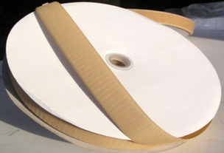
114 | Strap, velcro, 30mm, loop/velvet | Hook-and-loop fastener tape, LOOP (velvet/pile) side only, width 30 mm, black. Supplied on a continuous roll, sew-on (non-adhesive) backing. To be the mating partner of the 30 mm hook tape (OSBOVSBO22). Supplier to state roll length (m) and to quote price per metre and per roll. Reference: ICRC catalogue code OSBOVSBO23, or technically equivalent. | 1
115 | Strap, perlon webbing, 25mm | Webbing strap, perlon (polyamide), width 25 mm. Woven, non-elastic, high-tenacity; for orthosis and prosthesis suspension straps. Supplied on a continuous roll. Supplier to state roll length (m), colour and breaking strength (N), and to quote price per metre. Reference: ICRC catalogue code OSBOVSBO24, or technically equivalent. | 1 | 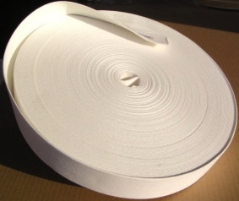
116 | Strap, elastic, 25mm | Elastic strap webbing, width 25 mm. Woven elastic tape for orthosis suspension where controlled give is required. Supplied on a continuous roll. Supplier to state roll length (m), colour, elongation at working load (%) and composition, and to quote price per metre. Reference: ICRC catalogue code OSBOVSBO26, or technically equivalent. | 1 | 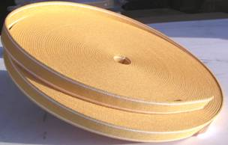
117 | Strap, elastic, 35mm | Elastic strap webbing, width 35 mm. Woven elastic tape for orthosis suspension where controlled give is required. Supplied on a continuous roll. Supplier to state roll length (m), colour, elongation at working load (%) and composition, and to quote price per metre. Reference: ICRC catalogue code OSBOVSBO27, or technically equivalent. | 1
118 | Strap, prostesis, 25mm | Prosthesis suspension strap, width 25 mm. Supplied on a continuous roll. Supplier to state material, roll length (m), colour and breaking strength (N), and to quote price per metre. Reference: ICRC catalogue code OSBOVSBO28, or technically equivalent. NOTE: the description does not state the material - confirm against a physical sample of current stock. | 1 | 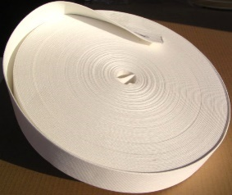
119 | Strap, prostesis, 35mm | Prosthesis suspension strap, width 35 mm. Supplied on a continuous roll. Supplier to state material, roll length (m), colour and breaking strength (N), and to quote price per metre. Reference: ICRC catalogue code OSBOVSBO29, or technically equivalent. NOTE: the description does not state the material - confirm against a physical sample of current stock. | 2
120 | Strap, polyester, black, 40mm | Webbing strap, polyester, width 40 mm, black. Woven, non-elastic, low-stretch; for orthosis straps and harnesses. Supplied on a continuous roll. Supplier to state roll length (m) and breaking strength (N), and to quote price per metre. Reference: ICRC catalogue code OSBOVSBO30, or technically equivalent. | 2 | 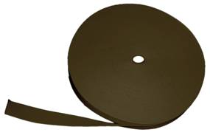
121 | Adhisive hook and loop black | Hook-and-loop fastener tape, SELF-ADHESIVE backing, black, hook and loop supplied together. Pressure-sensitive adhesive suitable for bonding to thermoplastic orthosis shells. Supplier to state width (mm), roll length (m) and service temperature range. DATA ISSUE: this line has no item code, no ICRC code and no width - specify fully before including it in the order. | 2
122 | Cosmetic soft foam cover  Tt | Cosmetic soft foam cover, PUR (polyurethane) soft foam, for modular trans-tibial prostheses. Pre-shaped calf profile, machinable and sandable to the contralateral limb; central bore for the tube adapter. Colour: skin tone. Supplier to state in the offer: length (cm), proximal and distal diameters (cm), bore diameter (mm) and applicable side (left/right/universal). Reference: Streifeneder 60A7, or technically equivalent. NOTE: the inventory description does not record a size - 60A7 is supplied in several calf circumferences (e.g. 60A47/36-44). Confirm sizes required. | 95 | 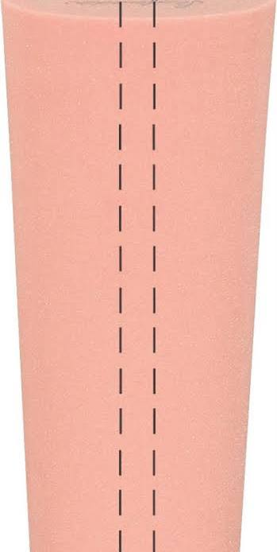
123 | Cosmetic soft foam cover left tf | Cosmetic soft foam cover, PUR (polyurethane) soft foam, LEFT, for modular trans-femoral prostheses, calf circumference 44 cm. Pre-shaped with knee flexion; machinable and sandable to match the contralateral limb; central bore for the tube adapter. Colour: skin tone. Order quantity is priced per piece. Reference: Streifeneder 60A47/44L, or technically equivalent. | 40 | 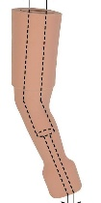
124 | Hd foam cover | Cosmetic foam cover, high-density (HD) grade. DATA ISSUE: 'HD Foam Cover' does not identify the amputation level (trans-tibial / trans-femoral), the side, the size or the manufacturer, and there is no item or ICRC code. This line cannot be tendered as written - identify from a physical sample before ordering. | 1
125 | Junior soft foam cover tf | Cosmetic soft foam cover for children, PUR (polyurethane) soft foam, RIGHT, for modular trans-femoral and hip-disarticulation prostheses. Pre-shaped with 30 degrees knee flexion and a distinctive pre-shaped calf; bore 19 mm; colour peach. Matching nylon cosmetic stocking 200K15. Calf circumference 42 cm. Reference: Streifeneder 600K42/R, or technically equivalent. NOTE: the 2019 catalogue lists this family at calf circumference 32 cm (600K32/L, 600K32/R); confirm that the 42 cm size is current. | 1 | 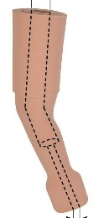
126 | Junior soft foam cover tt | Cosmetic soft foam cover for children, PUR (polyurethane) soft foam, for modular trans-tibial and knee-disarticulation prostheses. Length 50 cm; upper diameter 18 cm; lower diameter 15 cm; bore 19 mm; colour peach. Applicable to both left and right sides. Reference: Streifeneder 600K7, or technically equivalent. | 1 | 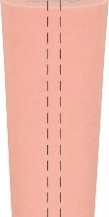
127 | Fiberglass stockinette type bufa width: 12omm, pu=1, 0 kg length per roll 12, 5m | Fibreglass stockinette, tubular, flat width 120 mm. E-glass filament, knitted seamless tube for reinforcement of laminated sockets and orthoses. Packing unit 1.0 kg per roll. Length per roll 12.5 m. To be free of sizing that would inhibit resin wet-out with acrylic (Orthocryl) systems. Reference: type BUFA, ICRC catalogue code ODROSTOC61G12, or technically equivalent. | 10 | 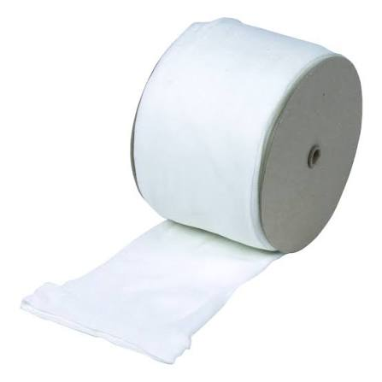
128 | Fiberglass stockinette type bufa width: 15omm, pu=1, 0 kg length per roll 9, 3m | Fibreglass stockinette, tubular, flat width 150 mm. E-glass filament, knitted seamless tube for reinforcement of laminated sockets and orthoses. Packing unit 1.0 kg per roll. Length per roll 9.3 m. To be free of sizing that would inhibit resin wet-out with acrylic (Orthocryl) systems. Reference: type BUFA, ICRC catalogue code ODROSTOC61G15, or technically equivalent. | 22 | 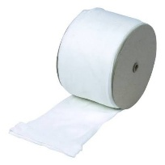
129 | Fiberglass stockinette type bufa width 200mm pu=1, 0kg length per roll 7, 2m | Fibreglass stockinette, tubular, flat width 200 mm. E-glass filament, knitted seamless tube for reinforcement of laminated sockets and orthoses. Packing unit 1.0 kg per roll. Length per roll 7.2 m. To be free of sizing that would inhibit resin wet-out with acrylic (Orthocryl) systems. Reference: type BUFA, ICRC catalogue code ODROSTOC61G20, or technically equivalent. | 15 | 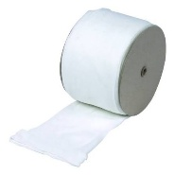
130 | Fiberglass Stockinette 300 mm | Fibreglass stockinette, tubular, flat width 300 mm. E-glass filament, knitted seamless tube for reinforcement of laminated sockets and orthoses. Packing unit 1.0 kg per roll. Supplier to state length per roll (m). To be free of sizing that would inhibit resin wet-out with acrylic (Orthocryl) systems. Reference: type BUFA, ICRC catalogue code 616G3=30, or technically equivalent. DATA ISSUE: this line has no item code and shows zero opening stock but 10 received - confirm it is an active line before ordering. | 10
131 | Perlon extra elastic wide 40mm | Perlon (polyamide) stockinette, extra-elastic, flat width 40 mm. Knitted seamless tube for lamination. Supplier to state packing unit (kg), length per roll (m) and colour. DATA ISSUE: this line has no item code and no ICRC code - assign one before ordering. | 2 | 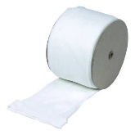
132 | Perlon stockinette, white width: 60mm pu=1, 0kg length per roll 37, 0m | Perlon (polyamide) stockinette, white, flat width 60 mm. Knitted seamless tube used as the primary reinforcement layer in acrylic-resin lamination of prosthetic sockets. Packing unit 1.0 kg per roll. Length per roll 37.0 m. To be free of finishes that inhibit resin wet-out with acrylic (Orthocryl) systems. Reference: ICRC catalogue code ODROSTOC95P66, or technically equivalent. | 5
133 | Perlon stockinette, white width: 100mm pu=1, 0kg length per roll 37, 0m | Perlon (polyamide) stockinette, white, flat width 100 mm. Knitted seamless tube used as the primary reinforcement layer in acrylic-resin lamination of prosthetic sockets. Packing unit 1.0 kg per roll. Length per roll 37.0 m. To be free of finishes that inhibit resin wet-out with acrylic (Orthocryl) systems. Reference: ICRC catalogue code ODROSTOC96P610, or technically equivalent. | 20
134 | Perlon stockinette, white width: 120mm pu=1, 0kg length per roll 33, 3m | Perlon (polyamide) stockinette, white, flat width 120 mm. Knitted seamless tube used as the primary reinforcement layer in acrylic-resin lamination of prosthetic sockets. Packing unit 1.0 kg per roll. Length per roll 33.3 m. To be free of finishes that inhibit resin wet-out with acrylic (Orthocryl) systems. Reference: ICRC catalogue code ODROSTOC96P612, or technically equivalent. | 14
135 | Perlon stockinette, white width: 150mm pu=1, 0kg length per roll 27, 0m | Perlon (polyamide) stockinette, white, flat width 150 mm. Knitted seamless tube used as the primary reinforcement layer in acrylic-resin lamination of prosthetic sockets. Packing unit 1.0 kg per roll. Length per roll 27.0 m. To be free of finishes that inhibit resin wet-out with acrylic (Orthocryl) systems. Reference: ICRC catalogue code ODROSTOC96P615, or technically equivalent. | 15
136 | Perlon stockinette, white width: 200mm pu=1, 0kg length per roll 20, 0m | Perlon (polyamide) stockinette, white, flat width 200 mm. Knitted seamless tube used as the primary reinforcement layer in acrylic-resin lamination of prosthetic sockets. Packing unit 1.0 kg per roll. Length per roll 20.0 m. To be free of finishes that inhibit resin wet-out with acrylic (Orthocryl) systems. Reference: ICRC catalogue code ODROSTOC96P620, or technically equivalent. | 5
137 | Carbon-fiber cloth, black-616g12=30 | Carbon-fibre cloth, black, flat width 300 mm, reference 616G12=30. Woven carbon reinforcement for selective stiffening of laminated sockets and orthoses. Supplier to state weave style, areal weight (g/m2) and length per roll (m). Reference: Ottobock 616G12=30, or technically equivalent. DATA ISSUE: this line carries item code ODROSTOC61G20, which is also used for the 200 mm fibreglass stockinette above. Assign a distinct code before ordering. | 1 | 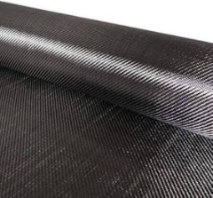
138 | Carbon fiber stokinette 100mm | Carbon-fibre stockinette, tubular, flat width 100 mm. Knitted seamless carbon tube for reinforcement of laminated sockets. Supplier to state areal weight (g/m2), packing unit and length per roll (m). Reference: Streifeneder 95P30/100, or technically equivalent. NOTE: stock and consumption are both zero - confirm this line is still required before ordering. | 1 | 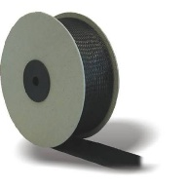
139 | Tubular stockinette, cotton, 60mm, roll(25m) | Tubular stockinette, 100 % cotton, flat width 60 mm. Knitted seamless tube used as an interface layer over the residual limb during casting and as a separating layer in lamination. Unbleached or white; free of dressing/starch. Supplied in rolls of 25 m. Reference: ICRC catalogue code ODROSTOC3T36, or technically equivalent. | 1 | 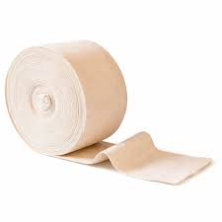
140 | Tubular stockinette, cotton, 80mm, roll(500g) | Tubular stockinette, 100 % cotton, flat width 80 mm. Knitted seamless tube used as an interface layer over the residual limb during casting and as a separating layer in lamination. Unbleached or white; free of dressing/starch. Supplied in rolls of 500 g. Reference: ICRC catalogue code ODROSTOCOT80, or technically equivalent. | 1
141 | Tubular stockinette, cotton, 100mm, roll | Tubular stockinette, 100 % cotton, flat width 100 mm. Knitted seamless tube used as an interface layer over the residual limb during casting and as a separating layer in lamination. Unbleached or white; free of dressing/starch. Supplier to state length and/or mass per roll. Reference: ICRC catalogue code ODROSTOCOT100, or technically equivalent. | 1
142 | Tubular stockinette, cotton, 120mm, roll | Tubular stockinette, 100 % cotton, flat width 120 mm. Knitted seamless tube used as an interface layer over the residual limb during casting and as a separating layer in lamination. Unbleached or white; free of dressing/starch. Supplier to state length and/or mass per roll. Reference: ICRC catalogue code ODROSTOCOT120, or technically equivalent. | 1
143 | Tubular stockinette, cotton, 150mm, roll | Tubular stockinette, 100 % cotton, flat width 150 mm. Knitted seamless tube used as an interface layer over the residual limb during casting and as a separating layer in lamination. Unbleached or white; free of dressing/starch. Supplier to state length and/or mass per roll. Reference: ICRC catalogue code ODROSTOCOT150, or technically equivalent. | 1
144 | Tubular stockinette, cotton, 200mm, roll | Tubular stockinette, 100 % cotton, flat width 200 mm. Knitted seamless tube used as an interface layer over the residual limb during casting and as a separating layer in lamination. Unbleached or white; free of dressing/starch. Supplier to state length and/or mass per roll. Reference: ICRC catalogue code ODROSTOCOT200, or technically equivalent. | 1
145 | Hip joint for Prothese | Modular hip joint for hip-disarticulation prosthesis. Supplier to state in the offer: material, proximal connection (lamination disc / plate), distal connection (tube clamp diameter or pyramid), flexion angle, effective height, mass and maximum patient body weight. Must be compatible with the 20 degree and 10 degree tilt tube clamp adapters already held in stock. Structural strength to ISO 10328 (lower-limb prosthesis components). NOTE: stock and consumption are both zero - confirm this line is still required before ordering. | 4 | 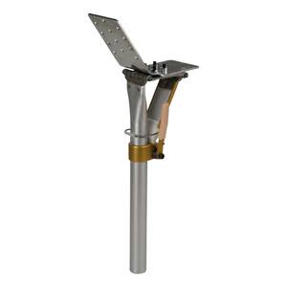
146 | Modular brake knee joint stainless steel - monocentric, incl.extension assist | Modular brake knee joint, stainless steel, monocentric (single-axis), with integrated extension assist. Load-dependent friction brake gives stance-phase stability from heel strike to toe-off; brake force and extension assist both adjustable to the patient. Proximal connection: adjustment core (pyramid). Distal connection: tube clamp 30 mm. Supplier to state: maximum patient body weight (kg), mobility grade, knee flexion angle, overall and effective height (mm) and mass (g). Structural strength to ISO 10328 (lower-limb prosthesis components). Reference: Streifeneder 3A15, or technically equivalent. | 5 | 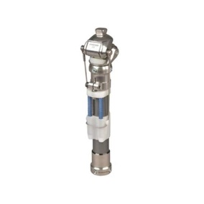
147 | Modular single axis knee joint stainless steel - monocentric, with lock & spring extension assist | Modular single-axis knee joint, stainless steel, monocentric, WITH LOCK and spring extension assist. Knee axis connects the upper and lower joint sections through bushings and ball bearings; the adjustable lock secures the knee in extension and is released for flexion via a lock cable; the extension assist re-locks the joint automatically at full extension. For trans-femoral amputees with a low functional level - high stance-phase stability, no swing-phase control. Maximum patient body weight 150 kg. Mobility grade 1. Knee flexion angle approx. 120 degrees. Head height (knee centre to upper edge) 37 mm; effective height 82 mm. Unit mass 562 g. Locking unit 4A40 and service parts set 3A17/E available separately. Structural strength to ISO 10328 (lower-limb prosthesis components). Reference: Streifeneder 3A17/S, or technically equivalent. | 6 | 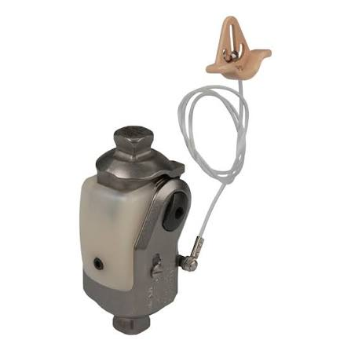
148 | Modular 4-bar linkage knee joint-stainless steel | Modular 4-bar (polycentric) linkage knee joint, stainless steel. Polycentric linkage places the instantaneous centre of rotation posterior and proximal in extension for stance-phase stability, and shortens the shank during swing phase to reduce stumbling. Structural strength to ISO 10328 (lower-limb prosthesis components). Supplier to state: maximum patient body weight (kg), mobility grade, knee flexion angle, proximal and distal connections, overall and effective height (mm) and mass (g). Reference: Streifeneder 3A20, or technically equivalent. DATA ISSUE - IMPORTANT: 3A20, 3A21 and 3A23 are recorded in the inventory with IDENTICAL descriptions but they are three DIFFERENT joints (in the manufacturer's range 3A20 pairs with the titanium 3A36; 3A21 is the version supplied with a lamination anchor; 3A23 is the version supplied with a lock control unit). Distinguish the three descriptions in the item master before ordering or the wrong joint will be delivered. | 7 | 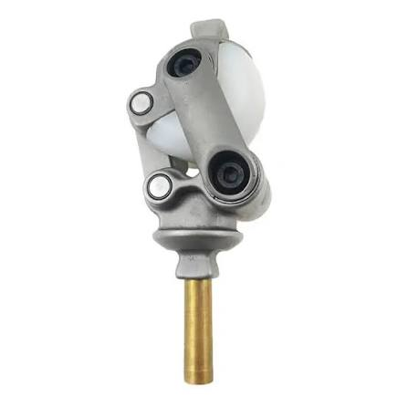
149 | Modular 4-bar linkage knee joint-stainless steel | Modular 4-bar (polycentric) linkage knee joint, stainless steel. Polycentric linkage places the instantaneous centre of rotation posterior and proximal in extension for stance-phase stability, and shortens the shank during swing phase to reduce stumbling. Structural strength to ISO 10328 (lower-limb prosthesis components). Supplier to state: maximum patient body weight (kg), mobility grade, knee flexion angle, proximal and distal connections, overall and effective height (mm) and mass (g). Reference: Streifeneder 3A21, or technically equivalent. DATA ISSUE - IMPORTANT: 3A20, 3A21 and 3A23 are recorded in the inventory with IDENTICAL descriptions but they are three DIFFERENT joints (in the manufacturer's range 3A20 pairs with the titanium 3A36; 3A21 is the version supplied with a lamination anchor; 3A23 is the version supplied with a lock control unit). Distinguish the three descriptions in the item master before ordering or the wrong joint will be delivered. | 6 | 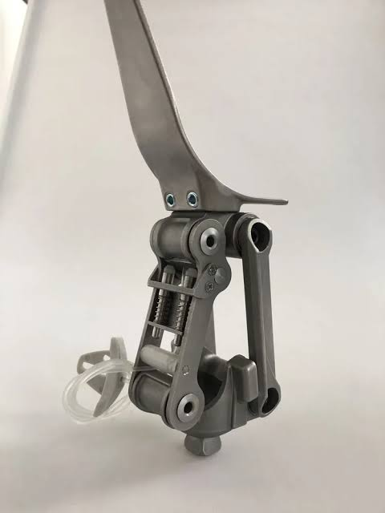
150 | Modular 4-bar linkage knee joint-stainless steel | Modular 4-bar (polycentric) linkage knee joint, stainless steel. Polycentric linkage places the instantaneous centre of rotation posterior and proximal in extension for stance-phase stability, and shortens the shank during swing phase to reduce stumbling. Structural strength to ISO 10328 (lower-limb prosthesis components). Supplier to state: maximum patient body weight (kg), mobility grade, knee flexion angle, proximal and distal connections, overall and effective height (mm) and mass (g). Reference: Streifeneder 3A23, or technically equivalent. DATA ISSUE - IMPORTANT: 3A20, 3A21 and 3A23 are recorded in the inventory with IDENTICAL descriptions but they are three DIFFERENT joints (in the manufacturer's range 3A20 pairs with the titanium 3A36; 3A21 is the version supplied with a lamination anchor; 3A23 is the version supplied with a lock control unit). Distinguish the three descriptions in the item master before ordering or the wrong joint will be delivered. | 6
151 | Stump sock, trans-tibial, flat width 10 cm, length 35 | Stump sock, trans-tibial, flat width 10 cm, length size 35. Knitted sock worn over the residual limb inside the prosthetic socket to manage volume and protect the skin. Supplier to state in the offer: fibre composition (e.g. wool/cotton/synthetic blend), ply/thickness, finished length (cm), colour and washing instructions. Seams must be flat-locked or the sock knitted seamless. Reference: ICRC catalogue code ODROSTOCTT35, or technically equivalent. NOTE: this is the highest-turnover consumable in the list - review the order quantity against actual issues before finalising. | 100 | 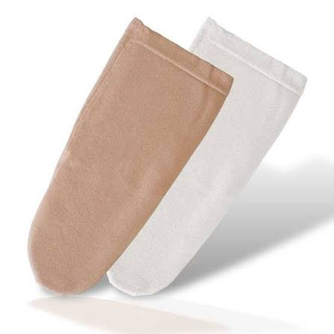
152 | Stump sock, trans-tibial, flat width 10cm, length 45 | Stump sock, trans-tibial, flat width 10 cm, length size 45. Knitted sock worn over the residual limb inside the prosthetic socket to manage volume and protect the skin. Supplier to state in the offer: fibre composition (e.g. wool/cotton/synthetic blend), ply/thickness, finished length (cm), colour and washing instructions. Seams must be flat-locked or the sock knitted seamless. Reference: ICRC catalogue code ODROSTOCTT45, or technically equivalent. NOTE: this is the highest-turnover consumable in the list - review the order quantity against actual issues before finalising. | 100
153 | Stump sock, trans-tibial, flat width 10 cm, length 55 | Stump sock, trans-tibial, flat width 10 cm, length size 55. Knitted sock worn over the residual limb inside the prosthetic socket to manage volume and protect the skin. Supplier to state in the offer: fibre composition (e.g. wool/cotton/synthetic blend), ply/thickness, finished length (cm), colour and washing instructions. Seams must be flat-locked or the sock knitted seamless. Reference: ICRC catalogue code ODROSTOCTT55, or technically equivalent. NOTE: this is the highest-turnover consumable in the list - review the order quantity against actual issues before finalising. | 60
154 | EVA FOAM, 3MM x 0.95M, 0.90M2, BEIGE | EVA (ethylene-vinyl acetate) foam sheet, beige, 3 mm x 0.95 m x 0.95 m (0.90 m2 per sheet). Closed-cell, heat-mouldable cushioning foam for socket liners, insoles and orthosis padding. Supplier to state Shore A hardness and density (kg/m3) and to guarantee sheet-to-sheet consistency within one delivery. Reference: ICRC catalogue code OPLAEVAFKIN03, or technically equivalent. | 25 | 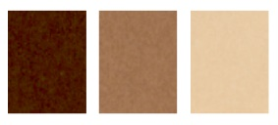
155 | Eva foam, 6mm x 0.95m x 0.95m, 0.90m2, beige | EVA (ethylene-vinyl acetate) foam sheet, beige, 6 mm x 0.95 m x 0.95 m (0.90 m2 per sheet). Closed-cell, heat-mouldable cushioning foam for socket liners, insoles and orthosis padding. Supplier to state Shore A hardness and density (kg/m3) and to guarantee sheet-to-sheet consistency within one delivery. Reference: ICRC catalogue code OPLAEVAFKIN06, or technically equivalent. | 50
156 | EVA FOAM, 12MM x 1.10M x 1.10M, 1.21M2, BEIGE | EVA (ethylene-vinyl acetate) foam sheet, beige, 12 mm x 1.10 m x 1.10 m (1.21 m2 per sheet). Closed-cell, heat-mouldable cushioning foam for socket liners, insoles and orthosis padding. Supplier to state Shore A hardness and density (kg/m3) and to guarantee sheet-to-sheet consistency within one delivery. Reference: ICRC catalogue code OPLAEVAFKIN12, or technically equivalent. | 12
157 | Connection disk for sach foot | Connection disc for SACH foot, moulded plastic. Bonded to the distal end of the cosmetic soft foam cover and clipped over the SACH foot adapter, closing the gap between the foam cover and the foot. Unit mass 12 g. Fits SACH foot adapters 16A1/M8, 16A1/M10, 16A2/M8, 16A2/M10, 16A6/M8 and 16A6/M10. Bonded with contact adhesive 118P12 or equivalent. Reference: Streifeneder 29A1, or technically equivalent. | 60 | 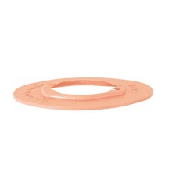
158 | Flat rubber valve automatic | Prosthetic socket valve, flat, rubber/plastic, AUTOMATIC (one-way) air outlet. Expels air on donning and on each loading cycle to establish and maintain suction suspension; removable insert for cleaning. Outer valve diameter 36 mm (to be confirmed - the equivalent children's valve 6K26 has an outer diameter of 26 mm, which indicates that the last two digits of the item number denote the outer diameter in mm). Supplier to state: overall diameter, seating/housing thread or bore required in the socket wall, and whether a matching lamination dummy is included. Reference: Streifeneder 6P36 / Ottobock 21Y40 (per ICRC code OHDWVSBO21Y40), or technically equivalent. DATA ISSUE: the item code (Streifeneder 6P36) and the ICRC code (which points to Ottobock 21Y40) refer to two different manufacturers' valves. Decide which is the standard before ordering. | 21 | 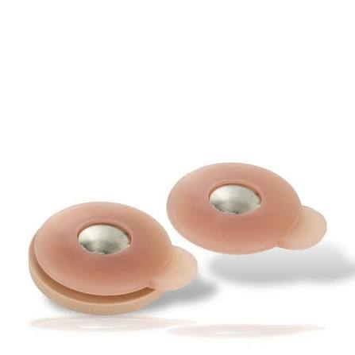
159 | Tube with seat ring | Prosthetic tube with seat ring. Tube with an integral proximal seating ring for modular builds. Supplier to state: material (aluminium / stainless steel / titanium), tube outside diameter and wall thickness (mm), overall length (mm), unit mass (g) and maximum patient body weight (kg). Must be compatible with the 30 mm modular system in use (tube clamp adapter 11A11/S). Structural strength to ISO 10328 (lower-limb prosthesis components). Reference: Streifeneder 28A1, or technically equivalent. NOTE: the manufacturer's 30 mm plain tube is 28A2/A500 (aluminium, 30 x 2 mm, 500 mm, 250 g, max. 100 kg). Confirm which part is actually required. | 2 | 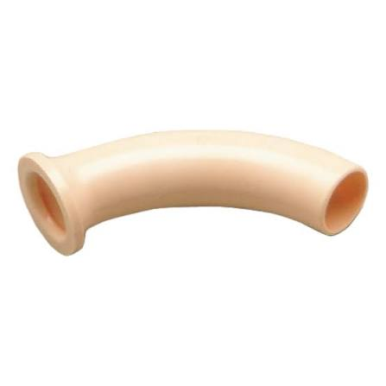
160 | Modular junction cup for lamination or thermof. Adult prot 1k90 | Modular junction cup / socket attachment cup for adult prostheses, for LAMINATION OR THERMOFORMING, reference 1K90. Cup-shaped distal socket attachment that is either laminated into a resin socket or drawn into a thermoplastic socket, providing the interface to the distal modular components. Supplier to state: material, cup diameter and height (mm), the modular connection provided (pyramid / adjustment core support / bolt pattern), unit mass and maximum patient body weight, and to confirm suitability for BOTH lamination and thermoforming. Structural strength to ISO 10328 (lower-limb prosthesis components). Reference: ICRC catalogue code OCPOMODUPR1K90, or technically equivalent. | 1 | 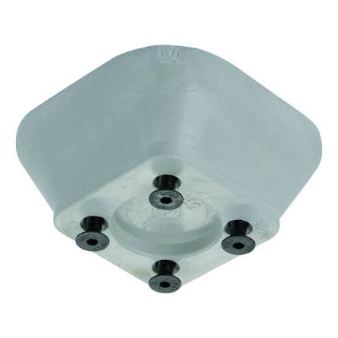
161 | Socket attachment block | Socket attachment block, poplar wood faced with plastic for optimal sanding and improved bond with the laminate. Block diameter 107 mm; height 33 mm. Supplied with 4 countersunk head bolts 22A5/M6x20, lamination dummy 12A3/E2 and sealing grease 22A100. Maximum patient body weight 125 kg. Structural strength to ISO 10328 (lower-limb prosthesis components). Reference: Streifeneder 12A7, or technically equivalent. | 1
162 | Orthocryl lamination resin | Orthocryl lamination resin, reference 617H19, 80:20 acrylic resin system. Cold-curing acrylic (PMMA-based) laminating resin for prosthetic sockets and orthoses; to be cured with hardening powder 617P37 (dibenzoyl peroxide) held separately in this list. Supplier to state: pack size (kg), mixing ratio, pot life at 20 C, cure time, storage temperature and shelf life. Deliveries must carry a batch number and at least 9 months' remaining shelf life on arrival, and must be accompanied by a current Safety Data Sheet. Resin and hardening powder must be from the same manufacturer and confirmed compatible. Reference: Ottobock 617H19, or technically equivalent. DATA ISSUE: the inventory does not record a pack size for this line - fix the pack size in the item master before tendering, otherwise offers will not be comparable. | 26 | 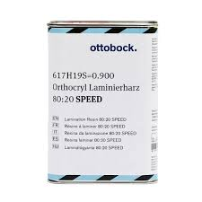
163 | Pva film, 1000 x 0.08 x 30 mstr | PVA (polyvinyl alcohol) film tubing, flat width 1000 mm, thickness 0.08 mm, roll length 30 m. Water-soluble film drawn over the plaster positive as the inner and outer bag in acrylic-resin lamination. To be supplied as seamless tube, free of pinholes, and to soften reliably in cold water. Supplier to state storage conditions and shelf life; PVA is hygroscopic and must be delivered in sealed moisture-proof packaging. Reference: ICRC catalogue code OPLAPOLY110P630, or technically equivalent. | 10 | 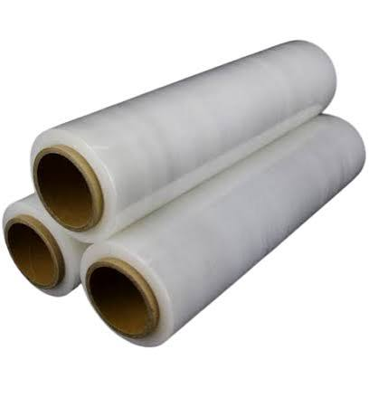
164 | Glue | Contact adhesive, neoprene (polychloroprene) based, for bonding EVA, Plastazote, leather and foam in prosthetic and orthotic fabrication. Solvent-based contact type applied to both surfaces. Supplier to state: pack size (litres or kg), open time, full-strength cure time, service temperature range and coverage (m2 per litre); a current Safety Data Sheet must accompany the offer and each delivery. Reference: ICRC catalogue code OHDWGLUENEO4, or technically equivalent. DATA ISSUE: the description is simply 'GLUE' and no pack size is recorded. Fix the adhesive type and pack size in the item master before tendering. | 15 | 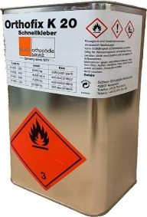
165 | Hard foam 300-617h32=4.6 pedline | Rigid polyurethane foam system, Pedilen type, density grade 300, reference 617H32, pack 4.6 kg. Two-component pour-in-place rigid foam used to build up cosmetic shape on exoskeletal prostheses and as a core material. To be used with the matching hardener (see the next line). Supplier to state: mixing ratio, cream time, rise time, demould time, cured density (kg/m3) and shelf life; a current Safety Data Sheet must accompany the offer and each delivery (isocyanate component). Foam and hardener must be from the same manufacturer and the same system. Reference: Ottobock Pedilen rigid foam 300, 617H32=4.6, or technically equivalent. | 1 | 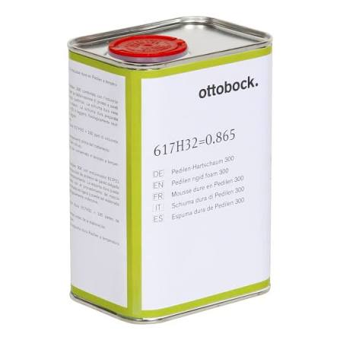
166 | Hardener for pedline | Hardener / component B for the Pedilen rigid polyurethane foam system 617H32 held on the previous line. Must be the manufacturer's matched component for the density grade 300 system - hardeners are NOT interchangeable between foam grades or between manufacturers. Supplier to state: pack size, mixing ratio by weight, shelf life and storage temperature; a current Safety Data Sheet must accompany the offer and each delivery. Reference: ICRC catalogue code OPLAPOLYLAM7P212. DATA ISSUE: the item code recorded (7P212) could not be matched to a published hardener reference for the 617H32 system. Confirm the correct component number with the manufacturer before ordering. | 1 | 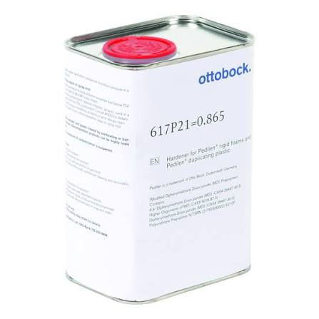
167 | Powder hardener | Hardening POWDER for Orthocryl lamination resin, reference 617P37. Dibenzoyl peroxide powder, phlegmatised, used to cure the Orthocryl 80:20 resin held in this list. Supplier to state: pack size, mixing ratio to resin, pot life at 20 C, storage temperature and shelf life. This is an ORGANIC PEROXIDE - deliveries must comply with the applicable dangerous-goods transport rules, must be temperature-controlled, and must be accompanied by a current Safety Data Sheet. Powder and resin must be from the same manufacturer. Reference: Ottobock 617P37, or technically equivalent. NOTE: the description is spelled 'POWER HARDNER' in the inventory; the item is a hardening POWDER. Correct the item master. | 36 | 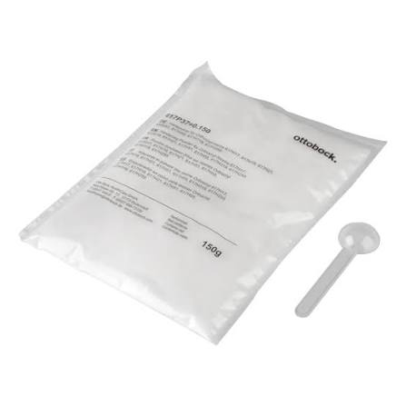
168 | Pigment paste  Beige | Pigment paste for acrylic lamination resin. Colour-fast paste stirred into Orthocryl resin to tint the laminate. Must be compatible with the Orthocryl 617H19 system and must not inhibit the peroxide cure. DATA ISSUE: this line has no item code and no ICRC code, and the description does not define a brand, grade or pack size. It cannot be tendered as written. Stock and consumption are both zero, and the line duplicates 'PIGMENT PASTE OTTOBOCK 1KG' elsewhere in the same category - delete this line or merge it, and specify each colour as its own item. | 1 | 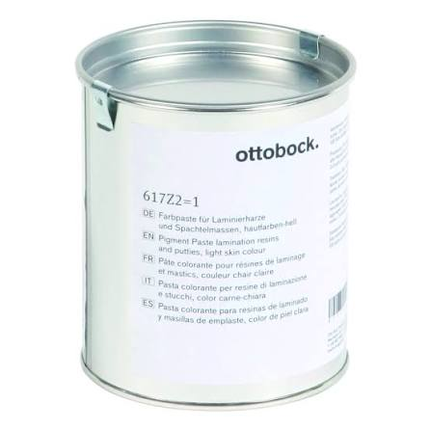
169 | Petroleum jelly | Petroleum jelly (white soft paraffin), technical grade, used as a release agent on plaster positives and modular components before lamination. Supplier to state pack size (kg) and grade. DATA ISSUE: the description is spelled 'Vasline' and no code or pack size is recorded. Correct the spelling and fix the pack size in the item master. | 1 | 
170 | Thinner | Solvent thinner for cleaning tools and thinning contact adhesive in prosthetic and orthotic fabrication. Must be compatible with the neoprene contact adhesive held in this list, and the supplier must confirm compatibility in writing. Supplier to state: chemical composition, flash point, pack size (litres) and a current Safety Data Sheet. DATA ISSUE: the description is spelled 'Tinner', no code or pack size is recorded, and opening stock is zero. Correct the item master and confirm the line is still required before ordering. | 2 | 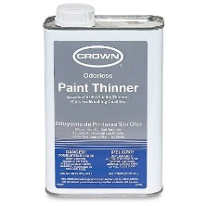
171 | Sealing | Sealing compound / sealing grease, used to seal the lamination dummy and socket attachment block against resin ingress during lamination. DATA ISSUE: the description is spelled 'CEALING', and there is no item code, no ICRC code and no pack size. The manufacturer's matched product for the socket attachment blocks held in stock (12A3, 12A5, 12A7) is sealing grease 22A100 - confirm this is the intended item, then correct the item master. | 1 | 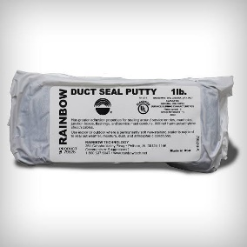
172 | Pigment paste ottobock 1kg | Pigment paste for acrylic lamination resin, 1 kg pack. Colour-fast paste stirred into Orthocryl resin to tint the laminate to skin tone. Must be compatible with the Orthocryl 617H19 system and must not inhibit the peroxide cure. Supplier to state: colour reference, recommended addition rate (% by weight) and shelf life, and to supply a colour chart with the offer. Reference: Ottobock pigment paste, 1 kg, or technically equivalent. DATA ISSUE: no colour is recorded in the item master. Pigment is not a single item - specify each colour required as its own line before ordering. | 5
173 | Streifydur, polypropylene, 2000x1000x5 mm, clear white | Streifydur polypropylene sheet, clear/white, 2000 x 1000 x 5 mm. Vacuum-formable thermoplastic sheet for prosthetic sockets and orthoses; forming temperature approx. 190-200 C. Supplier to state density (g/cm3) and to guarantee flatness and freedom from voids. Reference: Streifeneder 111P255 (Streifydur), or technically equivalent. | 5 | 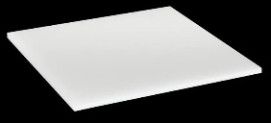
174 | Homopolymer, 3mm x 1m x 2m x 5.5kg, beige color | Polypropylene homopolymer sheet, beige, 3 mm x 1 m x 2 m, nominal sheet mass 5.5 kg. Vacuum-formable thermoplastic for prosthetic sockets and orthoses; forming temperature approx. 190-200 C. Homopolymer grade (stiffer than copolymer) - copolymer will NOT be accepted as an alternative. Supplier to state density (g/cm3) and melt flow index. Reference: ICRC catalogue code OPLAPOLYSKIN03, or technically equivalent. | 3
175 | Homopolymer, 4mm x 1m x 2m x 7.5kg, beige color | Polypropylene homopolymer sheet, beige, 4 mm x 1 m x 2 m, nominal sheet mass 7.5 kg. Vacuum-formable thermoplastic for prosthetic sockets and orthoses; forming temperature approx. 190-200 C. Homopolymer grade (stiffer than copolymer) - copolymer will NOT be accepted as an alternative. Supplier to state density (g/cm3) and melt flow index. Reference: ICRC catalogue code OPLAPOLYSKIN04, or technically equivalent. | 20
176 | Homopolymer, 5mm x 1m x 2m x 9.2kg, beige color | Polypropylene homopolymer sheet, beige, 5 mm x 1 m x 2 m, nominal sheet mass 9.2 kg. Vacuum-formable thermoplastic for prosthetic sockets and orthoses; forming temperature approx. 190-200 C. Homopolymer grade (stiffer than copolymer) - copolymer will NOT be accepted as an alternative. Supplier to state density (g/cm3) and melt flow index. Reference: ICRC catalogue code OPLAPOLYSKIN05, or technically equivalent. | 30
178 | Polymer, ldpe 2m x 1m x 4mm | Low-density polyethylene (LDPE) sheet, 2 m x 1 m x 4 mm. Vacuum-formable thermoplastic, more flexible than polypropylene; for orthoses requiring compliance and for check sockets. Supplier to state colour and density (g/cm3). Reference: ICRC catalogue code OPLAPOLYPELD4, or technically equivalent. | 5
179 | Polymer, ldpe 2m x 1m x 5mm | Low-density polyethylene (LDPE) sheet, 2 m x 1 m x 5 mm. Vacuum-formable thermoplastic, more flexible than polypropylene; for orthoses requiring compliance and for check sockets. Supplier to state colour and density (g/cm3). Reference: ICRC catalogue code OPLAPOLYPELD5, or technically equivalent. | 10
180 | Polypropylene welding rod, 4mm, beige color | Polypropylene welding rod, 4 mm diameter, beige. For hot-air welding and injection welding of polypropylene sockets and orthoses. Material must be compatible with the polypropylene homopolymer sheet held in stock. Supplier to state coil length or mass per packing unit. Reference: ICRC catalogue code OPLAPOLYRKI04, or technically equivalent. DATA ISSUE: stock is recorded as a fractional quantity (0.5) against a unit of 'piece' - define the unit (kg or coil) in the item master. | 1 | 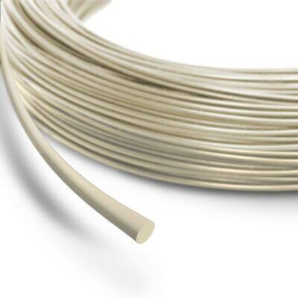
181 | Tube adapter | Tube adapter for children, aluminium, tube outside diameter 22 mm. Light-alloy tube 22 x 2 mm with adjustment-core support and 4 adjustment screws 22A2/M6x12, zinc-plated. Tube length 300 mm; adjustable effective height 85 mm (min.) to 335 mm (max.). Unit mass 186 g. Maximum patient body weight 45 kg. Structural strength to ISO 10328 (lower-limb prosthesis components). Reference: Streifeneder 15K2/A300, or technically equivalent. | 3 | 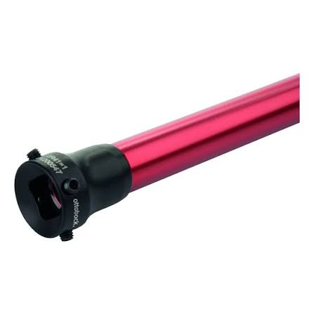
182 | Tube clamp adapter | Tube clamp adapter with adjustment core for children, aluminium, for tubes of 22 mm outside diameter. Total height 42 mm; effective (build) height 4 mm. Unit mass 50 g. Maximum patient body weight 45 kg. Structural strength to ISO 10328 (lower-limb prosthesis components). Reference: Streifeneder 110K15/A, or technically equivalent. NOTE: the inventory description 'TUBE CLAMP ADAPTER' omits 'with adjustment core' - the plain version (110K11/A, total height 55 mm, effective height 15 mm) is a different part. Confirm which is required. | 3 | 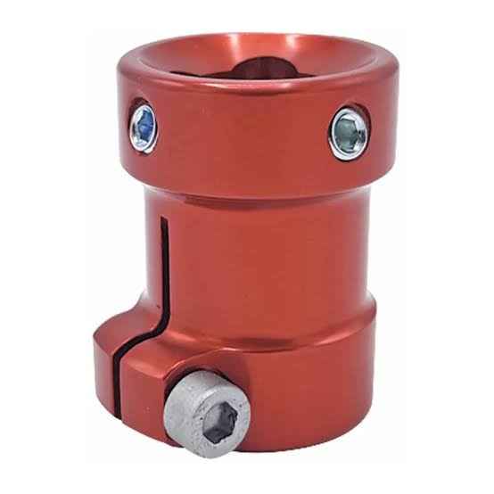
183 | Socket adapter with rotainal adjustment | Socket adapter for children, aluminium, with rotational adjustment. Rotation set by adjustment screws 22A2/M6x12 plus a clamping screw. For direct lamination; delivered with lamination aid. Effective (build) height 20 mm. Unit mass 60 g. Maximum patient body weight 45 kg. Structural strength to ISO 10328 (lower-limb prosthesis components). Reference: Streifeneder 100K4/A, or technically equivalent. | 1 | 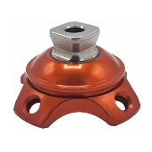
184 | Socket attachment block with lamination dummy | Socket attachment block for children, plastic, with lamination dummy. Supplied with 4 countersunk screws 22A5/M5x16. Block 80 x 80 mm; effective (build) height 32 mm. Unit mass 110 g. Maximum patient body weight 45 kg. Structural strength to ISO 10328 (lower-limb prosthesis components). Reference: Streifeneder 120K7, or technically equivalent. | 1 | 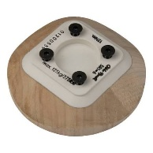
185 | Modular knee joint | Modular knee joint for children, monocentric (single-axis), light-alloy / high-strength aluminium. Proximal connection: adjustment core (pyramid), stainless steel. Distal connection: tube clamp 22 mm. With integrated extension assist. Knee flexion angle 145 degrees. Overall height 82 mm; effective height 41 mm. Unit mass 169 g. Maximum patient body weight 45 kg. Matching cosmetic soft foam cover 600K32. Structural strength to ISO 10328 (lower-limb prosthesis components). Reference: Streifeneder 3K31, or technically equivalent. | 1 | 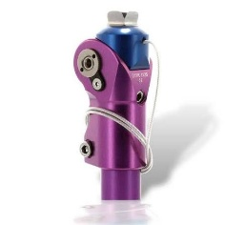
186 | Socket adapter with 4 adjustment set screws | Socket adapter for children, aluminium, with 4 adjustment set screws 22A2/M6x12, zinc-plated. For connection of modular parts or a distal socket end. Effective (build) height 18 mm. Unit mass 49 g. Maximum patient body weight 45 kg. Structural strength to ISO 10328 (lower-limb prosthesis components). Reference: Streifeneder 100K92/A, or technically equivalent. | 1 | 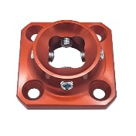
187 | Foot adapter junior m6 | SACH foot adapter for children, complete with bolted connection. DATA ISSUE: the inventory records the thread as M6, but the children's SACH foot range (30A26) and its adapter (160K1/M8, aluminium, steel bolt, effective height 5 mm, maximum patient body weight 45 kg) are M8. Verify the thread against a physical sample before ordering - an M6 adapter will not fit the M8 child feet held in stock. | 3 | 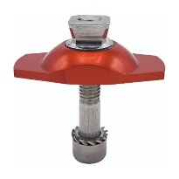
188 | Modular knee joint with lock | Modular knee joint with LOCK for children, monocentric (single-axis), lightweight high-strength aluminium. Proximal connection: adjustment core (pyramid), stainless steel. Distal connection: tube clamp 22 mm. Knee flexion angle 145 degrees. Overall height 82 mm; effective height 41 mm. Unit mass 152 g. Maximum patient body weight 45 kg. Matching cosmetic soft foam cover 600K32. Structural strength to ISO 10328 (lower-limb prosthesis components). Reference: Streifeneder 3K41, or technically equivalent. | 1 | 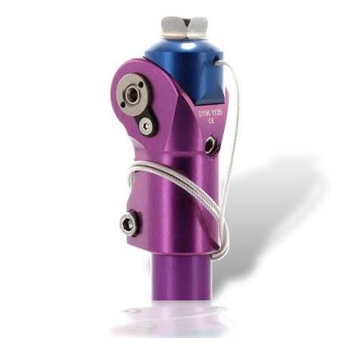
189 | Lamination anchor child | Lamination anchor for children's trans-femoral sockets. For direct lamination into the distal socket end; provides the interface to the modular knee joint. Supplier to state material, number and pattern of arms, effective height, mass and maximum patient body weight, and to confirm compatibility with the children's 22 mm modular system in use. Structural strength to ISO 10328 (lower-limb prosthesis components). Reference: Ottobock 4R110, or technically equivalent. | 1 | 