Annex 2 – Bid Form completed signed and stamped
- All bids must be typed; handwritten bids will not be considered.
- The contract will be awarded to the lowest-cost technically compliant bid/item.
- The quantities mentioned below are required unless there is a variation within a specified range with proper justification. The LRC reserves the right to increase or decrease the quantities.
- The bidder is not permitted to alter the section labelled “LRC to complete” below. Bidder is not allowed to use any other template.
- In the event of any discrepancy between the unit price and the total price, LRC reserves the right to rely on the unit price as stated in the financial bid, rather than the total price without going back to the supplier. The unit price must be provided with no more than two decimal places.
- Only one option is allowed for biding
- Sample/datasheet for each item must be submitted with the bid and labelled reference to each item number (please refer to annex 3)
- LRC reserves the right to award the items per LOT.
LRC To Complete |  |  |  | Bidder to Complete
Item number | Item/Milestone Required | Required UOM | Estimated Qty | Unit Price in USD, Exclusive VAT rated at 11%, but inclusive Labor, packing, packaging, Bank Transfer Fees, Delivery and all other fees | VAT (%) | Unit Price in USD, inclusive VAT, Labor, packing, packaging, Bank Transfer Fees, Delivery and all other fees | Total Price in USD, inclusive VAT, Labor, packing, packaging, Bank Transfer Fees, Delivery and all other fees | Lead time of delivery for any quantity from the date of each purchase order
1.1 | Safety Warning Triangle | Pc | 200
1.2 | Snow Chain for Tires (195/80R15) | Set | 75
1.3 | Snow Chain for Tires (265/75R16) | Set | 55
1.4 | Safety Cone Medium Size | Pc | 80
1.5 | Safety Cone Large Size | Pc | 130
1.6 | Safety Cone Foldable | Pc | 230
1.7 | Booster Jump Starter Portable | Pc | 60
1.8 | Cable Jumper | Set | 70
1.9 | Working Gloves | Set | 200
1.10 | Screwdriver Cross Head | Pc | 120
1.11 | Screwdriver Flat Head | Pc | 120
1.12 | Plier | Pc | 120
1.13 | Spanner 10mm | Pc | 120
1.14 | Tow Cable / Recovery Strap (5m) | Cable | 60
1.15 | Ring Anchor Shackles | Pc | 60
1.16 | Siren | Unit | 10
1.17 | Tire Puncture Repair Kit | Set | 50
1.18 | Tire Sealer & Inflator | Set | 100
1.19 | Hydraulic Car Jack + Tire Inflator 12V | Pc | 147
1.20 | Magnet Mount Light Bar | Pc | 135
1.21 | Vehicle Jack (Scissor Type) | Set | 130
1.22 | Wheel Spanner | Pc | 120
1.23 | Fire Extinguisher (2 kg) | Pc | 150
1.24 | Car Drying Towel | Set | 130
1.25 | Ratchet Straps 5 Tons | Set | 70
1.26 | Ratchet Straps 1 Ton | Set | 60
1.27 | Socket and Tool Set (137 pcs) | Set | 105
1.28 | 12 pcs 3/8" Ratchet Handle With Socket Set | Set | 27
1.29 | 13 mm spanner | Pc | 110
1.30 | Cutter | Pc | 110
1.31 | Heavy-duty plastic tool bag to store all the equipment | Box | 120
 | Total

ANNEX 3: DETAILED SPECIFICATIONS

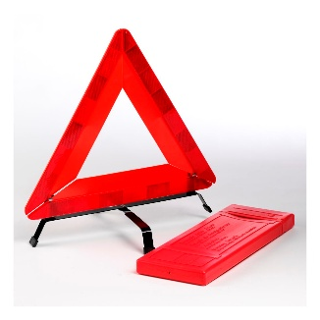
- Safety Warning Triangle
Type: Foldable reflective warning triangle
Material: Durable plastic with reflective surface
Color: Red with high-visibility reflective coating
Dimensions: Side length 40–45 cm
Visibility: Minimum 150 meters
Construction: Foldable design with stable support stand
Features: Weather resistant (heat, UV, water), lightweight, compact storage case,
Sample is required
- Snow Chain for Van/Ambulance
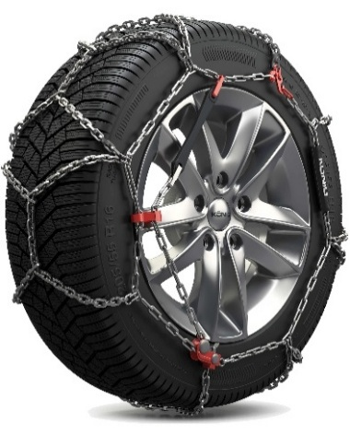
Type: Ladder or Diamond pattern
Material: Heavy duty steel
Link thickness: 5 mm minimum
Pattern: Full chain coverage
Tensioning: Manual or ratchet system
Finish: Rust Resistant
Supply: Set of two chains
Compatible with size: 195/80R15/Van
Sample is required
- Snow Chain for SUV
Type: Ladder or Diamond pattern
Material: Heavy duty steel
Link thickness: 5 mm minimum
Pattern: Full chain coverage
Tensioning: Manual or ratchet system
Finish: Rust Resistant
Supply: Set of two chains
Compatible with size: 265/75R16/SUV
Sample is required
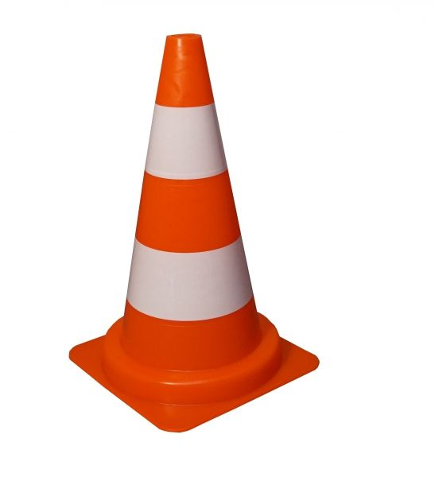
- Safety cones Medium Size:
Type: Traffic / Safety Cone
Height: Minimum 500 mm
Material: Flexible PVC or durable rubber base
Color: High-visibility orange
Reflective Bands: two white reflective bands (high-intensity grade)
Base: Weighted or wide anti-slip base for stability
Weather Resistance: UV resistant, suitable for outdoor use
Features: Impact-resistant, stackable design for storage
Sample is required

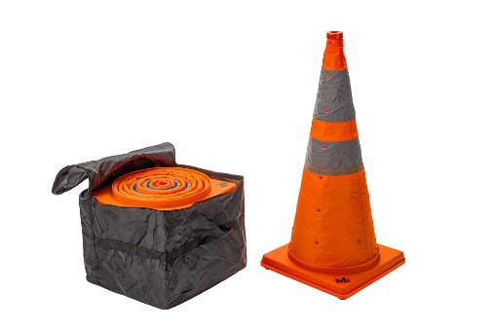
- Safety cones Foldable:
Type: Traffic / Safety Cone
Height: 30 - 40 cm
Material: Flexible PVC or durable rubber base
Color: High-visibility orange
Reflective Bands: two white reflective bands (high-intensity grade)
Base: Weighted or wide anti-slip base for stability
Weather Resistance: UV resistant, suitable for outdoor use
Features: Impact-resistant, stackable design for storage, storage bag.
Sample is required

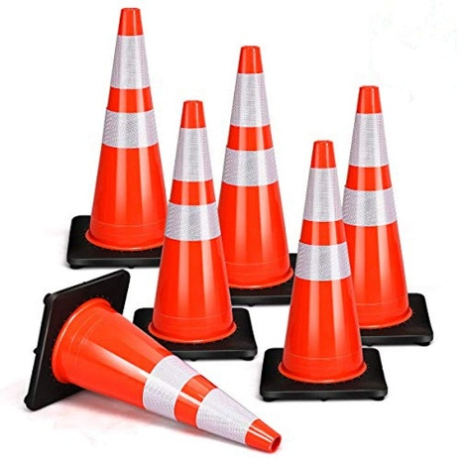
- Safety cones Big Size:
Type: Traffic / Safety Cone
Height: Minimum 70 - 75 cm
Material: Flexible PVC or durable rubber base
Color: High-visibility orange
Reflective Bands: two white reflective bands (high-intensity grade)
Base: Weighted or wide anti-slip base for stability
Weather Resistance: UV resistant, suitable for outdoor use
Features: Impact-resistant, stackable design for storage
Sample is required
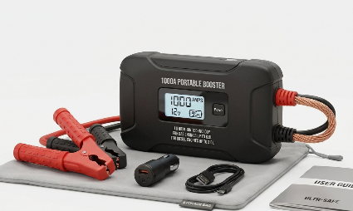
- Booster Jump Starter Portable size.
Battery Cell Composition: Lithium

Voltage: 12v
Vehicle Service Type: Passenger car, motorcycle, Van, Truck
Battery Capacity: 2000 – 3000 Milliamp Hours
Amperage 1000Amps
About this item
- Start Dead Batteries - Safely jump start a dead battery in seconds with this compact, yet powerful, 1000-amp lithium battery jump starter - up to 20 jump starts on a single charge - and rated for gasoline engines up to 6.0-liters and diesel engines up to 3.0-liters.
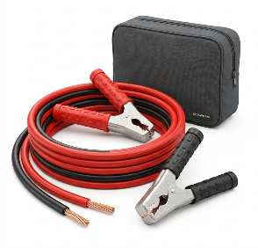
In The Box - Ultra Safe Portable Car Jump Starter, Heavy Duty Booster Clamps, 12-Volt Car Charger, Micro USB Charging Cable, Microfiber Storage Bag, User Guide, 1-Year Warranty, and Designed in the USA or EU or similar quality.
Datasheet is required
- Cable Jumper
Cable Gauge: 4 to 6 gauge
Length: 4 to 7.5 meters
Cables: Pure copper
Clamps: Heavy-duty, preferably coated to prevent rust and improve grip
Amperage Rating: 400 to 800 amps
Clamps: Strong spring-loaded clamps for a secure connection, Color-coded (red for positive, black for negative) for safety and ease of use
Compatibility: Suitable for various vehicle types, including cars, trucks, SUVs, and motorcycles
Carrying Case includes a storage bag or case for easy transport and organization.
Safety Features: Insulated handles to protect against electric shock.
Sample is required
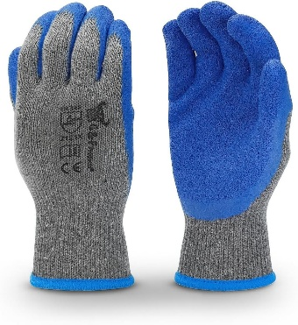
- Working Gloves
Nitrile-coated work gloves.
Seamless nylon/polyester liner.
Good grip in dry and oily conditions
Color: Blue
Elastic knitted wrist cuff.
Available in sizes M, L.
Suitable for general handling, warehouse, transport, and maintenance work.
Sample is required.

- Screwdriver Cross Head
Type: Phillips (Crosshead) Screwdriver
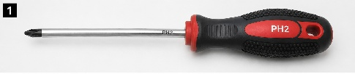
Size: PH2 (Medium)
Shaft Material: Heat-treated chrome vanadium steel.
Tip: Magnetic crosshead tip
Shaft Finish: Corrosion-resistant finish.
Handle: Ergonomic anti-slip rubber grip
Overall Length: 200–250 mm
Features: High-torque design, durable construction, comfortable grip for prolonged use
Application: Suitable for vehicle maintenance, mechanical repairs, and general workshop use.
Sample is required.

- Screwdriver Flat Head
Type: Slotted (Flat Head) Screwdriver

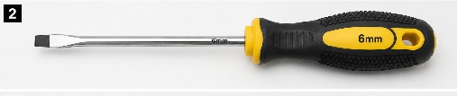
Blade Size: 6 mm (Medium)
Shaft Material: Heat-treated chrome vanadium steel.
Tip: Magnetic flat-head tip
Shaft Finish: Corrosion-resistant finish.
Handle: Ergonomic anti-slip rubber grip
Overall Length: 200–250 mm
Features: High-torque design, durable construction, comfortable grip for prolonged use
Application: Suitable for vehicle maintenance, mechanical repairs, and general workshop use.
Sample is required

- Plier
Type: Combination Pliers
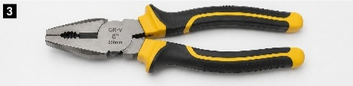
Size: 8 inches (200 mm)
Material: Drop-forged, heat-treated chrome vanadium steel
Finish: Corrosion-resistant finish
Jaws: Serrated gripping jaws with integrated wire cutter
Grip: Ergonomic anti-slip handle for secure handling
Features: Heavy-duty construction, smooth pivot action, high gripping, and cutting performance
Application: Suitable for vehicle maintenance, mechanical repairs, gripping, twisting, bending, and cutting wires and small components.
Sample is required

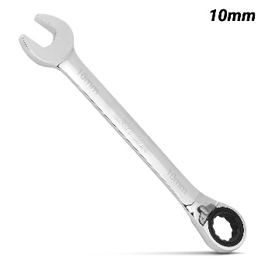
- Spanner
Type: Ratchet combination spanner (open-end + ring ratchet)
Size: 10 mm
Material: Chrome Vanadium (Cr-V) steel
Finish: Mirror polish or chrome plated, corrosion-resistant
Ratchet Mechanism: 72-tooth (or higher) fine ratcheting system.
Direction: Reversible ratchet (forward/reverse switching)
Head Angle: Offset ring head (typically 15°)
Design: Slim profile for access to tight engine compartments
Strength: Heat-treated for high torque resistance
Application: Suitable for vehicle maintenance, mechanical assembly, and confined space fastening tasks.
Sample is required

- Spanner
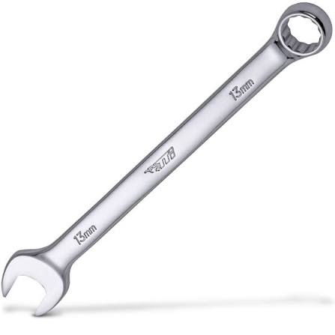
Type: Ratchet combination spanner (open-end + ring ratchet)
Size: 13 mm
Material: Chrome Vanadium (Cr-V) steel
Finish: Mirror polish or chrome plated, corrosion-resistant
Ratchet Mechanism: 72-tooth (or higher) fine ratcheting system.
Direction: Reversible ratchet (forward/reverse switching)
Head Angle: Offset ring head (typically 15°)
Design: Slim profile for access to tight engine compartments
Strength: Heat-treated for high torque resistance
Sample is required

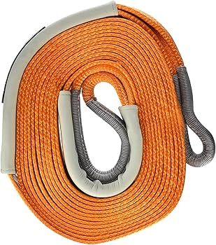
- Tow Cable / Recovery Strap – 5m.
Type: Recovery strap (tow cable)
Length: 5 meters
Material: High-strength polyester webbing
Width: 70–80 mm
Minimum Breaking Strength: ≥ 12,000 kg
Construction: Reinforced eye loops with protective sleeves
Features: Low stretch, weather resistant, high visibility
Compatibility: Suitable with rated shackles and recovery points
Sample is required

- Ring Anchor Shackles (Bow / D-Shackle)
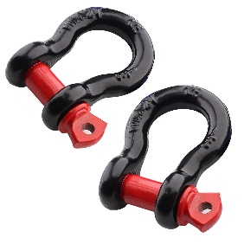
Type: Screw pin bow shackle (D-ring)
Material: Drop-forged high-strength steel
Pin Diameter: 16–19 mm
Working Load Limit (WLL): ≥ 4.75 tons
Breaking Strength: ≥ 20,000 kg
Construction: One-piece forged body with threaded screw pin
Features: Corrosion resistant, suitable for towing and recovery
Compatibility: Use only with rated recovery points and straps
Sample is required
- Siren Specifications
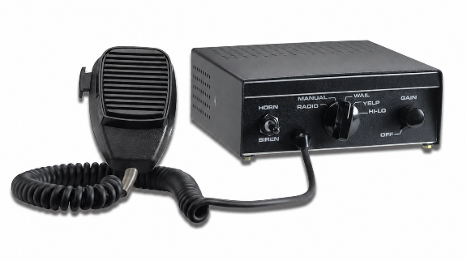
100 Siren with PA noise canceling microphone
Siren Tones, PA, Radio rebroadcast and air horn
Library of selectable siren tones
Horn ring transfer and park kill
(4) programmable inputs, plus dedicated inputs for park, horn, and ignition
Convergence network configuration software allows for easy customization of the siren
Five-year Warranty minimum.
Siren with self-contained controls 100W.
Specifications
Power 100W
Input voltage 11 – 28 VDC
Nominal output voltage 64V peak to peak.
Standby Current <0.1A
Max input current 10A
Frequency range 182 to 1600 hz
Operating temperature -40 to +80 Degree Celsius
Height 6.4cm
Length 15.2cm
- Width 20.5cm
- can be powered via the vehicle’s power center or directly from the vehicle’s battery.
- Origin: Manufactured in Europe, USA.
Datasheet is required.

- Tire Puncture Repair Kit
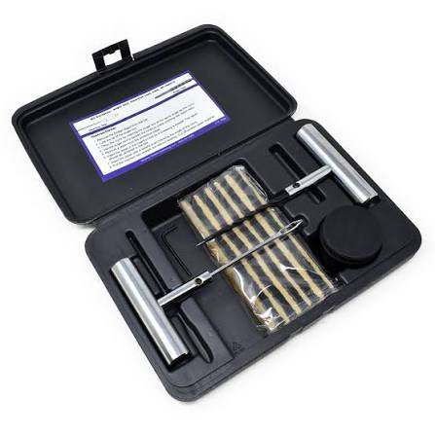
Type: Manual tire repair kit (for tubeless tires)
Includes:
Insertion tool
Probe tool
Repair plugs (at least 5 pcs)
Adhesive (glue)
Cutter or Blade
Function: Temporary repair of small punctures
Easy to use (no electricity required)
Packed in a small portable case
Instructions included
Suitable for cars, SUVs, and light trucks
Sample required
- Tire Sealer & Inflator – Specifications
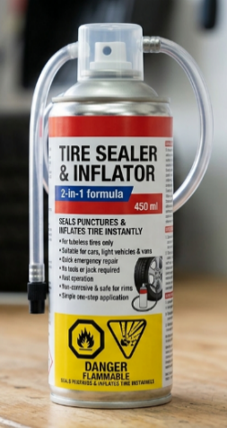
Type: Aerosol tire sealer and inflator (2-in-1).
Capacity: 400–450 ml per can.
Seals small tire puncture and inflate the tire instantly.
Provides temporary emergency repair to allow the vehicle to reach a workshop.
Seals puncture up to approximately 4–5 mm.
Fast operation within a few minutes.
Works without removing the tire.
No tools or jack required.
Easy connection to tire valves via hose/nozzle.
Simple one-step application.
Suitable for cars, light vehicles, and vans.
Compatible with tubeless tires only.
Contains a sealant and compressed gas formula.
Non-corrosive and safe for rims and tires.
Supplied in an aerosol can with hose/nozzle.
Properly sealed and suitable for storage in vehicles.
Minimum shelf life of 2–3 years.
Flammable aerosol.
Clear instructions and safety warnings printed on the can.
Sample required.

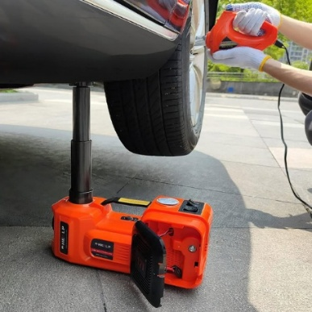
- Hydraulic Car Jack + tire inflator 12V
Type: Electric Hydraulic Car Jack
Capacity: 5 Ton
Voltage: 12V DC
Lifting Range: 150mm – 450mm (15–45cm)
Power Source: Car cigarette lighter / Battery clamp
Functions: Lifting + Tire Inflator + LED Lighting
Safety Features: Overload protection, anti-slip head
Suitable Vehicles: Sedan, SUV, MPV, pickup, light truck
Datasheet is required.

- Magnet Mount Light Bar Specifications
Features
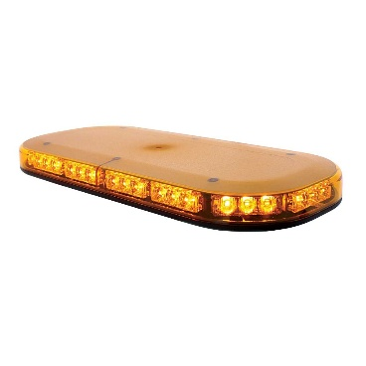
Low-profile 15” mini-light bar
Unique edge cruise lighting available in dual color model
(25) flash patterns
Multi voltage 12/24v
Magnet mount
Five-year warranty
Blue light only
Specifications
Operating voltage 12/24 vdc
Current draw 2.0 A @ 12VDC/ 1.0A @ 24 VDC
Operating temperature -40 to +65 degrees Celsius
Length 37.2 cm
Width 21.5cm
Height 5.4
Origin: Manufactured in Europe, USA.
Datasheet is required

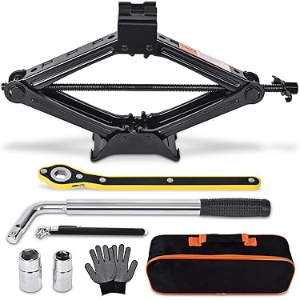
- Vehicle Jack (Scissor Type)
Type: Compact scissor jack, suitable for in-vehicle storage.
Capacity: Minimum lifting capacity of 2 tons (suitable for SUV weight).
Operation: Manual, with crank/handle provided.
Construction: Heavy-duty steel, rust- and corrosion-resistant finish.
Safety: Wide base plate for stability on uneven or soft surfaces.
Storage: Compact and lightweight design for storage inside the vehicle
Sample is Required

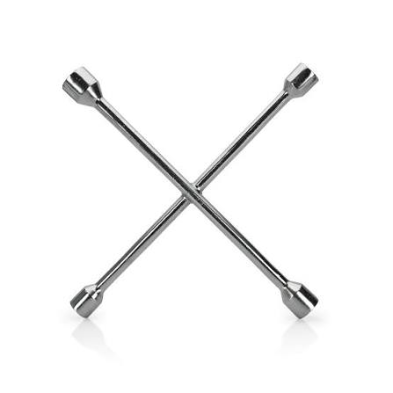
- Wheel Spanner
Type: Cross spanner.
Material: Hardened, corrosion-resistant steel.
Size: suitable for SUV’s and sedan
Durability: Strong enough for repeated use without bending.
Socket Sizes: 17, 19, 21, 23mm.
Sample is Required

- Car drying towel
Microfiber
90x60cm
Thickness 600-1000 GSM
Sample is Required
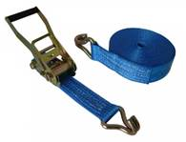
- Ratchet straps 5 tons
Ratchet straps with claw hook
5tons x10m
Color Blue
Material: Heavy duty
Suitable for outdoor use
Sample is Required
- Ratchet straps 1 ton
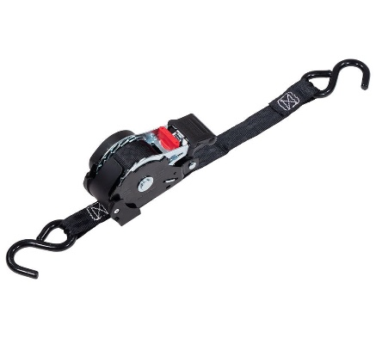
Type: Retractable ratchet tie-down strap
Load Capacity: 1 Ton (1,000 kg minimum breaking strength)
Working Load Limit (WLL): Minimum 300–500 kg
Strap Width: 25 mm
Material: High-strength polyester webbing
Finish: Zinc-plated or powder-coated metal components
UV Resistance: Yes, suitable for outdoor use.
Abrasion Resistance: High durability for repeated use
Operation: One-hand tightening and automatic retraction system
Application: Securing light cargo in vans, pickups, and small trucks
Safety: Designed for safe transport load securing applications
Sample required
- Socket and Tool set 137pcs.
Sockets
10 × 1/2″ drive standard sockets (18–32mm)
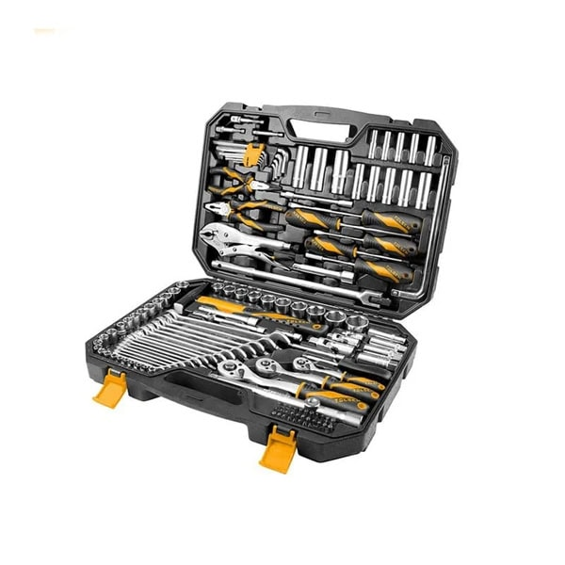
9 × 3/8″ drive standard sockets (10–19mm)
12 × 1/4″ drive standard sockets (4–13mm)
Deep sockets for 1/2, 3/8, and 1/4″ drives
Ratchets & Drive Tools
3 × 72-tooth reversible ratchets (1/4, 3/8, 1/2)
Extension bars for all drive sizes
Universal joints and socket handles
Flexible and offset handles.
Screwdriver Bits (33pcs Cr-V)
Phillips, Posidrive, Slot, Hex
Torx and Torx with hole
Square and M-type bits
Hand Tools
15 × Combination spanners (6–21mm)
9 × Hex key set (1.5–10mm)
Combination pliers (7″)
Long nose pliers (6″)
Locking pliers (10″)
Machinist hammer – 300g
Screwdrivers and nut driver
Sample is Required
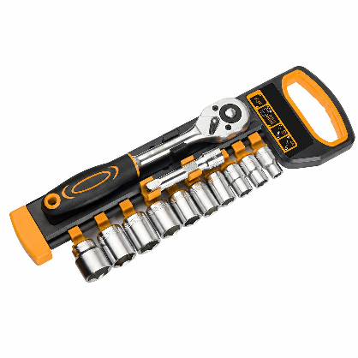
- 12Pcs 3/8″ Ratchet Handle with Socket Set
10pcs metric CrV sockets: 8,10,11,12,13,14,16,17,18,19mm
1pc CrV extension bar:75mm
1pc two-component ergonomic ratchet handle, 72T, CrV, quick release
Packing: plastic hanger with color label
Sample is Required

- Cutter
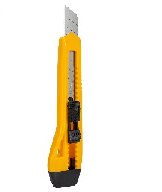
Heavy-duty 18 mm utility cutter.
Ergonomic high-impact plastic body with reinforced metal blade guide.
Replaceable 18 mm SK5 high-carbon steel snap-off blade (0.5 mm thickness).
Secure sliding blade locking mechanism for safe operation.
Suitable for cutting cardboard, paper, plastic, packaging materials, and other general-purpose applications
Sample is required

- Heavy-duty plastic tool bags to store all the equipment.
Heavy-duty durable plastic protective equipment case (rigid shell design)
Made from high-impact resistant polypropylene (PP) or similar engineering plastic.
Shockproof and crush-resistant structure for protection of sensitive tools and equipment
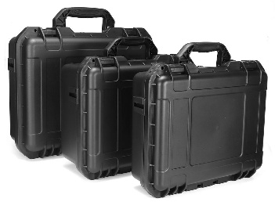
Ergonomic top handle for secure and comfortable carrying.
Reinforced locking latches for safe closure and transport security
Stackable design for efficient storage and transport optimization
Ribbed external frame for added strength and durability.
Resistant to dust, moisture, and light water exposure (splash-resistant)
Suitable for tools, electronics, and field equipment storage
Available in multiple sizes for different equipment storage requirements
Sample is required.

