Annex 2 – Bid Form completed signed and stamped
- All bids must be typed; handwritten bids will not be considered.
- The contract will be awarded to the lowest-cost technically compliant bid
- Under this Framework Agreement, the quantities indicated are estimates only and may vary depending on LRC operational requirements. Purchases will be executed through the issuance of Purchase Orders on an as-needed basis during the validity period of the agreement. LRC does not guarantee the procurement of the full estimated quantities.
- The bidder is not permitted to alter the section labelled “LRC to complete” below. Bidder is not allowed to use any other template.
- In the event of any discrepancy between the unit price and the total price, LRC reserves the right to rely on the unit price as stated in the financial bid, rather than the total price without go back to the supplier. The unit price must be provided with no more than two decimal places.
- Unit price must include manufacturing, labor, packaging, transport, delivery to LRC warehouse, and all applicable bank transfer charges.
- Note: A sample and technical data sheet is mandatory for all requested items, except for Item #6, for which only a technical data sheet is required. All required samples and technical data sheets must be submitted before the tender submission deadline.
LRC To Complete |  |  |  | Bidder to Complete
Item # | Item/Milestone Required | UOM | QTY | Unit Price in USD  Exclusive of VAT | VAT (%) | Unit Price in USD  Inclusive of VAT | Total Price in USD  Inclusive of VAT | Lead time of delivery  (in calendar days) from the date of each Purchase Order.
1 | Ceramic Filter | Pieces | 50
2 | Net roll | Pieces | 92
3 | Solar Lantern | Pieces | 50
4 | CCOM Household (HH) Toolbox Kit | Kit | 50
5 | Sanitation Kit | Kit | 5
6 | Wall vending machine for sanitary pads | Pieces | 5

Item #4: CCOM Household (HH) Toolbox Kit(Breakdown price)

LRC To Complete |  |  |  | Bidder to Complete
Item # | Item/Milestone Required | UOM | QTY/1 Kit | Unit Price in USD  Exclusive of VAT | VAT (%) | Unit Price in USD  Inclusive of VAT | Total Price in USD  Inclusive of VAT
4.1 | Wrench | Piece | 1
4.2 | PTFE Tape | Roll | 2
4.3 | Utility Cutter | Piece | 1
4.4 | Waterproof tape | Roll | 2
4.5 | Sandpaper | Piece | 2
4.6 | 1/2-Inch Isolation Valve | Piece | 1
4.7 | Toolbox | Piece | 1
Total Price Including VAT per Kit
Total Price including VAT for 50 Kit

item #5: Sanitation Kit (Breakdown price)
LRC To Complete |  |  |  | Bidder to Complete
Item # | Item/Milestone Required | UOM | QTY/1 Kit | Unit Price in USD  Exclusive of VAT | VAT (%) | Unit Price in USD  Inclusive of VAT | Total Price in USD  Inclusive of VAT
5.1 | Heavy duty wheelbarrow | Pieces | 2
5.2 | Heavy duty metal steel pickaxe | Pieces | 5
5.3 | Hoe | Pieces | 5
5.4 | Shovel | Pieces | 5
5.5 | Working Gloves | Pair | 15
5.6 | Mason trowel | Pieces | 2
5.7 | Plastic Boots | Pair | 2
5.8 | Plastic gloves | Pair | 2
Total Price Including VAT per Kit
Total Price including VAT for 5 Kit

ANNEX 3: DETAILED SPECIFICATIONS
ITEM # | ITEM NAME | Technical Specifications | Picture
1 | Ceramic Filter | Free standing gravity water filter with 3 ceramic candles (cartridges) and 20 Liters water containers with lid.  Free-standing gravity-fed water filter comprising two (2) plastic containers, each with a capacity of 20 litres, fitted with three (3) ceramic filter candles/cartridges and lids.  The Ceramic filter ensures a filtration capacity of approximately 4 Liters of water per hour.  Water filter containers:  2 X 20 liters plastic bucket  Each bucket volume = 20 liters  Weight: 3.3 kg Dimension: 25*45 cm  Water tap:  Plastic heavy-duty tap and leak-proof  Is attached to the bottom bucket and compatible with the bucket wall thickness.  Middle of the tap is positioned 4.5 cm from the bottom of the lower bucket.  Tap is composed of double gasket and to be installed part from inside the bucket and part from outside the bucket to prevent any leaking (attached reference photo)  Colour: White  Recycled plastic not allowed  Suitable for drinking water  Water filter candles (or cartridges):  For use within gravity-fed water filter systems  Type: Ceramic  Width (mm): 56  Diameter (mm): 56  Height (mm): 228  Weight KG: 0.26  Flow rate: 1.5 litres per hour per candle (cartridge)  Working temperature range: 5 – 30-degree Celsius Filtration rating: microfilter plus granular activated carbon. 0.2-micron ceramic depth filter (Cleanable)  Biodegradable sponge:  Natural cellulose non-scratch sponge  Eco-friendly and 100% biodegradable  Dimensions: 19x10x5 cm  Sample Mandatory to be submitted | 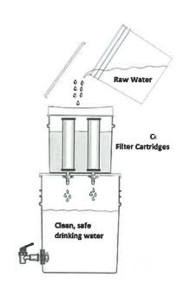  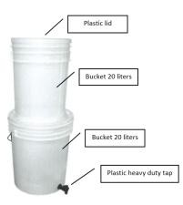  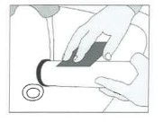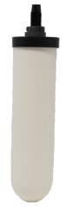  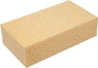
2 | Net roll | Supply and deliver heavy-duty plastic net rolls manufactured from UV-stabilized HDPE or equivalent polymer material, suitable for outdoor drainage, filtration, insect-barrier, and site-protection applications. Preferably made of recyclable material.  Each roll shall be 1.00 m width × 25.00 m length, with mesh opening 5 × 5 mm ±1 mm tolerance, and strand thickness minimum 2–3 mm. The mesh shall be extruded/integrally formed (non-woven) with uniform square grid pattern and reinforced thermally bonded edges.  Material shall be black colour, UV-resistant, weatherproof, water-resistant and resistant to tearing and deformation. Product shall be flexible while maintaining dimensional stability during installation.  Each delivered roll shall include either:  1. manufacturer technical datasheet attached to the roll/package OR  2. Certificate of manufacture/origin confirming material composition, UV stabilization, manufacturing date, and country of origin.  Inspection shall verify dimensions, mesh opening, strand thickness, edge reinforcement, packaging condition, documentation, and absence of defects or cuts.
3 | Solar Lantern | - Time to charge: 12 hours sunlight.  - Rechargeable lithium-ion batteries only.  - Lifespan: 2 years minimum in daily use.  - Shelf life: 5 years when kept in original packaging between –10°C and 50°C. The lights are delivered with partially charged batteries; it is recommended to re-charge the batteries before use to ensure full maximum power. When stored fully charged, the batteries will hold charge for approximately 1 year, slowly discharging.  Specification:  Lamp, solar: Rechargeable by solar panel and 220 V (cable and charger must be provided with the lamp, charger can be integrated or separate)  General quality: Up to the highest industry standards.  Connectors: Female USB outlet, to charge a mobile phone, Compatible connector inlet for connecting the solar panel or the charger  Features: At least 2 luminosity positions, high beam and low beam, Battery charging indicator light  Lighting performance  - High mode: ≥ 300 lumens  - Runtime at ≥ 300 lumens: minimum 4 hours  - Low mode: ≥ 75 lumens  - Runtime at ≥ 75 lumens: minimum 12 hours  Light output angle: 360 degrees, omnidirectional  - Color temperature: 5000–6500K  - Material: Casing made of shockproof plastic  - Waterproof: Rain resistant – minimum IPX4  - Battery: Lithium-ion battery, Minimum capacity 18Wh  - Charge cycles: Low Self Discharge, 500+ charges  - Battery protection: Automatic protection against deep battery discharge and overcharge  Solar panel:  - Integrated or separate (with a 3m cord with male Micro-USB/ or other compatible connector to connect to the Micro-USB inlet of the lamp or to charge a mobile phone)  - Minimum panel power: ≥ 4W  - Time to fully charge: 12h maximum bright sun light  Charging outlet (USB-A) performances:  - Outlet minimum voltage with no load: 5V  - Outlet minimum current with load: 0.4A at 4.5V Outlet minimum available energy: 3.5Wh  - Outlet minimum available energy after 4 hours charge starting from 100% discharged battery: 1Wh  Indicator and usability:  - Foldable handle, hook, strap or other mechanism to suspend the lamp e.g. from tent pole or branch.  - Charging indicator, low battery indicator  Packaging: Wrapped in soft cardboard for protection (no plastic bags), packed in an individual strong cardboard box.
4 | CCOM Household (HH) Toolbox Kit | 4.1 Adjustable wrench 200 mm 8" Specification:  Supply and deliver professional adjustable wrench, 200 mm / 8 inch, manufactured from drop-forged chrome vanadium steel or equivalent high-strength alloy steel, heat-treated and induction-hardened.  Maximum jaw opening shall be 24–30 mm, with precision-machined adjustable jaw operated by hardened worm gear mechanism, ensuring smooth adjustment with no backlash.  Jaws shall have anti-slip serration and hardness not less than 45–50 HRC.  Finish shall be chrome-plated, corrosion-resistant, and easy to clean.  Handle shall be ergonomic and anti-slip.  Product shall be relevant DIN/ISO hand tool standards, and supplied free from deformation, cracks, rust, or loose moving parts. | 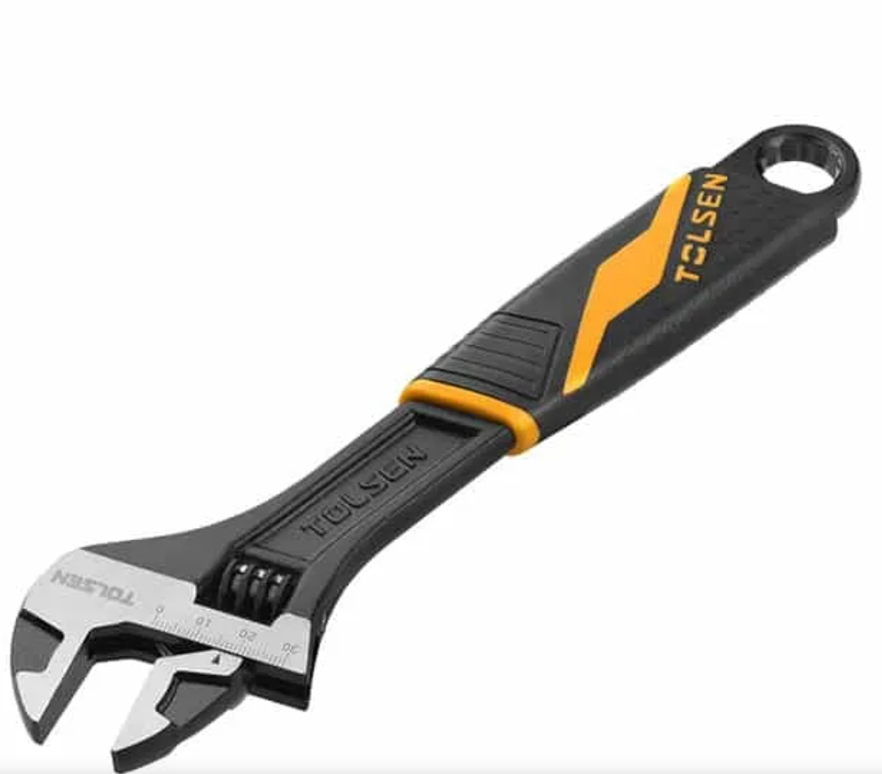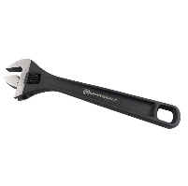
4 | CCOM Household (HH) Toolbox Kit | 4.2 PTFE Tape 100% 19mm * 15m * 0.2mm Specification:  Supply and deliver professional thread sealing tape made from 100% virgin PTFE (Polytetrafluoroethylene), suitable for sealing threaded plumbing connections for water supply systems.  Tape dimensions shall be 19 mm width × 15 m length × 0.20 mm thickness.  Tape shall be chemically inert, non-toxic, non-flammable, water-resistant, and suitable for metal and plastic pipe threads.  Each roll shall be supplied on plastic spool with protective cover.  Product packaging shall be indicating material, dimensions, and manufacturer.  Inspection shall confirm roll length, width, thickness, packaging condition, and sealing quality. | 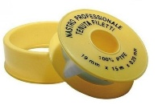
4 | CCOM Household (HH) Toolbox Kit | 4.3 Utility Cutter 18 mm Specification:  Supply and deliver heavy-duty utility cutter with retractable 18 mm snap-off blade, manufactured with reinforced aluminium or impact-resistant ABS body.  Blade shall be high-carbon steel or stainless steel, segmented, replaceable, and securely fixed by mechanical slide-lock or auto-lock system.  Handle shall be ergonomic, anti-slip, and suitable for site use.  Cutter shall allow safe blade replacement and controlled cutting of plastic, cardboard, rubber, rope, and light construction materials.  Product shall be compliant with relevant hand-tool safety requirements.  Inspection shall confirm blade locking, body strength, blade sharpness, and safe operation. | 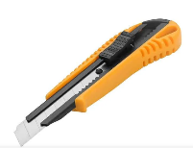
4 | CCOM Household (HH) Toolbox Kit | 4.4 Waterproof tape (High polymer butyl rubber) Specification:  Supply and deliver waterproof sealing tape made from high-performance butyl rubber compound laminated with polyethylene or aluminium foil backing.  Tape shall be self-adhesive, flexible, UV-resistant, water-resistant, and suitable for sealing joints, cracks, roofs, concrete, metal, plastic, and drainage-related repairs.  Thickness shall be 1.0–1.5 mm — not meters — with width 50–100 mm, recommended 75 mm, and minimum length 5 m per roll or approved equivalent.  Product shall be supplied in sealed packaging with datasheet.  Inspection shall confirm thickness, width, adhesion, backing quality, roll condition, and absence of dry or damaged adhesive. | 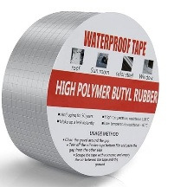
4 | CCOM Household (HH) Toolbox Kit | 4.5 Sandpaper Specification:  Supply and deliver silicon carbide abrasive sandpaper sheets, grit size P220, suitable for fine finishing of plastic, PVC, metal, wood, painted surfaces, and wet/dry sanding applications.  Sheet dimensions shall be approximately 280 × 230 mm, with flexible moisture-resistant cloth backing and backing thickness 0.4–0.6 mm.  Abrasive grains shall be uniformly distributed with strong adhesion to backing material. Sandpaper shall be suitable for professional construction and maintenance applications. Manufacturing date of supplied material shall not exceed one year from delivery date, and supplier shall provide proof of manufacturing date upon request.  Product shall be supplied in original manufacturer packaging indicating grit size, backing type, manufacturer, and manufacturing date. Inspection shall confirm grit classification, dimensions, backing quality, flexibility, packaging condition, and manufacturing date compliance. | 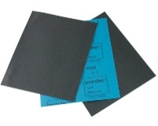
4 | CCOM Household (HH) Toolbox Kit | 4.6 1/2-Inch Isolation Valve Specification:  1/2 inch isolation valve for controlling water flow from the tank to the plumbing distribution line. Valve shall be pressure-rated, easy to operate, corrosion-resistant, accessible for maintenance, and installed in the correct flow direction with watertight threaded joints.  Inspection shall confirm solid brass construction for all metallic parts, coating quality, thread accuracy, dimensions, pressure resistance, sealing performance, and absence of cracks or leakage | 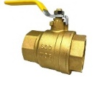  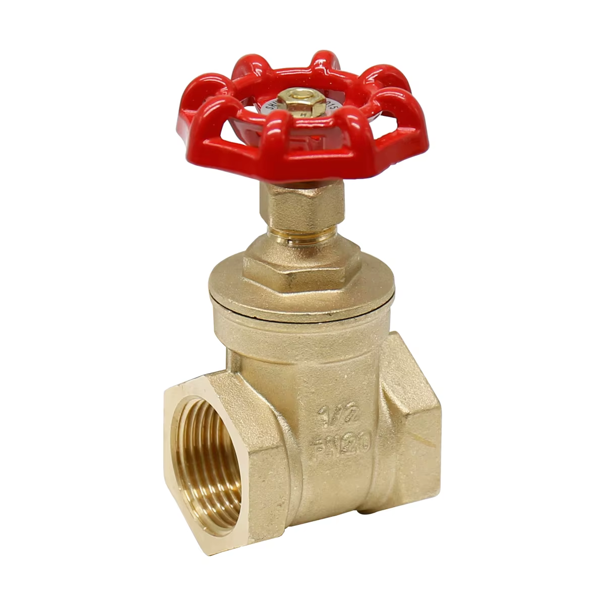
4 | CCOM Household (HH) Toolbox Kit | 4.7 Toolbox 400mm * 200mm * 186mm Specification:  Supply and deliver heavy-duty portable steel toolbox, suitable for construction, maintenance, and site works.  Toolbox dimensions shall be approximately 400 × 200 × 180 mm or approved equivalent. Body shall be fabricated from powder-coated steel sheet with minimum thicknesses as follows: base thickness 0.8–1.0 mm, side walls and lid thickness 0.7–0.9 mm. All corners and edges shall be curved/smooth-finished to prevent injuries during handling.  Toolbox shall include reinforced steel carrying handle with anti-slip grip, heavy-duty steel hinges, and metal locking clips/latches minimum thickness 1.0–1.2 mm.  Load capacity shall be minimum 15–20 kg.  Steel surfaces shall be anti-rust treated and electrostatically powder-coated for corrosion resistance.  Toolbox shall include removable internal tray or compartment organizer where applicable. Colour: dark colours only.  Inspection shall confirm steel thicknesses, coating quality, handle rigidity, hinge alignment, latch operation, load resistance, smooth curved edges, and absence of sharp edges, dents, or corrosion. | 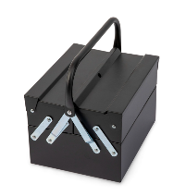
5 | Sanitation Kit | 5.1 Heavy duty wheelbarrow Specification:  Metal steel tray  Thickness > 1mm  100L capacity  Frame Ø ≥ 30mm  Supply and deliver heavy-duty wheelbarrow suitable for construction, drainage cleaning, and general site works.  Tray shall be pressed mild steel with minimum capacity 100 L and thickness 1.2–1.5 mm, including reinforced front lip and fully curved/smooth-finished edges to eliminate sharp edges and improve handling safety.  Supporting frame shall consist of continuous welded steel pipe structure with diameter minimum 30–32 mm and wall thickness minimum 1.5 mm, with no spot welding permitted. All steel components shall be anti-rust treated and powder-coated for corrosion resistance.  Wheel shall consist of heavy-duty pneumatic rubber tire minimum 35cm diameter mounted on galvanized steel rim.  Rubber tire wall thickness shall be minimum 4–6 mm with inner tube thickness minimum 1.2–1.5 mm. Rubber material manufacturing date shall not exceed one year from delivery date. Supplier shall provide certificate/document confirming rubber manufacturing date. Handles shall include ergonomic anti-slip rubber grips.  Minimum load capacity shall be 100–150 kg.  Inspection shall verify tray thickness, frame welding continuity, curved edges, coating quality, wheel dimensions, tire manufacturing date certification, rubber condition, load stability, and absence of deformation or sharp edges. | 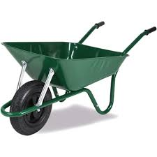
5 | Sanitation Kit | 5.2 Heavy duty metal steel pickaxe Specification:  6" pick end with a 1.5" chisel blade, Wooden ± 120cm handle  Supply and deliver heavy-duty pickaxe with forged high-carbon steel head, minimum weight 2–3 kg, heat-treated for hardness, strength, and impact resistance.  One side shall be pointed and the opposite side chisel-shaped, both sharpened and polished.  Handle shall be solid hardwood, ash/hickory or approved equivalent, length 100–150 cm, kiln-dried, smooth-sanded, moisture-resistant, and securely fixed through tapered eye with wedge locking system. Suitable for this item  Steel head shall have anti-corrosion paint or lacquer coating.  Product shall be compliant with relevant hand-tool safety standards.  Inspection shall confirm head weight, handle fixing, straightness, coating, sharpness, and absence of cracks or looseness. | 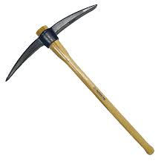
5 | Sanitation Kit | 5.3 Hoe Specification:  - Heavy duty metal steel hoe  - ±7" * 7" digging blade  - Wooden ± 120cm handle  Supply and deliver heavy-duty agricultural/site hoe with forged carbon steel blade, blade size approximately 7 × 7 inch, thickness 3–5 mm, sharpened edge, and reinforced socket connection.  Handle shall be hardwood, length 120–150 cm, smooth-finished, moisture-resistant, and mechanically fixed using wedge, rivet, or approved secure connection. Suitable for this item  All metal parts shall be anti-rust coated and suitable for repetitive soil cutting and landscaping works.  Inspection shall confirm blade thickness, handle fixing, coating, sharpness, balance, and absence of deformation. | 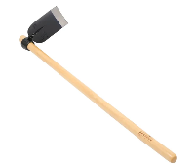  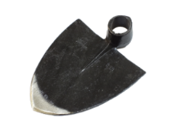
5 | Sanitation Kit | 5.4 Shovel Specification:  - Digging in hard soil shovel  - Metal ± 22cm * ±30cm blade  - Wooden ± 120cm handle  Supply and deliver heavy-duty digging shovel suitable for hard soil and construction works. Blade shall be pressed and hardened carbon steel, approximately 220 × 300 mm, thickness 1.5–2.0 mm, with reinforced curvature and steel collar/socket.  Handle shall be hardwood or fiberglass-reinforced core, length 100–150 cm, fixed by rivet or bolt connection. Suitable for this item  All steel parts shall be powder-coated or painted for corrosion resistance.  Inspection shall confirm blade thickness, handle strength, D-grip fixing, coating quality, and safe edges. | 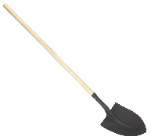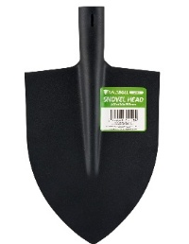
5 | Sanitation Kit | 5.5 Working Gloves Specification:  Supply and deliver reusable heavy-duty working gloves manufactured from blended fabric composed mainly of cotton (minimum 70–80%) with small percentage polyester fibres (approximately 20–30%) to improve flexibility, dimensional stability, and durability, in accordance with common international PPE textile specifications.  Palm and fingers shall be nitrile-coated for abrasion resistance and anti-slip performance. Fabric thickness shall be 0.8–1.2 mm, nitrile coating thickness 0.5–0.8 mm, and total combined glove thickness approximately 1.5–2.2 mm.  Total glove length shall be 240–260 mm from cuff to fingertip.  Gloves shall be tear-resistant, puncture-resistant, breathable on upper side, and fitted with elastic wrist cuff. Double stitching shall be provided at high-stress areas.  Sizes: Standard (XL/L), flexible fit.  Product shall be compliant with EN 388 or equivalent PPE standards.  Inspection shall verify fabric composition, nitrile coating quality, stitching, thickness, flexibility, sizing, and packaging condition. | 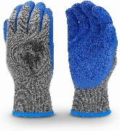
5 | Sanitation Kit | 5.6 Mason trowel Specification:  Masonry, pointing type, 200mm blade  Supply and deliver professional mason/pointing trowel suitable for masonry, plastering, mortar application, and repair works.  Blade length shall be 200 mm, manufactured from hardened and tempered carbon steel or stainless steel with minimum blade thickness 1.0–1.2 mm.  Total trowel length including handle shall be approximately 300–330 mm.  Blade shall have polished finish with tapered shape and securely welded or riveted shank connection.  Handle shall be ergonomic wood, rubber, or composite grip suitable for repetitive professional use and securely fixed to the shank without movement.  Product shall be compliant with professional hand-tool quality standards.  Inspection shall confirm blade length, total length, blade thickness, handle fixing, straightness, polished finish, and absence of cracks, rust, deformation, or unsafe sharp edges. | 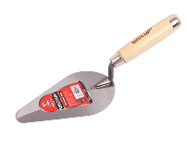
5 | Sanitation Kit | 5.7 Plastic Boots Specification:  Liquid resistant plastic boots, Size 42 – 44  Supply and deliver waterproof safety boots manufactured from PVC or rubber compound with seamless moulded construction suitable for wet, muddy, drainage, and cleaning works. Boots shall include anti-slip deep tread sole, shock-absorbing heel, and liquid-resistant upper body. صبة واحدة  Internal lining fabric shall be composed mainly of cotton (minimum 1 mm) with small percentage polyester fibres (approximately 20–30%) for comfort, moisture absorption, durability, and faster drying, based on international PPE footwear textile standards. Height shall be minimum 30–35 cm, sizes 42–44, colour green or black.  Optional steel toe cap may be included where required.  Product shall be compliant with EN ISO 20347 or equivalent PPE standards.  Inspection shall confirm size, fabric lining composition, waterproofing, sole grip quality, flexibility, seams, and absence of cracks or deformation. Inspection shall confirm size, fabric lining composition, waterproofing, sole grip quality, flexibility, seams, and absence of cracks or deformation. | 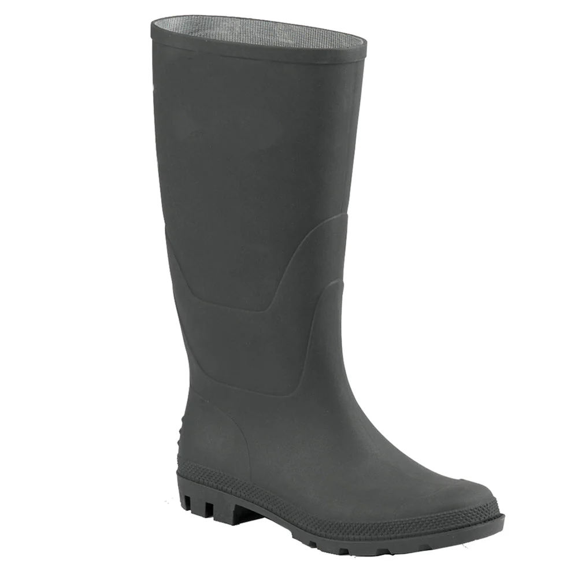
5 | Sanitation Kit | 5.8 Plastic gloves Specification:  Liquid resistant gloves , Used to collect solid waste in drainage channels  Supply and deliver heavy-duty liquid-resistant protective gloves suitable for drainage-channel cleaning, sanitation works, waste collection, hygiene operations, and light-to-medium duty site protection.  Gloves shall be manufactured from high-quality nitrile rubber, powder-free and ambidextrous, providing high resistance against liquids, detergents, contamination, and puncture during sanitation activities. صبة واحدة  Nitrile thickness shall be 0.08–0.12 mm with minimum total glove length of 240 mm and extended cuff preferred for additional wrist protection.  Gloves shall be flexible, tear-resistant, textured for improved grip in wet conditions, and suitable for prolonged professional outdoor and hygiene use.  Gloves shall be supplied in sealed manufacturer boxes containing 100 pieces.  Product shall be compliant with applicable PPE and hygiene standards.  Inspection shall confirm material type, thickness, glove length, packaging integrity, powder-free condition, flexibility, and absence of tears, perforations, or manufacturing defects. | 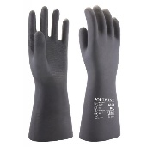
6 | Wall vending machine for sanitary pads | Detailed Specifications (Vending Machine)  Type: Wall mounted vending machine for Sanitary pad.  Color: White  Material: Metal (powder coated)  Storage Capacity: Minimum capacity 64 pcs – Maximum capacity 100 pcs  Type of items (rows): 4 items  Capacity per row: Minimum capacity 16 pcs – Maximum capacity 25 pcs  Type of operation: Mechanical  Dimension: 520 mm * 725 mm * 125 mm, Customized.  Payment system : Token  Warranty: Minimum One Year  After sales services: Online support, video technical support  Detailed Specifications (Token)  Type: Tokens for the vending machine  Color: Light grey / White  Material: Hard Plastic or Metal (coated)  Number of items: 1000 token  Type of items (rows): Standards, Fits with the with mode of payment (vending machine)  Capacity per row: One token per item  Type of operation: Mechanical  Dimension: Fits with the vending machine diameter  Warranty: Minimum One Year  After sales services: Online support, video technical support  The supplier is requested to submit only data sheet for this item | 

