Annex 2 – Bid Form completed signed and stamped
- All bids must be typed; handwritten bids will not be considered.
- The contract will be awarded to the lowest-cost technically compliant bid/Item
- Under this Framework Agreement, the quantities indicated are estimates only and may vary depending on LRC operational requirements. Purchases will be executed through the issuance of Purchase Orders on an as-needed basis during the validity period of the agreement. LRC does not guarantee the procurement of the full estimated quantities.
- The bidder is not permitted to alter the section labelled “LRC to complete” below. Bidder is not allowed to use any other template.
- In the event of any discrepancy between the unit price and the total price, LRC reserves the right to rely on the unit price as stated in the financial bid, rather than the total price without go back to the supplier. The unit price must be provided with no more than two decimal places.
- Unit price must include labor, packaging, transport, delivery to LRC warehouse, and all applicable bank transfer charges.
LRC To Complete |  |  |  | Bidder to Complete
Item # | Item/Milestone Required | Unit of Measurement (UOM) | Estimated  Quantity/ 2 Year | Unit Price in USD  Exclusive of VAT | VAT (%) | Unit Price in USD  Inclusive of VAT | Total Price in USD  Inclusive of VAT | Lead time of delivery  (in calendar days) from the date of each Purchase Order.
1 | Plastazote 20 mm | Sheet | 40
2 | Ankle Stirrup | Pcs | 50
3 | Rubber Sheet | Sheet | 40
4 | Tubular Super Stretch Nylon | Roll | 100
5 | Volara foam rolls | Roll | 2

ANNEX 3: DETAILED SPECIFICATIONS
# | ITEM NAME | Technical Specifications | Estimated Qty/2 Years | Picture
1 | Plastazote 20 mm | Plastazote foam sheet, white or beige, 20 mm thick. Material: closed-cell cross-linked polyethylene. Density: LD45 grade (approximately 45 kg/m³). Sheet size: 2000 mm x 1000 mm. Thickness tolerance: ±1 mm. Color: white throughout (not surface-coated).  Heat-moldable at 120–130°C. Non-toxic and waterproof.  Intended use: orthotic and insole fabrication.  Each sheet labeled with grade and batch reference.  Data sheet is mandatory to be submitted | 40 Sheet | 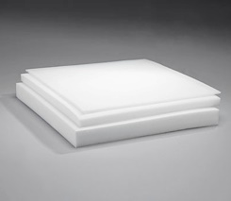
2 | Ankle Stirrup | Ankle stirrup brace with standard action ankle Joints.  Construction: one-piece stamped, weld-free.  Shells with ankle Joints: rigid stainless steel or aluminum, minimum 3 mm (1/8 inch) thickness, medial and lateral.  Accepts ¾’’ Uprights  Sizes to be supplied:  - child (tongue length minimum 55 mm)  - youth (minimum 70 mm)  - adult (minimum 175 mm).  Equivalent to Becker Orthopedic ankle stirrup Model W3050-A or approved equal.  Data sheet is mandatory to be submitted | 50 Pcs | 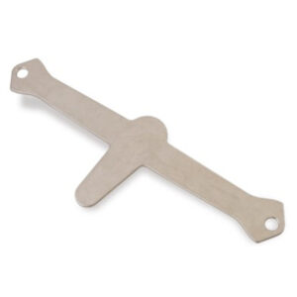
3 | Rubber Sheet | Black rubber sheet for insole production.  Material: natural rubber or high-quality SBR compound. Hardness: Shore A minimum 70.  Thickness: minimum 5 mm, supplier to state exact thickness offered.  Surface: smooth on both sides, no cracks or voids.  Sheet dimensions: minimum 500 mm x 500 mm.  Color: black throughout.  Data sheet + Sample is mandatory to be submitted | 40 Sheet | 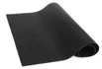
4 | Tubular Super Stretch Nylon | Tubular stretch nylon stockinette for orthotic and DAFO use.  Material: nylon or nylon-spandex knit, tubular construction.  Elasticity: minimum 150% stretch with full recovery. Wall thickness: 1–2 mm.  Color: white or natural. Latex-free, hypoallergenic. Roll length: minimum 25 m per roll.  Supplier to state diameter range available.  Data sheet + Sample is mandatory to be submitted | 100 Roll | 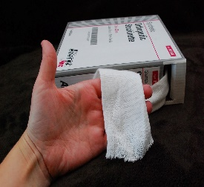  This Photo by Unknown Author is licensed under CC BY-NC-ND
5 | volara foam rolls | Volara foam roll.  Material: closed-cell irradiation cross-linked polyethylene foam.  Surface: smooth skin on both sides, fine uniform cell structure.  Roll width: minimum 600 mm.  Roll length: minimum 15 m.  Supplier to state thickness and density of product offered.  Intended use: orthotic padding and casting interface.  Data sheet is mandatory to be submitted | 2 Roll | 