Annex 2 – Bid Form completed signed and stamped
- All bids must be typed; handwritten bids will not be considered.
- The contract will be awarded to the lowest-cost technically compliant bid per item/lot
- The quantities indicated are estimates only and may vary depending on LRC operational requirements. does not guarantee the procurement of the full estimated quantities.
- The bidder is not permitted to alter the section labelled “LRC to complete” below. Bidder is not allowed to use any other template.
- In the event of any discrepancy between the unit price and the total price, LRC reserves the right to rely on the unit price as stated in the financial bid, rather than the total price without go back to the supplier. The unit price must be provided with no more than two decimal places.
- Unit price must include labor, packaging, transport, delivery to LRC warehouse, and all applicable bank transfer charges.
LRC To Complete |  |  |  | Bidder to Complete
Item # | Item/Milestone Required | Unit of Measurement (UOM) | Estimated  Quantity | Unit Price in USD  Exclusive of VAT | VAT (%) | Unit Price in USD  Inclusive of VAT | Total Price in USD  Inclusive of VAT | Lead time of delivery  (in calendar days) from the date of each Purchase Order.
1 | Electric Thyme, Zaatar & Sumac Grinder | Unit | 1
2 | Multifunctional Press, Grinder & Puree Machine | Unit | 1
3 | Manual Vertical Eggplant Basket Press – 100 L | Unit | 2
4 | Electric Hot-Air Food Dehydrator – 22 Trays, 50 kg Capacity | Unit | 2
5 | Vegetable Cutter | Unit | 2
6 | Industrial Fruit Juice Extractor – 100 kg/h | Unit | 1
7 | Heavy-Duty LPG Gas Cooking Burner – 3 Concentric Burners | Unit | 7
8 | 100 L Stainless Steel Jacketed Cooking Kettle with Motorized Agitator | Unit | 3
9 | Commercial Display Refrigerator – 2 Glass Doors | Unit | 1
10 | Chest Freezer – 600 L | Unit | 2
11 | Chest Freezer – 470 L | Unit | 1
12 | Chest Freezer – 380 L | Unit | 1

ANNEX 3: DETAILED SPECIFICATIONS
# | ITEM NAME | Technical Specifications | Picture
1 | Electric Thyme, Zaatar & Sumac Grinder | Type: Electric commercial grinder suitable for thyme, zaatar and sumac.  - Power supply: 220 V, 50 Hz.  - Motor power: 3 HP.  - Production capacity: 50–100 kg/hour.  - Main product-contact parts: Food-grade stainless steel, minimum SS304.  - Approximate net weight: 18 kg.  - Supplier shall provide all accessories required for normal operation.  - Minimum 12-month warranty.  - Operating instructions to be provided.  Delivery Location: Ouwainet | 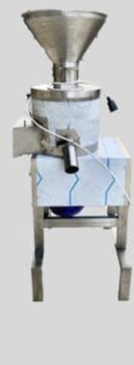
2 | Multifunctional Press, Grinder & Puree Machine | - Multi -functional: it presses, grinds, and purees. It presses tomatoes, green grapes, peppers, pomegranates, grapes, blackberries, and apples, and atomically separates impurities from the pulp.  - It grinds thyme, sumac, dried mint, and purees tomatoes, peppers, quinces, and apples.  - Self-cleaning program, equipped with three sieves.  - All sieves are made of food-grade stainless steel 316.  - Type of sieves: Ø Fine sieve for juice. Ø Medium sieve for thyme and sumac. Ø Coarse sieve for tomato pulp, apples, peppers, walnuts and for stuffing eggplants.  - Dimensions: Ø Juice sieve Approx. width 12 cm, Length: 30 cm Mesh size: 1 mm. Ø Thyme and sumac sieve Approx. width:12 cm, Length: 30 cm Mesh size: 2 mm. Ø Pyramid sieve approx. width: 12 cm, Length: 30 cm Mesh size: 8 mm.  - Rota on speed of the gear: 14 RPM.  - Voltage: 220 V  - Motor capacity: 3 hp motor.  - Produce on capacity: approximately 50 kilo per hour for Zaatar, 30 kilo per hour for Sumac, Tomatoes 12 crates per hour, Pomegranates 100 kilo per hour, Unripe grapes 100 Kilo per hour without stems, Peaches 100 kilo per hour, Hot peppers 75 kilo per Hr  - Electricity: draws 6 amps initally, then stabilizes at 3 amps.  - Dimensions: 110 cm x 85 cm x 34 cm.  - Material: 316 stainless steels.  - Switch ON/OFF with a button to change operational modes.  - Power (kw): 1.5 Kw  Delivery Location: Ouwainet | 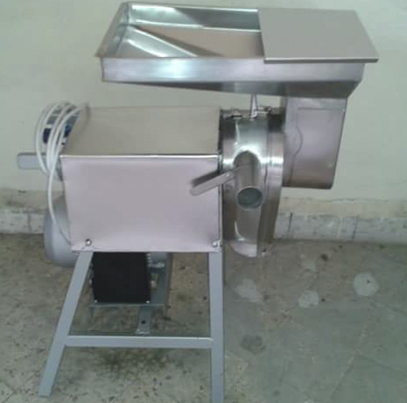
3 | Manual Vertical Eggplant Basket Press – 100 L | - Capacity: 100 L.  - Type: Vertical manual basket press.  - Application: Eggplant and similar food products.  - Pressing system: Manual vertical pressing mechanism.  - Basket: Removable/open-top, perforated basket with double-wall/double-jacket construction.  - Frame and product-contact parts: Food-grade stainless steel.  - Pressing plate: Stainless steel.  - jjuice collection: Integrated stainless-steel collection tray/platform.  - Outlet: Built-in conical outlet/spout for efficient discharge into a collection container.  - Operation: Batch processing with manual loading and unloading.  - Minimum press force: 24.2 kN.  - Equipped with hydraulic pressure gauge and appropriate pressure-relief/safety mechanism.  - Supplier shall provide operating and cleaning instructions.  - Minimum 12-month warranty.  - Delivery location: 1 Unit to Bebnine & 1 Unit to Bellenet Hissa | 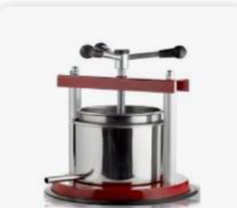
4 | Electric Hot-Air Food Dehydrator – 22 Trays, 50 kg Capacity | - Type: Electric hot-air circulation food dehydrator/dryer.  - Capacity: 22 stainless-steel trays/racks.  - Tray dimensions: approximately 40 × 50 cm per tray.  - Loading capacity: approximately 50 kg.  - Drying system: Forced hot-air circulation with internal fan.  - Temperature control: Adjustable digital/thermostatic controller.  - Timer: Digital timer.  - Cabinet construction: Stainless steel.  - Door: Insulated front door with mechanical locking handle.  - Trays: Food-grade stainless-steel mesh/sieve racks.  - Rated electrical power: approximately 18–22 kW.  - Supplier shall state the temperature-control range/accuracy, timer range and total electrical load.  - Suitable for food preservation, moisture reduction and shelf-life extension.  - Minimum 12-month warranty.  - Operating instructions and local after-sales/spare-parts support required.  - Delivery location: 1 Unit to Bebnine & 1 Unit to Bellenet Hissa | 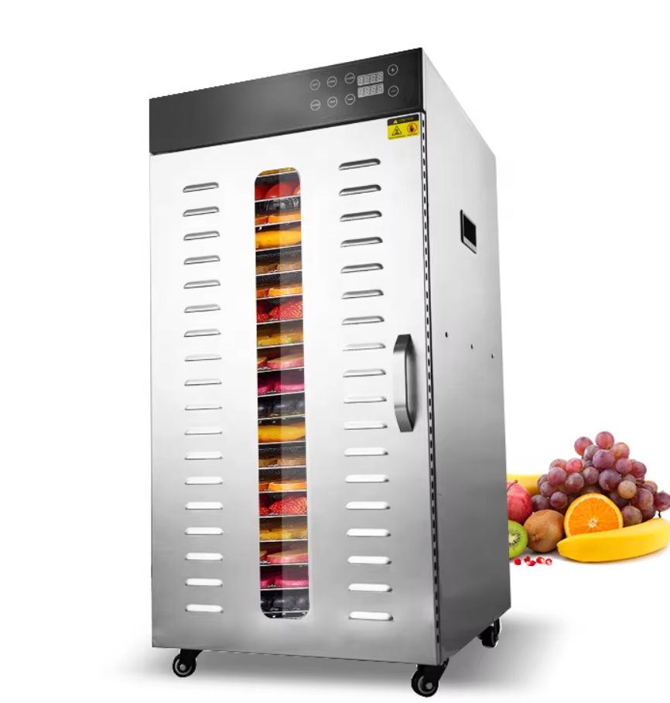
5 | Vegetable Cutter | - Type: Professional/industrial vegetable cutter.  - Capacity: 200–300 kg/hour.  - Functions: Slicing, shredding, grating, julienne and dicing.  - Construction: Food-grade stainless steel and/or aluminium suitable for food processing.  - Motor power: approximately 0.55–0.75 kW.  - Power supply: 220–240 V, single phase, 50 Hz.  - Safety: Safety microswitch/interlock on cover and handle.  - Cleaning: Removable cutting discs/blades.  - Motor overload protection.  - Suitable for green peppers, potatoes, carrots, onions, cabbage, tomatoes, cucumbers and similar vegetables.  - All discs/blades required for slicing, shredding, grating, julienne and dicing shall be included.  - Minimum 12-month warranty.  - Operating instructions and local after-sales/spare-parts availability required.  - Delivery location: 1 Unit to Bebnine & 1 Unit to Bellenet Hissa | 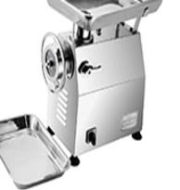
6 | Industrial Fruit Juice Extractor – 100 kg/h | - Type: Industrial fruit juice extractor/juicer.  - Minimum processing capacity: 100 kg/hour.  - Construction: Food-grade SS304 stainless steel.  - Basin/hopper capacity: approximately 40 kg.  - Power supply: 220 V, 50 Hz, single phase.  - Suitable for continuous industrial juice production.  - Supplier shall provide all accessories required for normal operation.  - Minimum 12-month warranty.  - Operating instructions to be provided.  - Delivery location: Bebnine
7 | Heavy-Duty LPG Gas Cooking Burner – 3 Concentric Burners | - Type: Heavy-duty/freestanding LPG gas cooking burner.  - Burner configuration: 3 concentric burners.  - Fuel: LPG.  - Construction: Heavy-duty stainless-steel/semi-stainless-steel construction.  - Grates: Heavy-duty cast-iron grates.  - Flame control: Individual/appropriate flame-control mechanism.  - Suitable for cooking pots with capacity up to 60 L.  - Stable construction with adequate load-bearing capacity.  - Easy-to-clean and hygienic design.  - Complete with all necessary fittings/connections for integration with the LPG supply system.  - Supplier shall specify LPG consumption and burner power/output.  - Minimum 12-month warranty.  Delivery Location:  - Bebnine-2 Units  - Bellenet Hissa-2 Units  - Ouwainet-3 Units | 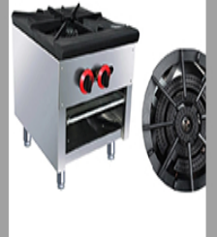
8 | 100 L Stainless Steel Jacketed Cooking Kettle with Motorized Agitator | - Capacity: 100 L.  - Type: Commercial cooking kettle with motorized agitator and jacketed heating system.  - Construction: Food-grade SS304 stainless steel.  - Heating: Jacketed system; electric, gas or external heating source acceptable, subject to supplier's technical proposal.  - Jacket: Double-wall/steam jacket; manufacturer shall state and certify the jacket design and pressure rating where applicable.  - Agitator: Geared motor with food-grade stainless-steel mixing blades.  - Scraper: Food-grade scraper suitable for viscous products to reduce sticking/burning.  - Supplier shall state agitator motor power and operating speed.  - Variable-speed control is preferred.  - Temperature control: Thermometer or digital temperature sensor.  - Safety/pressure components, where applicable: Steam inlet, pressure regulation, pressure gauge, safety/relief valve and condensate outlet/trap arrangement.  - Discharge: Hygienic bottom outlet valve suitable for viscous products or hygienic tilting mechanism.  - Power supply: 220–230 V, single phase, where applicable.  - Safety: Emergency stop and appropriate agitator/lid safety protection.  - Installation and commissioning included.  - Operating instructions and minimum 12-month warranty required.  Delivery Location:  - Bebnine-1 Unit  - Bellenet Hissa-1 Unit  - Ouwainet-1 Unit | 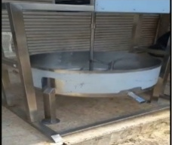
9 | Commercial Display Refrigerator – 2 Glass Doors | - Type: Commercial display refrigerator with 2 glass doors.  - Shelving: Adjustable/internal wire shelves.  - Internal lighting: LED.  - Cooling system: Forced-air circulation.  - Temperature range: +1°C to +10°C.  - Temperature control: Adjustable thermostat/digital temperature controller.  - Defrost: Automatic or manual defrost, to be specified by bidder.  - Power supply: 230 V, single phase, 50 Hz.  - Approximate dimensions: W 120 × D 64 × H 198 cm.  - Maximum current draw: 5 A.  - Complete with all accessories required for normal operation.  - Minimum 12-month warranty.  - Local after-sales service required.  - Delivery Location: Ouwainet | 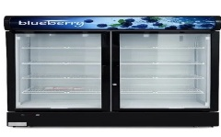
10 | Chest Freezer – 600 L | - Type: Commercial chest freezer.  - Nominal capacity: approximately 600 L.  - Approximate dimensions: 202 × 70 × 96 cm.  - Colour: White.  - Operating temperature: -18°C or below, with capability of reaching approximately -25°C where specified by the manufacturer.  - Power supply: 220 V.  - Approximate operating current: 1.1–2.7 A, subject to manufacturer's specification.  - Defrost system: To be specified by bidder.  - Minimum 12-month warranty.  - Local after-sales service required.  - Delivery Location: Bellenet Hissa | 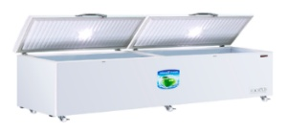
11 | Chest Freezer – 470 L | - Type: Commercial chest freezer.  - Nominal capacity: approximately 470 L.  - Approximate dimensions: 146 × 70 × 96 cm.  - Colour: White.  - Operating temperature: -18°C or below during normal operation.  - Power supply: 220 V.  - Approximate operating current: 1.2–1.5 A, subject to manufacturer's specification.  - Defrost system: To be specified by bidder.  - Minimum 12-month warranty.  - Local after-sales service required.  - Delivery Location: Bellenet Hissa | 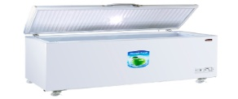
12 | Chest Freezer – 380 L | - Type: Commercial chest freezer.  - Nominal capacity: approximately 380 L.  - Approximate dimensions: 101 × 70 × 96 cm.  - Colour: White.  - Operating temperature: -18°C or below during normal operation.  - Power supply: 220 V.  - Approximate operating current: 1.2–1.5 A, subject to manufacturer's specification.  - Defrost system: To be specified by bidder.  - Minimum 12-month warranty.  - Local after-sales service required.  - Delivery Location: Bellenet Hissa | 