Annex 2 – Bid Form completed signed and stamped
- All bids must be typed; handwritten bids will not be considered.
- The contract will be awarded to the lowest-cost technically compliant bid
- Under this Framework Agreement, the quantities indicated are estimates only and may vary depending on LRC operational requirements. Purchases will be executed through the issuance of Purchase Orders on an as-needed basis during the validity period of the agreement. LRC does not guarantee the procurement of the full estimated quantities.
- The bidder is not permitted to alter the section labelled “LRC to complete” below. Bidder is not allowed to use any other template.
- In the event of any discrepancy between the unit price and the total price, LRC reserves the right to rely on the unit price as stated in the financial bid, rather than the total price without go back to the supplier. The unit price must be provided with no more than two decimal places.
- Unit price must include manufacturing, labor, packaging, transport, delivery to LRC warehouse, and all applicable bank transfer charges.
LOT #1: Floor-Standing Infrared Thermoplastic Heating Oven with Integrated Mobile Material Cart
LRC To Complete |  |  |  | Bidder to Complete
Item # | Item/Milestone Required | UOM | QTY | Unit Price in USD  Exclusive of VAT | VAT (%) | Unit Price in USD  Inclusive of VAT | Total Price in USD  Inclusive of VAT | Lead time of delivery  (in calendar days) from the date of each Purchase Order.
1 | Floor-Standing Infrared Thermoplastic Heating Oven with Integrated Mobile Material Cart | Unit | 1

LOT #2: 3D Printing System, Consumables and Spare Parts
LRC To Complete |  |  |  | Bidder to Complete
Item # | Item/Milestone Required | UOM | QTY | Unit Price in USD  Exclusive of VAT | VAT (%) | Unit Price in USD  Inclusive of VAT | Total Price in USD  Inclusive of VAT | Lead time of delivery  (in calendar days) from the date of each Purchase Order.
1 | 3D Printer – Desktop, Independent Dual Extruder (IDEX) | Unit | 1
2 | PLA Filament | Spool (1 kg) | 20
3 | PETG Filament | Spool (1 kg) | 15
4 | TPU 95A Filament | Spool (1 kg) | 20
5 | TPU 85A Filament | Spool (1 kg) | 15
6 | Filament – Carbon-Fiber Reinforced Nylon (PA-CF) | Spool (1 kg) | 10
7 | Filament – PVA Water-Soluble Support | Spool (0.5 kg) | 8
8 | Hardened Nozzle Set | Set | 4
9 | Spare Print Head / Extruder Assembly | Pcs | 2
10 | Spare Flexible Build Plate | Pcs | 3
11 | Bed Adhesion Product | Pcs | 12
12 | Filament Drying and Storage Unit | Pcs | 2
13 | Spare HEPA / Activated Charcoal Filter Cartridge | Pcs | 4
14 | Maintenance and Cleaning Kit | Kit | 2
15 | 3D Foot Scanner | Unit | 1

ANNEX 3: DETAILED SPECIFICATIONS

ITEM # | ITEM NAME | Technical Specifications | Picture
LOT #1: Infrared Thermoforming Oven for Orthotic
INFRARED THERMOFORMING OVEN – Equipment for heating thermoplastic sheet prior to vacuum forming of sockets and orthoses.
1 | Floor-Standing Infrared Thermoplastic Heating Oven with Integrated Mobile Material Cart | Floor-standing infrared plate oven for the controlled heating of thermoplastic sheet in prosthetic and orthotic fabrication, complete with integrated mobile material cart.  HEATING SYSTEM  Heating type: infrared quartz tube emitters with reflectors.  Emitter count: minimum 24 quartz tubes, arranged for uniform heat distribution across the full usable area.  Switching: minimum two-stage emitter switching (e.g. 6 of 24 / 24 of 24) to permit low-power holding and full-power heating.  Total connected load: maximum 12 kW.  TEMPERATURE MEASUREMENT AND CONTROL  Temperature measurement: opto-electronic infrared measuring head reading the SURFACE TEMPERATURE OF THE MATERIAL directly. Ovens measuring only chamber air temperature are not acceptable, as air-temperature control overheats and degrades thermoplastic sheet.  Controller: digital PID, infinitely adjustable across a minimum range of 30 to 250 degrees C.  Interface: PLC controller with a touch panel of minimum 3.5 inch, displaying both set and actual values.  Functions required: timer, temperature ramp control, graphical progress display, automatic maintenance notification.  User interface language: must include English. Multilingual interface preferred; Arabic an advantage.  Software: field-upgradable via USB or equivalent interface.  CHAMBER AND DIMENSIONS  Internal usable dimensions: minimum 1,300 mm (W) x 1,550 mm (D) x 480 mm (H).  External dimensions: maximum 1,650 mm (W) x 1,850 mm (D) x 1,450 mm (H) with the door closed. Bidder to state the total height with the door fully open.  Floor area: maximum 2.6 square meters.  Interior finish: stainless steel.  Interior lighting: minimum 100 W total.  Door: vertically travelling sliding door, ball-bearing guided on both sides, gas-spring assisted, with a double-glazed viewing window. Side-hinged doors requiring additional swing clearance are not preferred.  MATERIAL CART  Mobile material cart, fully integrated with the oven, supplied as part of this line item.  Usable cart area: minimum 1,240 mm x 1,540 mm.  Working height: infinitely adjustable between approximately 820 mm and 1,050 mm by gas pressure spring, operable with one hand.  Fitted with four (4) lockable castors.  Fitted with a foldable holder to receive deep-drawing / blister-forming frames.  NOTE: deep-drawing frames themselves are tendered separately under item 11.2.  ELECTRICAL AND INSTALLATION  Electrical supply: 400 V, 50 Hz, 3-phase, 32 A CEE connection. Bidder must confirm the supply configuration offered and state whether alternative voltage configurations are available.  Bidder to state net and gross (crated) weight, and crated shipping dimensions.  Supply, delivery to the LRC workshop, positioning, electrical commissioning and functional handover to be included in the unit price. Bidder to state any site preparation required of LRC.  Operator training: minimum one (1) day on site, included in the unit price.  Warranty: minimum twenty-four (24) months. Bidder to state the availability of spare quartz emitters, the infrared measuring head and control boards, and the expected lead time for spares to Lebanon.  Certification: CE marked. Declaration of Conformity to be submitted with the bid.  With all the attachments needed to be included  Equivalent to Witzel Vacupress IR1303 XTR (Art. 07-133XTR) or approved equal.  Data sheet Conformity is mandatory to be submitted | 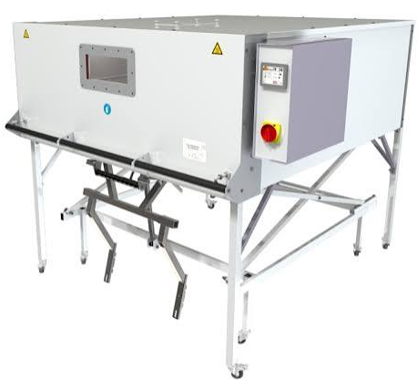

LOT #2: 3D Printer – Desktop, Independent Dual Extruder (IDEX) with consumables and spare parts
Note: Data sheet is mandatory to be submitted for all the items listed below
ITEM # | ITEM NAME | Technical Specifications | Picture
1 | 3D Printer – Desktop, Independent Dual Extruder (IDEX) | Desktop fused filament fabrication (FFF) 3D printer for the fabrication of prosthetic and orthotic components, insoles and positive models.  Print technology: Fused Filament Fabrication (FFF), fully enclosed heated build chamber.  Print head system: Independent Dual Extruders (IDEX), supporting mirror and duplication printing modes. Print heads to be user-swappable without tools.  Build volume: minimum Single Extruder Print: 330 × 240 × 240 mm  Dual Extruder Print: 295 × 240 × 240 mm  Filament diameter: 1.75 mm.  Nozzle: 0.4 mm supplied as standard; machine to accept 0.2 / 0.6 / 0.8 / 1.0 mm nozzles. Maximum nozzle temperature: minimum 300 degrees C.  Layer height: adjustable within the range 0.1 - 0.5 mm.  Positioning resolution (XYZ step size): minimum 0.78125 / 0.78125 / 0.078125 micron.  Print head travel speed: 15 - 150 mm/s.  Build plate: flexible steel plate with removable print surface. Heated bed, maximum temperature minimum 110 degrees C, silicone heating element.  Bed levelling: automatic mesh levelling with flatness detection.  Safety and reliability features (all mandatory): filament run-out sensor, power-loss recovery, automatic pause on door opening.  Air filtration: HEPA filter with activated charcoal, integrated.  Material compatibility: PLA, ABS, HIPS, PC, TPU, TPE, Nylon, PETG, ASA, PP, PVA, and glass-fiber / carbon-fiber infused filaments. Must reliably process flexible filaments down to Shore 70A hardness.  Open material system: machine must accept third-party filaments without licensing restriction, chip lock or software lock-out.  Connectivity: Wi-Fi, Ethernet (LAN), minimum 2 x USB 2.0 ports, and integrated camera for remote print monitoring.  User interface: minimum 7-inch color touchscreen, minimum resolution 1024 x 600.  Software: slicing software supplied with the machine at no additional license cost, with cloud or network print-management capability. Supported file types: STL, OBJ, 3MF. Compatible with Windows and macOS.  Electrical supply: 100 - 240 V AC, 50/60 Hz, suitable for operation on the Lebanese 220 V / 50 Hz network. Supplier to state power consumption.  Noise emission: below 50 dB(A) during operation.  Operating ambient conditions: 15 - 30 degrees C, 10 - 90% RH non-condensing.  Machine dimensions: maximum 607 × 596 × 465 mm (L+W+H)  Net weight: supplier to state; approximately 35 kg.  Certification: CE and RoHS as a minimum; CB / FCC / RCM an advantage. Copies of certificates to be submitted with the bid.  Supplied with: power cable, tool kit, minimum one spare print head or spare nozzle set, and a user manual in English.  Warranty: minimum twelve (12) months from date of commissioning, covering parts and labor. Supplier to state after-sales support arrangements and spare parts availability in Lebanon.  Installation, commissioning and a minimum of one (1) day of on-site operator training to be included in the unit price.  Equivalent to Raise3D E2  or approved equal.  Data sheet is mandatory to be submitted | 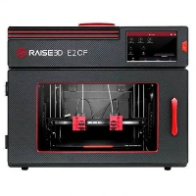
Note: All filaments to be 1.75 mm diameter, supplied on spools, vacuum-sealed with desiccant, and labelled with material type, color, batch number, production date and recommended printing parameters.
Shelf life at delivery: minimum 18 months remaining.
2 | Filament – PLA | Polylactic acid (PLA) filament for test prints, positive models and non-load-bearing prototypes.  Diameter: 1.75 mm, tolerance +/- 0.03 mm.  Ovality: maximum 0.05 mm.  Spool weight: 1 kg net of filament.  Recommended printing temperature: 190 - 230 degrees C.  Color: supplier to state colors available; minimum three colors to be offered.  Free of visible voids, kinks, contamination or diameter variation. Wound without tangles or crossed layers.  RoHS and REACH compliant.  Data sheet + Sample is mandatory to be submitted | 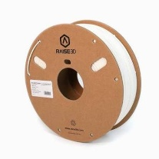
3 | Filament – PETG | Polyethylene terephthalate glycol (PETG) filament for durable orthotic components and jigs.  Diameter: 1.75 mm, tolerance +/- 0.03 mm.  Spool weight: 1 kg net of filament.  Recommended printing temperature: 230 - 250 degrees C.  Tensile strength: minimum 45 MPa. Supplier to state elongation at break and impact strength.  Good layer adhesion, low warping, resistant to moisture and common cleaning agents.  Color: supplier to state colors available.  RoHS and REACH compliant.  Data sheet + Sample is mandatory to be submitted | 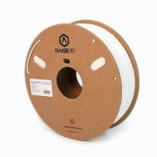
4 | Filament – TPU, Shore 95A | Thermoplastic polyurethane (TPU) filament, semi-rigid, for insole shells, orthotic interfaces and flexible components.  Diameter: 1.75 mm, tolerance +/- 0.05 mm.  Hardness: Shore 95A, tolerance +/- 3.  Spool weight: 1 kg net of filament.  Recommended printing temperature: 210 - 235 degrees C.  Elongation at break: minimum 400%.  Resistant to abrasion, hydrolysis and perspiration.  Skin contact: printed parts are in prolonged contact with patient skin. Supplier to submit a biocompatibility or skin-safety statement (ISO 10993-5 cytotoxicity or equivalent).  RoHS and REACH compliant, latex-free.  Data sheet + Sample is mandatory to be submitted | 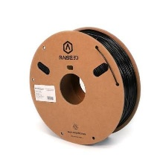
5 | Filament – TPU, Shore 85A | Thermoplastic polyurethane (TPU) filament, soft grade, for cushioning layers, diabetic insoles and soft liners.  Diameter: 1.75 mm, tolerance +/- 0.05 mm.  Hardness: Shore 85A, tolerance +/- 3.  Spool weight: 1 kg net of filament.  Recommended printing temperature: 200 - 225 degrees C.  Elongation at break: minimum 500%.  Compression set: supplier to state; material must retain cushioning properties under repeated loading.  Skin contact: supplier to submit a biocompatibility or skin-safety statement (ISO 10993-5 cytotoxicity or equivalent).  RoHS and REACH compliant, latex-free.  Data sheet + Sample is mandatory to be submitted | 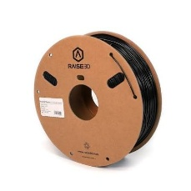
6 | Filament – Carbon-Fiber Reinforced Nylon (PA-CF) | Polyamide (nylon) filament reinforced with chopped carbon fiber, for load-bearing orthotic components such as AFO struts and prosthetic brackets.  Diameter: 1.75 mm, tolerance +/- 0.05 mm.  Carbon fiber content: minimum 15% by weight.  Spool weight: 1 kg net of filament.  Recommended printing temperature: 260 - 300 degrees C.  Tensile strength: minimum 80 MPa. Flexural modulus: minimum 4,000 MPa. Supplier to state both values.  Supplied vacuum-sealed with desiccant; material is hygroscopic and must be delivered dry.  Note: this material is abrasive and requires a hardened nozzle (see item 3.1).  Data sheet + Sample is mandatory to be submitted | 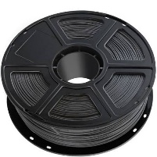
7 | Filament – PVA Water-Soluble Support | Polyvinyl alcohol (PVA) water-soluble support filament for use with the second extruder on complex or overhanging geometries.  Diameter: 1.75 mm, tolerance +/- 0.05 mm.  Spool weight: minimum 0.5 kg net of filament.  Recommended printing temperature: 190 - 220 degrees C.  Fully dissolves in room-temperature water without agitation or solvents.  Compatible with PLA, PETG and TPU as the model material.  Supplied vacuum-sealed with desiccant.  Data sheet is mandatory to be submitted | 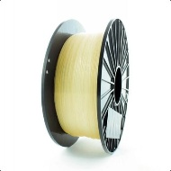
OPERATING CONSUMABLES AND SPARE PARTS: All items to be compatible with the 3D printer supplied under item 1. Supplier to confirm compatibility in writing.
8 | Hardened Nozzle Set | Set of hardened steel or ruby-tipped nozzles, required for printing abrasive carbon-fiber reinforced filament.  Sizes per set: 0.4 mm, 0.6 mm and 0.8 mm, minimum one of each.  Compatible with the print head of the printer supplied under item 1.  Maximum working temperature: minimum 300 degrees C.  Supplied with any sealing washers or thermal paste required for fitting. | 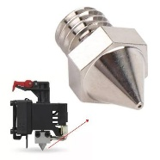
9 | Spare Print Head / Extruder Assembly | Complete spare print head assembly, interchangeable with the units supplied on the printer under item 1.  Supplied ready to install, including hot end, heater cartridge, thermistor and cooling fan.  Standard 0.4 mm nozzle fitted.  Maximum nozzle temperature: minimum 300 degrees C.  Original manufacturer part or manufacturer-approved equivalent. | 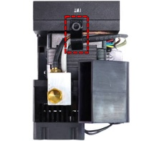
10 | Spare Flexible Build Plate | Spare flexible spring-steel build plate with adhesive print surface, matching the bed dimensions of the printer supplied under item 1.  Removable and re-flexible for part release without damage to the printed component.  Rated for bed temperatures up to minimum 110 degrees C.  Supplied with replacement print surface sheet where the surface is a separate consumable. | 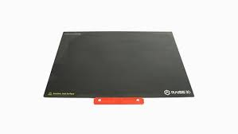
11 | Bed Adhesion Product | Build-plate adhesion product (glue stick or spray) for improved first-layer adhesion, suitable for PLA, PETG, TPU and nylon.  Non-toxic, water-soluble and washable, leaving no permanent residue on the build plate.  Minimum 35 g per stick, or minimum 100 ml per spray can.  Supplier to state shelf life; minimum 18 months remaining at delivery. | 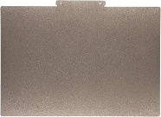
12 | Filament Drying and Storage Unit | Active filament dryer or sealed dry-storage box, required for nylon, PVA and TPU filaments which absorb atmospheric moisture and fail if stored open.  Capacity: minimum two (2) spools of 1 kg.  If active: adjustable temperature 40 - 70 degrees C with timer, and feed-through port allowing printing directly from the unit.  If passive: airtight seal with reusable rechargeable desiccant and integrated humidity indicator.  Electrical supply (active units): 220 V / 50 Hz, standard European plug. | 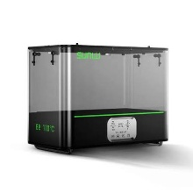
13 | Spare HEPA / Activated Charcoal Filter Cartridge | Replacement air filtration cartridge for the printer supplied under item 1.  HEPA media combined with activated charcoal layer.  Original manufacturer part or manufacturer-approved equivalent.  Supplier to state recommended replacement interval in operating hours. | 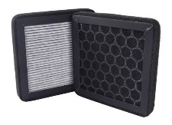
14 | Maintenance and Cleaning Kit | Routine maintenance kit for the printer supplied under item 1.  Kit to include as a minimum: cleaning / purging filament (minimum 100 g), nozzle cleaning needles, PTFE feed tubing, lubricating grease for linear rails and lead screws, spare belts, and spatula.  Supplier to state contents in full in the bid.  Consumables to be compatible with printing temperatures up to 300 degrees C. | 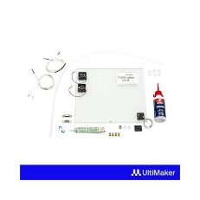
15 | 3D Foot Scanner | Professional 3D Foot Scanner for orthotic fabrication, open ecosystem. Scan Tech; Optical 3D Laser / Structured Light (Class 1 Eye-Safe). Data Capture;3D Volumetric Mesh & 2D Colour Texture mapping. Scans; Direct Foot (Full/Semi/Non-weight) & Foam Boxes/Plaster Casts. Speed;<= 7 seconds per foot. Accuracy; Sub-millimetres precision (error <= 0.5mm - 1.0mm). Scan Area; Min 350x160x80 mm (up to US Size 20 / EU Size 55). Load Limit; Chassis supports up to 150 kg (330 lbs) minimum. Formats; Unencrypted, native export to .STL, .OBJ, and .PLY. OS; Windows 10 / 11 native application with auto-measurements. | 