LEBANESE RED CROSS
DISASTER MANAGEMENT SECTOR
WASH and Shelter Program
Rehabilitation of School No. 04
Cleaning, Architectural & Civil, Mechanical and Electrical Works

1. Background
School No. 04 was used as a shelter for displaced persons during 2024-2026 and sustained damage and heavy wear, including flooding of basement levels B3-B4 and temporary or unauthorized electrical cabling installed for displaced persons' needs. The Ministry of Education & Higher Education has asked LRC to rehabilitate the school urgently so that students from neighboring schools can resume learning there.

2. Objective
LRC invites qualified contractors to submit one consolidated technical and financial offer for the cleaning, architectural and civil, mechanical, and electrical rehabilitation works required to restore School No. 04 to a safe, functional and operational condition.

3. Project Information
Project | Rehabilitation of School No. 04, Mazraa, Beirut
Location | Beirut, Lebanon
Contract type | One time purchase
Core work sections | A. Cleaning & Desludging; B. Architectural & Civil; C. Mechanical; D. Electrical

4. Scope of Work
The Contractor shall supply all materials, labor, supervision, tools, equipment, temporary works and transport required to complete the works described below and in the consolidated Bill of Quantities. The scope is divided into four coordinated work sections for pricing, implementation, inspection and handover.

4.1 Section A - Cleaning, Mobilization & Desludging
- Mobilization and site establishment.
- General cleaning and disinfection of the school from basement levels through Floor 6, including roof, terraces, corridors, stairs, balconies, canopies and glazed surfaces.
- Dewatering of flooded basement areas at B3 and B4.
- Removal of sludge, contaminated residues, waste and debris, with environmentally sound transport and disposal.
- Clearing of basement drains and channels before mechanical works.
- Protection or temporary relocation of school furniture and equipment.
- Post-cleanup photographic and written condition survey of B3 and B4.

4.2 Section B - Architectural & Civil Works
- Patching former air-conditioning wall openings and repairing localized moisture damage and cracks.
- Repair, refinishing or replacement of door frames, door leaves and hardware.
- Reinstatement and repainting of stair handrails.
- Grinding, polishing and cleaning of marble stair treads.
- Replacement of missing bathroom mirrors and restoration of suspended ceilings.
- Localized ceiling repainting and full repainting of the specified classrooms.
- Replacement or repair works for windows and doors
- Cleaning and re-pointing of sanitary-area wall and floor tiling.
- Painting and epoxy works
- Flooring and tiles works

4.3 Section C - Mechanical Works
- Rehabilitation of plumbing fixtures, water tanks, roof water connections, drains and municipal connections.
- Rehabilitation of pipes, ducts and pumps.
- Mechanical rehabilitation of parking and toilet exhaust fans.
- Generator-room ventilation, suppression, damper, sound-insulation and fuel-piping works.
- Replacement damaged sanitary fixtures.
- Recovery or replacement or removal of drinking fountains, replacement of playground rainwater tanks, and rehabilitation of the potable-water treatment station.

4.4 Section D - Electrical Works
- Inspection and testing of the on-grid solar inverter system and changing and upgrading it to hybrid system.
- Removal of temporary cabling and reinstatement of code-compliant electrical connections.
- Repair or replacement of lighting fixtures, outlets, and electrical accessories.
- Replacement of the damaged photovoltaic panels.
- Testing and repairing of electrical and control systems.
- Replacement of damaged cabling and feeders in flooded basement areas.
- Electrical reconnection and testing of rehabilitated mechanical equipment.
- Testing and certification of distribution boards, repaired circuits and systems.

5. Technical Requirements and Workmanship
- All materials and equipment supplied shall be new, consistent in quality and fit for their intended purpose.
- Repairs and replacements shall match the existing type, size, colour and finish unless otherwise approved by the LRC Engineer.
- No material or equipment shall be installed, and no existing element removed or altered, without prior approval of the LRC Engineer.
- The Contractor shall submit required shop drawings, material data and samples for approval before execution.
- All applicable works and systems shall be tested and commissioned. A written handover report and as-built documentation shall be provided.
- The Contractor shall protect existing building elements, furniture and equipment and make good, at its own cost, any damage caused by its operations.
- Waste generated by the works shall be collected, transported and disposed of lawfully and in an environmentally sound manner at the Contractor's cost.

6. Sequencing and Coordination
The Contractor shall submit one integrated program covering all four works sections and shall coordinate all trades through a single site management structure. The following minimum sequencing requirements apply:
- Cleaning, disinfection and dewatering of each basement level shall be completed and accepted by the LRC Engineer before mechanical or electrical works commence in that level.
- At least 3 working days' notice shall be given before the anticipated completion of cleaning for each basement level.
- Mechanical and electrical activities shall be coordinated for isolation, reconnection, controls, fire-alarm linkage and final commissioning.
- Civil making-good and final finishes shall follow completion of concealed mechanical and electrical interventions.
- The programme shall account for partial occupation of the school and utilization for education activities and the need to maintain safe controlled access.
- The Contractor shall submit all required samples, datasheets, catalogues, certificates of conformity, testing certificates and shop drawings for review and approval by the LRC Engineer prior to procurement and installation. Approval of materials shall not relieve the Contractor of responsibility for compliance with the contract requirements. Long-lead items including pumps, fire-fighting equipment, water treatment equipment, sanitary fixtures, lighting fixtures, PV panels, UPS batteries, distribution boards and major mechanical/electrical equipment shall not be procured until written approval is obtained.

7. Insurance
The cost of all required insurance policies shall be included in the contract price. Coverage shall include the Contractor's personnel, equipment and liabilities related to the Employer and its representatives, in accordance with the conditions of contract and applicable laws and regulations. Insurance shall explicitly cover risks related to war, armed conflict, civil unrest and acts of terrorism. LRC shall not be liable for loss, damage, injury or claims arising from inadequate, insufficient or missing insurance coverage. An insurance policy with a minimum value of 1 million USD paid in fresh funds should be presented to LRC and valid though out the period of implementation at no additional cost to LRC covering the contractors all risks, workers, and their party liability, machinery tools and equipment The Contractor shall maintain these policies throughout the contract period and any defects liability period. Failure to maintain adequate coverage shall constitute grounds for suspension of work

8. Health, Safety and Environmental Requirements
- Implement applicable local and international health and safety requirements and industry good practice.
- Provide appropriate PPE, signage, barriers, controlled access, safety induction, monitoring and toolbox talks.
- Apply enhanced hygiene and biohazard controls for flood and sewage-contaminated areas, including safe handling and disposal of contaminated waste.
- Ensure electrical works are undertaken by qualified electricians, with circuits isolated, tested and certified before re-energization.
- Provide safe working-at-height arrangements for roof and solar works.
- Safeguard students, staff and visitors throughout the works, particularly because the school may be partially occupied
- Qualified HSE officer with university degree is present at all time

9. Site conditions and preliminary inspection
The preliminary inspection concluded that the building is generally in good structural and architectural condition. Most identified deficiencies relate to cleaning, routine maintenance, localized deterioration, and the repair or replacement of missing, relocated or damaged components following intensive and non-standard use. The principal architectural requirements include comprehensive cleaning and disinfection; removal of waste from roofs, canopies and external areas; localized repair of moisture-damaged wall finishes and cracks below classroom windows; repainting or replacement of corroded steel door frames; repair or replacement of doors and hardware; reinstatement and repainting of handrails; maintenance of suspended ceilings; localized repainting; and replacement of missing bathroom fixtures, mirrors and drinking-water facilities.
The four basement levels were significantly affected by rainwater and sewage flooding, together with accumulated waste and debris, particularly around the staircases. These areas require dewatering where necessary, removal of contaminated materials, comprehensive cleaning, disinfection and sanitization before further rehabilitation activities. Appropriate health, hygiene and safety controls must be applied during these works. Following cleaning and safe access, a detailed secondary inspection is required to determine the condition of previously concealed or inaccessible finishes, doors, mechanical and electrical services, and other building components.
The mechanical assessment identified required maintenance, testing, rehabilitation and partial replacement across the school’s water-supply, drainage, sanitary, ventilation, fire-protection and mechanical-service systems. Key interventions include repairing leaking rooftop water tanks; cleaning rainwater outlets; reinstating water pipes and connections; replacing damaged taps, valves, flexible connections, WC accessories and sanitary fixtures; restoring drinking-water facilities; rehabilitating the potable-water treatment station; testing and repairing drainage and water networks; replacing rainwater collection tanks; rehabilitating exhaust fans, booster pumps, submersible pumps and fire pumps; testing generator-room ventilation and fire-suppression systems; repairing fuel-piping and insulation components.
The electrical assessment found that the school is supplied by Electricity of Lebanon, three generators and an on-grid solar photovoltaic system. The distribution boards are generally in good condition; however, temporary electrical cabling has been installed to serve shelter-related water-heating needs. With some lighting fixtures and electrical outlets in classrooms and offices are damaged, while other fixtures had been disconnected and require reinstatement. The required electrical works include removal of temporary cabling, repair or replacement of damaged electrical accessories, reconnection of disconnected installations, replacement of deteriorated UPS batteries, replacement of damaged photovoltaic panels, inspection of the solar inverter room and existing system.
Overall, the rehabilitation works should restore the school to a safe, hygienic, functional and operational condition suitable for educational use. The works must be carefully sequenced, with basement cleaning, dewatering and disinfection completed before detailed inspection and mechanical or electrical rehabilitation begins in affected areas. A further condition assessment should also be undertaken after the school has been fully vacated and cleaned, particularly in previously occupied, locked or inaccessible rooms, to identify any additional defects not visible during the initial assessment.

Site conditions pictures:
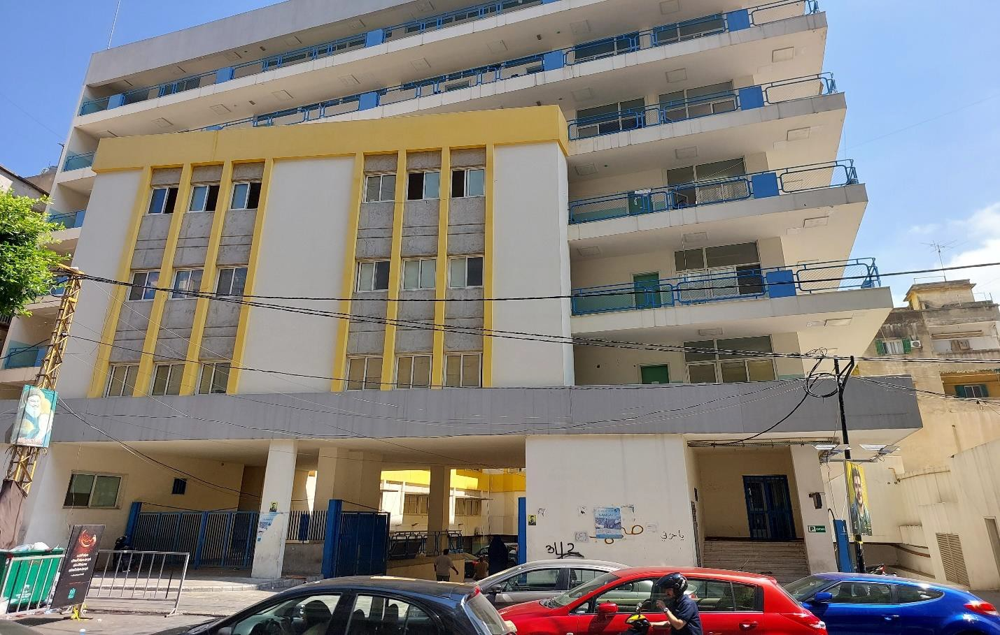
واجهات المدرسة الخارجية
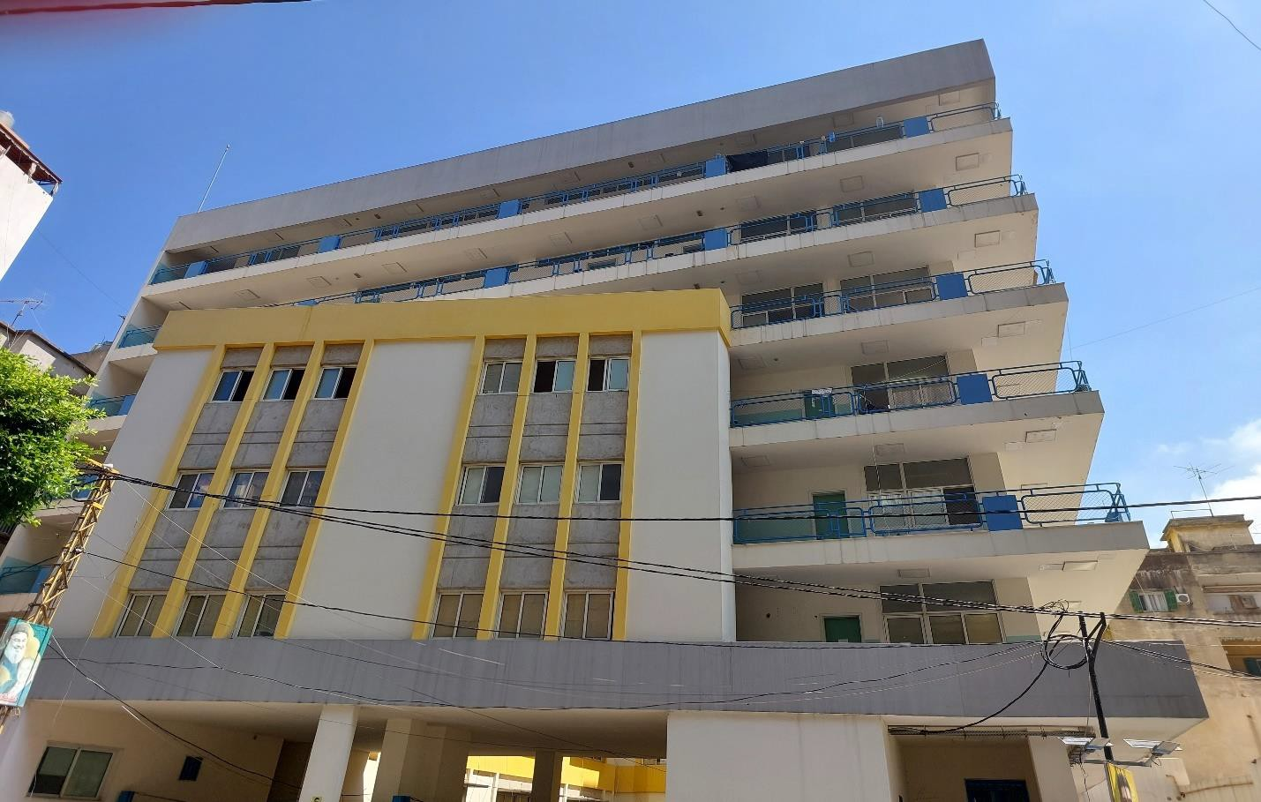

واجهات المدرسة الخارجية

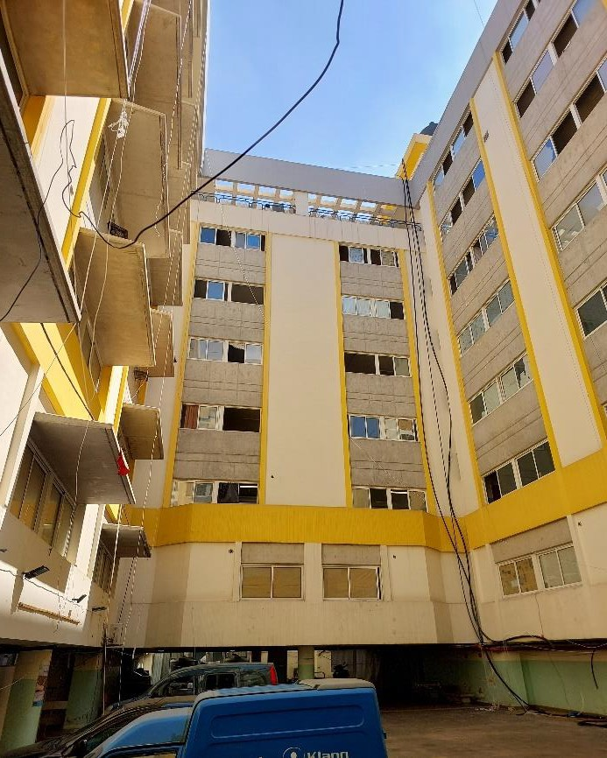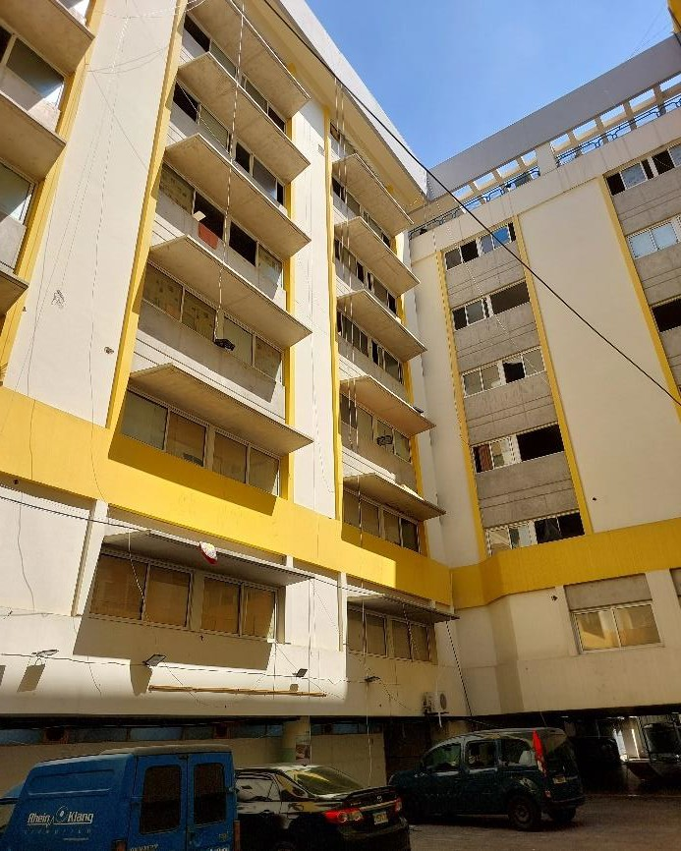

واجهات المدرسة الداخلية

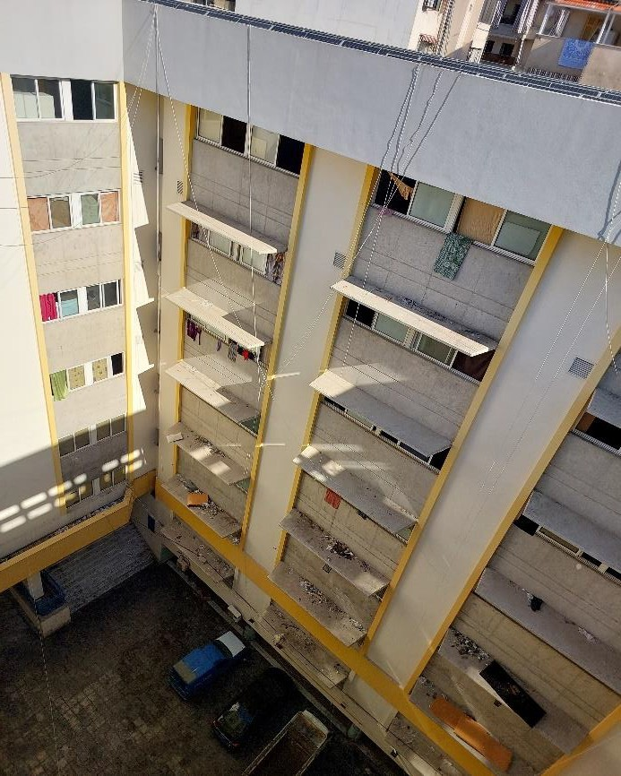
واجهات المدرسة الداخلية
واجهات المدرسة الداخلية
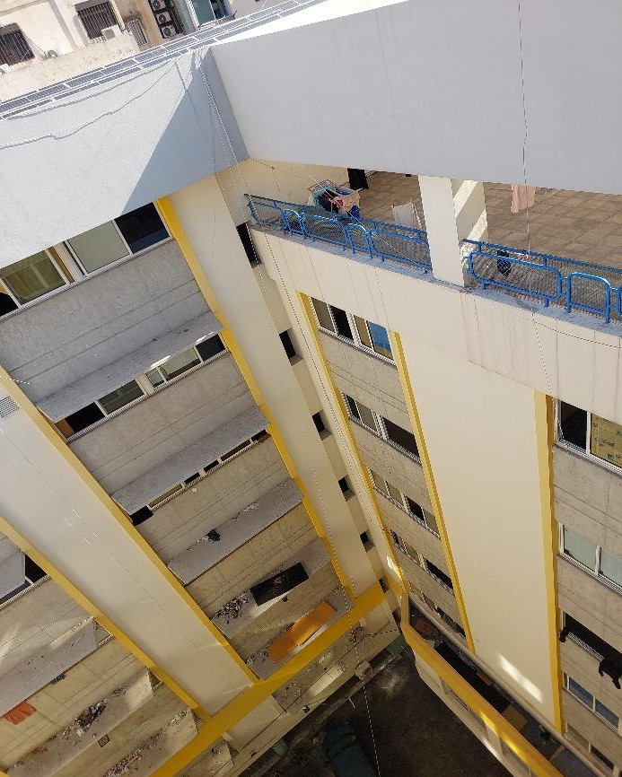
واجهات المدرسة الداخلية

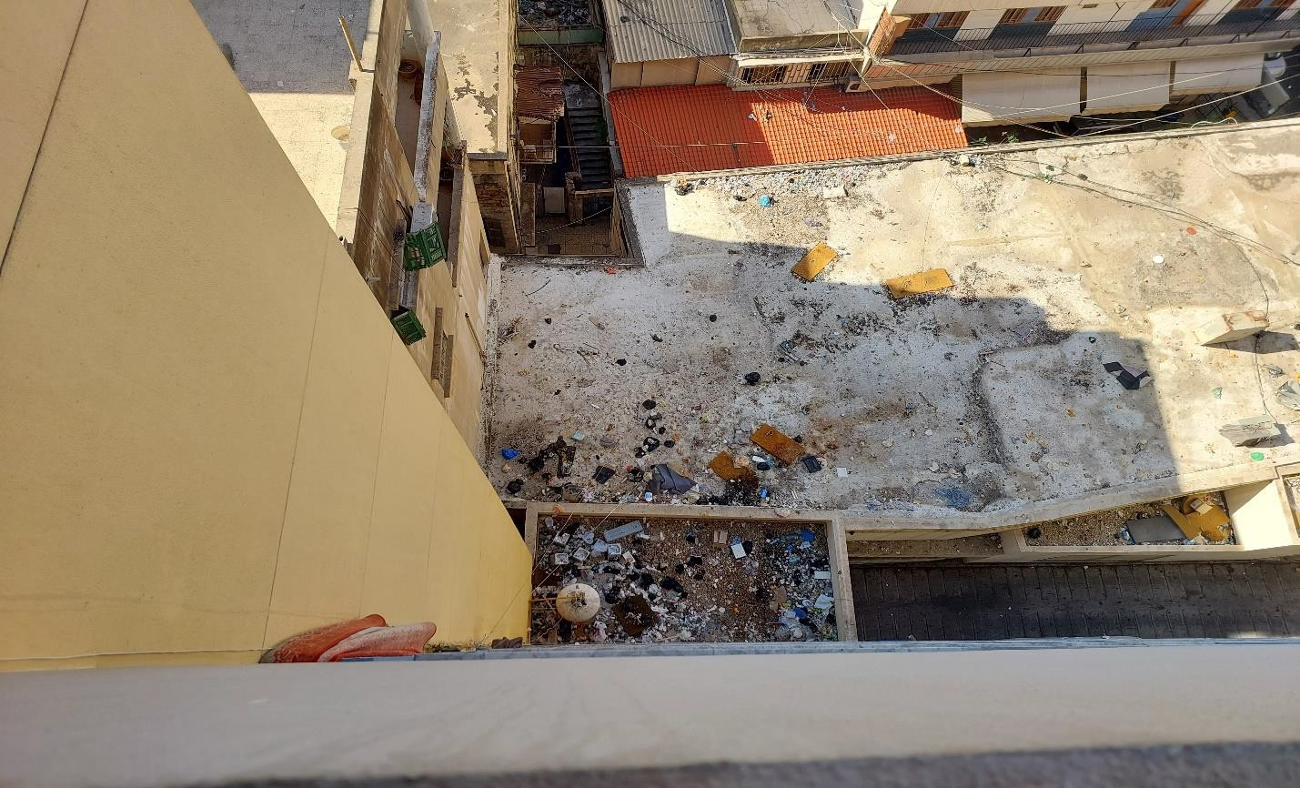
الاوساخ على الاسطح
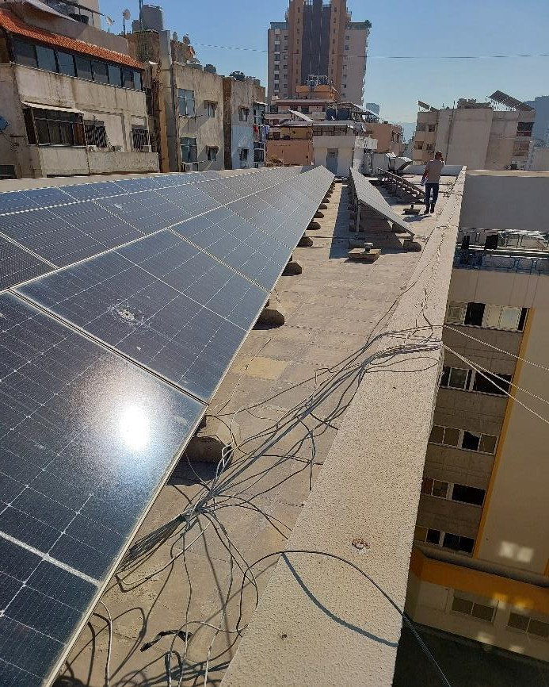
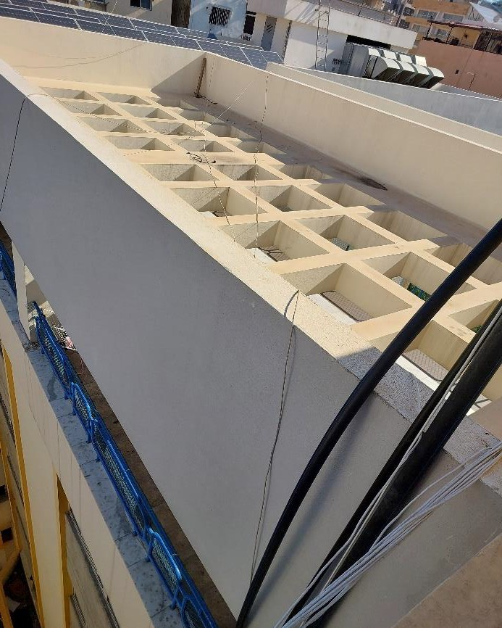
تمديدات كهربائية ظاهرة على الواجهات الواح الطاقة الشمسية

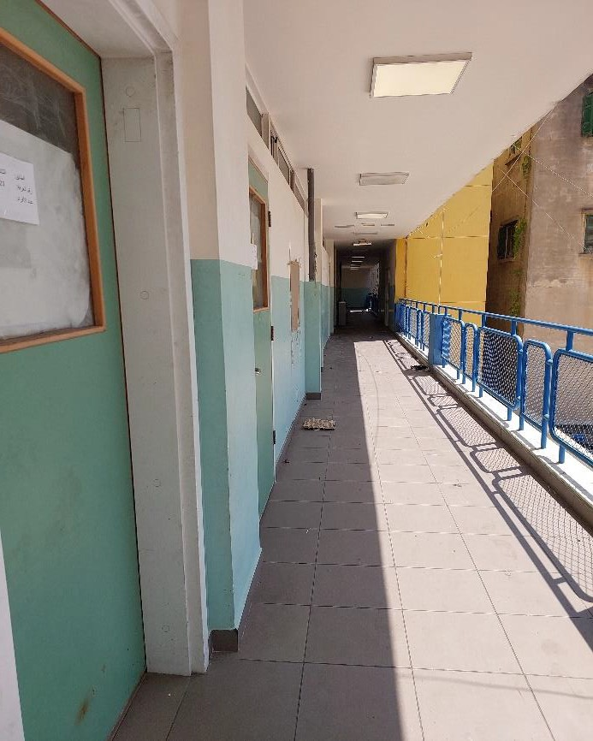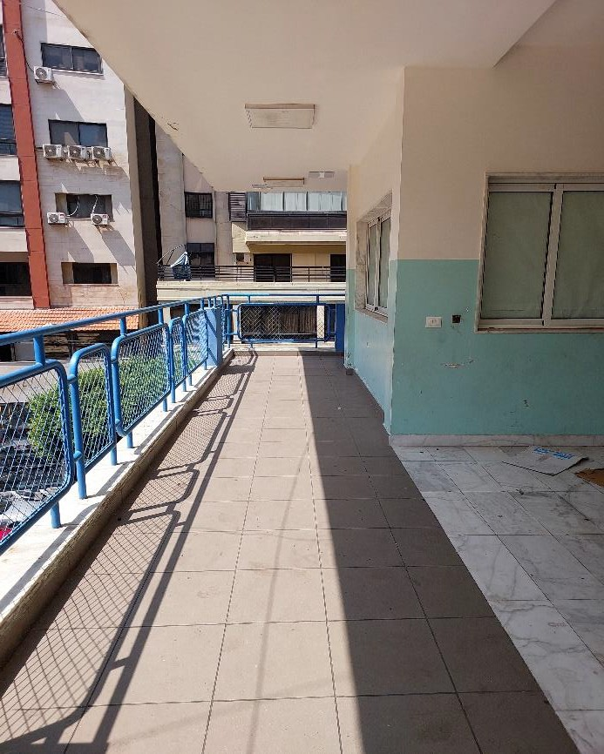
الممرات الخارجية الممرات الخارجية
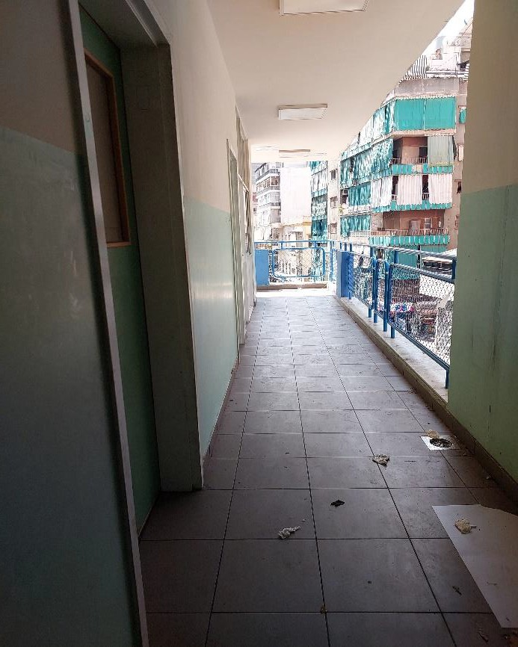
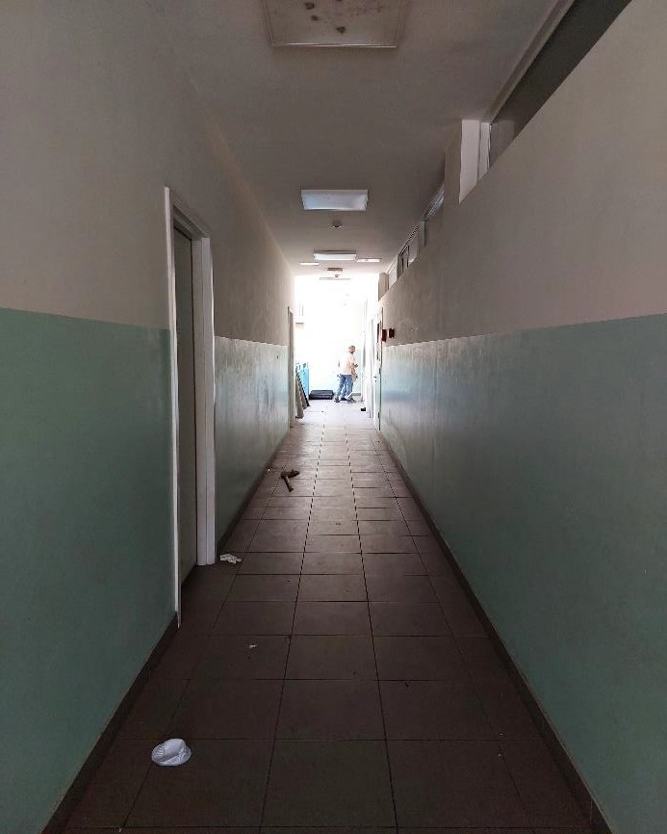
الممرات الداخلية الممرات الداخلية

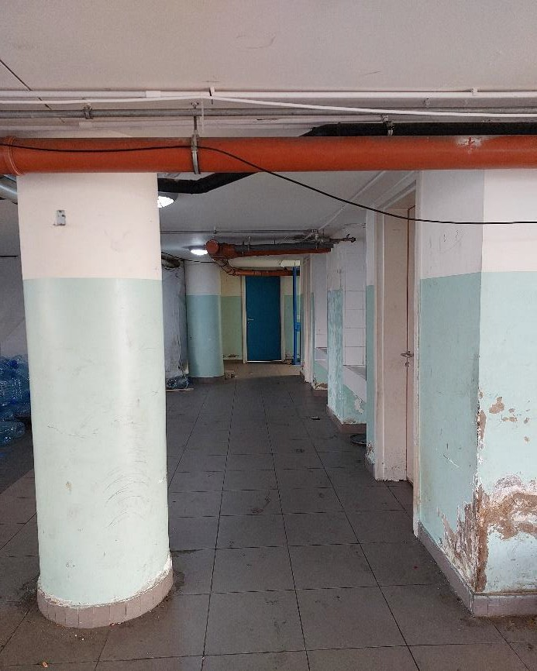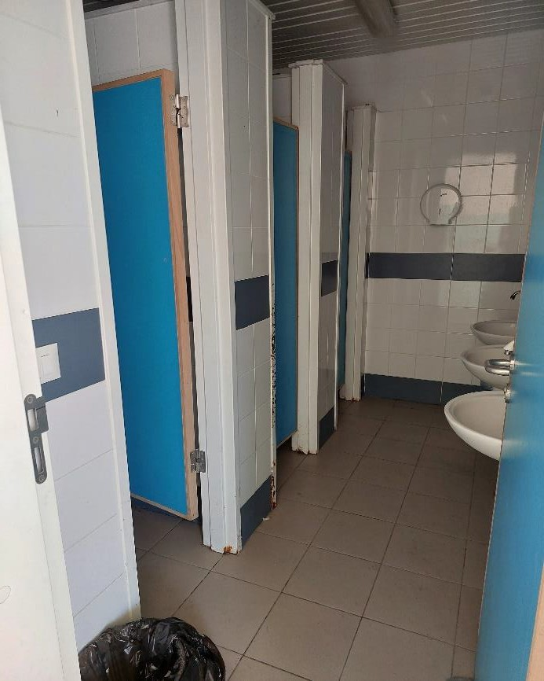
الحمامات الداخلية تضرر الدهان الداخلي
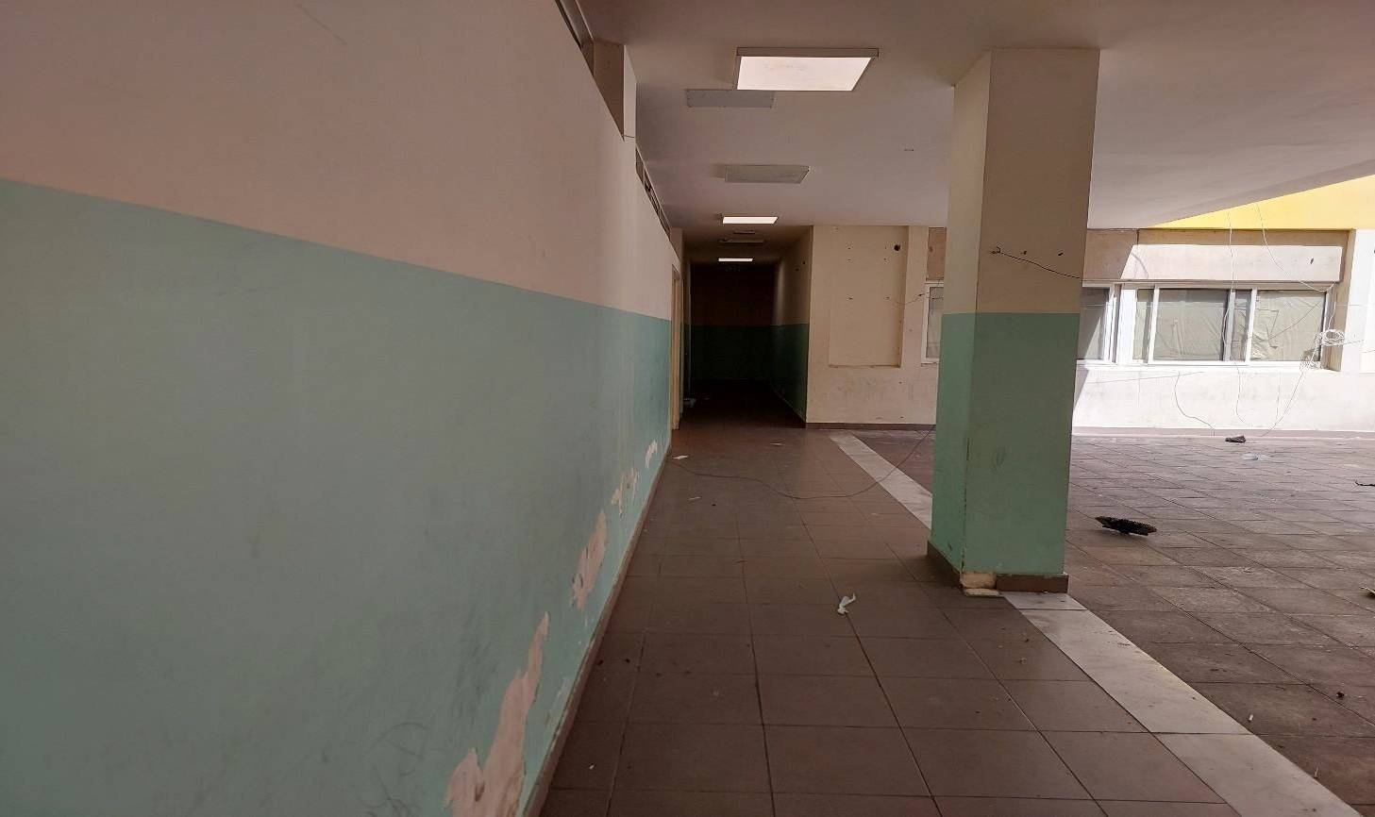
تضرر الدهان الداخلي

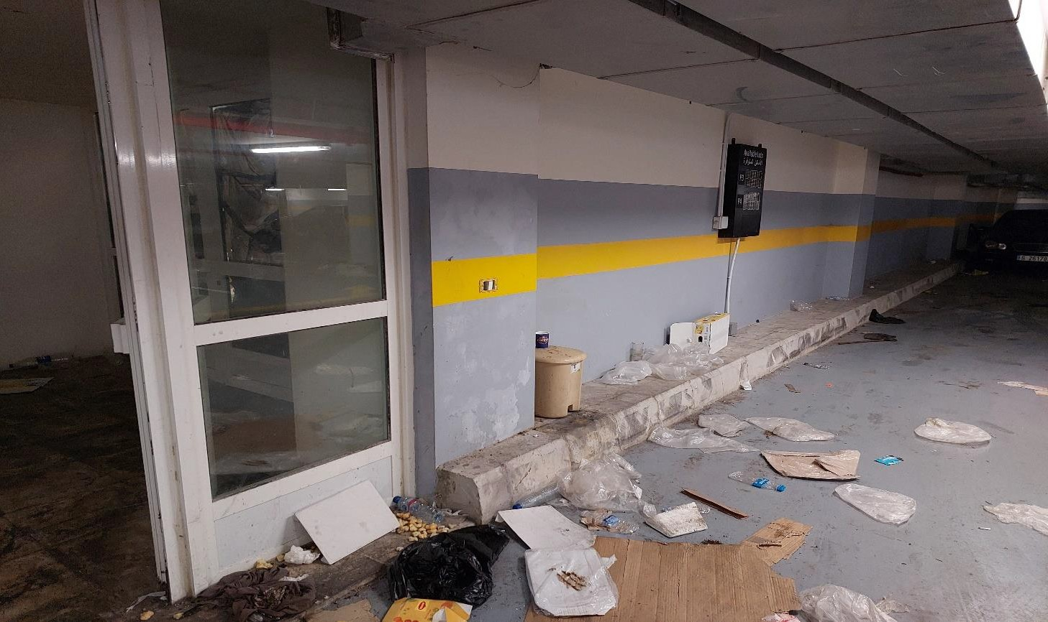
الوضع الراهن للطوابق السفلية
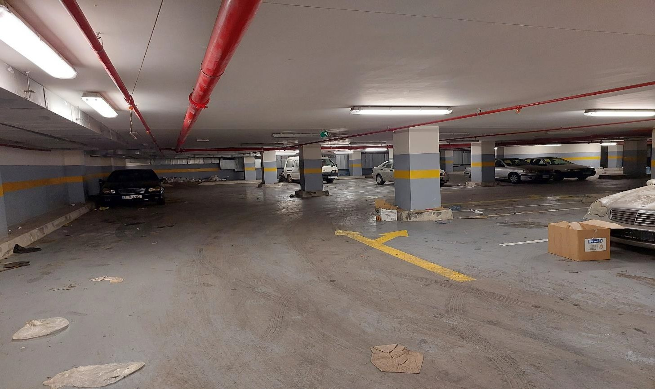
الوضع الراهن للطوابق السفلية

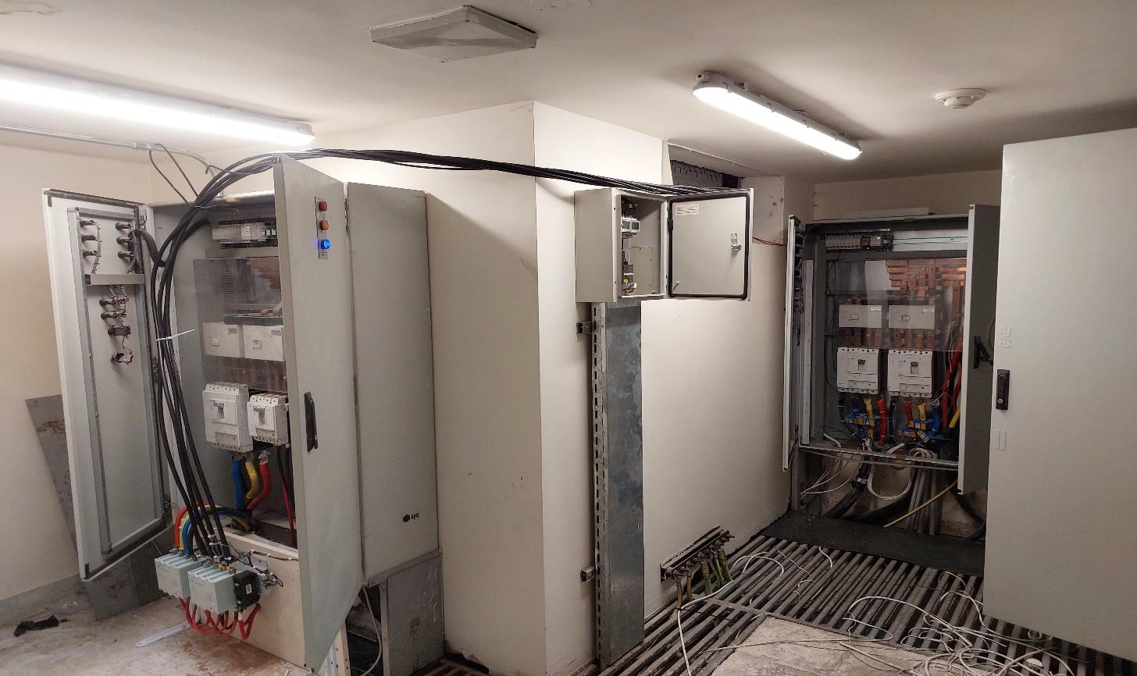
التمديدات الإضافية على التابلوهات الكهربائية الاساسية

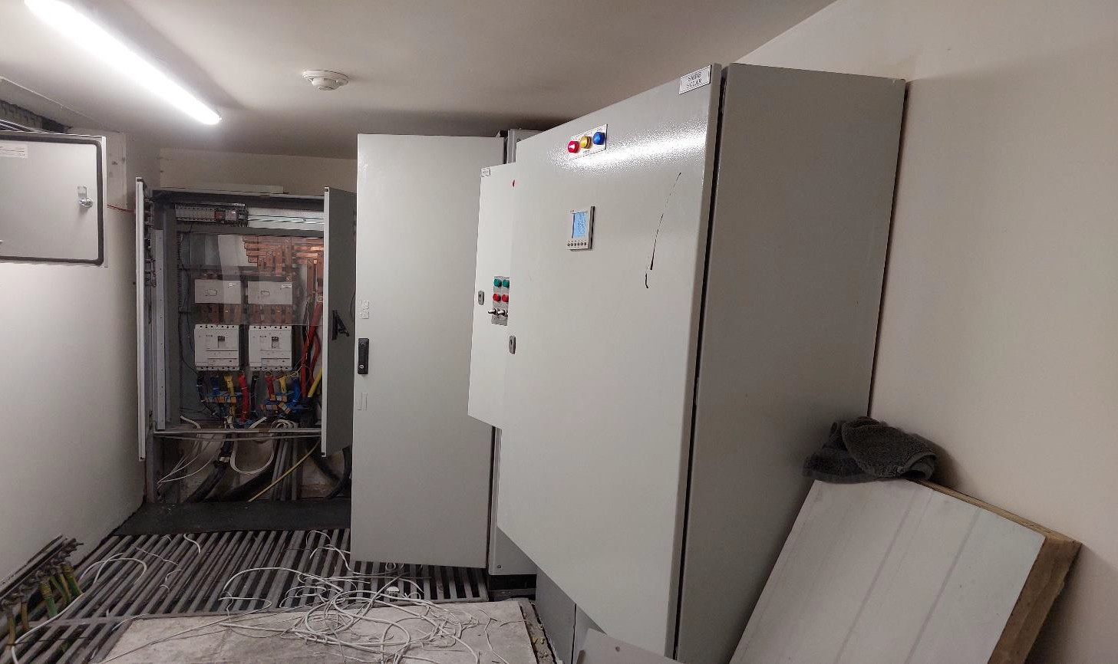
التمديدات الإضافية على التابلوهات الكهربائية الاساسية

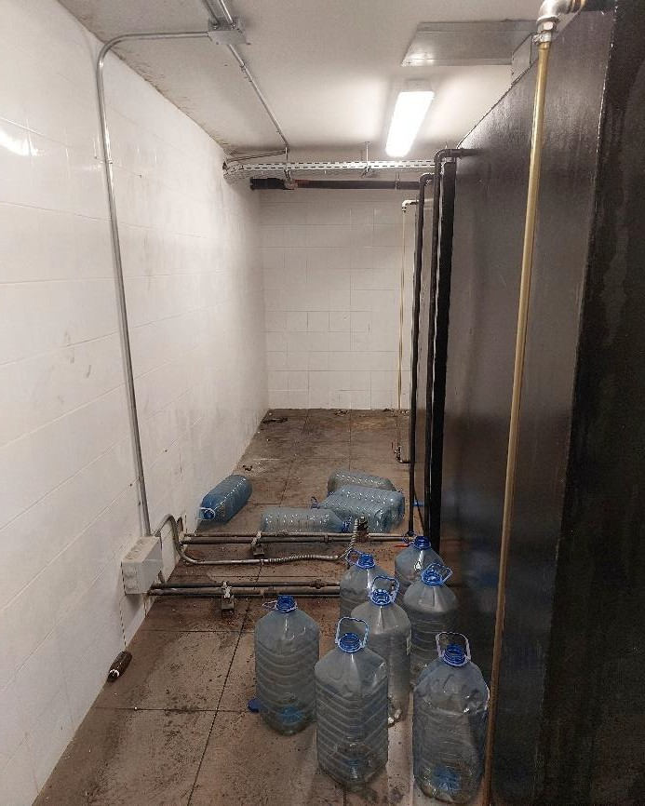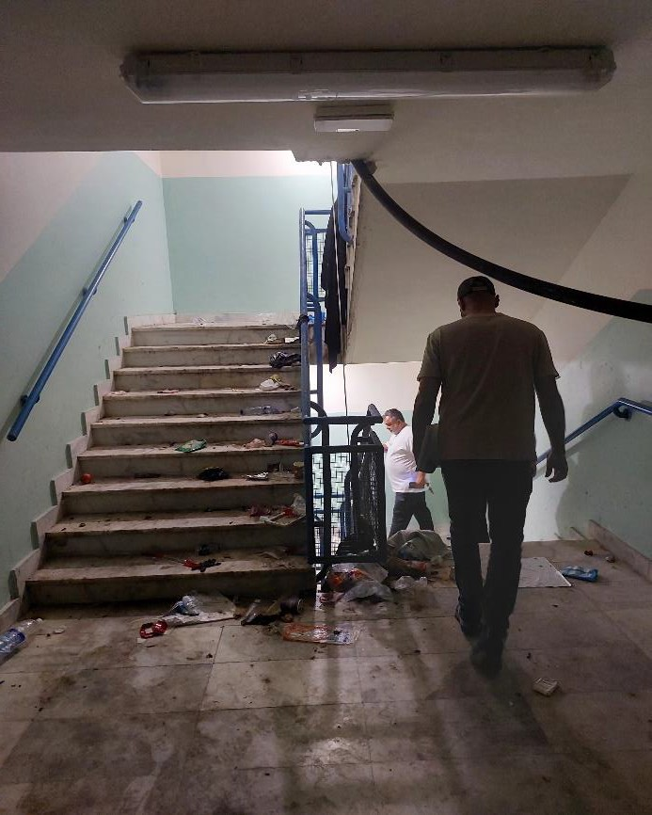

غرفة المازوت

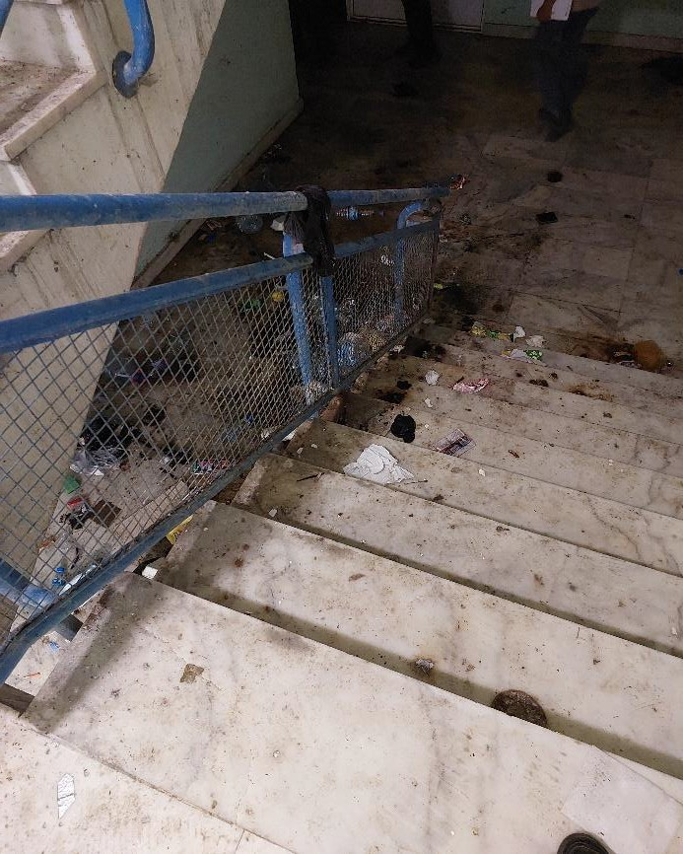
الحالة الحالية للأدراج السفلية
الحالة الحالية للأدراج السفلية
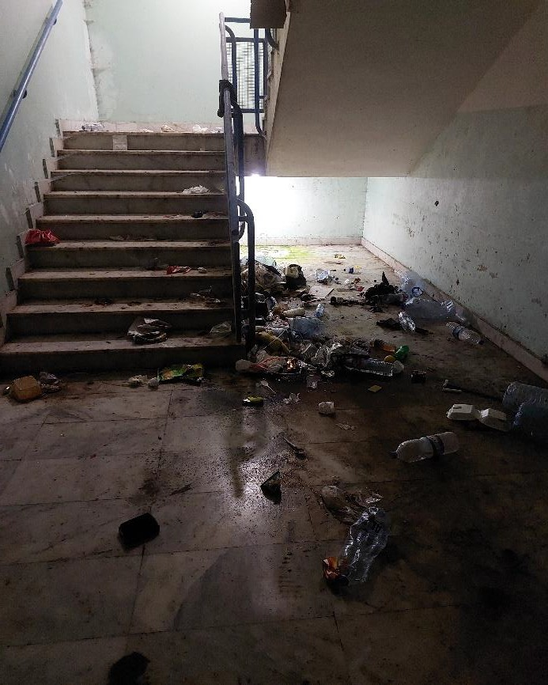
الحالة الحالية للأدراج السفلية

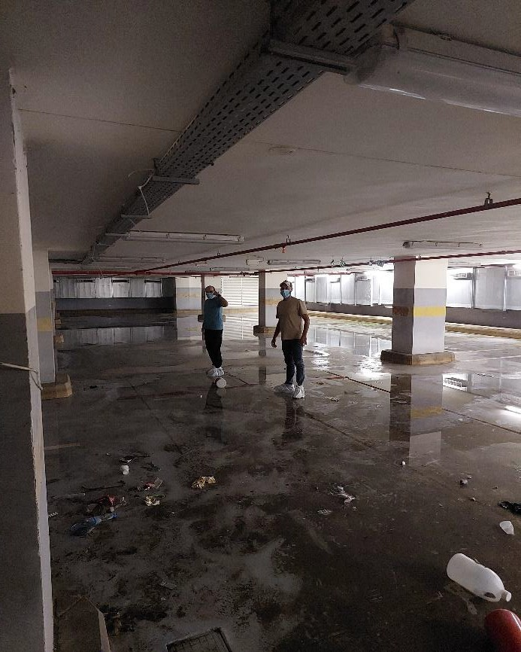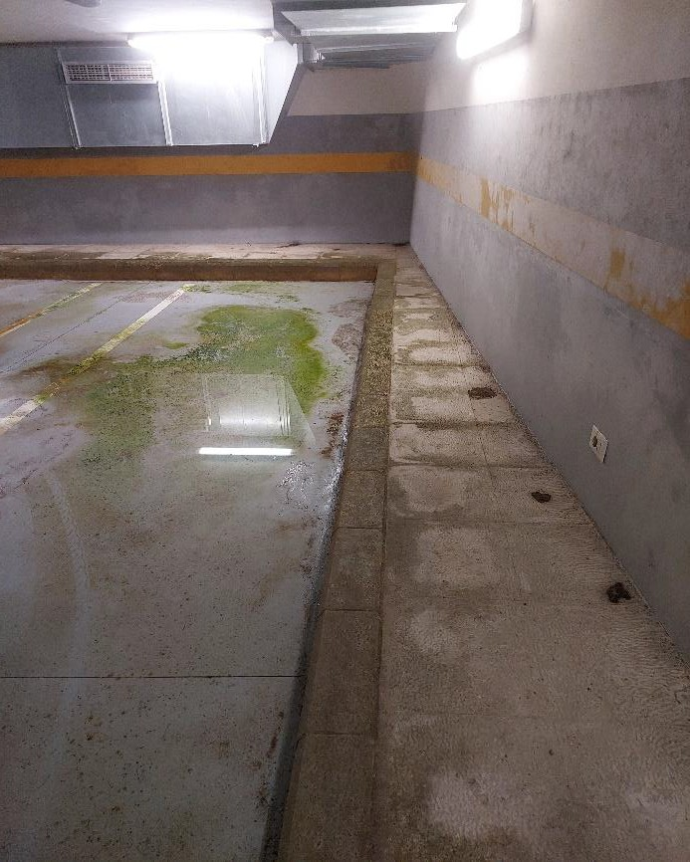
الوضع الراهن للأدوار السفلية الوضع الراهن للأدوار السفلية
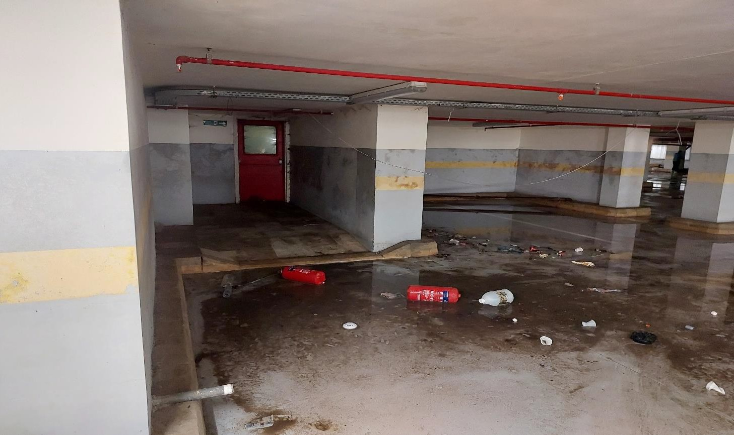
الوضع الراهن للأدوار السفلية

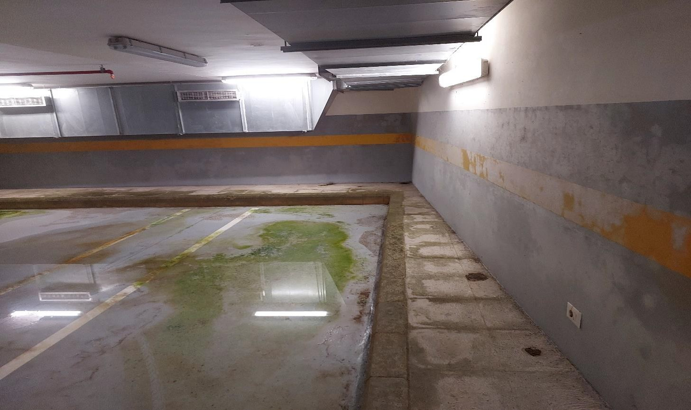
الوضع الراهن للأدوار السفلية
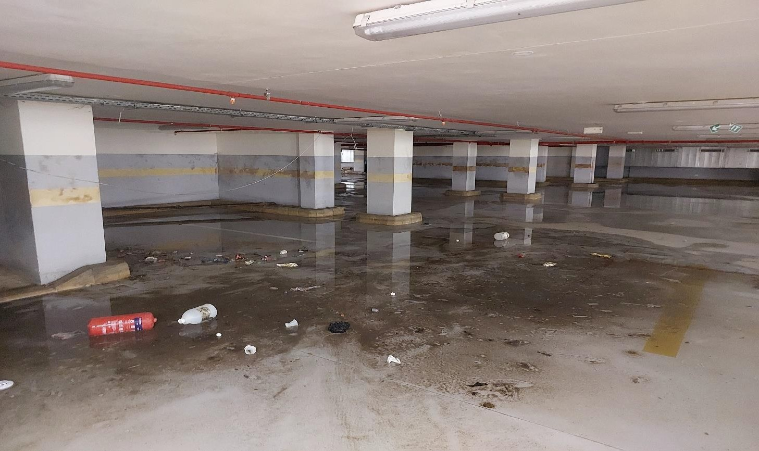
الوضع الراهن للأدوار السفلية

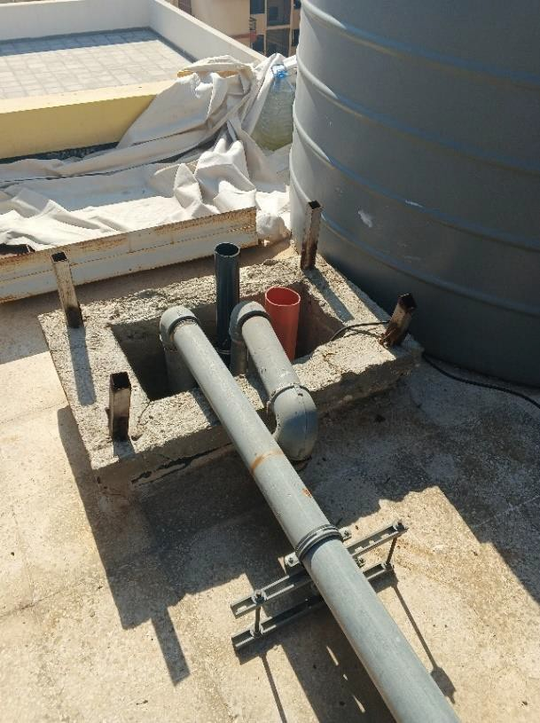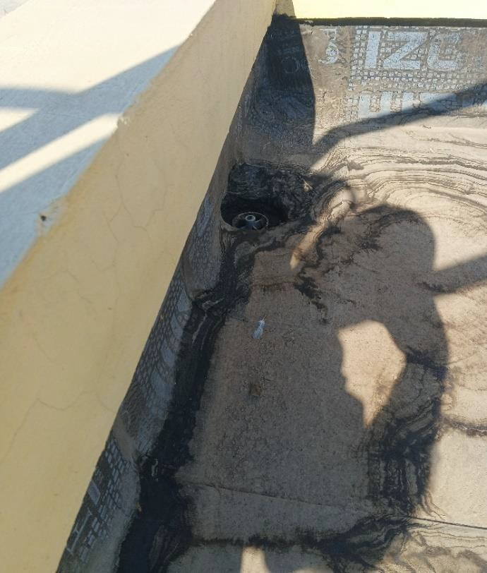
غطاء مصرف مياه الأمطار مفقودة أغطية فتحات التهوئة مفقودة
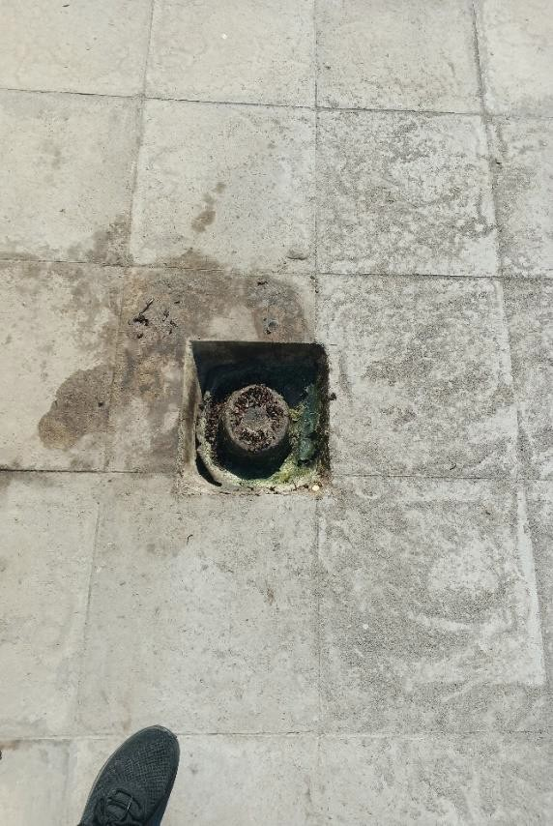
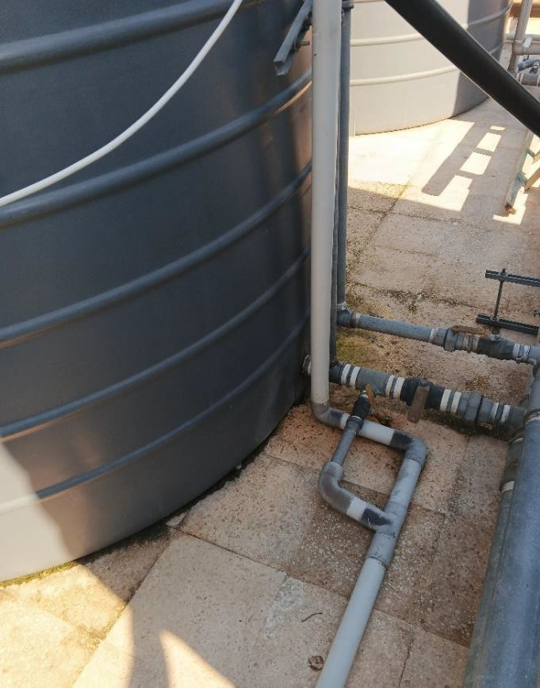
تسريب مياه من الخزان على السطح العلوي أضرار وأوساخ في مصارف مياه الأمطار

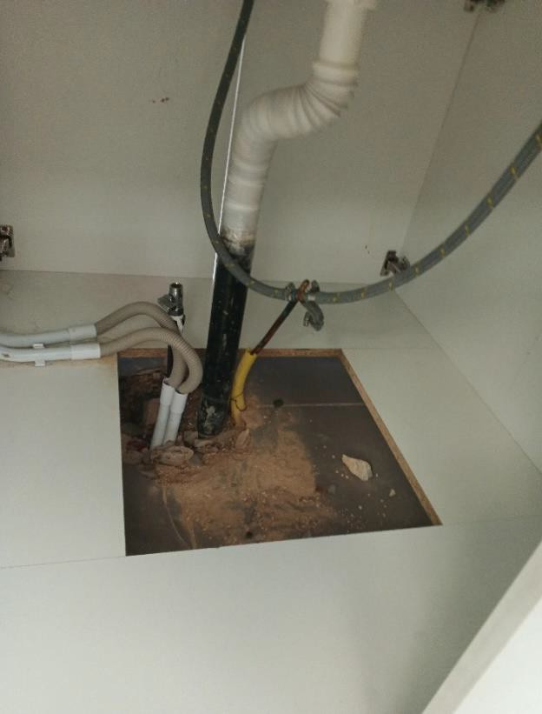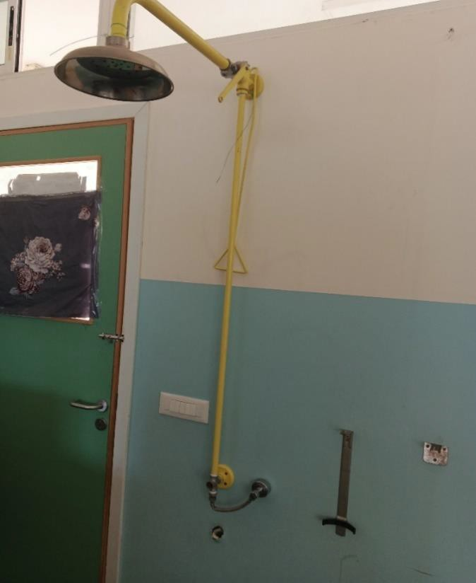
أضرار في حوض غسيل العيون ودوش الطوارئ اضرار في توصيلات المختبر
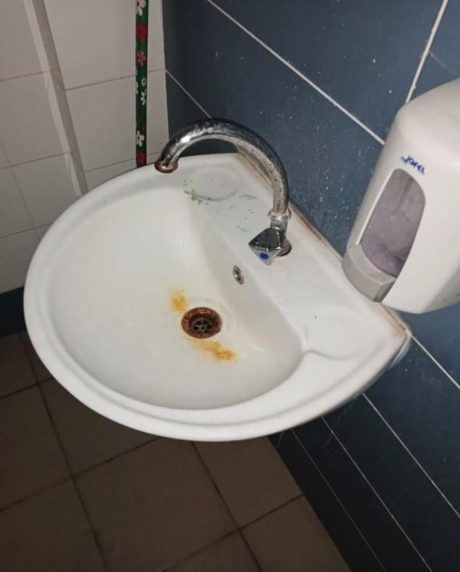
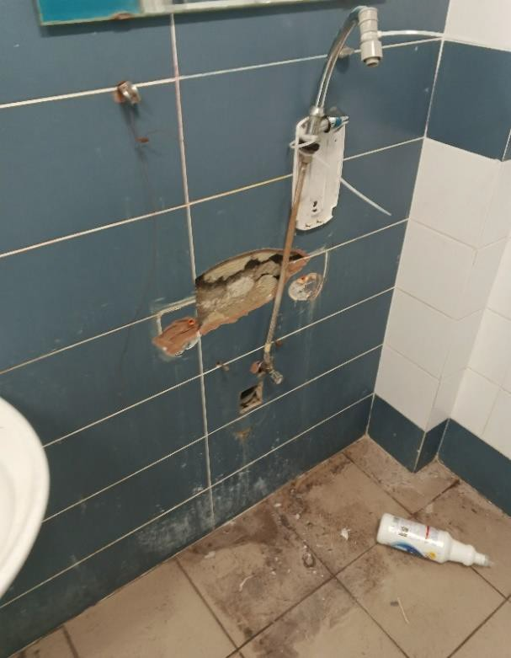
مغسلة مفقودة اضرار في المغاسل

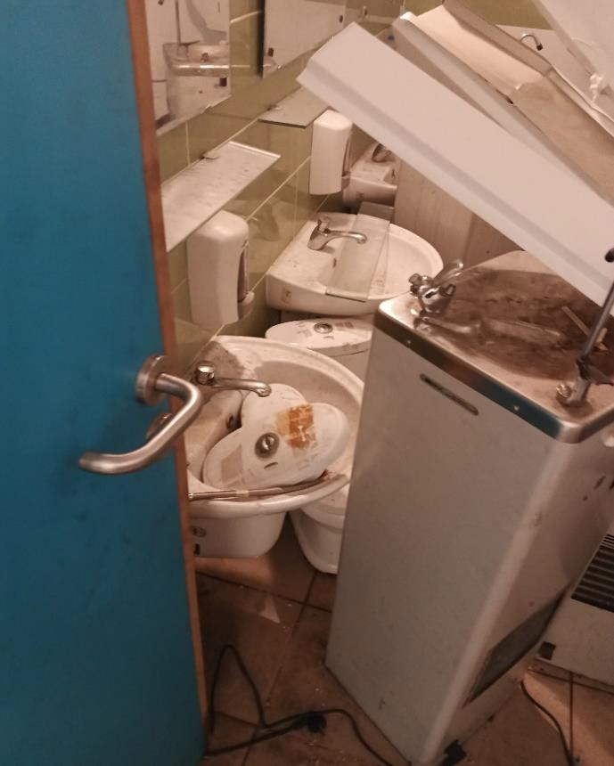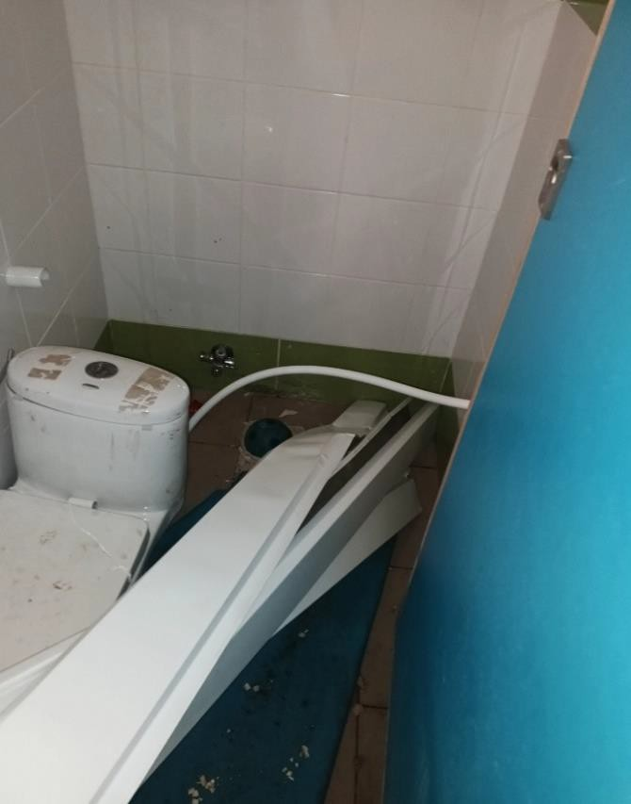
كراسي حمامات الروضات مكسورة مغاسل حمامات الروضات مكسورة
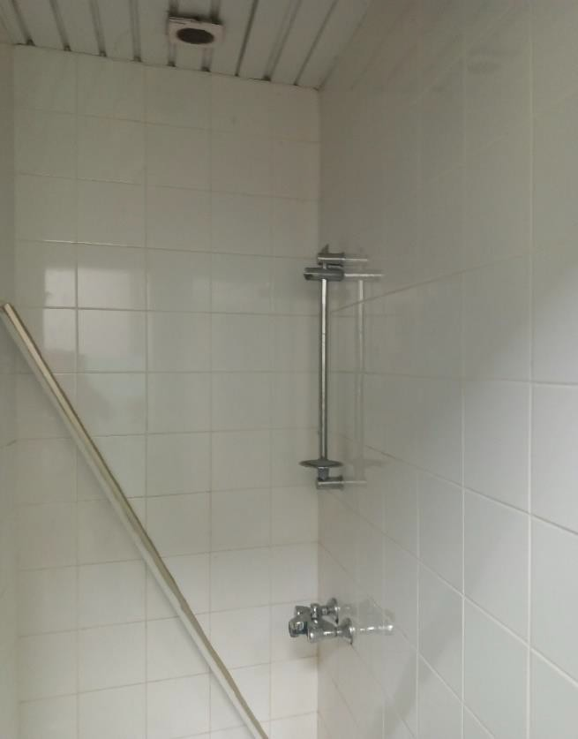
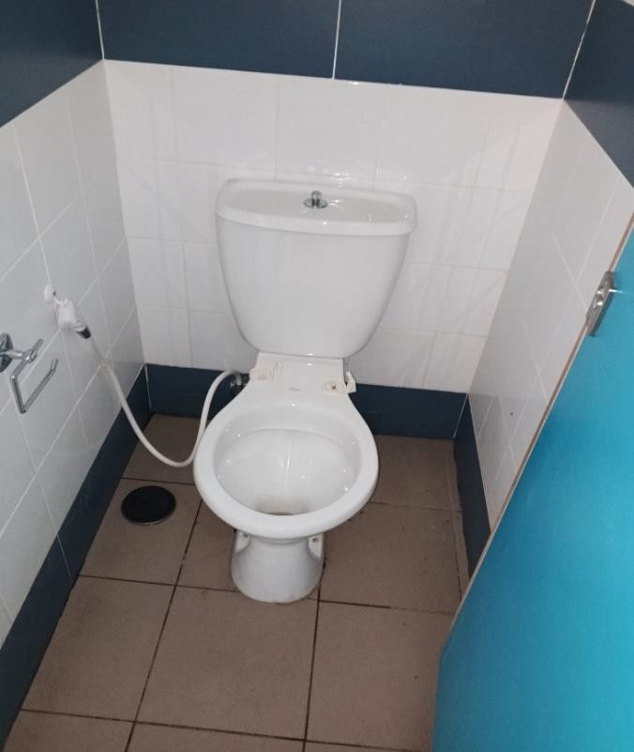
اضرار في كراسي الحمامات اضرار في خلاط ورأس الدوشات

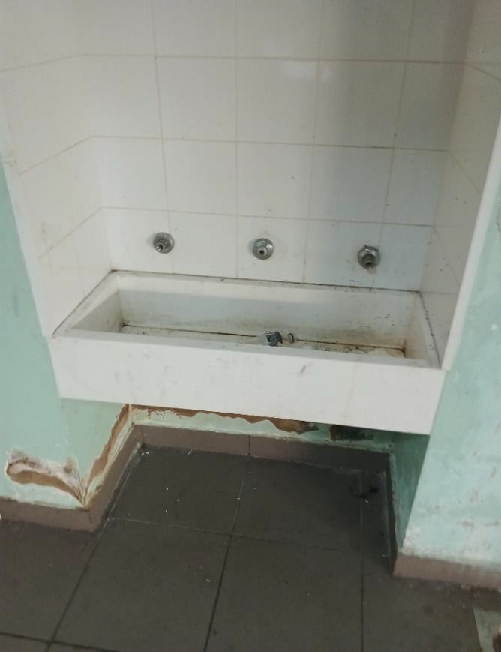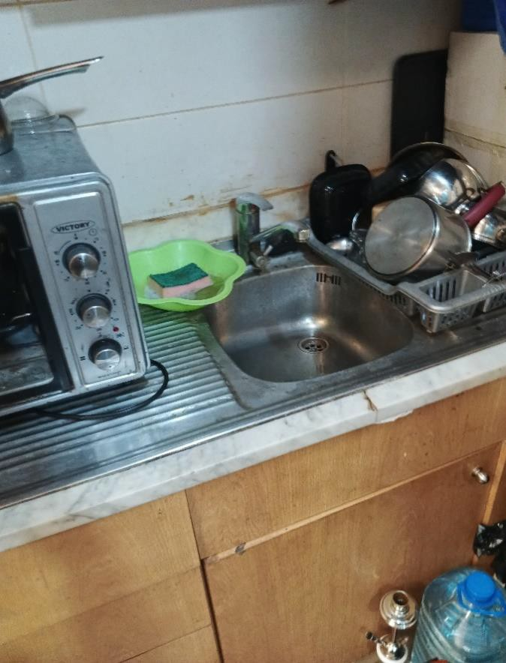
اضرار أحواض المجال حنفيات مياه الشرب مفقودة
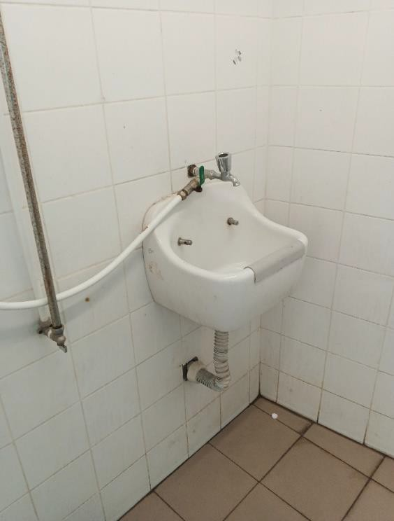
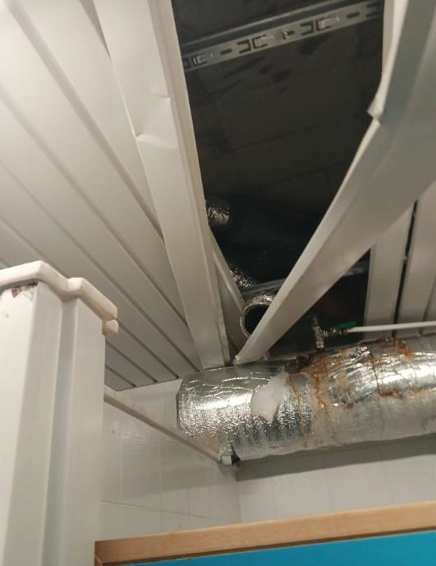
اضرار في مراوح الشفط اضرار في احواض التنظيف

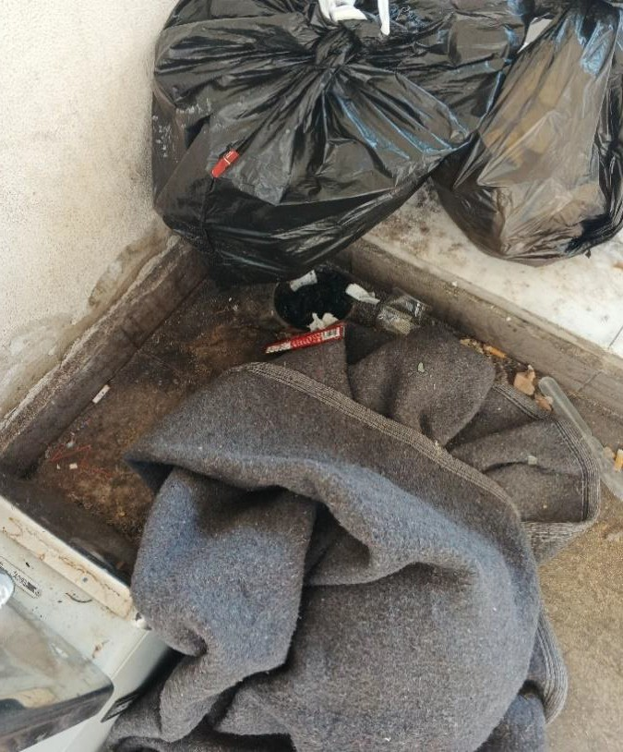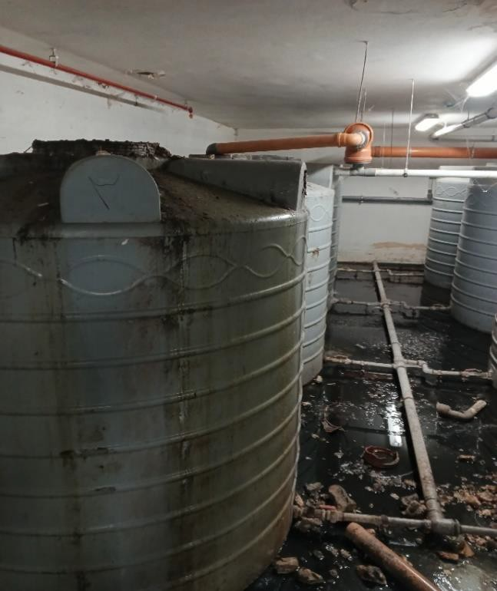
أضرار في خزانات تجميع مياه الامطار اضرار في مصارف المياه الارضية
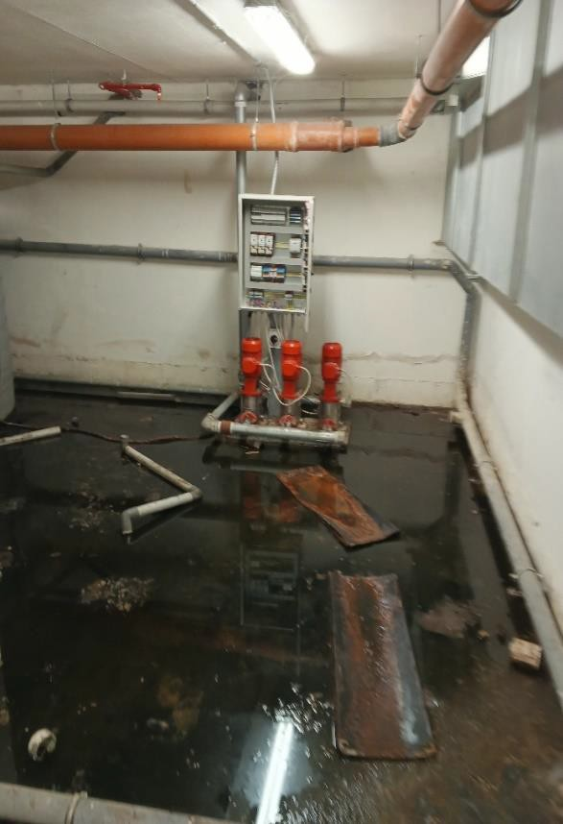
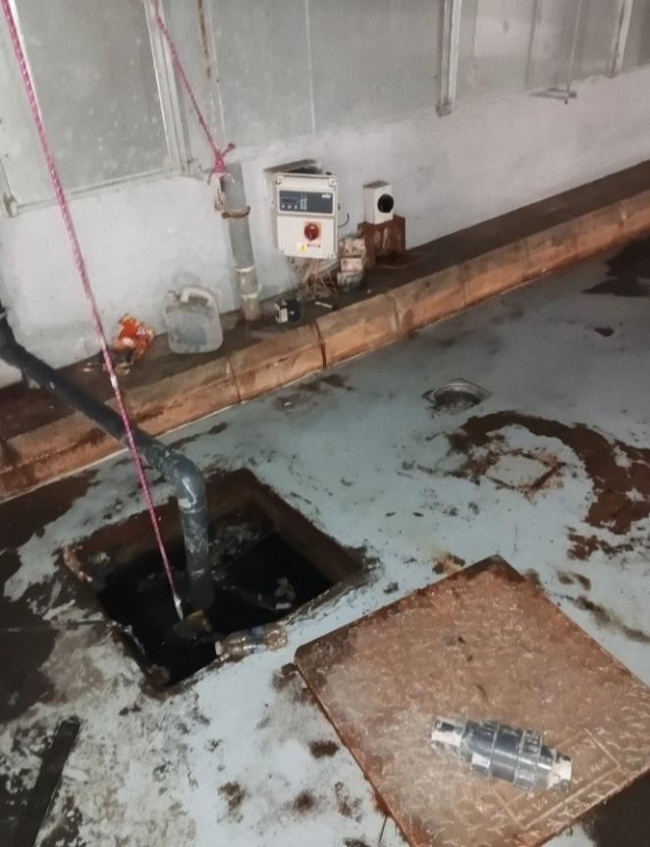
اضرار في المضخات الغاطسة للمواقف اضرار في مضخات نقل مياه الامطار من خزانات التجميع

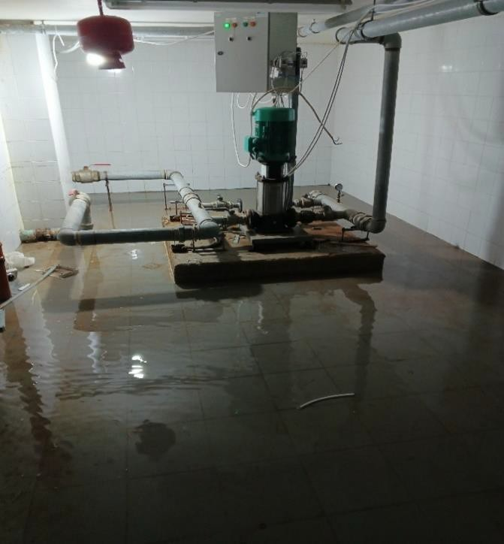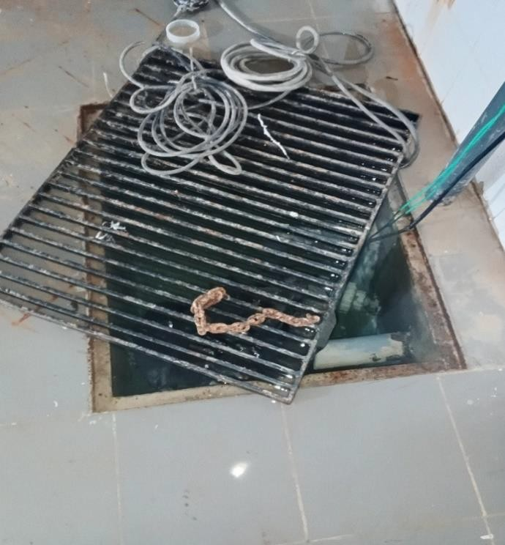
اضرار في المضخات الغاطسة لغرفة الميكانيك اضرار مضخة نقل مياه الخدمة
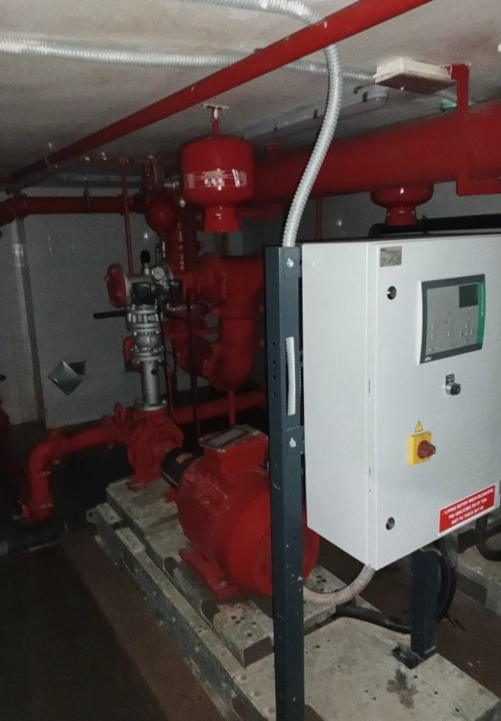
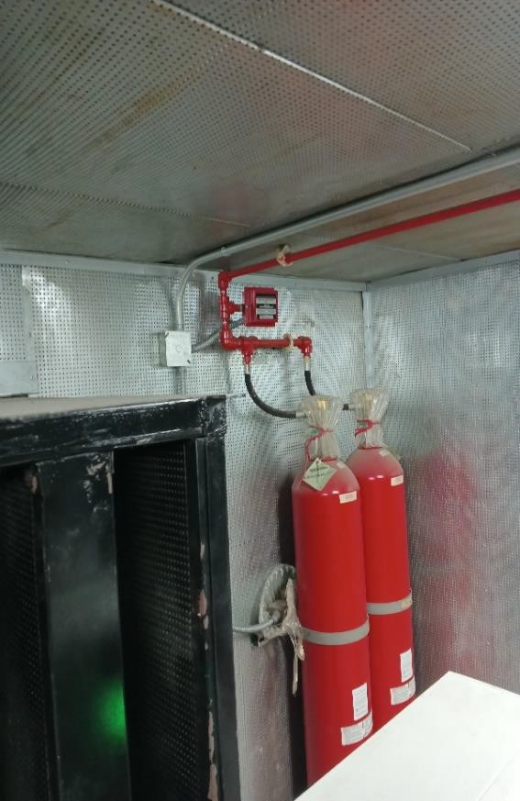
اختبار وفحص نظام الحريق داخل غرف المولدات اختبار وفحص مضخات الحريق

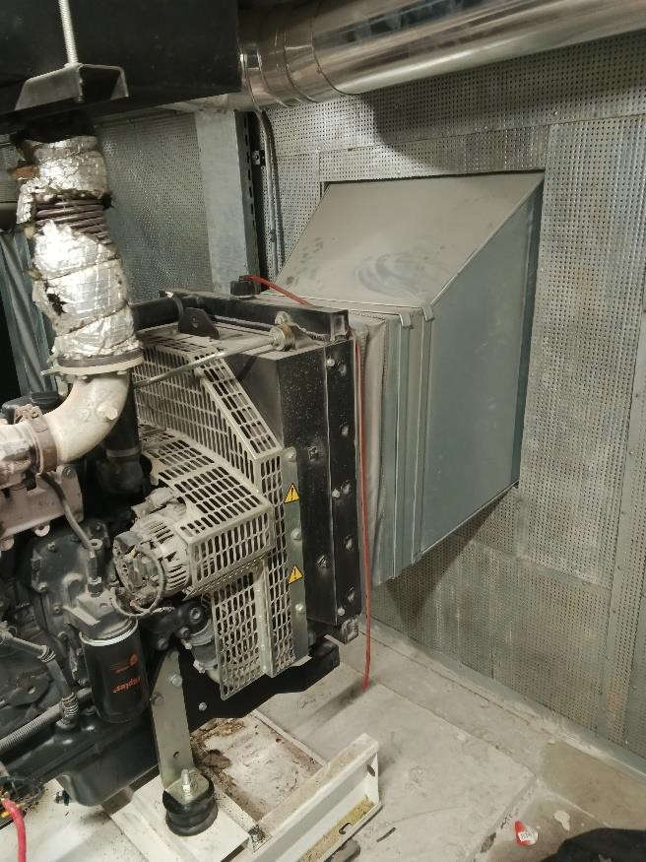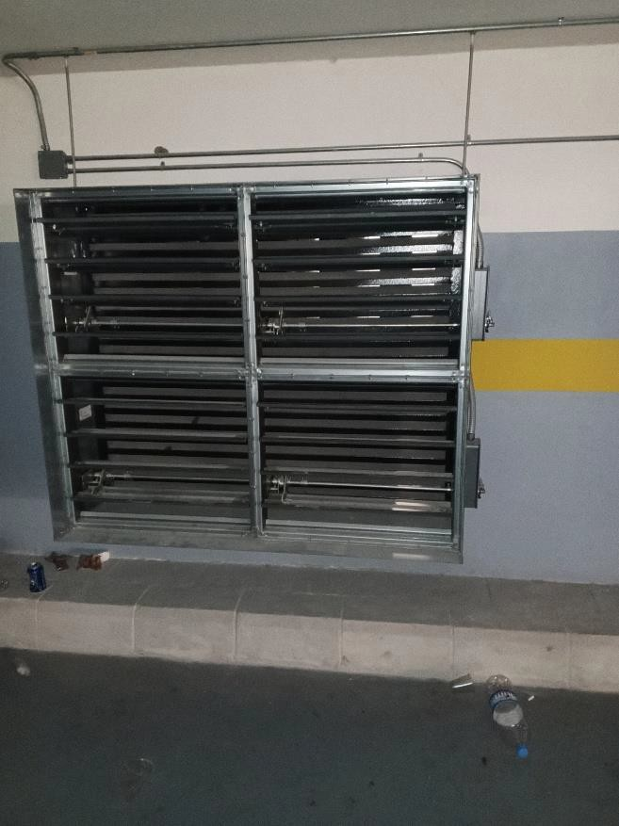
اختبار وفحص بوابات التحكم مع الصمامات الكهربائية معالجة العزل، اختبار وفحص نظام التهوئة
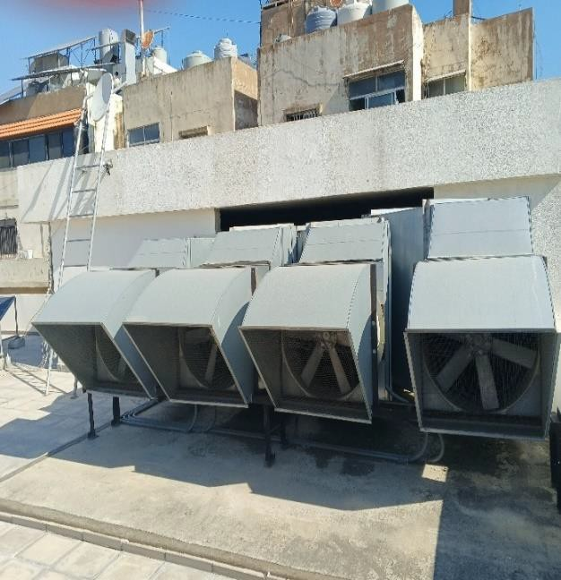
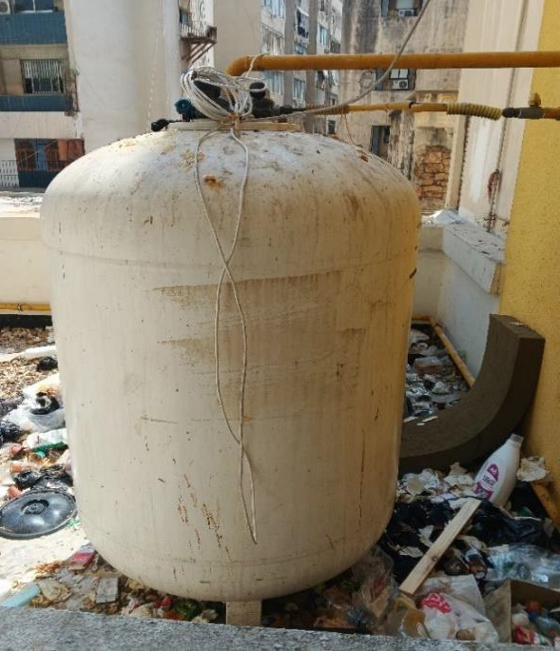
اضرار خزان الغاز اختبار وفحص مراوح الشفط للمواقف

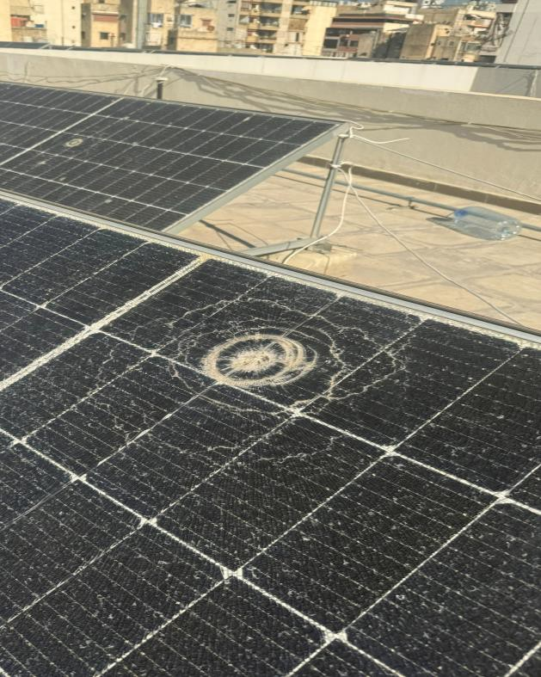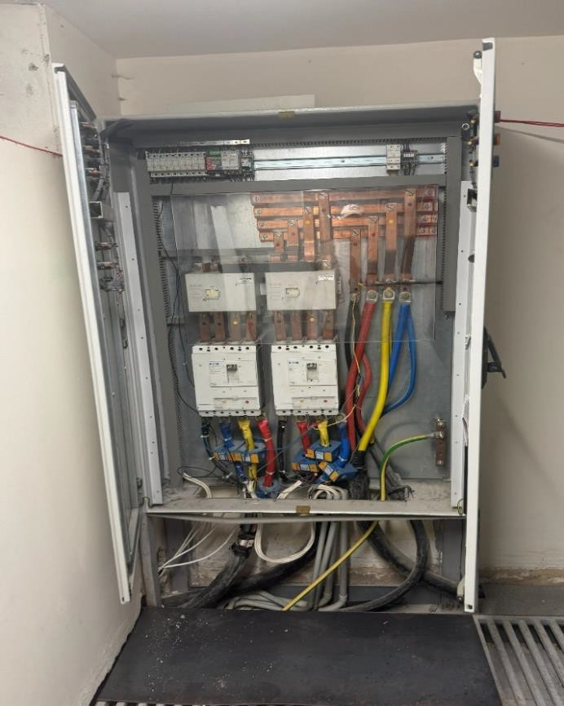

تضرر الالواح الشمسية

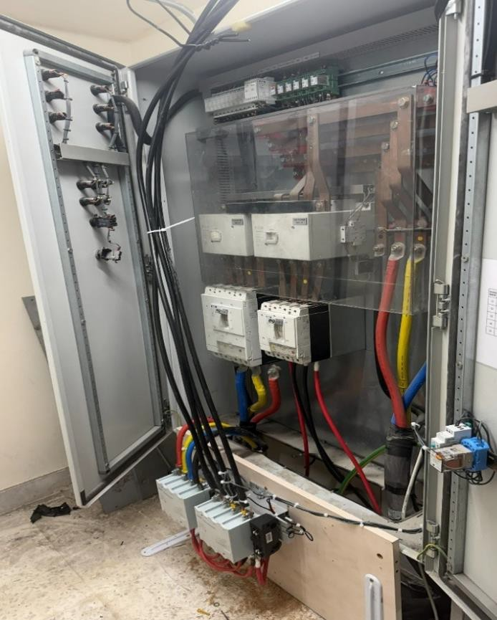
تعديلات في التابلوهات الكهربائية
تعديلات في التابلوهات الكهربائية
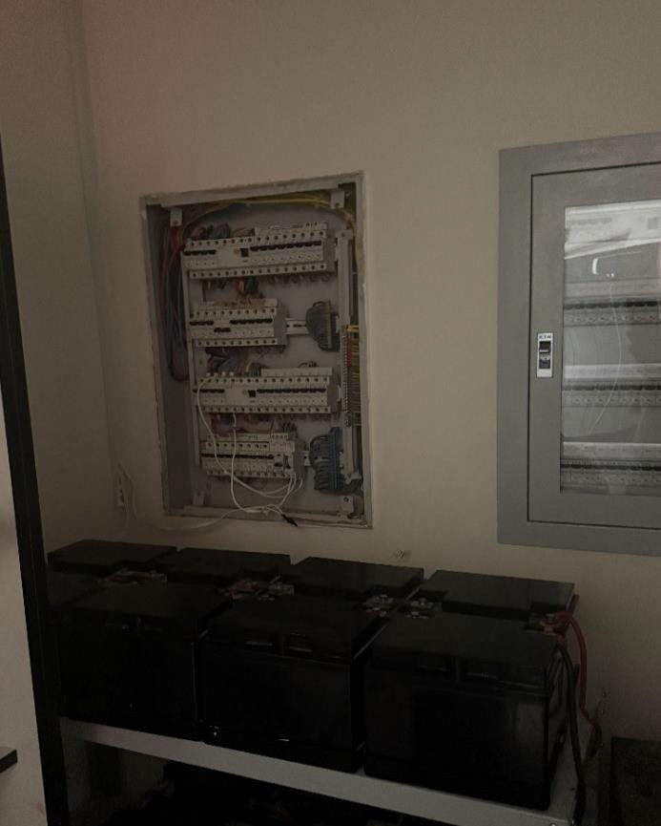
تعديلات في التابلوهات الكهربائية

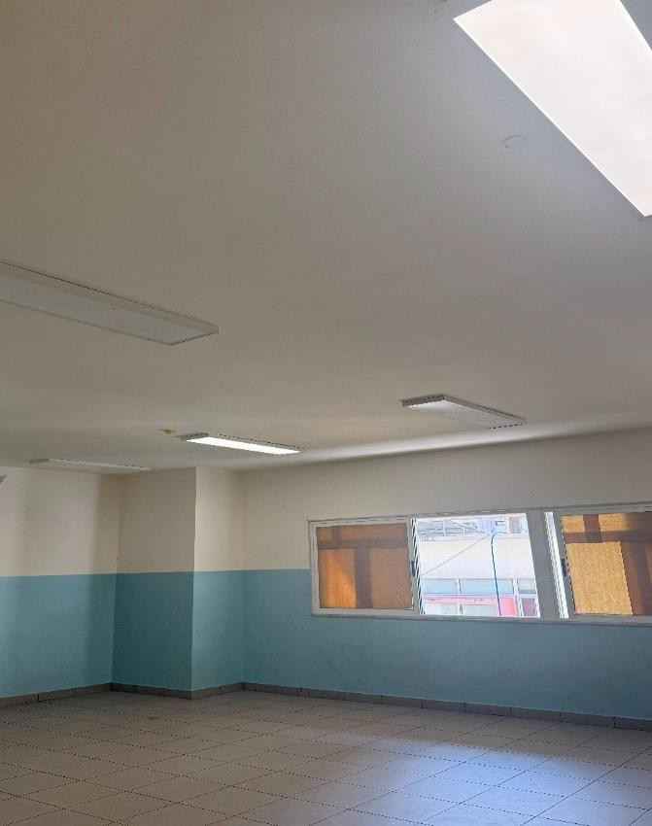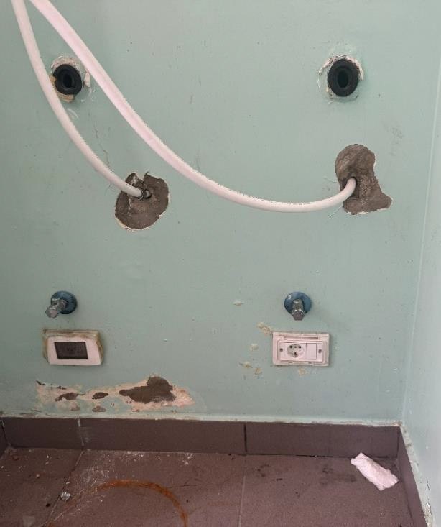

أجهزة الانارة

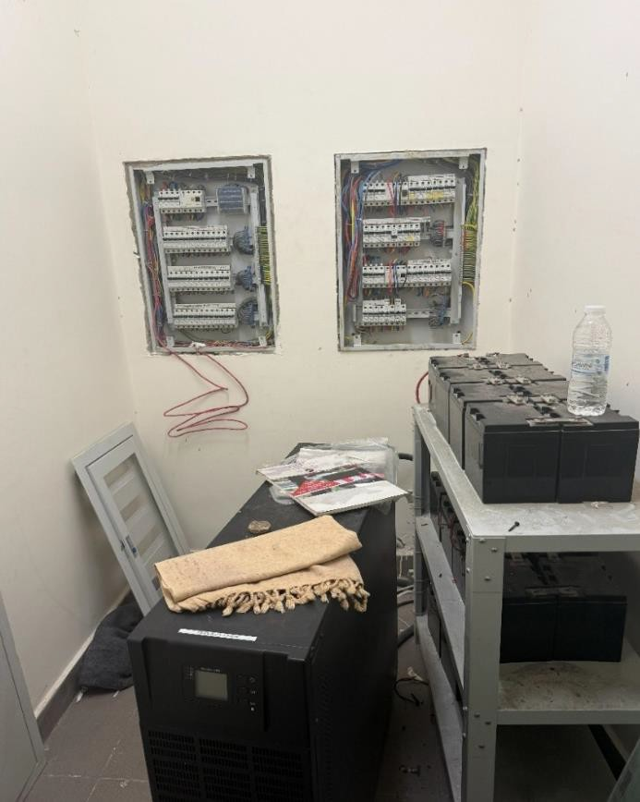
تعديلات في التابلوهات الكهربائية
اضرار متفرقة
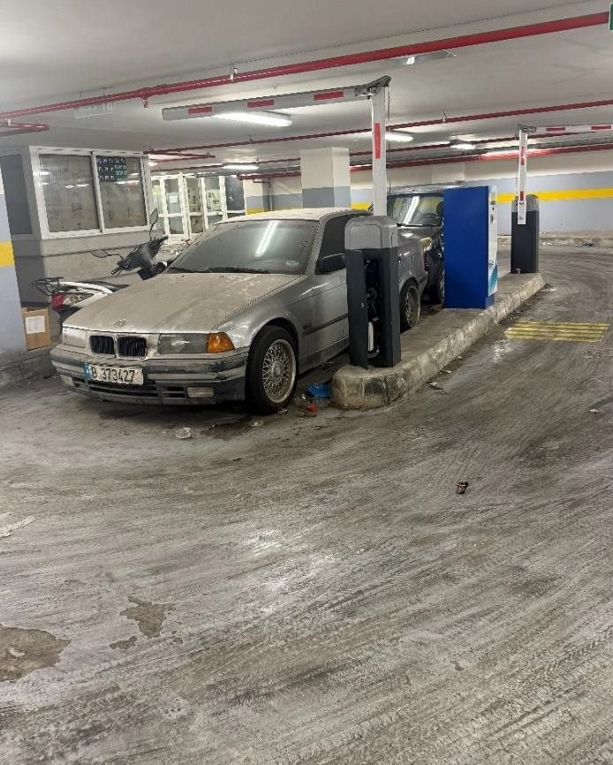
نظام مواقف السيارات

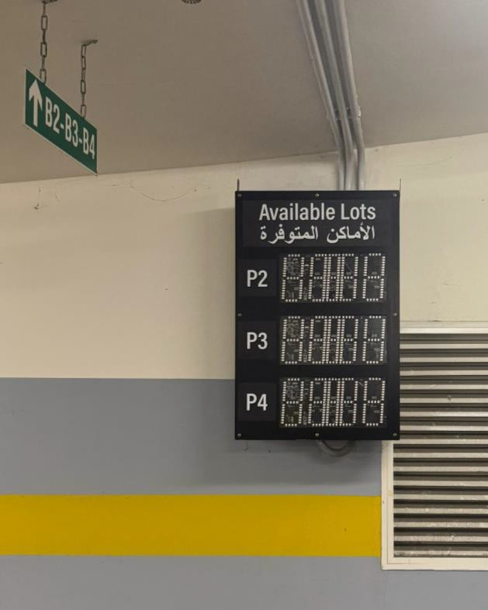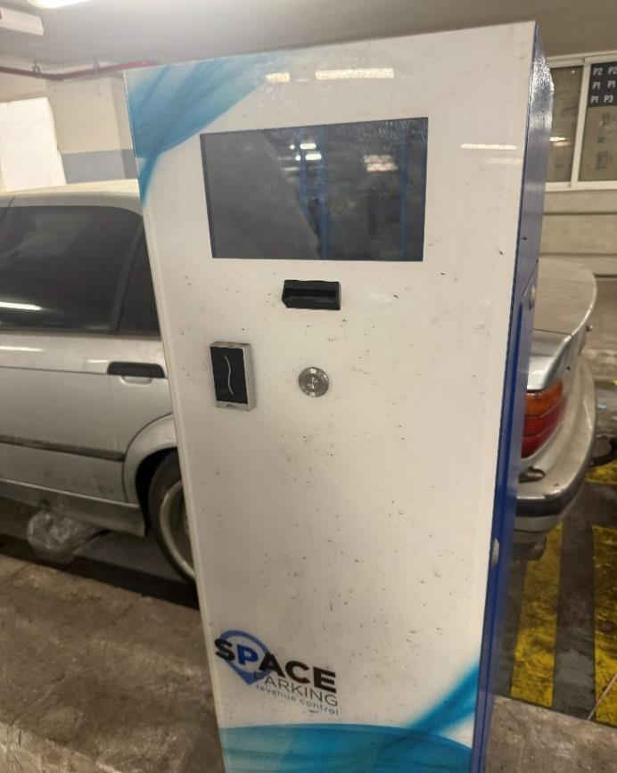
نظام تعداد السيارات نظام تعداد السيارات
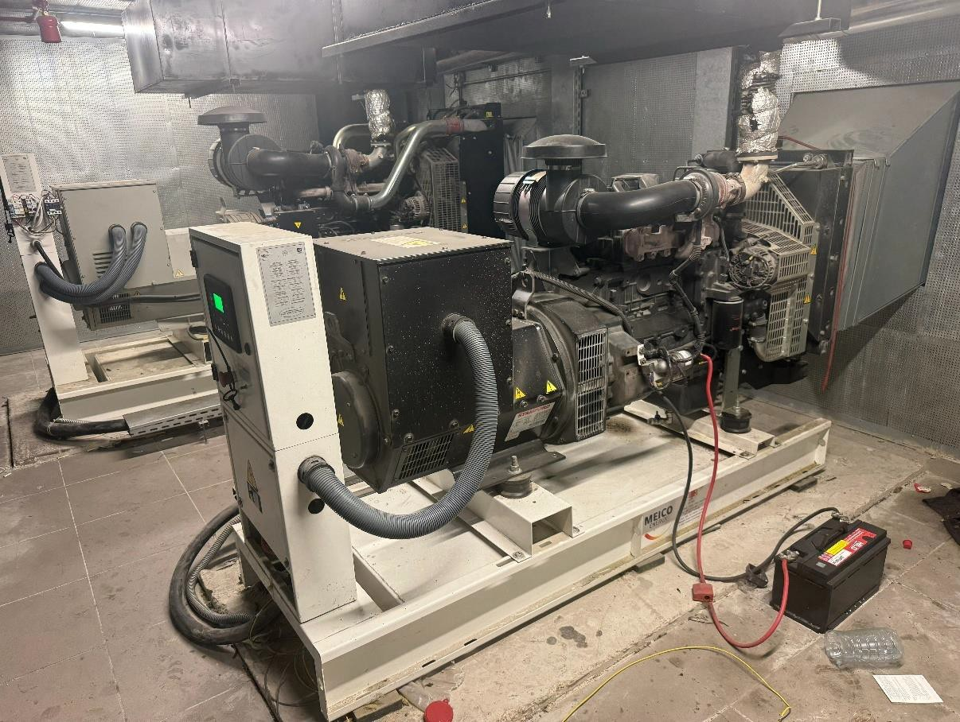

المولدات الكهربائية

10. Mandatory Site Visit
A site visit to School No. 04, Mazraa, Beirut, is mandatory for all bidders before submitting an offer. Bidders shall inspect all areas relevant to the four work sections and confirm dimensions, quantities, access conditions and site constraints before pricing the BOQ.
- Location: School No. 04, Mazraa, Beirut, Plot No. 1230, Mazraa Cadastral Zone.
- Meeting point: Main entrance gate of the school.
- Failure to attend the mandatory site visit shall result in disqualification of the bidder's offer.

11. Bid Validity and Submission
- Only complete bids will be accepted

12. Contractor Submission Requirements
- Company profile and valid registration documents.
- signed and stamped priced Bill of Quantities (Annex 2), with each work section priced separately and the consolidated total completed.
- Datasheets shall be submitted with the bid and shall clearly identify the proposed manufacturer, brand, and model. For repair or rehabilitation of items, datasheets are required only where new materials, equipment or replacement components are proposed. Safety Data Sheets shall accompany all disinfectants, paints, coatings, sealants, adhesives and chemical products.
- (BOQ Lots and items) as follows:
Lot | BOQ Item No. | Major Item Requiring Datasheet | Required Technical Documentation
Lot 1 | 1.3, 1.5 | Disinfectant and sanitizing products | Product datasheets and SDS
Lot 2 | 2.2, 2.3 | Plaster-repair and crack-repair products | Technical datasheets
Lot 2 | 2.4, 2.5, 2.9, 2.10, 2.11 | Anti-corrosion treatment and metal-coating systems | Complete coating-system datasheets
Lot 2 | 2.6, 2.7 | Panic push bars and major door hardware | Manufacturer’s catalogues or datasheets
Lot 2 | 2.14 | Aluminum suspended-ceiling system | Datasheets for aluminum strips, accessories and suspension system
Lot 2 | 2.15, 2.16, 2.17, 2.18, 2.19, 2.20 | Interior, exterior, damp-proof and protective paint systems | Complete paint-system datasheets
Lot 2 | 2.21, 2.22, 2.28, 2.29, 2.30 | Exterior, timber and steel doors | Datasheets for door construction, frames, glazing and major hardware
Lot 2 | 2.31 | Replacement glass and perimeter sealant | sealant datasheet
Lot 2 | 2.32, 2.33, 2.34, 2.35, 2.36 | Ceramic, anti-acid, skirting and replacement floor tiles | Datasheet for each tile type, adhesive and grout
Lot 2 | 2.37 | PVC flooring system | Datasheets for PVC flooring, skirting, welding product and adhesive
Lot 2 | 2.38, 2.39, 2.40, 2.41 | Accessible bathroom rails and emergency alarm pull cord | Manufacturer’s catalogues or datasheets
Lot 2 | 2.42 | Epoxy and polyurethane coating system | Complete technical datasheets
Lot 2 | 2.43 | HPL signage system | Datasheets for HPL panel
Lot 3 | 3.2, 3.3 | Taps, valves, traps and WC accessories | Manufacturer’s catalogues or datasheets
Lot 3 | 3.4 | Potable-water tank leak-sealing product | Technical datasheet,
Lot 3 | 3.17 | PVC, PPR, HDPE, steel or copper pipes and fittings | Manufacturer’s datasheets for each proposed pipe and fitting type
Lot 3 | 3.18, 3.19, 3.20 | Ductwork, grilles, registers and sprinkler components | Technical datasheets
Lot 3 | 3.21, 3.22, 3.23, 3.24 | Exhaust fans, booster pumps and submersible pumps | Manufacturer’s datasheets indicating capacity, head, power and materials, where replacement is proposed
Lot 3 | 3.25, 3.26, 3.27 | Ventilation components, sound insulation and pipe insulation | Technical datasheets indicating materials, thickness
Lot 3 | 3.28, 3.29, 3.30 | Fuel-oil piping components, fuel-fill cabinet components and generator oil filters | Manufacturer’s datasheets indicating materials, ratings and equipment compatibility
Lot 3 | 3.31 | Exhaust-fan flexible connections, dampers and attenuators | Manufacturer’s catalogues or datasheets
Lot 3 | 3.32, 3.33, 3.34, 3.35, 3.36, 3.37, 3.38, 3.39, 3.40 | WCs, lavatories, taps, mixers, sinks and sanitary accessories | Manufacturer’s catalogue or datasheet for each proposed fixture type
Lot 3 | 3.42 | Drinking fountains | Manufacturer’s datasheet indicating construction, dimensions and connections
Lot 3 | 3.43 | 3,000-litre PE rainwater tanks | Datasheet indicating capacity, dimensions, material and connections
Lot 3 | 3.44 | 100-litre electric water heater | Datasheet indicating capacity, power and safety features
Lot 3 | 3.45 | Heavy-duty trench drain and galvanized steel grating | Datasheets indicating dimensions, materials and load class
Lot 3 | 3.46 | Flood barriers, backflow valves and sealing products | Datasheets indicating dimensions, materials, pressure rating and design performance; SDS for sealing products
Lot 3 | 3.47 | Water-treatment filters, RO unit, UV steriliser, booster pumps and stainless-steel tank | Manufacturer’s datasheet for each proposed replacement component
Lot 4 | 4.2, 4.3, 4.28, 4.29, 4.30 | Electrical power, lighting, feeder and control cables | Datasheets indicating conductor material, size, insulation, voltage rating and current capacity
Lot 4 | 4.3, 4.4, 4.5 | Circuit breakers and waterproof disconnecting switches | Datasheets indicating ratings, breaking capacity, number of poles and IP rating
Lot 4 | 4.6, 4.7, 4.8, 4.9, 4.10, 4.11, 4.12, 4.13 | Electrical sockets, switches and push-button switches | Manufacturer’s catalogue or datasheet for each proposed type
Lot 4 | 4.14, 4.15, 4.16, 4.17, 4.18, 4.19, 4.20, 4.21, 4.22, 4.23 | LED lighting fixtures, LED tubes, emergency lights and exit signs | Datasheets indicating wattage, lumen output, CCT, CRI, IP rating, dimensions and emergency-battery performance
Lot 4 | 4.25 | 600W photovoltaic panels | PV module datasheet, warranty and applicable compliance certificates confirming compatibility
Lot 4 | 4.31, 4.32 | Earthing and lightning-protection components | Datasheets for earth bars, connectors, Franklin rod, bare copper conductor and related accessories
Lot 4 | 4.33 | Hybrid inverter | Datasheet indicating capacity, DC/AC ratings, input/output configuration, system compatibility letter, warranty and compliance certificates
Lot 4 | 4.33 | Automatic transfer/changeover switchgear and protection devices | Datasheets indicating ratings, operating arrangement and breaking capacity

- Proposed work schedule
- Detailed methodology addressing all four work sections, sequencing, interfaces, quality control, testing and commissioning.
- Integrated work program showing key milestones, trade interfaces and total duration.
- List of similar projects completed in the last 5 years, with references relevant to the work sections proposed.
- List of machinery and equipment available for the project.
- CVs of proposed key personnel, including a qualified site/project engineers at least one Civil and one Electro mechanic engineers , HSE officer with university degree, site foreman, and suitably qualified technical personnel for civil, mechanical and electrical works.
- Identification of any proposed subcontractors and the work sections assigned to them.

13. Key Deliverables and Handover
- Approved integrated work program and method statements.
- Approved shop drawings, material submittals and samples as applicable.
- Daily site records and progress updates as required by the LRC Engineer.
- Post-cleanup condition survey for basement levels B3 and B4.
- Testing and commissioning reports for mechanical, electrical, fire-safety, water-treatment, UPS and solar systems as applicable.
- As-built drawings and final certification for repaired or reconnected electrical systems.
- Clean the site and remove all debris and surplus materials upon completion. The Contractor shall be solely responsible for the collection, transportation, and disposal of all generated waste and debris in an environmentally sound manner. LRC shall bear no responsibility for the handling, transportation, or final disposal of such materials. And Waste disposal records where requested.
- Defects list closure and final written handover report.

14. BOQ

Lot 1 — Site Cleaning, Mobilization & Desludging
Bill of Quantities for Tender — Contractor to price. Rates shall be all-inclusive of materials, labour, transport, equipment, and incidental works unless stated otherwise.
Item | Description of Works | Detail | Unit | Qty
1.1 | Mobilization & Site Establishment | Mobilize personnel, equipment, temporary site facilities, signage and safety barriers, and set up welfare and storage facilities for the duration of the works. Work to include: coordination of site access and working hours with the school administration and LRC Engineer; submission of a method statement and programme prior to start of works; and all labour, equipment and materials needed to establish the site, to the satisfaction of the Engineer. | L.S. | 1.00
1.2 | General Cleaning - All Floors (incl. Basements) | Thorough cleaning of the school premises, including collection, removal, loading, transportation and lawful disposal of accumulated litter, waste, debris and unwanted materials from classrooms, corridors, staircases, offices, laboratories, WCs, playgrounds, external areas, roofs, sun-shading canopies, terraces and balconies (per the original specification), extended to also cover basement levels B1 and B2 (unaffected by flooding; B3 and B4 are covered separately under Item 1.5 given the heavier flood/sewage-remediation scope there). Work to include: sweeping and gathering of all affected areas, with particular thoroughness at corridors, staircases and balconies; removal of loose fixtures/rubbish left by prior occupants; wet-wiping of accessible surfaces; and leaving the premises clean, safe and ready for use, to the satisfaction of the Engineer. | L.S. | 1.00
1.3 | Disinfection & Sanitization - All Occupied Spaces | Supply and apply approved disinfectant/sanitizing agents to all classrooms, rooms, offices, laboratories, WCs, corridors, terraces and balconies throughout the building (basement levels B1 and B2, and Ground Floor to Floor 6 — B3 and B4 are covered separately under Item 1.5), given the building's recent use as a displacement shelter. Work to include: all disinfectant materials, application equipment and labour; surface disinfection of floors, walls (to hand height), door handles, sanitary fixtures and fittings; and appropriate PPE and ventilation during application, all to the satisfaction of the Engineer. | L.S. | 1.00
1.4 | Dewatering of Basement Levels B3 & B4 | Supply, install and operate pumps and dewatering equipment as required to remove standing water from basement level B4 (fully flooded) and the flooded portion of basement level B3 (40% of floor area). Work to include: all pumping equipment, hoses and power supply; safe discharge of pumped water to an approved point; and continuation of pumping until the affected areas are free of standing water, to the satisfaction of the Engineer. | L.S. | 1.00
1.5 | Cleaning, Disinfection & Sanitization of Flooded Basement Areas (B4 full + B3 40%) | Comprehensive cleaning, disinfection and sanitization of basement level B4 (fully flooded, 2,200 m²) and the flooded portion of basement level B3 (40% of 2,200 m² = 880 m²) following exposure to rainwater/sewage flooding and accumulated waste, particularly around staircases. Work to include: removal of sludge, contaminated residues and floating debris; washing of all affected floor and wall surfaces; application of approved disinfectant; and implementation of appropriate health, safety and hygiene measures (PPE, ventilation, controlled access) given the nature of the contamination. Basement levels B1 and B2 (unaffected by flooding) are covered under the general cleaning and disinfection items above. | m2 | 3,080.00
1.6 | Waste, Sludge & Debris Disposal | Collection, transportation and disposal of all waste, sludge and debris generated by the cleaning works, to approved dumps, during a time agreed between the school administration, Contractor and LRC Engineer. Work to include: all handling, loading and transport equipment; segregation of contaminated waste where required by the receiving facility; and all disposal/tipping fees, at the Contractor's cost and responsibility and in an environmentally sound manner. LRC shall bear no responsibility for handling, transport or final disposal. | L.S. | 1.00
1.7 | Parking-Level Drain & Channel Clearing (All Basement Levels) | Clear accumulated debris from parking-area floor drains, trench drains and drainage channels across all four basement levels ahead of the mechanical rehabilitation works. Work to include: manual/mechanical removal of silt and debris from drain bodies and channels; confirmation that drains run free; and lawful disposal of removed material, to the satisfaction of the Engineer. | L.S. | 1.00
1.8 | Protection of School Furniture & Equipment | The Contractor is fully responsible, and at his own cost, to relocate the school's furniture, appliances, documents, cameras, computers, etc. during the works and where needed. The Contractor is fully responsible to protect the school's furniture, appliances, documents, cameras, computers, etc. from any damage during the whole period of the works, and shall repair or purchase at his own cost new furniture, appliances, documents, cameras, computers, etc. if damaged by his labour and works. | L.S. | 1.00
1.9 | Post-Vacancy Condition Survey - Whole School (incl. Basement Levels) | Following full vacancy of the school and completion of the cleaning and disinfection works, carry out and submit a detailed condition survey covering the ENTIRE building, not only the basement levels. Particular attention to be given to: (a) basement levels B3 and B4, to define the scope of any further finishes-repair works there; and (b) any classrooms, offices, stores or other rooms throughout the school that were previously occupied by displaced persons, kept locked, or otherwise inaccessible during the initial assessment, to identify any additional defects not visible at that time. Work to include: a room-by-room photographic record across all floors; a written assessment of floor, wall, door and MEP component condition; and a summary report identifying items requiring repair, submitted to the LRC Engineer for approval before any further works in the affected areas are instructed. | L.S. | 1.00

Lot 2 — Architectural & Civil Works
Bill of Quantities for Tender — Contractor to price. Rates shall be all-inclusive of materials, labour, transport, equipment, and incidental works unless stated otherwise.
Item | Description of Works | Detail | Unit | Qty
2.1 | Patch Exterior Wall Openings (Former A/C Sleeves) - Both Faces | Cut back, fill and make good 20 no. openings (10 cm radius) left in the exterior walls from temporary air-conditioning unit installations, accessed and finished from BOTH the interior and exterior faces. Work to include: cutting back and cleaning the opening; cement mortar fill; render reinstatement to match existing texture; paint finish matching existing colour on both sides; and any scaffolding, ladders or rope access equipment required for exterior work above ground level, to the satisfaction of the Engineer. | No. | 20.00
2.2 | Localized Wall Plaster & Paint Repair (Moisture Damage) | Rehabilitate and repair cracked and damaged plaster in indoor and outdoor areas. Work to include: determine the location and remove all loose material around the area; remove the cracked plaster layer; install galvanized steel mesh (20 cm width minimum); clean the affected areas with suitable materials; reinstate plaster and apply paint finish to match existing colour and texture. Priority to lower wall sections above skirting and former drinking-fountain locations, where deterioration is linked to moisture/water presence, all as per specifications and Engineer's instructions. | m2 | 950.00
2.3 | Crack Repair Below Classroom Windows | Rehabilitate and repair cracks observed below windows in classrooms. Work to include: routing out and cleaning of the crack; filling with suitable crack-repair compound; reinstatement of plaster; and repainting of the affected area to match existing colour and finish, all to the satisfaction of the Engineer. | No. | 35.00
2.4 | Refinish Existing Powder-Coated Steel Door Frames | Refinish existing powder-coated steel door frames to restore an as-new appearance, representing the majority of frames assessed to be in serviceable condition. Work to include: on-site surface preparation (sanding/etching/degreasing); application of a 2-pack enamel or equivalent system compatible with the existing powder-coat finish; and colour-matching to existing. Full factory re-powder-coating is not required. | No. | 300.00
2.5 | Replace Severely Corroded Steel Door Frames | Supply and install new steel door frames matching existing size, type and finish, at locations where the existing frame is found to be severely corroded beyond repair, particularly in toilet areas. Work to include: removal and disposal of the existing frame; making good the surrounding wall/reveal finish; supply and fixing of the new frame with all related accessories; and finishing paint, all as per specifications. | No. | 16.00
2.6 | Treat/Replace Emergency Push-Bar Hardware | Clean and apply anti-rust treatment to emergency/panic push-bar hardware on stair doors showing light surface rust, and confirm smooth operation. Work to include: full replacement of the push-bar unit, with all fixings, at locations where treatment alone is not sufficient to restore safe operation. | No. | 20.00
2.7 | Repair/Replace Damaged Door Metal Fittings | Repair or replace missing or damaged door metal fittings and accessories (hinges, closers, handles, locksets) at various locations throughout the building. Work to include: removal of damaged fittings; supply and fixing of new fittings of similar type and quality to existing; and adjustment to confirm smooth, safe operation of the door. | No. | 60.00
2.8 | Repair Door Leaves & Hardware (Wood, Handles) - Classrooms, Toilets & Offices Only | Repair damaged door leaves and hardware limited to classrooms, toilets/WCs and administrative offices only - corridors, staircases, labs, storerooms and mechanical/electrical rooms are excluded from this item. Work to include: repair of delaminated/water-damaged panels, edges and cores; replacement of damaged handles, hinges and locks; and re-hanging/adjustment for smooth operation, finished to match existing. Priority to toilet/WC cubicle and entry doors, followed by classroom and office doors, per the condition assessment findings. | No. | 43.00
2.9 | Reinstate Missing Wall-Mounted Stair Handrails | Supply and install new steel wall-mounted handrail at stairs, similar to existing in shape, form, length, finish and colour, at locations currently missing a handrail. Item to include labour, equipment, material and all works required to complete the works. Contractor to submit shop drawings and samples prior to installation, for the Engineer's approval. | m | 110.00
2.10 | Rehabilitate & Maintain Wall-Mounted Steel Handrail (Existing) | Rehabilitate and maintain existing wall-mounted steel handrails at staircases and balconies, returning them to their original form and condition. Work to include: straightening and welding of loose, bent or detached sections; grinding and polishing of welded joints; anti-rust treatment; and repainting to match existing colour and finish, all as per specifications and to the Engineer's approval. | m | 350.00
2.11 | Rehabilitate & Maintain Above-Parapet Steel Handrail (Existing) | Rehabilitate and maintain existing above-parapet steel handrails, returning them to their original form and condition. Work to include: straightening and welding of loose, bent or detached sections; grinding and polishing of welded joints; anti-rust treatment; and repainting to match existing colour and finish, all as per specifications and to the Engineer's approval. | m | 350.00
2.12 | Grind, Polish & Clean Marble Stair Treads | Grind, polish and clean existing marble stair treads showing general wear, to restore a smooth, non-slip and presentable surface. Work to include: diamond grinding of the tread surface, polishing to a consistent finish matching adjacent treads, and final cleaning, all to the satisfaction of the Engineer. | m | 140.00
2.13 | Replace Missing Bathroom Mirrors | Supply and install new mirrors at bathroom/lavatory locations found missing. Work to include: mirror glass with polished edges, dimensions as per site conditions; anti-corrosion wall-fixing hardware suitable for a humid environment; and sealing of edges, similar to the existing and according to the Engineer's approval. | No. | 35.00
2.14 | Clean, Secure & Reinstall Suspended Ceiling Strips | Supply and install aluminum strip suspended ceiling as per specifications, and fix or replace any damaged part. Work to include: materials (aluminum sheet thickness similar to existing); labour; accessories; angles; and a heavy-duty metal suspension system, cleaned and secured throughout, similar to existing. | m2 | 200.00
2.15 | Localized Ceiling Repaint | Rehabilitate and repaint ceiling areas including corridor soffits and stairwell void edges. Work to include: surface preparation (cleaning, filling of minor imperfections); application of primer where bare substrate is exposed; and two coats of finish paint matching existing colour, to the satisfaction of the Engineer. | m2 | 180.00
2.16 | Wall & Ceiling Paint - Super Rubber Paint (Old Walls/Ceilings) | Supply and apply super rubber paint to old internal walls and ceilings. Work to include: surface preparation, filling of minor imperfections, primer where bare substrate is exposed, and two coats of finish paint, colour as directed by the Engineer. Quantity is 70% of the original design's building-wide allowance (14,000 m²), per LRC's phased-scope decision. | m2 | 9,800.00
2.17 | Wall & Ceiling Paint - Oil Paint (Old Walls/Ceilings) | Supply and apply oil paint to old internal walls and ceilings. Work to include: surface preparation, primer where required, and two coats of finish paint, colour as directed by the Engineer. Quantity is 70% of the original design's building-wide allowance (8,000 m²), per LRC's phased-scope decision. | m2 | 5,600.00
2.18 | Treat & Clean Fairfaced Concrete Ceiling and Walls | Treat and clean existing fairfaced (exposed) concrete ceiling and wall surfaces. Work to include: cleaning of surface contamination, minor patch repair, and application of an approved clear protective/sealing treatment to restore appearance. Quantity is 70% of the original design's building-wide allowance (2,000 m²), per LRC's phased-scope decision. | m2 | 1,400.00
2.19 | Outside Walls Paint (Existing Walls and Ceilings) | Paint for external old and new walls, smooth touch. Work to include: removal of any loose paint or obstacles; rehabilitation of the surface and making it good; polyurethane sealant where needed for cracks; and application of 2 coats of exterior-grade paint. Quantity is 70% of the original design's building-wide allowance (5,000 m²), per LRC's phased-scope decision. | m2 | 3,500.00
2.20 | Paint Damp-Proof Colourless Layer (Unleaded) on Facades | Supply and paint with damp-proof paint after cleaning and washing all walls; remove the existing paint and enlarge all cracks, especially at the intersection of hollow concrete blocks and reinforced concrete elements, prior to application. Quantity is 70% of the original design's building-wide allowance (5,000 m²), per LRC's phased-scope decision. | m2 | 3,500.00
2.21 | Replace Guard-Room Exterior Door | Supply and install new external door for the guard room, found in poor condition, suitable for the security/access requirements of the location. Work to include: new door leaf and frame, all hardware (hinges, lockset, handle), and finishing paint to both faces of the door and box frame, similar to existing in size and function. | No. | 1.00
2.22 | Replace Guard-Room Toilet Door | Supply and install new solid single-leaf flush timber door similar to existing, with a minimum 10 cm wide frame between the plywood faces filled with timber beads (tongue and groove, each 5 cm), and door edges in bead wood fixed by tongue and groove frames, all as specified. Work to include all accessories and fittings (hinges, lockset, handle), and finishing paint to both faces of the door leaf and the box frame. | No. | 1.00
2.23 | Replace Guard-Room Kitchen Counter | Supply and install new marble worktop (counter) for the guard room's kitchenette, similar to existing in size, thickness and finish, to replace the damaged unit. Work to include: removal and disposal of the existing counter, supply and fixing of the new marble top with polished edges, and sealing to the adjoining cabinetry. | m | 2.00
2.24 | Clean & Re-point Sanitary Area Tiling | General cleaning and re-pointing/grouting of wall and floor tiling and joints in bathroom areas throughout the building. Work to include: removal of degraded/discoloured grout, cleaning of tile surfaces, and reinstatement of grout/pointing matching existing colour, to a sound, hygienic finish. | m2 | 500.00
2.25 | New Curbstone | Supply and install new precast fairfaced concrete curbstone similar to the existing . Work to include: labour, material and equipment; curb fill and mortar; removal of existing damaged units; casting of concrete behind the curbstone; and handicapped concrete units where required. All works as per specifications and Engineer's instructions. | m | 15.00
2.26 | Rehabilitate Existing Curbstone | Inspect and rehabilitate existing curbstone as per specifications. Work to include: removal of all loose or damaged parts and re-installation as existing; materials; and cleaning. All works as per specifications and Engineer's instructions. | m | 200.00
2.27 | Rehabilitate Precast Concrete Tiles (Covered Playgrounds) | Supply and install precast concrete tiles similar to existing. Samples to be provided for approval. Work to include: labour, material and equipment; the necessary fill below tiles; and installation of tiles, all as per specifications and Engineer's instructions. | m2 | 15.00
2.28 | New Timber Door (Single Leaf) | Supply and install flush timber door with laminated plastic facing. The door shall have a 10 cm wide frame between the plywood, filled with timber beads by tongue and groove (each 5 cm), and the door edges shall be bead wood, fixed by tongue and groove frames, all as specified. Work to include all accessories and fittings, pre-painting and finishing paint to both sides of the door and box frame. | No. | 3.00
2.29 | New Timber Door with View Frame | As Item 2.28 (flush timber door with laminated plastic facing, 10 cm frame, timber bead tongue-and-groove construction, all accessories, fittings and finishing paint), with the addition of a vision/view frame (glazed panel) incorporated into the door leaf, as per specifications. | No. | 8.00
2.30 | New Steel Double-Leaf Door | Supply and install new steel double-leaf door with related accessories, similar to existing, as per specifications. Work to include: two door leaves, frame, all hardware (hinges, lockset, handle) and finishing paint to both faces of the door leaves and box frame. | No. | 1.00
2.31 | Repair of Existing Aluminum Windows & Replace Broken Glass | Repair existing aluminum windows and replace broken glass throughout the building. Work to include: checking the functionality of latches, hinges and other hardware, and replacing broken parts with new ones so each window operates smoothly; removal and replacement of cracked/broken glass panes to match existing type and thickness; and application of a high-quality sealant around all edges to prevent moisture ingress, with all associated finishing works. | L.S. | 1.00
2.32 | Tiling Works - Classroom & Corridor Ceramic (60x60cm) | Supply and install anti-skid coloured ceramic tiles, 60 x 60 cm, first choice, for classrooms and corridors. Work to include: surface preparation, bedding mortar, tile laying to true line and level, and grouting to match tile colour & similar to the existing | m2 | 85.00
2.33 | Tiling Works - Kitchen & Toilet Ceramic (30x60 or 30x30cm) | Supply and install anti-skid coloured ceramic tiles, 30 x 60 cm or 30 x 30 cm, for kitchens and toilets. Work to include: surface preparation, bedding mortar, tile laying to true line and level, and grouting to match tile colour & similar to the existing. | m2 | 5.00
2.34 | Tiling Works - Laboratory Ceramic (60x60cm, Anti-Acid) | Supply and install anti-acid and anti-skid coloured ceramic tiles, 60 x 60 cm, for laboratories. Work to include: surface preparation, bedding mortar, tile laying to true line and level, and chemical-resistant grouting & similar to the existing. | m2 | 5.00
2.35 | Tiling Works - Skirting | Supply and install skirting tiles to match flooring finish (10 cm height), same type and matching colour as the ceramic floor tiles, neatly fixed and grouted to the wall/floor junction. | m | 5.00
2.36 | Repair Existing Broken Floor Tiles & Skirting (All Types) | Inspect the entire floor area, then rehabilitate and repair all damaged and broken tiles and skirting of any type (marble, ceramic, mosaic, cement). Work to include: removal of all debris as specified; all materials and labour; matching of tile shape, thickness, dimension and pattern to existing; and reinstatement similar to existing, for all rooms and corridors, to the Engineer's approval. | L.S. | 1.00
2.37 | Colored P.V.C. Flooring for KG Classrooms | Rehabilitate and clean existing coloured PVC flooring for KG classrooms. Work to include: cutting and patching of damaged areas (matching thickness, shape and colour); welding of joints; fixing of skirting; and general cleaning, with all works approved by the Engineer prior to installation. | L.S. | 1.00
2.38 | Handicapped Bathroom Accessories - Vertical Grab Rail | Supply and install vertical grab rail, 60 cm bars, complete with heavy-duty anti-corrosion fixings suitable for a wet environment, to the Engineer's approval. | No. | 2.00
2.39 | Handicapped Bathroom Accessories - Horizontal Grab Rail | Supply and install horizontal grab rail, 60 cm bars, complete with heavy-duty anti-corrosion fixings suitable for a wet environment, to the Engineer's approval. | No. | 2.00
2.40 | Handicapped Bathroom Accessories - Drop-Down Removable Arm Rail | Supply and install drop-down rail, removable arm, 80 cm, complete with heavy-duty anti-corrosion fixings suitable for a wet environment, to the Engineer's approval. | No. | 2.00
2.41 | Handicapped Bathroom Accessories - Emergency Alarm Pull Cord | Supply and install alarm pull cord for emergency use, wired to the nurse/supervisor station, complete with all accessories and testing prior to handover. | No. | 2.00
2.42 | Epoxy Floor - Concrete Benches (Different Colours) | Supply and install epoxy with polyurethane layer finishing on existing concrete benches, different colours, suitable for playground use. Work to include: surface preparation and cleaning of the existing bench, filling of any cracks or chips, and application of the epoxy/polyurethane finish system to a durable, weather-resistant standard. | m | 36.00
2.43 | Signage | Supply and install sliding panel signs for all rooms, high-pressure laminate (HPL) 1.2 cm thick, movable inside a stainless steel rail (316), fixed on walls, letters vinyl-printed with engravement for special-need purposes. Colours and shape as per Engineer's instruction. Dimension: 20cm x 10cm. | No. | 240.00

Lot 3 — Mechanical Works
Bill of Quantities for Tender — Contractor to price. Rates shall be all-inclusive of materials, labour, transport, equipment, and incidental works unless stated otherwise.
Item | Description of Works | Detail | Unit | Qty
3.1 | General Technical Requirements & Shop Drawings | Prepare shop drawings for all mechanical works for the Engineer's approval prior to execution, and mobilize for maintenance, rehabilitation, testing and commissioning of the existing mechanical systems. Work to include: survey of existing installations, preparation of drawings/method statements, and submission for approval before any works commence. | Item | 1.00
3.2 | LAV for Non-Kids - Taps, P-Traps & Angle Valves | Supply and install new taps, P-traps and angle valves with flexible pipe connections for non-kids lavatories throughout the building, similar to existing. Work to include: removal and disposal of the existing failed fittings, supply of new fittings of equivalent or better quality, connection to existing supply and waste points, and testing for leaks. | No. | 96.00
3.3 | WC for Non-Kids - Seat Covers, Flushing Hoses & Tank Accessories | Supply and install new seat covers, flushing hoses, tank accessories, and angle valves with flexible pipe connections for non-kids WCs throughout the building, similar to existing. Work to include: removal and disposal of failed components, fitting of new components, and testing of flush and shut-off operation. | No. | 84.00
3.4 | Water Tank Leak Treatment | Treat water leakage from the two existing 10,000-litre PE tanks located at roof level. Work to include: locating the source of leakage, cleaning and preparing the affected surface, application of an approved leak-sealing compound/patch suitable for potable water contact, and confirmation the tank holds water without leaking. | No. | 2.00
3.5 | Float Valves | Test and rehabilitate float valves at water tanks and cisterns to confirm correct shut-off operation. Work to include: removal of the existing valve where faulty, supply and fitting of a new valve of matching size/type, and testing of water level control. | No. | 10.00
3.6 | Roof Drains | Clean and rehabilitate roof drains located on the roof. Work to include: removal of debris and blockages, checking and repair of the drain body and strainer, and confirmation of free-flowing drainage. | No. | 9.00
3.7 | Vertical Pipes Fixation at Top of Roof Level | Reinstall and re-secure vertical water filling pipes at roof level in a proper technical manner. Work to include: supply of new pipe clips/brackets as required, correct alignment and fixing of pipework, and confirmation the installation is stable and watertight. | No. | 10.00
3.8 | Water Pipe Connection at Roof Level | Reinstate and reconnect water pipe connections at roof level, including a previously disconnected water pipe, as required. Work to include: supply of any missing fittings, jointing/sealing of connections, and pressure/leak testing on completion. | No. | 1.00
3.9 | Flushing & Leak Test - Drainage and Water Pipes | Carry out flushing and leak testing for the existing drainage and water pipes throughout the building. Work to include: flushing of all accessible lines to clear debris, pressure/gravity testing as applicable, identification of any leaks or blockages, and repair of any defects found to achieve a fully functioning system. | item | 1.00
3.10 | Flushing & Gravity Test - Manholes | Carry out flushing and gravity testing for the existing manholes and related pipe connections. Work to include: opening and inspecting manholes, flushing connected pipe runs, confirming correct fall/gravity flow, and repair of any defects found. | item | 1.00
3.11 | Leak Treatment - Main Drainage Networks (B1/L1 High Level) | Treat leaks in the main drainage networks at basement B1 / Level 1 high level. Work to include: locating the source of the leak, exposing the pipe/joint as necessary, repair or replacement of the defective section, and confirmation of a leak-free system on completion. | item | 1.00
3.12 | Floor Drain Covers | Supply and install new floor drain covers throughout the building, similar to existing, complete with cleaning of the drain body beneath each cover. | No. | 60.00
3.13 | Trench Drain + Rust Treatment/Paint | Clean and rehabilitate the trench drain at parking level. Work to include: removal of debris and silt, rust treatment of steel grating/frame, and repainting of steel parts to prevent further corrosion. | No. | 1.00
3.14 | Parking Drain + Rust Treatment/Paint | Clean and rehabilitate parking-level drain outlets. Work to include: removal of debris and silt, rust treatment of steel grating/frame, and repainting of steel parts to prevent further corrosion. | No. | 20.00
3.15 | Testing - Drainage Connection to Municipality | Test the drainage connection to the municipal network to confirm it is functioning correctly and free of blockages or backflow, and report any deficiencies to the LRC Engineer. | item | 1.00
3.16 | Testing - Water Connection to Municipality | Test the water supply connection to the municipal network to confirm adequate pressure and supply, and report any deficiencies to the LRC Engineer. | item | 1.00
3.17 | Parking & Mechanical Rooms - Pipes | Carry out maintenance, rehabilitation, testing and commissioning of pipework within the parking and mechanical rooms. Work to include: inspection of all accessible pipe runs, repair or replacement of damaged sections, re-fixing of loose supports, and pressure testing on completion. | Ls | 1.00
3.18 | Parking & Mechanical Rooms - Ducts | Carry out maintenance, rehabilitation, testing and commissioning of ductwork within the parking and mechanical rooms. Work to include: inspection of accessible ductwork, repair of damaged sections and joints, re-fixing of loose supports, and confirmation of correct airflow. | Ls | 1.00
3.19 | Parking & Mechanical Rooms - Grilles/Registers | Carry out maintenance, rehabilitation, testing and commissioning of grilles and registers within the parking and mechanical rooms. Work to include: cleaning, repair or replacement of damaged grilles/registers, and confirmation of free operation of adjustable louvres. | Ls | 1.00
3.20 | Parking & Mechanical Rooms - Sprinklers | Carry out maintenance, rehabilitation, testing and commissioning of the sprinkler system within the parking and mechanical rooms. Work to include: inspection of sprinkler heads and pipework, replacement of damaged/corroded heads, and flow testing to confirm the system is operational. | Ls | 1.00
3.21 | Parking Exhaust Fans - Mechanical Rehabilitation & Testing | Mechanically rehabilitate and test parking-level exhaust fans, repairing identified mechanical faults. Work to include: inspection of fan blades, bearings and mounts; cleaning and lubrication; repair or replacement of faulty mechanical components; and confirmation of free rotation. Electrical connection/reconnection of the fans is covered under the Electrical Works Lot. | No. | 4.00
3.22 | Transfer Booster Pump (B4) - Mechanical Rehabilitation & Testing | Mechanically rehabilitate and test the transfer booster pump located at B4. Work to include: inspection of pump casing, seals and couplings, repair or replacement of worn mechanical components, and confirmation of correct mechanical operation. Electrical connection is covered under the Electrical Works Lot. | No. | 1.00
3.23 | Submersible Pumps + Sump Pits - Mechanical Rehabilitation & Testing | Mechanically rehabilitate and test submersible pumps and associated sump pits. Work to include: removal and inspection of each pump, repair or replacement of the pump unit where beyond economical repair, cleaning and repair/replacement of sump pit covers, and confirmation of correct mechanical operation. Electrical connection is covered under the Electrical Works lot. | Set | 2.00
3.24 | Transfer Booster Pumps (B1) - Mechanical Rehabilitation & Testing | Mechanically rehabilitate and test transfer booster pumps located at B1. Work to include: inspection of pump casings, seals and couplings, repair or replacement of worn mechanical components, and confirmation of correct mechanical operation. Electrical connection is covered under the Electrical Works Lot. | No. | 3.00
3.25 | Generator Rooms - Ventilation System (Mechanical) | Mechanically check and repair the ventilation system, interlocked with generator operation, for each of the three generator rooms. Work to include: inspection of louvres, dampers and ductwork, repair or replacement of damaged mechanical components, and confirmation of correct airflow when the generator runs. | No. | 3.00
3.26 | Generator Rooms - Sound Insulation | Check and repair sound insulation within the generator rooms. Work to include: inspection of existing acoustic lining/panels, repair or replacement of damaged sections, and re-fixing to achieve the original level of sound attenuation. | Ls | 1.00
3.27 | Generator Rooms - Pipes Insulation | Repair pipe insulation within the generator rooms. Work to include: removal of damaged/degraded insulation, supply and fitting of new insulation matching existing thickness and type, and finishing with protective cladding where originally provided. | Ls | 1.00
3.28 | Generator Rooms - Fuel Oil Piping & Connections | Inspect and repair fuel oil piping and connections to the generators. Work to include: checking all joints and fittings for leaks, repair or replacement of defective sections, and pressure/leak testing on completion. | Ls | 1.00
3.29 | Generator Rooms - Fill Cabinet | Check and repair the fuel fill cabinet. Work to include: inspection of the cabinet door, seals and fill point fittings, repair or replacement of damaged components, and confirmation of secure, leak-free operation. | No. | 1.00
3.30 | Generator Rooms - Oil Filter Replacement | Supply and replace oil filters for the three generators, of the correct type and specification for each unit, with disposal of the used filters in an environmentally sound manner. | No. | 3.00
3.31 | Exhaust Fans - Mechanical Rehabilitation & Testing | Check and rehabilitate existing exhaust fans throughout the building, mechanical scope only. Work to include: all ductwork connections via flexible connections, dampers, attenuators, acoustic cladding to connection ductwork, and inspection doors, identification and bonding, and all sundry mechanical items needed to restore each fan to correct operation. Electrical/control power wiring and reconnection is covered under the Electrical Works Lot. | No. | 41.00
3.32 | Replace Broken Kids WC (K.G.) | Supply and install new WC (EWC, same sizing as existing) for the kindergarten, complete with all accessories, to replace units found broken. Work to include: removal and disposal of the broken unit, supply and fixing of the new unit, connection to existing supply and waste, and testing of flush operation. | No. | 6.00
3.33 | Replace Broken Non-Kids WC | Supply and install new WC (EWC, same sizing as existing) for non-kids areas, complete with all accessories, to replace units found broken. Work to include: removal and disposal of the broken unit, supply and fixing of the new unit, connection to existing supply and waste, and testing of flush operation. | No. | 5.00
3.34 | Replace Broken Kids Lavatories (K.G.) | Supply and install new wall-hung lavatory (45 x 35 cm) for kids in the K.G., complete with all accessories, to replace units found broken. Work to include: removal and disposal of the broken unit, supply and fixing of the new unit, connection to existing supply and waste, and leak testing. | No. | 6.00
3.35 | Replace Broken Non-Kids Lavatories | Supply and install new semi-pedestal lavatory with mixer (55 x 45 cm) for non-kids areas, complete with all accessories, to replace units found broken. Work to include: removal and disposal of the broken unit, supply and fixing of the new unit, connection to existing supply and waste, and leak testing. | No. | 5.00
3.36 | Self-Close Taps - Kids & Students Lavatories | Supply and install self-close taps on kids' and students' lavatories, similar to existing. Work to include: removal of the existing tap, fitting of the new self-close mechanism, connection to supply, and testing of shut-off timing. | No. | 14.00
3.37 | Self-Close Taps - Drinking Basins | Supply and install wall-type self-close taps on drinking basins, similar to existing. Work to include: removal of the existing tap, fitting of the new self-close mechanism, connection to supply, and testing of shut-off timing. | No. | 12.00
3.38 | Kitchen Sink Accessories | Supply and install kitchen/cafeteria sink accessories (trap, angle valve, mixer), complete, similar to existing. Work to include: removal of failed components, fitting of new components, and testing for leaks. | No. | 3.00
3.39 | Shower Head & Mixer Replacement | Supply and install new shower heads and mixers, complete, similar to existing. Work to include: removal of the existing fittings, connection of the new fittings to supply, and testing of flow and mixing operation. | No. | 2.00
3.40 | Janitor Sink & Bathroom Accessories (JS) | Supply and install janitor sink and bathroom accessories (same sizing as existing): mixer, elbow trap, angle valves with flexible pipes, WC cover, tank accessories, and water heater. Work to include: removal of failed components, fitting of new components matching existing, and testing for leaks and correct operation. | No. | 8.00
3.41 | Repair Option (Alt. 1) - Reinstate Relocated Drinking Fountains | Locate, recover and reinstall drinking fountains that were relocated from their original positions during the building's use as a shelter. Work to include: identifying and recovering each unit, reinstating it at its original position, reconnection to water supply and drain, and testing of flow and drainage. | No. | 40.00
3.42 | Repair Option (Alt. 2) - Supply New Drinking Fountains (Missing/Damaged) | Supply, install, test and commission new drinking fountains at locations where the original unit is confirmed missing or beyond repair, similar to existing in type and finish. Work to include: fixing of the new unit, connection to water supply and drain, and testing of flow and drainage. | No. | 16.00
3.43 | Rainwater Collection Tanks - Playground | Supply and install new 3,000-litre PE water tanks for playground rainwater collection, including connecting pipes with all accessories. Work to include: removal and disposal of failed tanks, fixing of new tanks, connection to collection and outlet pipework, and testing for leaks. | No. | 8.00
3.44 | Electric Water Heater Replacement | Supply and install new electric water heater (100 L) serving the janitor's bathroom, similar to existing. Work to include: removal and disposal of the existing unit, fixing and electrical/plumbing connection of the new unit, and testing of safe operation. | No. | 1.00
3.45 | Ramp-Top Stormwater Interception Drain (B3 & B4 Entry Ramps) | Supply and install a heavy-duty trench/channel drain with galvanized steel grating at the top of each basement vehicle ramp serving levels B3 and B4 (7m per ramp, 2 ramps), to intercept surface rainwater before it flows down into the basement. Work to include: excavation, drain channel and grating supply and installation, connection to an independent stormwater outfall (NOT the sanitary/sewage line, to avoid cross-contamination and backflow risk), and all sealing and making-good of the surrounding pavement: Asphalt layer (new subbase + base + asphalt). The works include sub-base and base preparation, prime/tack coat, laying and compaction to 5 cm after rolling, and reinstatement to match existing. | m | 14.00
3.46 | Flood Barriers, Backflow Valves & Sealing (B3 & B4 Entries + Drainage) | Supply and install remaining flood-protection measures at basement levels B3 and B4, in addition to the ramp-top interception drain above. Work to include: raised/flood-resistant thresholds or removable flood barriers at basement vehicle and pedestrian entrances; backflow-prevention (non-return) valves on all drainage/sewage lines serving the affected levels, to stop surcharged municipal sewers pushing water back into the building; and sealing of any identified wall/slab penetrations or construction joints found to be a water entry path. To be coordinated with the Lot 1 post-vacancy condition survey and the existing sump/submersible pump capacity at B1. | L.S. | 1.00
3.47 | Potable Water Treatment Station - Rehabilitation | Rehabilitate the potable water treatment station, repairing identified damage and replacing damaged components to ensure a fully integrated operating system, regardless of which drinking-fountain option (below) is selected. Work to include: sand filter; carbon filter; RO unit ; cartridge filter (5 micron); UV steriliser; booster pumps; and stainless steel tank, each replaced/repaired as required and tested for correct operation. | No. | 1.00
3.48 | Alternate Alt 3 - Remove All Drinking Fountains & Make Good Walls (In Lieu of Repair Option Items Above) | As an alternate to the Repair Option items above: remove all existing drinking fountains (56 no. building-wide) complete with all accessories and connections, cap off water supply and drain safely, and make good the wall finish (plaster, paint/tiling to match surrounding surfaces) at each vacated location. | No. | 56.00

Lot 4 — Electrical Works
Bill of Quantities for Tender — Contractor to price. Rates shall be all-inclusive of materials, labour, transport, equipment, and incidental works unless stated otherwise.
Item | Description of Works | Detail | Unit | Qty
4.1 | Solar Inverter Room - Access & Inspection | Gain access to, inspect and test the On-Grid solar system inverter room, currently inaccessible, and confirm correct operation of the inverter. Work to include: safe access/entry to the locked room, visual and functional inspection of the inverter and associated switchgear, and a written report of findings to the LRC Engineer. | L.S. | 1.00
4.2 | Remove Temporary Cabling & Reinstate Proper Connection | Remove the temporary electrical cable extension installed to run water heaters for displaced persons, and reinstate a proper, code-compliant permanent connection/isolation as per the original design. Work to include: safe isolation and removal of the temporary cabling, making good any surfaces disturbed, and reinstatement of the circuit to its original, correctly protected configuration. | L.S. | 1.00
4.3 | Fixing and Repairing - General Cables, Wires, Panels | Check and repair all existing cables, wires, sockets, outlets, electrical panel boards and circuit breakers, then prepare the suitable location to reinstall. Work to include: visual and continuity testing of accessible circuits, repair or replacement of damaged cabling/accessories, and confirmation of correct, safe operation prior to closing up. | L.S. | 1.00
4.4 | Disconnecting Switches - 4x63A 4-Pole Waterproof (Basement) | Supply and install new disconnecting switch, 4 x 63A, 4-pole, waterproof-rated, located in the basement, similar to existing. Work to include: removal of the failed unit, fixing and wiring of the new switch, and testing of isolation function. | No. | 2.00
4.5 | Disconnecting Switches - 4x40A 4-Pole Waterproof (Basement) | Supply and install new disconnecting switch, 4 x 40A, 4-pole, waterproof-rated, located in the basement, similar to existing. Work to include: removal of the failed unit, fixing and wiring of the new switch, and testing of isolation function. | No. | 6.00
4.6 | Electrical Sockets - 16A Simplex 2P+E | Supply and install new 16 Amp Simplex Socket, 2P+E, similar to existing, complete with back box, wiring to the nearest suitable point, and cover plate. | No. | 40.00
4.7 | Electrical Sockets - 16A Simplex Waterproof | Supply and install new 16 Amp Simplex Socket, waterproof-rated, similar to existing, complete with back box, wiring to the nearest suitable point, and weatherproof cover. | No. | 20.00
4.8 | Electrical Sockets - 16A Simplex UPS Socket | Supply and install new 16 Amp Simplex UPS socket, 2P+E, similar to existing, complete with back box, dedicated wiring to the UPS distribution circuit, and cover plate. | No. | 10.00
4.9 | Switches - 10A One Way One Gang | Supply and install new 10 AMP switch, one way, one gang, similar to existing, complete with back box, wiring and cover plate. | No. | 16.00
4.10 | Switches - 10A One Way Two Gangs | Supply and install new 10 AMP switch, one way, two gangs, similar to existing, complete with back box, wiring and cover plate. | No. | 16.00
4.11 | Switches - 10A Two Ways One Gang | Supply and install new 10 AMP switch, two ways, one gang, similar to existing, complete with back box, wiring and cover plate. | No. | 6.00
4.12 | Switches - 10A Two Ways Two Gangs | Supply and install new 10 AMP switch, two ways, two gangs, similar to existing, complete with back box, wiring and cover plate. | No. | 6.00
4.13 | Staircase Light Push-Button (Minuterie) | Supply and install new 10 AMP staircase light push-button switch for minuterie control, similar to existing, complete with back box, wiring and cover plate, and tested for correct timed operation. | No. | 20.00
4.14 | Lighting Fixtures - TYPE B Twin T8 LED (Replace Complete) | Supply and install TYPE B lighting fixture, replacing the complete existing fixture with new: Twin T8 LED tube, surface-mount luminaire for interior use, 120cm, 40W - 4000K - 4700Lm, polycarbonate light grey colour, injected polyurethane double gasket, cover in clear UV-stabilised polycarbonate, cosφ ≥ 0.9. Work to include: removal and disposal of the existing fixture, fixing and wiring of the new fixture, and testing of correct illumination. | No. | 100.00
4.15 | Lighting Fixtures - TYPE B Tube Replacement Only | Supply and replace only the T8 tubes in existing TYPE B lighting fixtures, similar to existing specification, complete with testing of correct illumination on completion. | No. | 200.00
4.16 | Lighting Fixtures - TYPE A 120cm LED Panel (Classroom) | Supply and install TYPE A 120 cm LED panel for classrooms, similar to existing. Work to include: removal and disposal of the existing fixture, fixing and wiring of the new panel, and testing of correct illumination. | No. | 50.00
4.17 | Lighting Fixtures - TYPE A1 LED Panel (Corridor) | Supply and install TYPE A1 LED panel, 3600lm - 33W - 4000K - 80CRI, surface-mount/recessed, die-cast aluminum, IP20, 600 x 600mm, for corridors. Work to include: removal and disposal of the existing fixture, fixing and wiring of the new panel, and testing of correct illumination. | No. | 50.00
4.18 | Lighting Fixtures - TYPE H Round Spot (Ground Floor) | Supply and install TYPE H round spot with E27 holder, for the Ground Floor, similar to existing. Work to include: removal and disposal of the existing fixture, fixing and wiring of the new fixture, and testing. | No. | 8.00
4.19 | Lighting Fixtures - E27 LED 14W | Supply and install LED light, E27 fitting, 14W, similar to existing. Work to include: removal and disposal of the existing lamp/fixture as applicable, fixing and wiring, and testing of correct illumination. | No. | 50.00
4.20 | Lighting Fixtures - TYPE CC Twin T8 LED (WC) | Supply and install TYPE CC Twin T8 LED tube, recessed-mounted luminaire, for WC areas, similar to existing. Work to include: removal and disposal of the existing fixture, fixing and wiring of the new fixture, and testing of correct illumination. | No. | 10.00
4.21 | Lighting Fixtures - TYPE M Motion-Sensor LED | Supply and install TYPE M LED fixture, 1500lm - 17W - 4000K - 80CRI, ceiling-mounted, with integral motion sensor, similar to existing. Work to include: removal and disposal of the existing fixture, fixing and wiring of the new fixture, and testing of sensor operation and illumination. | No. | 10.00
4.22 | Lighting Fixtures - Emergency (Replace Existing EM) | Supply and install new LED emergency light fixture to replace each existing emergency (EM) fixture. Work to include: removal and disposal of the existing unit, fixing and wiring of the new fixture on the emergency circuit, and testing of battery back-up operation. | No. | 50.00
4.23 | Lighting Fixtures - Exit Signs (Replace Existing) | Supply and install new LED exit sign to replace each existing exit sign. Work to include: removal and disposal of the existing unit, fixing and wiring of the new sign on the emergency circuit, and testing of illumination and battery back-up operation. | No. | 10.00
4.24 | Test UPS System (No Replacement) | Test the existing Uninterruptible Power Supply (UPS 10 KVA) system to confirm it is functioning correctly and operating within acceptable parameters. Work to include: functional testing under load, battery-backup duration check, and a written report of findings and any deficiencies to the LRC Engineer. Battery replacement is excluded from this item. | L.S. | 1.00
4.25 | Replace Damaged Photovoltaic Panels (600W) | Remove damaged/broken 600W multi-crystalline photovoltaic panels and supply, install and reconnect new panels matching existing specification. Work to include: safe isolation of the affected string, removal and disposal of damaged panels, fixing of new panels to the existing mounting structure, re-wiring, and testing of the affected string(s) for correct output. Quantity per the original Ministry design's surveyed count of damaged panels. | No. | 15.00
4.26 | Rooftop Access / Working-at-Height Provision | Provide safe access (scaffolding/MEWP/fall-arrest system as applicable) for rooftop electrical and solar works, for the duration of those works, complete with all necessary certification and safety supervision. | L.S. | 1.00
4.27 | Parking Management System - Test Only (No Repair) | Test the electrical and control wiring for the car-parking management system (automatic barriers/gates, car-counting system, card readers) once power supply is confirmed. Work to include: functional testing of each component, and a written report of any faults found to the LRC Engineer. Repair works are excluded from this item and, if required, will be scoped separately. | L.S. | 1.00
4.28 | Replace Damaged Cabling - Lighting & Power Circuits, Flooded Basement Levels (B3 40% + B4 100%) | Remove and replace damaged lighting and general power circuit cabling within basement level B4 (fully flooded, 2,200 m²) and the flooded portion of basement level B3 (880 m²), following exposure to flood/sewage water. Work to include: safe isolation, removal and disposal of contaminated cabling and accessories, supply and installation of new cabling in accordance with applicable electrical codes, and full testing/certification prior to re-energization. Scope excludes B1 and B2 (unaffected). | m2 | 3,080.00
4.29 | Replace Feeder Cables to Pumps & Panels - Flooded Basement Levels | Remove and replace feeder cables serving pumps and distribution panels located within the flooded portions of basement levels B3 and B4. Work to include: safe isolation, removal and disposal of contaminated feeder cabling, supply and installation of new feeder cables sized to the connected load, and testing and reconnection to each piece of equipment. | L.S. | 1.00
4.30 | Electrical Reconnection & Testing - Mechanical Equipment | Carry out electrical reconnection, control-wiring and testing of mechanical equipment rehabilitated under the Mechanical Works Lot, including pumps (submersible, booster, fire), exhaust fans and generator-room safety systems (fire suppression, dampers, solenoid valves). Work to include: reinstatement of power and control wiring to each item of equipment, functional testing, and linking of relevant systems to the fire alarm system where applicable. | L.S. | 1.00
4.31 | Earthing System - Testing | Test the earthing system to confirm perfect operating condition, including the earth pits, earth test links, earth bars, and earth continuity conduits to all panels and motors. Work to include all civil works and earthing of all low-current systems as per specifications, with a written test report on completion. | L.S. | 1.00
4.32 | Lightning Protection System | Rehabilitate and test the complete lightning protection system to ensure safety, comprising a Franklin rod at roof level with copper stranded bare conductor (3 x 25 mm) and all accessories and connections to the ground earth network. Work to include: inspection and repair of the air terminal, down-conductors and earth connections, continuity testing, and a written test report on completion. | L.S. | 1.00
4.33 | Hybrid Inverter system upgrade | Supply, install, test and commission a hybrid inverter, with similar capacity of the existing on-grid inverter, to provide backup power to critical loads (emergency/basement lighting, fire and water pumps) during grid or generator outages. Work to include: the inverter unit, automatic transfer/changeover switchgear, DC and AC wiring, protection devices, labelling, and full testing and commissioning with a written handover report. | L.S. | 1.00
4.34 | Distribution Boards - Testing & Certification | Carry out general testing and certification of low-voltage distribution boards throughout the building. Work to include: visual inspection, insulation resistance and continuity testing, verification of correct labelling, and issue of a test certificate for each board. | L.S. | 1.00
4.35 | Final Testing & Handover Certification | Carry out final testing and certification of all repaired/reconnected circuits and systems prior to handover. Work to include: functional testing of each system, compilation of test results, and preparation of as-built documentation for the LRC Engineer. | L.S. | 1.00

15. Evaluation and Award
The technical evaluation will assess the bidder's capability, multidisciplinary experience, understanding of the requirements, methodology, staffing, proposed materials and ability to deliver the integrated programme. Only technically compliant offers shall proceed to financial evaluation. The technical offer will be evaluated out of 75 points, with a minimum qualifying score of 53 points.

Mandatory requirement (PASS/FAIL)
The bidder must comply with the below mandatory requirements listed below. Failure to meet any mandatory requirement will render the bid non-responsive and the bidder will not proceed to the technical scoring phase.
# | Technical Mandatory Requirement | PASS/FAIL | Evidence Required
1 | Bidder must submit the required technical datasheets and samples specified in Section 12. | PASS/FAIL | Submitted technical documents/sample
2 | Bidder must propose at least one qualified Civil Engineer and one Electro mechanical engineer , one HSE officer with university degree, one site foreman, and suitably qualified technical personnel for civil, mechanical and electrical works one for each role with relevant experience as specified in Section 12. | PASS/FAIL | CVs of proposed personnel
3 | No relevant or verifiable similar project experience demonstrated | PASS/FAIL | Past Experience
4 | Any missing submittal (relevant experience, key personnel, list of machinery, methodology, work plan & schedule, data sheets) | PASS/FAIL | Submittals
5 | Commitment letter that they will arrange for the requested insurance policy once the contract is awarded | PASS/FAIL | Commitment letter
6 | work schedule | PASS/FAIL | ability to finalize works within 2 months

Criterion | Assessment basis | Score
Multidisciplinary capability and similar experience | Relevant experience in school or occupied-building rehabilitation, including cleaning/remediation, civil/finishing, mechanical systems and electrical/solar works. Evidence may include the bidder's own experience and declared specialist subcontractors. | 20
Qualifications and experience of key personnel | Project/site engineers Civil, and electromechanical engineers, HSE officer with university degree , foreman, and discipline specialists technicians and proposed subcontractors if any as previously indicated. | 15
Available machinery and equipment | Adequacy and availability for cleaning, dewatering, civil, MEP, access and testing activities. | 5
Quality and understanding of requirements | Methodology (5), understanding of the consolidated tender and interfaces (5). | 10
Delivery dates and reliability of plan | Integrated program, sequencing, mobilization, coordination and ability to meet the required completion date. | 25
TOTAL TECHNICAL SCORE: 75 points. Minimum qualifying score: 53 points.
Financial Score = (Lowest Financial Offer / Bidder Financial Offer) x 30. The lowest financial offer is the lowest-priced compliant bid, and the bidder financial offer is the consolidated price submitted by each technically qualified bidder.

16. Contract Management
- The Contractor shall nominate one authorized focal point with overall responsibility for all work sections.
- Instructions, approvals and acceptance shall be issued through the LRC Engineer.
- The Contractor remains fully responsible for the work, coordination and performance of all subcontractors.
Payment measurement shall follow accepted completed quantities and the conditions of contract

- Appendix A: Drawings

